Monday 4th May 2020 – English
SPaG
Spellings - The u sounds spelt ou.
young - ___________________________________________________________________
touch - ___________________________________________________________________
double - __________________________________________________________________
county - __________________________________________________________________
trouble - __________________________________________________________________
cousin - ___________________________________________________________________
encourage - ______________________________________________________________
flourish - __________________________________________________________________

Look up the meaning of each of these words in a dictionary so you understand what each word means.
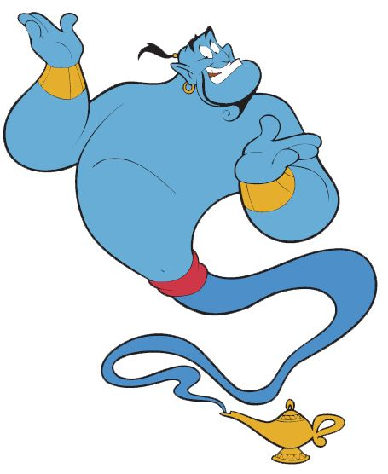
Word of the Day – annual

Definition ____________________________________________
_____________________________________________________
_____________________________________________________
Used it in a sentence: ____________________________________________________
_________________________________________________________________________
Word Class: ____________________________________________________
Synonyms

English
This week we are looking at a book called The Egyptian Cinderella. You can hear Mrs Tuck reading the story and asking you questions if you click on the following link. https://youtu.be/kqrnP7Julxw Thanks to Malaika Tuck for the technical support
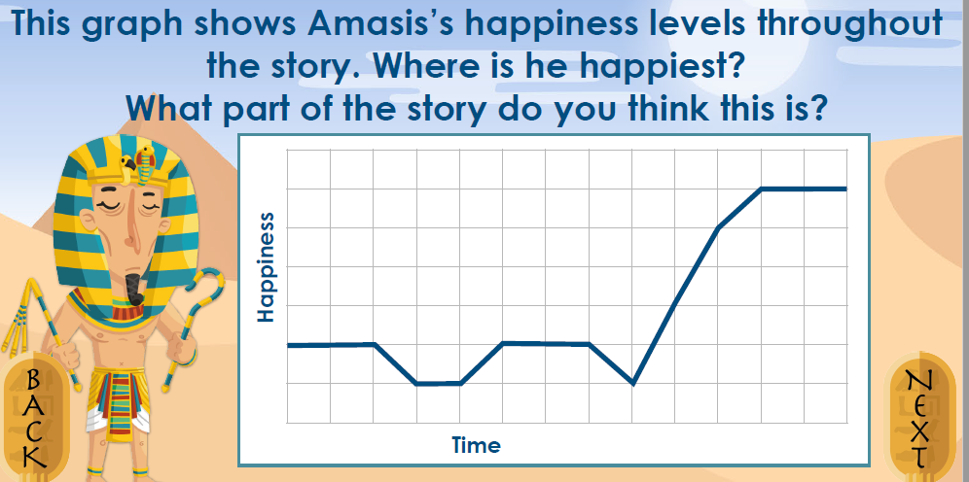
After you have listened to the story can you answer the question below on Amasis’s happiness levels.
Then can you draw the graph below and map out Rhodopis’s happiness throughout the story. When do you think she was happiest? When do you think she was saddest?

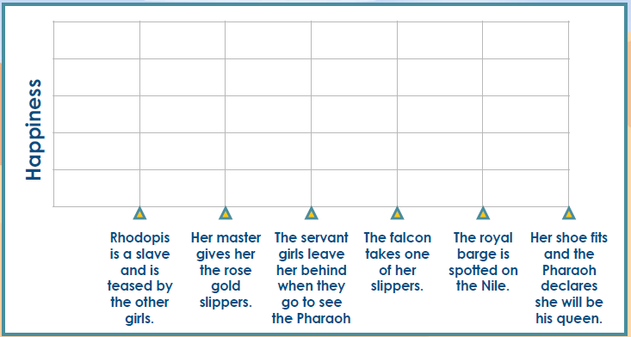

Maths Starter
1) What is the time 15 minutes after the current time in your house?

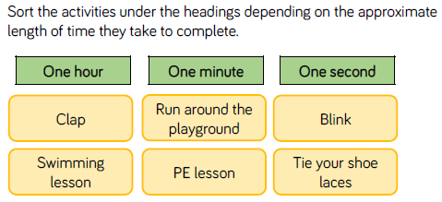
2)

Maths Main Lesson – What are decimals?
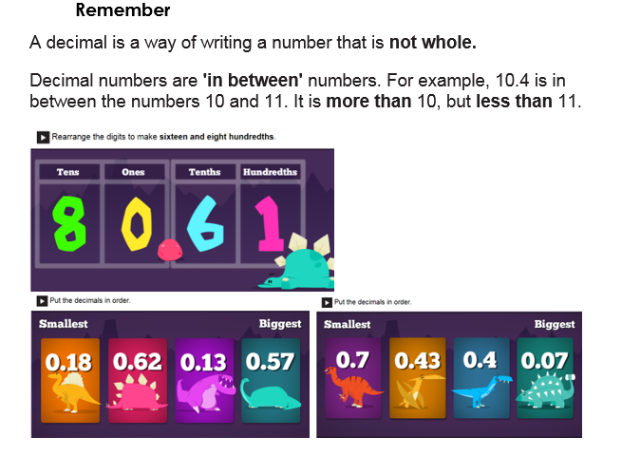
Watch - https://www.bbc.co.uk/bitesize/topics/zsjqtfr/articles/zsbd7p3

History
How can we learn about periods of history that happened a long time ago?
What do you think is meant by ‘a source of evidence’?
Why do you think so much historical evidence is about the wealthy?
Ordinary houses from Ancient Egyptian times do not still exist. Not only were they made of sun-dried bricks, so the chances of them surviving thousands of years were slim, their location in the Nile Valley was valuable so old homes were pulled down to make space for new ones.
Pyramids and tombs still exist because they were built out in the desert where people didn't need the space to build houses and they were built with stone.
This also explains why we know a lot more about death and the wealthy rather than the lives of ordinary people. Most of our evidence from that time was found inside the pyramids and tombs with the dead bodies of the kings and the rich elite.
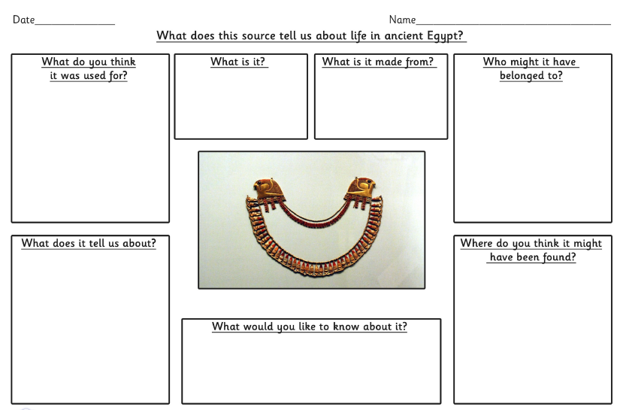
When we look at historical artefacts (an object made by a human being) and evidence it’s important to ask questions. Try this:

