English - Monday 13th July 2020

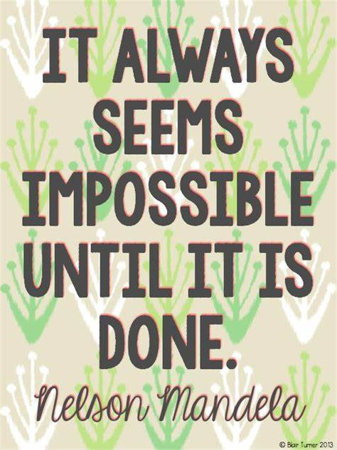
Fact of the day. We made it! How did that happen! The end of the school year. Give your grown ups a huge hug and a massive thank you from us. They made it and what a good job they have done too. It might not seem possible now but you will always remember this year and hopefully with fond memories not of school but of spending that time at home with your grown ups. We were lucky in year 2 that we got to put on our Christmas play, and wasn’t it good too. We also got to have lots of fun with our topics. Which was your favourite? My favourite story was about Togo, which one was yours? This week I have put together a booklet that you can fill in all about year 2. You can do a little bit each day or if you want do some over the holidays.

My Time in Year 2

Name: ___________________________
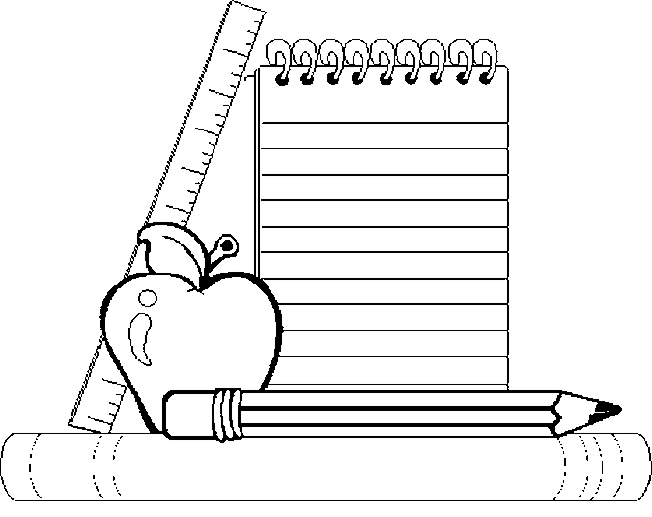
Age: ____________________________

Birthday: ________________________
My Self-Portrait

A few of my Favourite Things
My favourite subject:
My favourite place in school:
____________________
____________________
____________________

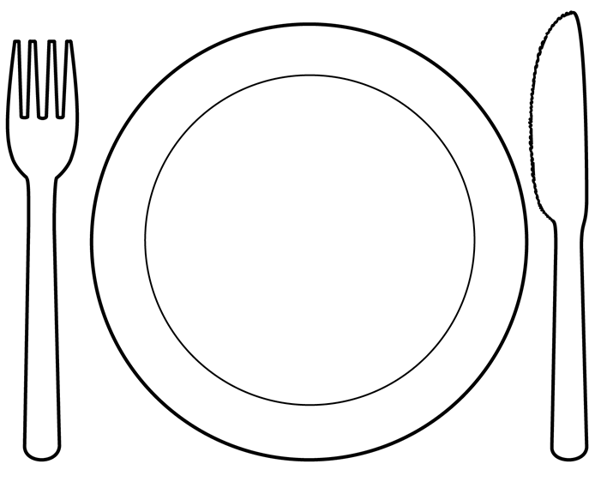

My favourite school lunch:
________________________
________________________

My favourite book:
_____________________
_____________________
_____________________

My Favourite Things about Year 2
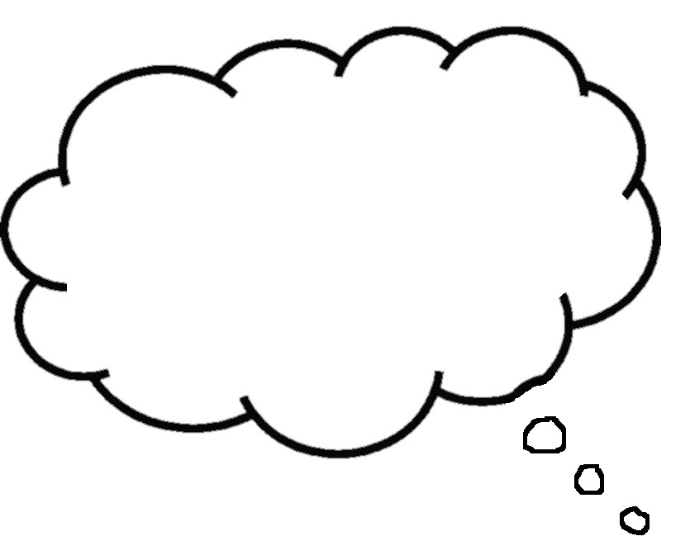
_______________________________________

_______________________________________

_______________________________________

_______________________________________

____________________________________

_______________________
My Best Memory
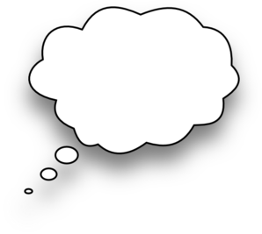

____________________________

____________________________

____________________________

____________________________

My Funniest Memory

Subject: _______________________

______________________________________

______________________________________

Subject: _______________________

______________________________________

______________________________________

Subject: _______________________

______________________________________

______________________________________
My Favourite Lessons
My Best Friends

My best friends are: _________________________

_________________________________________

_________________________________________

Because: __________________________________

_________________________________________

_________________________________________

_________________________________________

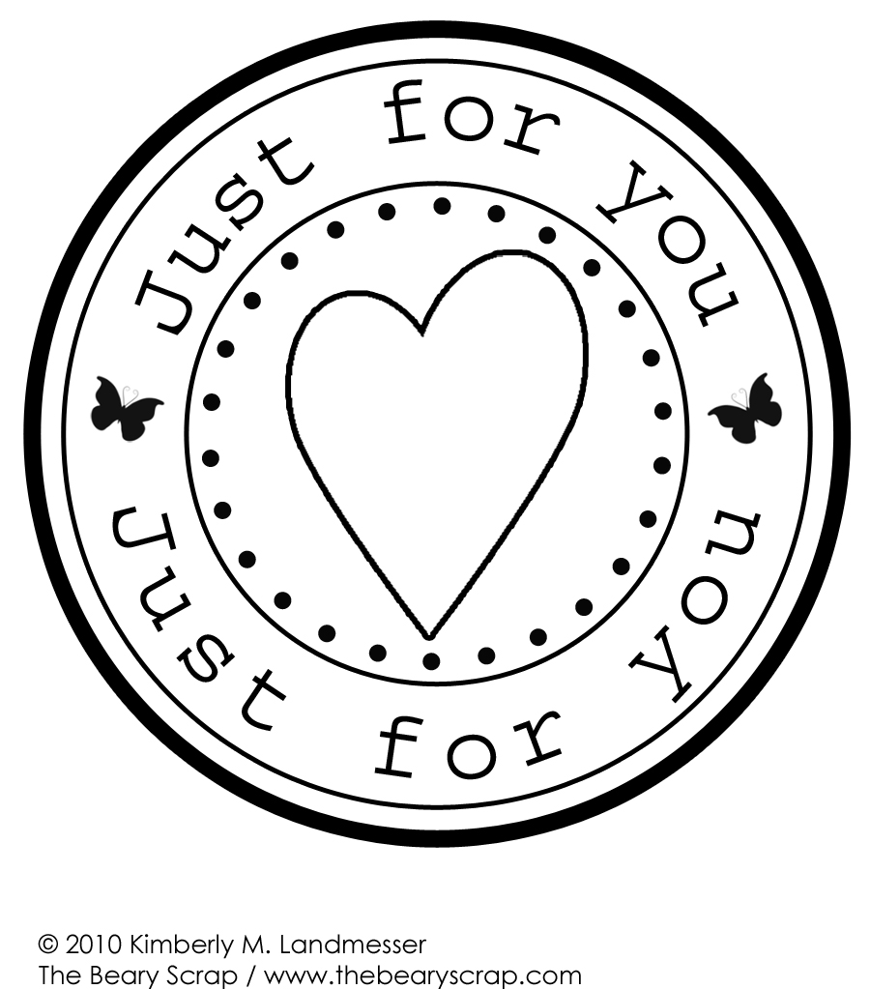
_________________________________________

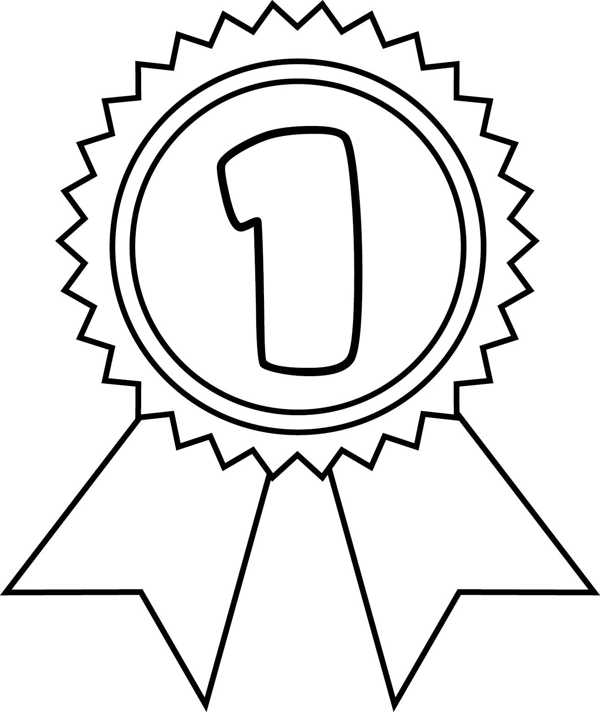

My Achievements

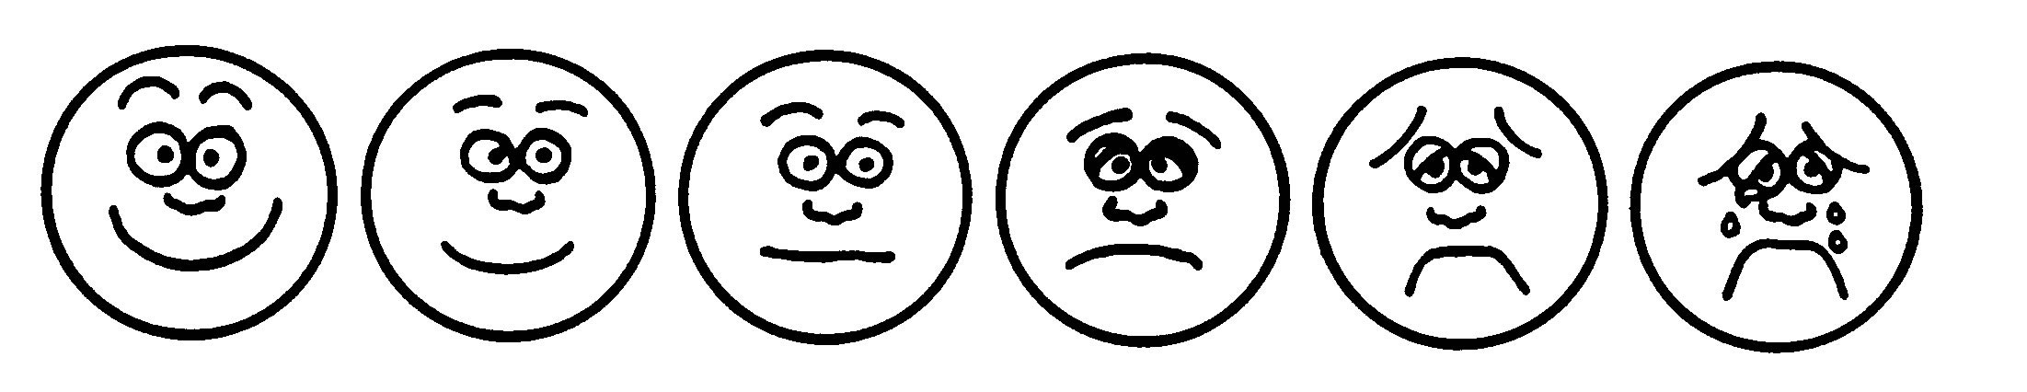
Reading ………………………………………………………………..

Writing ………………………………………………………………..

Phonics …………………………………………………………………

Maths …………………………………………………………………..

Science ………………………………………………………………..

RE …………………………………………………………………………

Geography …………………………………………………………..

History ………………………………………………………………..

Art ………………………………………………………………………

Music …………………………………………………………………..
How I Feel About School

____________________________________

____________________________________

____________________________________

____________________________________
What I am looking forward
to next year
