Milestones Document - Art in Year 1
Intent
Art, craft and design embody some of the highest forms of human creativity. A high-quality art and design education should engage, inspire and challenge pupils, equipping them with the knowledge and skills to experiment, invent and create their own works of art, craft and design. As pupils progress, they should be able to think critically and develop a more rigorous understanding of art and design. They should also know how art and design both reflect and shape our history, and contribute to the culture, creativity and wealth of our nation.

Subject Content, Knowledge and Skills:
Pupils should be taught:  - to use a range of materials creatively to design and make products  - to use drawing, painting and sculpture to develop and share their ideas, experiences and imagination  - to develop a wide range of art and design techniques in using colour, pattern, texture, line, shape, form and space  - about the work of a range of artists, craft makers and designers, describing the differences and similarities between different practices and disciplines, and making links to their own work. | Progression Outcomes  Developing/ Applying Ideas  I can show my ideas/imagination through drawing, painting and sculpture and produce simple designs  I can respond to ideas and starting points  I can explore ideas by collecting visual information  I can explore different techniques and media as ideas develop  Drawing (pencil, coloured pencil, wax crayon, pastels, charcoals, ball-point/biro, felt tip pens and fine liners)  With pencil, I can make different marks: dots, dashes, scribbles, sweeping lines, wavy lines, straight lines to show pattern  With coloured pencil, I can keep within the lines of a drawing when adding colour  With wax crayon, I can push down to make bold and strong lines and apply less pressure to make soft lines  With pastel/charcoal, I can make faint, soft lines and apply more pressure to make stronger lines  With pastel/charcoal, I can blend and smudge  I can use charcoal pieces to create: different lines, large sweeping movements  I can use different types of pen to make different types of line  I can use ball-point & felt tip pens to make fine marks  Painting  I can hold a brush correctly and use different types and sizes of brush  I can use a paint brush to: dab, wash, stipple and stroke  I can mix primary colours and describe how to make secondary colours with them, and add white to colours to make tints and add black to colours to create shades  I can control paint and water to mix paint of different thicknesses  I can load a brush with the correct amount of paint (for effect) and choose the correct brush size  I can use different brush types to make different marks: lines, blobs, dots, dashes  Sculpture/Form  I can make a model using natural and man-made materials to show a simple idea or using my imagination using lines and textures  I can explain how I am making my sculpture using a combination of shapes  I can used rolled paper, straws, paper, card and clay materials and use techniques such as rolling, cutting, moulding and carving  Print  I can use objects to create prints i.e fruit/vegetables/sponges or polystyrene tiles  I can press, roll, rub and stamp to make prints  I can use repeating or overlapping shapes  I can make my own print designs or mimic that from the environment (natural rubbings) or a famous artist (e.g. William Morris)  Digital Media  I can use a wide range of tools in 2Paint, word, paint or similar to create texture, lines, tints/shades and shapes  Independent Artist  I can begin to recall some of the equipment needed for an art session  I can help clear away my art area  Take Inspiration from Art History and Artists  I can describe differences and similarities between two contrasting drawings, paintings and sculptures by well-known artists and designers  I am beginning to describe how my own work is similar and/or different to the work of well-known artists and designers  I can use some ideas from artists studied to create pieces
Key Vocabulary and information:  Drawing, Painting, Sculpture, form, print, collage, textiles, digital media, artist, designer  Watercolour, poster paint  Weaving, stitching  Dyeing  Torn/ripped  Landscape/Portrait, Background/Foreground  Pattern, Symmetry/Asymmetry  Vertical, Horizontal, diagonal, sig-zag, chevron, spiral, curved, hatching, cross-hatching, scallop  Visual information  Techniques (see below), Elements (see below), Media (see below)  Coloured pencil, Wax crayon, Pastels, Charcoals, Ball-point pen  Soft/hard, Bold/faint, Blend/smudge, stippling  Line, Thick/thin, Sweeping  Dab, Smooth, wash, sponge, stipple, stroke  Primary, secondary colours, hot colours, cold colours, complementary/contrasting colours  Colour wheel  Tint/Shade  Bristles |  | Building on from…  Expressive Art and Design: Begin to explore the different medias of art with a strong focus on imagination and expression of ideas. Children take inspiration for art from the world around – including themselves (through self-portraits). Begin to understand what colours we frequently use and their effect on a piece of art.  The children create art for a purpose (card making).  What comes next…  Developing/Applying Ideas: Use imagination to produce designs and appropriately respond to and explore ideas.  Drawing: Increase control when using pencil, colour within lines and begin to use tones. Create lines using a range of media, blend and smudge pastels/charcoal. Use different pens to make lines and fine marks.  Painting: Explore brush types and the marks they can make (focus on refining marks and making them increasingly smooth). Mix primary colours to make secondary (then change tone/shade).  Digital Media: Use a programme to create an image.  Independent Artist: Begin to organise their own art area.  Art History and Artists: Compare contrasting art, compare their own work and use other pieces as inspiration.

Artists
Drawing and Illustration | Painting | Sculpture | Print | Collage/ Textiles
 | Henri Rousseau (post-impressionist)  Sharon Hall (clear line and colour) | Giuseppe Arcimboldo (surreal portraiter) | Andy Warhol (pop art)

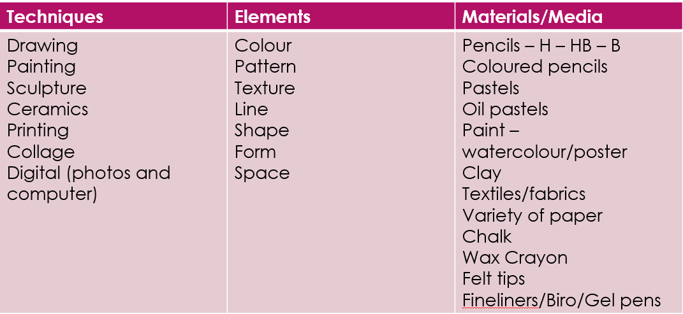 | 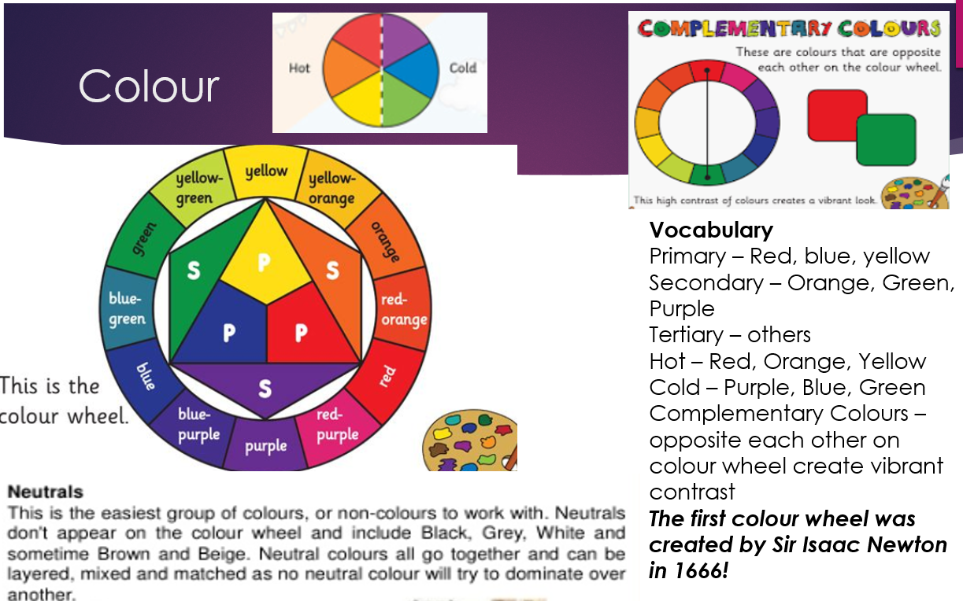
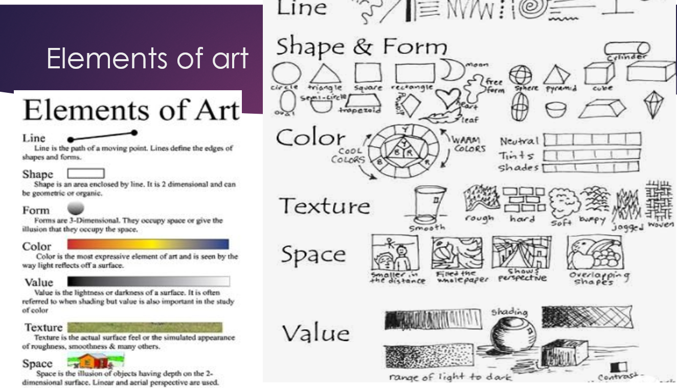 | 