Monday 16th March 2020
Dear Parents and Carers,
I hope you are well and have had a restful weekend.
I am writing to you at this time in relation to the latest information we are aware of regarding Coronavirus. As a school, we ensure our response to situations are well-planned and calm. I hope this letter will support your understanding of this in relation to Coronavirus.
We have been rigorously following guidance for educational establishments in the UK provided to us by the Department for Education and informed by Public Health England. Following this advice, the school has taken the following daily action for infection control.
- Displaying coronavirus infection control measures information posters in reception
- Providing facilities for handwashing with soap and water and offering antibacterial hand gel to staff and visitors.
- Ensuring good hygiene from all members of our school by promoting the information from Public Health England through staff briefings and children’s assemblies.
- Carrying out touch point cleaning at the beginning and end of the day and a further, deeper clean after school as usual. The touch point clean includes door handles, tops of taps and keyboards.
Please be aware that we would like to limit our open door policy at this time. Please drop children off at classroom doors without entering classrooms and corridors where possible in the mornings. Please then leave the school site quickly.
Self-Isolation
The most recent advice given states that anyone with a new persistent cough (coughing repeatedly) or high temperature (above 37.8) is now advised to self-isolate for seven days, as the UK government moves to the "delay" phase of its plan to tackle coronavirus. Currently, this is only about an individual’s symptoms, not within your household. For example, if dad had symptoms, it does not stop his children attending school as usual. Please also note the countries that are listed as having travel restrictions on the www.gov.uk website. Please look at the following websites for support with this...
www.gov.uk/guidance/travel-advice-novel-coronavirus
www.gov.uk/government/publications/coronavirus-action-plan
www.nhs.uk/coronavirus
https://kidshealth.org/en/parents/coronavirus-how-talk-child.html
We have a current record of all unauthorised leave of absence requests for term time. We will not have records of any holidays that are planned over the Easter holidays. Whilst considering your travel plans, please ensure that you have used the advice from the Government regarding travel to these countries.
School Closure
The Prime Minister has announced that schools are not to close at this time. If our school has to close, I will inform you as soon as I am able to do so via a text message, an emailed letter and notification on our school website. The text message will be sent first, followed by the emailed letter. The website will be updated at this point and I will ensure there is a phone message on our answerphone. Please can I ask you to ensure that you update school with any changes of contact details e.g. mobile phone numbers and email addresses? This is vital for any emergency situation we may experience at school. Thank you.
Plans are being put in place to ensure we are able to provide at least some learning activities for our children and families. The details of this will be included in the letter that I mentioned above.
If you are concerned by a school closure resulting in your child being unable to access free school meals, please do not hesitate to contact us confidentially via the school e-mail address: office@russell-lower.co.uk
In the event of a school closure, you will still be able to read updates on the school’s website. We will also text and email any important updates. We will continue to work to monitor the safeguarding of children in our school.
Decisions regarding future school events and trips will be shared in due course. Our decisions are always made using the latest medical advice from Public Health England.
We are aware that some children are becoming concerned as they hear from the news, overheard conversations or from older siblings about the Coronavirus. Consequently, we are attaching a help sheet with this letter, which provides some useful guidance on how to discuss the topic with children and how to respond to any questions they might ask.

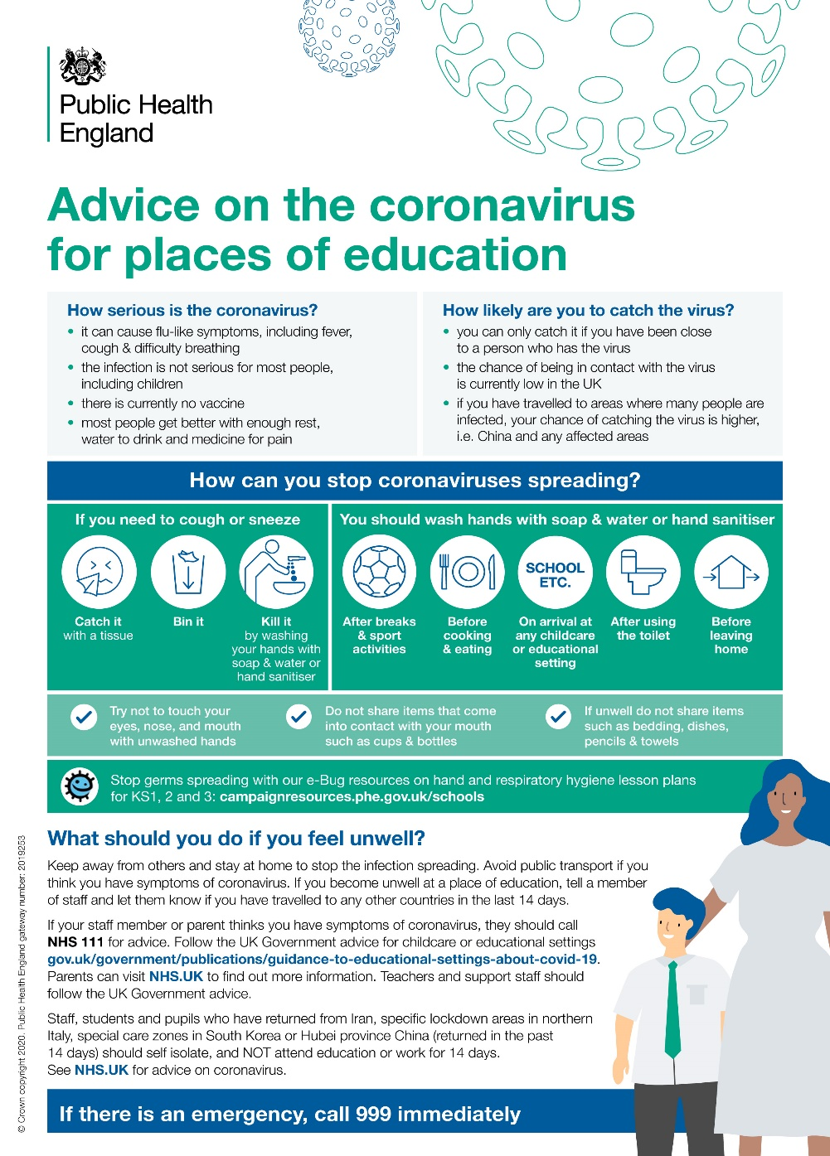
If you have any questions or concerns, please do not hesitate to ask.
Thank you for your support at this very challenging time for everyone.
Kind regards

Nicki Walker
Headteacher

