Activity across Russell Lower School 2020-2021
Year | Date | Activity | Rational/Outcome/Impact | Next step
Whole school | October 2020 | Travel to school – pupils and staff | 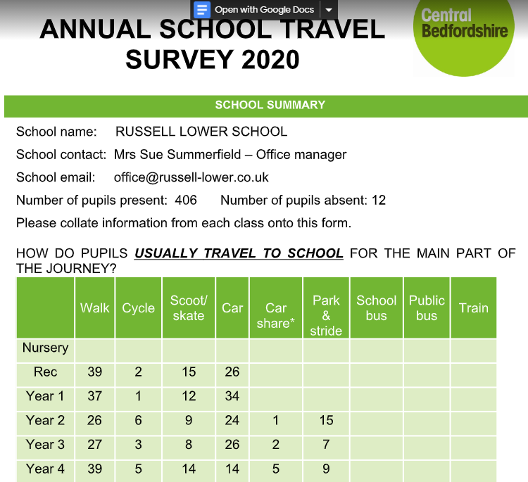  61% of children actively travel to school  8% of children are partial active travelling to school  Total – 69%  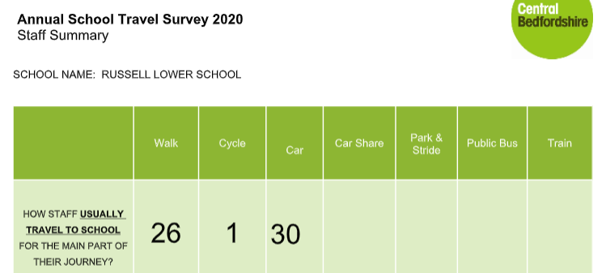 | To continue to promote the importance of active travel to school through work with Sustrans and bike and scoot sessions.
 | 13/11/20 | Children in Need 5 to Thrive - unique programme of wellbeing activities for our Appeal Week (9-13 Nov), led by Joe Wicks, Dr Radha and Blue Peter. Inspired by the 5 Ways to Wellbeing. | The whole school took part in 5 to Thrive for Children in Need with a variety of activities including one on being active led by Joe Wicks. Use of resources designed to help children feel better about themselves – as well as helping others.
 | Throughout Oct and Nov 20 | Cross country through RSSP  KS1 – 400m  KS2 - 800m | All children took part in class bubbles and fastest girl and boy from each year entered into virtual school games  Year 1 boy = 3m 58s, girl = 4m 44s  Year 2 boy = 1m 50s, girl = 2m 02s  Year 3 boy = 4:31, girl = 5:04  Year 4 boy = 3:43, girl = 4:02  Thank you very much to all schools that took part in the RSSP virtual competitions this term. Approximately 10,000 young people from the Lower Schools competed in the 6 events that were on offer this term. Please pass our congratulations on to those individuals that took part!!  After carefully checking the results, the following schools will receive a set of medals for their 'team' winning the SSP Virtual competition. A set of medals will be on its way to your school before the end of term.  Event Lower School Cross Country KS1 Tennis KS1 Rugby  School Russell Lower Westoning Lower Toddington St. George  Team Name n/a West 1 Hummingbirds 5  We are currently putting the finishing touches to the virtual competitions for next term, and will circulate these shortly. | To celebrate within a celebration assembly.  To continue to take part in virtual festivals next term
 | December | 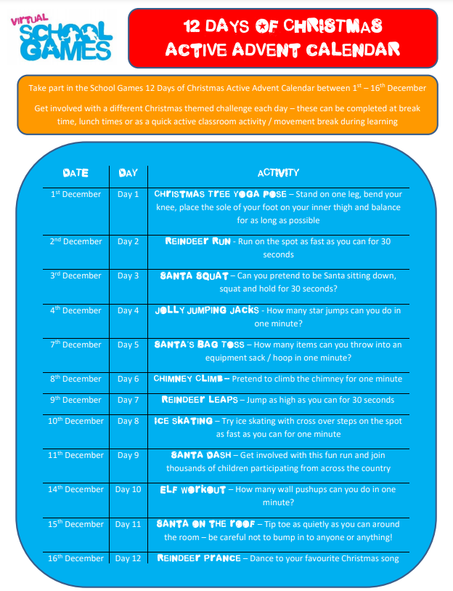 | To increase activity levels across the school in a fun and engaging way.
 | December | 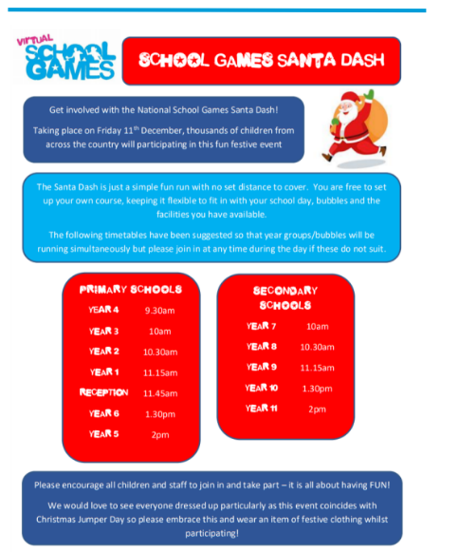 | 11th December 2020 all bubbles took part in the Santa Dash. Fun run with no set distance. This was made more fun and exciting by many bubbles by turning it into a scavenger hunt.
 | February | The Joy of Moving Winter Games is a pack emailed out to all families. | This has been shared with us by Luton Town Fc Community Trust who are working in partnership with the EFL Trust to deliver this national initiative.  Last May over 250,000 pupils took part in the Joy of Moving Home School Festival and there are likely to be hundreds of thousands of children taking part again this year.  The Joy of Moving Winter Games is a pack of fun activities designed to suit the current lockdown restrictions.  The games and activities are designed to inspire active lifestyles in children, aiming to teach them how to enjoy moving through play and to help them develop positive habits for adulthood.  All games and activities are appropriate for children in Key Stage 1 and 2.  All children involved in the Joy of Moving Winter Games can achieve a certificate which can be downloaded from the Winter Games Pack.
 | February | National Half Term Distance Competition: 15-21st February | We are delighted to inform you that the school has signed up for The Children’s Challenge Half Term Distance Competition. This is a national competition and we will be competing against at least 80 other primary schools (growing daily!) from around the country. These schools represent over 25,000 pupils!  Parents are encouraged to walk, run, cycle or scooter with their children from Monday 15th to Sunday 21st February and then log their child’s daily distance under “Submit Daily Distance” on the following website:  https://thechildrenschallenge.com/feb-1521-half-term-competition.  The sum of the distances travelled by all children attending our primary school should be submitted by parents at the end of each day. All rules, as well as the all important daily leaderboard, can be found on the above website. The leaderboard will show the absolute distance travelled by all the children at the school as well as the average distance per pupil. The key to national glory will be maximum participation!  Please feel free to use the hashtag #TheChildrensChallenge to post any photographs to instagram that could inspire other families both at the school and across the country to participate.  It promises to be a highly engaging, competitive and fun event. The purpose is to encourage children from all around the country to exercise everyday for both their mental and physical health.  Good luck and do the school proud!
Year 1 | 11/11/20 | Rugby virtual school games festival via RSSP  To enable children to still participate in interschool competitions during the CV-19 pandemic | 6 children from each bubble were able to represent RLS in a virtual school games  Puffin: 1:22 and 1:11  Wrens: 1:06 and 1:04  Owls: 1:10 and 1:00
Year 2 | 11/11/20 | Tennis virtual school games festival via RSSP To enable children to still participate in interschool competitions during the CV-19 pandemic | 6 children from each bubble were able to represent RLS in a virtual school games  Penguins: 1:44 and 1:34  Robins: 2:21 and 1:44  Greenfinch: 1:47 and 1:37
Year 3 | 18/11/20 | Dodgeball virtual school games festival via RSSP  To enable children to still participate in interschool competitions during the CV-19 pandemic | 6 children from each bubble were able to represent RLS in a virtual school games  Goldfinch: 35  Blackbird: 28  Nightingale: 26
Year 4 | 18/11/20 | Table tennis virtual school games festival via RSSP  To enable children to still participate in interschool competitions during the CV-19 pandemic | 4 children from each bubble were able to represent RLS in a virtual school games  Woodpecker: 149  Starling: 97  Kingfisher: 278

Least active children
Children who report to not do or have done any clubs inside or outside of school
Year group | Least active number of children
Owls | 5
Puffins | 8
Wrens | 5
Greenfinch | 6
Penguins | 3
Robins | 4
Total KS1 | 31/171 18%
Goldfinch | 3
Blackbirds | 1
Nightingales | 4
Woodpeckers | 6
Starlings | 3
Kingfishers | 2
Total KS2 | 19/168 11%
Average | 14.5%

