MAY NEWSLETTER
May 2022
Dear Parents/Carers,
Welcome to our May newsletter. These newsletters are sent out on a monthly basis to keep you informed about what is happening in school. If you ever want to contribute an ‘article’ or suggest information that should be on the newsletters, I would be delighted to hear about them.
Please note events that are underlined and in italics are new since the previous newsletter.
Thursday 26th May – Foundation Stage Pirate Day – more information to follow
Friday 27th May – Queen’s Platinum Jubilee Celebrations in school

Half term holiday 30/5 – 3/6 – Premier holiday camp running

Monday 6th June – Year 1 (and some Year 2) Phonics assessment week, Alameda dance assembly, National Fieldwork week (Geography) (NO INSET DAY)
Friday 10th June – Quad kids athletics festival for Year 4
Monday (Kf), Tuesday(Wp) and Friday (St) 14th – 16th June, Alameda Class visits 2 – 3pm
Wednesday 15th June – Greenfinch and Penguin Class to Marston Vale
Thursday 16th June – Robins to Marston Vale, Y3 tennis festival, New Intake Meeting for parents of September 2022 entry children at 6:30pm
Monday 20th June – Friendship letter home for Year 2 and Year 3 children (these two year groups will be the only ones where children are ‘mixed’ into new classes for the following year)
Tuesday 21st June – History off the Page visit Year 1
Wednesday 22nd June – PTA meeting at 7:30pm
Friday 24th June – Year 2 and 3 friendship letter deadlines
Saturday 25th June – Litter pick with PTA and ACCG (Ampthill Climate Change Group), 1 – 3pm meet on Foundation Stage Playground
Tuesday 28th June – Big Concert at Russell day (more information to follow)
Wednesday 29th June – Russell Lower School Sports Day Morning (am), Ladybirds Sports Afternoon (pm)
Thursday 30th June – History off the Page visit Year 1
Friday 1st July – Krispy Crème Friday – run by PTA on field after school
Sunday 3rd July – Ampthill parade and gala day – more information below
Monday 4th July – Y2 Cricket festival, 6:30 CLS Governors meeting
Wednesday 6th July – Y3 and 4 girls’ football festival
Thursday 7th July – Russell Lower School Commonwealth Games – more information to follow, possible PTA Quiz Night (more information to follow)
Friday 8th July – Middle school transition day, Class swap at Russell day, stay and play sessions for new Foundation Stage 2022
Saturday 9th July – PTA Inflatable fun day (more details to follow)
Monday 11th July – 6:30pm Full Governors meeting
Tuesday 12th July – 2:30pm and 6pm – Year 4 performance to parents (tickets and more information to follow)
Wednesday 13th July – Foundation Stage Visit to Herrings Green Farm, Alameda meet the tutor night
Thursday 14th July – 2:30pm and 6pm – Year 1 performance to parents (tickets and more information to follow)
Friday 15th July – End of year school reports home to all
Monday 18th July – 2:30pm onwards – Open afternoon – parents invited in to see children’s books/work and classrooms, parents may take children home when they have finished, PTA sunflower competition winners announced in assembly
Tuesday 19th July – 9:15am Year 4 Leavers’ Assembly (with parents), 1:15 – 3:30pm Year 4 Leavers’ Party (no parents)
Thursday 21st July – last day of school – Break up for summer

Friday 22nd July – Friday 2nd September – Summer holiday – Premier Sports Camps running much of the holiday (Thursday 1st and Friday 2nd September are INSET days)

Monday 5th September – All children (Y1 to 4) back at school, new Foundation Stage children will start later. Home visits continue

More detailed information on the above events will follow in due course

Kitchen hygiene rating:
Congratulations to our brilliant kitchen team headed up by Liz. Yet again, they have retained their hygiene rating of 5! (May 2022) Well done ladies!

SHEU (Schools Health Education Unit) survey results:
Back in the autumn term, Y4 took part in the national SHEU survey which enables us to compare the ‘health’ of our children at Russell with ‘all’ children living in Central Bedfordshire.
The results are always interesting and we always adapt what we do in school as a result.

Compared to other Central Bedfordshire children, children at Russell were ‘better’ in these 5 main areas:
- Our children do not worry about school work or exams/tests as much as other children in other schools in CBC
- Our pupils say they keep on trying, don’t give up and always try hard more than other children in CBC do
- Our pupils report less bullying at or near school than other children in CBC
- Our children like PE lessons more and drink plenty of water compared to other children in CBC
- Our children have higher self-esteem and can ‘keep calm and carry on’ when things go wrong better than other children in CBC
Compared to Central Bedfordshire children, children at Russell were ‘worse’ in these 5 main areas:
- Our children say that they do not get enough sleep to feel awake all day compared to other children in CBC
- Our children missed spending time with their friends more than other children in CBC during lockdown
- Our children didn’t feel like they knew enough about how their bodies grow and change as they get older, and that their parents don’t speak to them about it, in comparison to others in CBC
- Our children said they hadn’t all had at least 4 days in the last week where they had to ‘breathe hard’ compared to others in CBC
- Our pupils reported that they did not eat 5 portions of fruit or veg a day as frequently as other children across CBC
Of course, all these findings are dependent on the children answering the survey accurately, but it is certainly food for thought. As a school, we have reviewed the 5 ‘worst’ areas and changed the PSHRE curriculum accordingly. Could you please review these 5 ‘worst’ areas too and see if there is anything that could be changed at home to support children in these areas too? For example, it was very worrying the number of boys particularly, that reported that they did not get enough sleep to feel awake the next day. Thank you for your support.

Pupil absence:
Thank you for your support in getting children back to school, following huge Covid-related absences. As you know, we are now fully implementing our Redborne School’s Partnership attendance policy, which does not make any provision for term time holidays, and may well result in fines for those who do. Thank you for also using our preferred method of reporting pupil absence: an email to pupilabsence@russell-lower.co.uk This is working really well and we now receive the majority of notifications this way (which saves us a lot of time). Please be as specific as you can about why a child is absent. Just ‘tired’, ‘unwell’ or ‘sick’ is not enough information. The details you give us all needs to be recorded and reviewed by our attendance officer. Thank you again.

Medical/Bump notes:
As you know (April newsletter) we have now moved to completely paperless medication administration notifications and first aid, or ‘bump’ notes which will arrive via email. We will not send a first aid/bump email home for every scratch, graze or bump as we would spend more time writing and sending these home rather than supervising the children, but please be assured that for any more significant incidents or injuries we will send an email home and often even call home too. Thank you for your understanding.

Parking plea:
Please can I again request that you do not mount the pavement or grass verges to park when dropping/collecting children from school. It is far too dangerous for all concerned. Please park safely and respectfully at all times. Keeping our whole community safe is of paramount importance.

Reminder - Being prepared for any weather:
Can we please ask you to ensure that your child has a named water bottle and a raincoat in school every day? Equally, if at all possible can you please apply sun cream to your child before they come to school as this will save an awful lot of difficulty for them as we cannot apply it for them? Thank you.

Snacks:
Please can we remind you that we ask parents to provide one healthy snack (chopped fresh vegetables or fruit please) each day? Increasingly, we have children coming to school without a snack. Not only does this help children get one of their ‘5 a day’, it also ensures that they don’t feel left out when others are ‘snacking’. Thank you.

Ampthill Gala and parade:
This year, we will again be joining the Gala day parade on Sunday 3rd July. We usually meet at around 11:15am by the Firs Lower School and then parade through the town, arriving at the Gala as it opens. This year we will be creating a red, white and blue ‘River of Hope’ to celebrate the jubilee, and will be asking children and parents to join us. Look out for more details to be emailed out soon. It is a lot of fun parading through the town and very atmospheric being part of the parade. Do save the date.

Very busy summer term:
As you will see from the calendar, the summer term is the busiest of the school year! Please bear with us as there will be an awful lot to communicate with you about!

Russell Raiders Victory:
We had some great news a few weekends ago - Russell Raiders U9’s (Year 4) entered the Ramsey Manor football tournament at Barton Rovers FC and ended up winning the Ramsey Shield Trophy! The boys played five fantastic matches eventually winning 5-0 in the final against Harlington. It was a great team effort and all the boys were brilliant. The other boys who are part of the football team but did not play in this particular tournament also deserve a mention too. A great team effort!
Well done from everyone at Russell Lower School and from Coach Andy too! The shield now sits proudly in the school trophy cabinet.

Russell Lower School Gardening Club Wheelbarrow competition entry 2022:
Did you see the Wheelbarrow planted and created by Russell Lower School Gardening Club? It was stood outside the office and is part of a competition run by Bedfordshire Garden Trust and will be displayed at the Swiss Garden, Shuttleworth, over May half term.
This year there are over 20 primary schools taking part and all members of the public will be given a token in which to vote for their favourite wheelbarrow.
Do go along and join in the fun - and don't forget to vote for our entry!
Flitwick and Ampthill Tennis Club – open day:
Flitwick and Ampthill Tennis Club will be holding an open day between 1pm and 4pm on Saturday 18th June at the Flitwick Club site for anyone who would like to try out tennis.
It’s completely free of charge and all age groups and abilities are welcome.
The event was well attended by local children last year, with many going on to take up tennis.
All equipment will be provided and there will be games and free coaching for adults and children alike with refreshments available. Do go along and have a try!
www.flitwicktennis.co.uk

Wildlife Trust for Beds, Cambs and Northants Event on Copper’s Hill:
Flit Vale Wildlife Watch are running a family fun afternoon in half term specifically aimed at primary aged children. It is on Monday 30th May, 2 – 4pm
Please see the link for more details
https://www.wildlifebcn.org/events/2022-05-30-flit-vale-wildlife-watch-family-fun-coopers-hill

Reminder - Keech Hospice:
Keech Hospice Care is a charity which supports adults from Luton and South Bedfordshire, and children from Bedfordshire, Hertfordshire and Milton Keynes, who have life-limiting illnesses. They are unique as they are one of the few hospices in the UK which provides care for both adults and children.
They are a charity, relying on their supporters for around 70% of their funding. This means they need to raise over £6 million every year (over £16,000 every day!) to continue their specialist care for adults and children, and their families. They are enormously grateful for whatever you can do or give.
After a very difficult 2 years for Keech, they are delighted to be holding their Colour Dash Family Fun 5K on Sunday 17 July 2022 at the Luton Regional Recreation Ground, St. Thomas’s Road, Luton, LU2 7UX. If you think you could join in to raise funds, please visit https://www.keech.org.uk/whats-on/colour-dash/ for more information. Thank you in advance.

Reminder - Queen’s Platinum Jubilee:
To celebrate our Queen’s truly incredible achievement of 70 years’ reign, we are planning to hold a day of celebrations for the children on Friday 27th May. Please see below (and attached to last month’s newsletter) for details of Ampthill’s community celebrations:
Children’s Quiz:
Children are invited to “Go and visit the flags on Market Square from 29th May, and you may find some of the answers to these questions. See how many you can answer?”
Complete your name and contact details and hand in to Ampthill Library or Ampthill Town Council offices by Friday June 10th, 2022.
They are collecting school names on the form so that they can feed back to children via the schools. Here’s the link for the quiz sheet
https://www.ampthilltowncouncil.org.uk/contentfiles/735.pdf

Platinum Jubilee Concert:
Treat yourself to a concert on Saturday 4th June, 7:30pm at Parkside Hall, where Gary Wood and his Swing Band will play a Platinum Jubilee concert. Tickets cost £10 from No. 14, Cambridge wine or Ampthill Town Council (council@ampthill-tc.gov.uk). For more detail, please see attached.

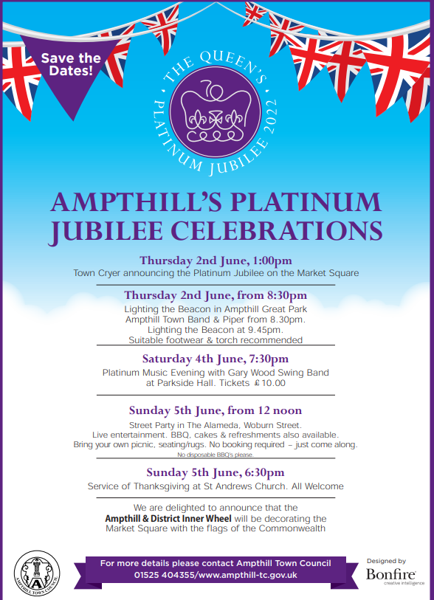

And finally:

Thank you for taking the time to read this newsletter. I hope you have a lovely half term and Jubilee bank holiday weekend with the children.
Many thanks and kind regards,
Nicki Walker
Headteacher

