Year 2 Phonics/Spelling Practice w/c 19.5.20 Tuesday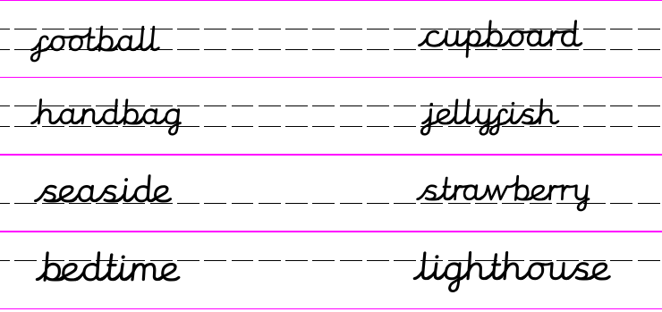
Here are some more compound words. Write a caption word for each.

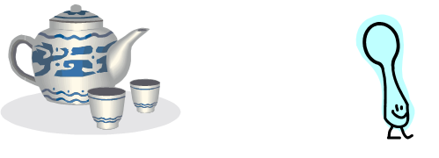 | 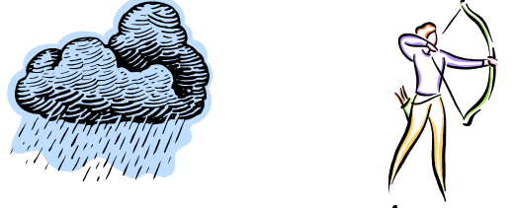

Dictation:
Ask someone to read out the sentence below so that you can write it down – try not to look until after you’ve written it. Check your punctuation and spelling.
I took my football to the seaside.

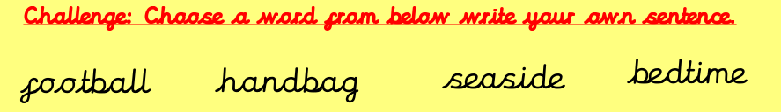

Wordbank: teaspoon, rainbow, snowman, butterfly, goldfish, pancake
Maths 19.5.20 Add 2-digit numbers
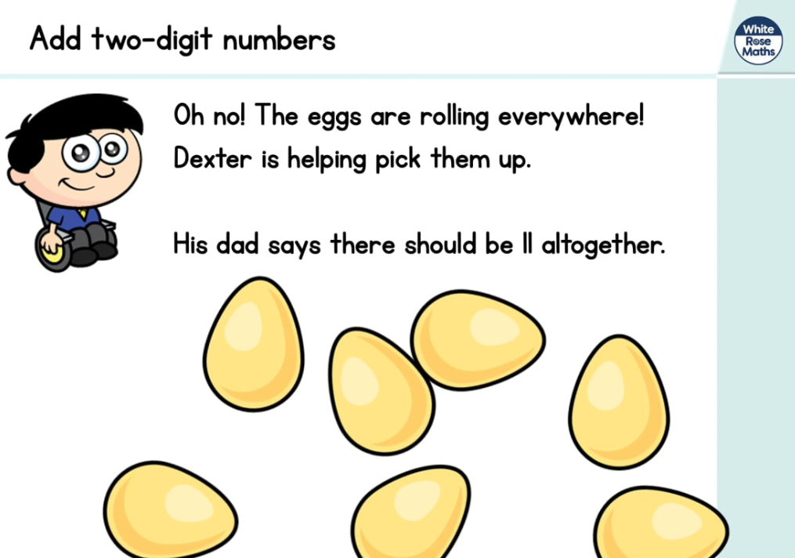
https://whiterosemaths.com/homelearning/year-2/ (week 4 dated w/c 11.5.20 Lesson 2)
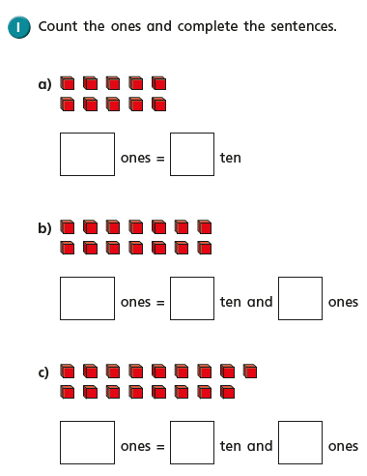
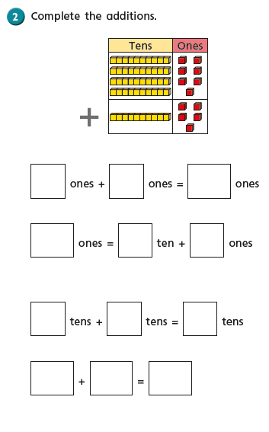
Copy and complete these
additions using 10s and 1s to help:
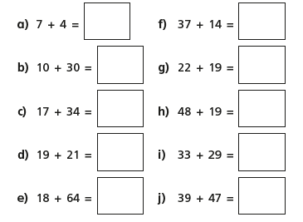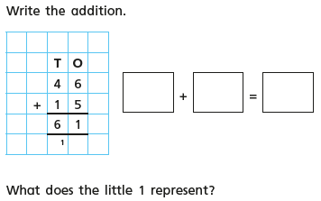

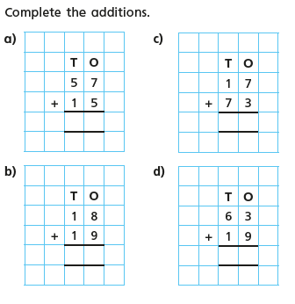

English - Tuesday 19th May. Quote of the day.
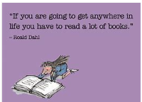
Word of the week: Suspense
WALT scan text for information. Draw upon what we have read to answer questions about the text.

Today we are going to read the three chapters from yesterday again to refresh our memories then we have some viper style questions to answer about what we have read.
V – vocabulary, I – inference, P – prediction, E – explain, R – retrieve, S - sequence
The Three Farmers
R – What are the names of the three farmers?
R – Where do they live?
E – Why is Farmer Boggis so fat?
E – What makes Farmer Bunce have such a ‘beastly temper’?
V - What other word/adjective could Roald Dahl have used instead of disgusting?
R – What does Farmer Bean have instead of food?
E – What do the farmers think of the children’s song?

Challenge me – Can you make up some comprehension questions of your own using the text and ask your grown-ups to find out the answer.
Feeling confident - Answer all the questions.
Need more practise – Answer the first three questions then ask your grown up for the answers to the other three.

History - Tuesday 19TH May 2020
WALT understand the significance of historical events in our locality.
Word of the day interview

Can you believe this is week 5 of our history topic! Your historical evidence is now beginning to build up and will be a fantastic primary resource for historians in the future as well as something you will be able to share with family and friends.

Today is a good day to look back at what we have done so far as we are approaching the half term holidays. You may want to add to the work already done as things have changed/adapted for you.

I am hoping that we will all be back in school very soon, not just the younger years so that we can share our work and experiences with each other.

Today’s tasks are to go back over our previous work and read through and reflect on how much has changed since we began making our time capsule. Then, I thought it would be nice for you to be able to interview your parents or other adults in your family about their experiences at this strange time.

It will be interesting to see if you were to interview more than one person if their answers are very different.

Have fun and keep safe.

