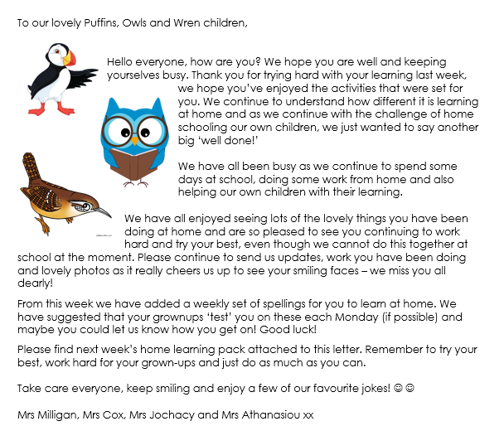

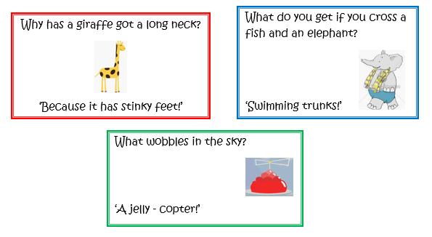

**Year 1 Phonics Activities – Summer 1 Week 3 (w/c 4.5.20)**

|  |  |
| --- | --- |
| **Session 1 - Monday 4th May 2020**  **Warm up activity– Phase 3 digraphs (2 letters together that make 1 sound)**  Use the sound mat below– choose a digraph/trigraph (igh, ear, ure, air) and ask your child to write it down/make it with magnetic letters/paint it outside on the pavement using paint brushes and water/chalk etc. | **Session 1 - Main activity**  **Split digraph a** (a__e – e,g, cake, tale, make, mate)  Introduction to split digraph a – watch the video to introduce the sound.  <https://www.youtube.com/watch?v=f0aCGmNNl-s>    Click the link and watch the video about split digraph a. The children will listen to, read and say words with the split diagraph a – there is also a sentence to read at the end to challenge yourself!  <https://www.youtube.com/watch?v=AoSD16T8Puo> |
| **Session 2 - Tuesday 5th May 2020**  **Warm up activity** – Recap ‘split digraph a’ from yesterday.  2 minute challenge!  How many split digraph a words can your child write in 2 minutes? Maybe you could have a go too and see who gets the most! Encourage your child to check your words. | **Session 2 - Main activity**  Play ‘BINGO’ with split digraph a words:  Real and nonsense words:  **make flate**  **amaze pabe**  **snake vate**  **escape prake**  **game lafe**  Ask your child to write these words on post its or chopped up paper so everyone playing can see them (or an adult could write them out).  Each player splits their board into 4 quarters and then chooses 4 words to write down, one in each quarter.  The words could then be turned over or put in a bag/ box for the bingo caller to pull out and read. The first person to cross off all 4 of their words is the winner! |
| **Session 3 - Wednesday 6th May 2020**  **Warm up activity– Phase 5 digraphs (2 letters together that make 1 sound)**  Use the sound mat below– choose a digraph and ask your child to write it down/make it with magnetic letters/paint it outside on the pavement using paint brushes and water/chalk etc. | **Session 3 - Main activity**  Children to create their own ‘split digraph a’ word search.  Children to think of some ‘split digraph a’ words and put them into their own word search.  See example below: |
| **Session 4 - Thursday 7th May 2020**  **Warm up activity** – choose books, magazines, instructions, cards – anything with writing on and become sound detectives!  How many ‘split digraph a’ words can you find?  Make a list of the words you found. | **Session 4 - Main activity**    **(Children to draw their own ‘phoneme frames’ e.g.**   |  |  |  |  | | --- | --- | --- | --- | | **t** | **r** | **ea** | **t** | |

**Weekly spellings:**

We will be adding weekly spellings to the bottom of the phonics planning. Please continue to practise them at home as you had been doing before school closed. We find the ‘look, read, cover, write, check’ approach the best way to learn the spellings.

At school the children are usually ‘tested’ on their spellings on a Monday. Please feel free to keep to this structure.

The children should hopefully remember which group they were in for their spellings. If any children from group 1 or 2 want to challenge themselves with more spellings, please feel free to let them have a go.

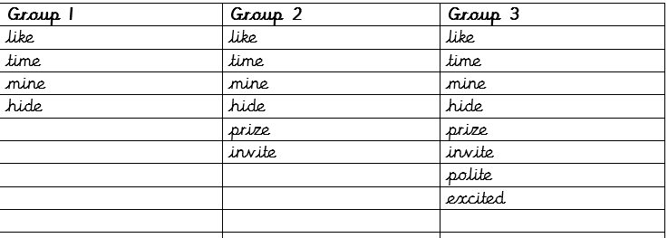

**Year 1 Maths Activities – Summer 1 Week 3 (w/c 4.5.20)**

This week we are going to be working on **addition and subtraction**, + and – (up to 20)

Please follow the bbc bitesize link below:

<https://www.bbc.co.uk/bitesize/topics/zwv39j6>

Here you will find video clips, games and quizzes to work through.

You could also use objects and do this practically.

|  |  |  |
| --- | --- | --- |
| **Date** | **BBC bitesize activities** | **Challenges** |
| **Monday**  **4th May** | What is addition? | http://ts1.mm.bing.net/th?id=HN.608036523413147064&pid=15.1&H=89&W=160http://ts1.mm.bing.net/th?id=HN.608036523413147064&pid=15.1&H=89&W=16011 people are on the bus.  5 more people get on the bus.  How many people are on the bus now?  http://ts4.mm.bing.net/th?id=HN.608021718660416019&pid=15.1&H=222&W=160  On Saturday Jon scored 7 goals.  On Sunday he scored 4 goals.  How many goals did he score at  the weekend? |
| **Tuesday**  **5th May** | What is subtraction? | Meerkat Stock Illustrations – 1,190 Meerkat Stock Illustrations ...14 meerkats are foraging for food.  An eagle flies over and 7 run away.  How many are left?    There are 12 vultures in a tree.  5 fly away to find food.  How many are left in the tree? |
| **Wed 6th May** | What are number bonds? | Number Bonds To 10 - Butterflies | Mathematics & Number | Outside ...Make a poster to display in your home, showing number bonds to 10 or number bonds to 20. |
| **Thurs 7th May** | Use this game to practise addition and subtraction facts (answers up to 20)  <https://www.ictgames.com/mobilePage/funkyMummy/index.html> | Now have a go at writing your own number stories for your grown-ups to answer using addition and subtraction. You could draw pictures to help them too.  e.g. |

**Year 1 Foundation Activities – Summer 1 Week 3 (w/c 4.5.20)**

|  |  |
| --- | --- |
| **Date:** | **Activity:** |
| **Monday 4th May** | **Science –** looking closely at animals and humans in different seasons.  Do you think it is easier for animals to find food in the summer or winter? Explain why? Do you think it is easier for animals to stay warm in the summer or winter? Can you explain why?  How do animals adapt for each season? What does hibernate means? Can you name any animals that hibernate? |
| **Tuesday 5th May** | **Music**  Listen to and join in singing traditional seaside songs. Can you use your voice expressively and creatively when singing songs?  <https://www.youtube.com/watch?v=kcHyyuGjuk0>  <https://www.youtube.com/watch?v=YOA3he2Gv4M> |
| **Wednesday 6th May** | **Geography**  <https://www.bbc.co.uk/teach/class-clips-video/geography-ks1-ks2-jobs-and-tourism-in-a-seaside-town/zd88qp3>  Discuss what you have learned from the video.  Can you find Weymouth on a map? Can you find other seaside towns in England?  What jobs are linked to the seaside? Can you make a list of them? |
| **Thursday 7th May** | **History – VE Day**  <https://www.bbc.co.uk/newsround/48201749> - What is VE Day   * Use a cereal box and design a suitcase and then put things that an evacuee would have in the suitcase. * Photograph the day using 21st century technology then use editing software to make B&W / sepia and add effects to make look like old photos.   Here are some more ideas:  <https://www.teachingideas.co.uk/world-war-2/world-war-2-day-ideas> - The ideas on this website were contributed by teachers from all around the world. However, a lot of them were planned for Year 5, many of them can be used in all year groups.  Some art activities: |

**Year 1 English Activities – Summer 1 Week 3 (w/c 4.5.20)**

|  |  |
| --- | --- |
| **Monday**  **4th May** | Retell the story of The Three Little Pigs to a grown up. Remember to use the repeated phrases. |
| **Tuesday**  **5th May** | Harry woke up one morning. He was invisible!  What did he do next? Write a story about him. |
| **Wednesday 6th May** | Can you write these tricky words?  Friend, school, said, there, once, where, ask, house, your, full. |
| **Thursday 7th May** | Video  Espresso – KS1 – English – Grammar and punctuation – Word – Adding –s or –es to words to make them plural.  <https://central.espresso.co.uk/espresso/primary_uk/subject/module/video/item910810/grade1/module910304/collection910301/section910915/index.html>  Then ask you child to write the plural of the following words:  Peach, cat, tiger, fox, car, bush, kiss, lion |