Hello Puffins, Owls and Wrens!

How have you been? Have you had a nice half term? We can’t wait to hear what you’ve been up to over the last week!
If you can, please let us know what fun things you have done during half term, we look forward to hearing from you 😊
We hope you enjoyed the glorious weather, kept hydrated and safe.
Please find the next week’s Home Learning pack attached to this letter. Have a go and try your best. We are very proud of all of you for trying hard and completing the activities we sent you every week. We can’t wait to see how you are going to impress us and your grown-ups this week!

Take care, look after yourselves and your families and keep smiling!

We miss you all,
Mrs. Cox, Mrs. Milligan, Mrs. Jochacy and Mrs. Athanasiou xxxx

Year 1 Phonics activities – Summer 2 – Week 1 and Year 1 spellings

Session 1 - Monday 1st June 2020  Warm up activity – listen to the ‘tricky word song’  Encourage your child to sing along and have a go at writing the words.  https://www.youtube.com/watch?v=R087lYrRpgY&t=2s  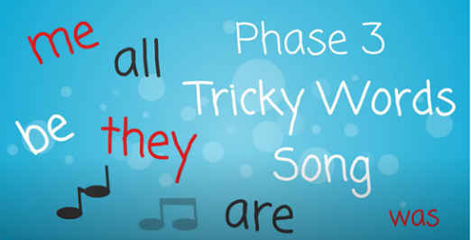  At the end of the clip see if they can write a sentence using one or more of the tricky words they have written down. | Session 1 - Main activity  Split digraph ‘a_e’  (make, take, bake)  Introduction to split digraph – watch the video to introduce the sound.  You will need to login to ‘Espresso’ which can be accessed from the school website – ‘kids area’ and follow the link  https://central.espresso.co.uk/ (once logged in please go to – Espresso/Key Stage1/ English/Phonics / Ash’s Phonics /a-e)  Have a go at making a list of split digraph a_e words together.  If for any reason you are unable to access Espresso then please use the YouTube link below which will give you some split digraph words to read.  https://www.youtube.com/watch?v=W1xqLjHF53A
Session 2 - Tuesday 2nd June 2020  Warm up activity– review Phase 3 digraphs (2 letters together that make 1 sound)  Spray the Letter  Set up the activity by using chalk to write some digraphs/trigraphs on a surface in your outdoor area. Give the children a spray bottle filled with water and ask them to find and spray the digraphs/trigraphs. You can extend this by asking them to find and spray the digraphs/trigraphs needed to spell given words.  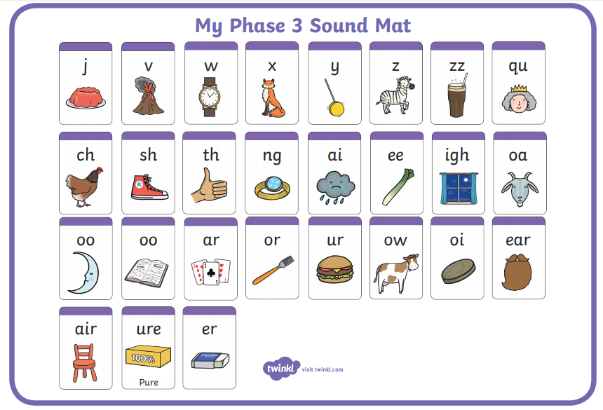 | Session 2 - Main activity  Play ‘4 in a row’  Make a grid with split digraph ia_e words in it e.g.  make snake flame lake  bake gaze grape blaze  cake shake plate skate  made game brave brake  Take it in turns to read a word aloud. If your partner agrees it is correct then cover it with a counter. Try and get 4 correct in a row in a certain time.
Session 3 - Wednesday 3rd June 2020  Warm up activity –  How many words with split digraph i_e can you make in one minute? You can ony use the letters on the page.  e.g. kite | Session 3 - Main activity  Hopscotch  Draw a grid on the floor with numbers 1 – 10 in a hopscotch grid formation.  Write ten words on post-it notes that contain the split digraph a_e and place one in each square.  Throw a stone/counter, hop to where it lands and read the word in the square.
Session 4 - Thursday 4th June 2020  Warm up activity – Recap ‘split digraph e’ from last week.  2 minute challenge!  How many split digraph words can your child write in 2 minutes? Maybe you could have a go too and see who gets the most! Encourage your child to check your words. | Session 4 - Main activity  Literature Laundry  String a washing line across the garden/room. Write words with split digraph a_e and some words with other digraphs (e.g. oa, ar, ee) on pieces of paper and put them in the washing basket/floor. Call out words with split digraph a_e (one at a time) and ask your child to pick out a card featuring the sound from a laundry basket/floor and peg it to the line. Alternatively hang large sheets of paper from the line with words containing split digraph a_e and get the children having fun making a mess with paint and painting the letters/sounds as you read them out highlighting the split digraph.
Session 5 - Friday 5th June 2020  Warm up activity– Phase 5 digraphs (2 letters together that make 1 sound)  Use the sound mat below– choose a digraph and ask your child to write it down/make it with magnetic letters/paint it outside on the pavement using paint brushes and water/chalk etc.  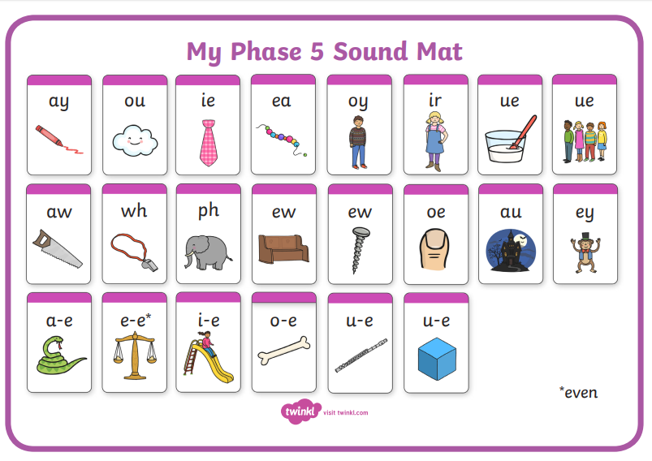 | Session 5 – Main activity – Tricky words  Children to choose words and think of a sentence.  Children to say the sentence and then write it down.  They could ask you to write their sentence down and then be the teacher and check it! Or you could think of a sentence, write it down and ask your child to highlight the tricky words they can see!  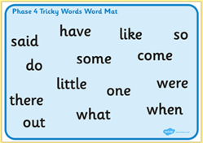

Year 1 spellings
Weekly spellings:

Dear Parents/ Carers,
This week we will not be sending new spellings home. However, you can still revisit and continue to practise the spellings you have done so far. Possibly focusing on the ones which you have found trickier.
Please continue to use ‘look, read, cover, write, check’ approach when learning / practising spellings.
Here are the spellings from the last week before half term.
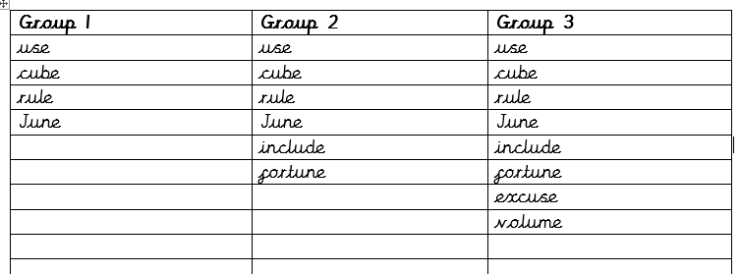

Year 1 English Activities – Summer 2 Week 1
This week’s English will be based around the book ‘The Snail and the Whale’ by Julia
Donaldson. If you have the book at home, read it either on your own or to a grown up.
If you don’t have the book you can watch the video here...
https://www.youtube.com/watch?v=x887mPO9X9c
Monday  1st June | Choose one of the places that the snail and the whale have visited and write a  postcard about what you have been doing to send back to the other snails on the rock.
Tuesday  2nd June | In the story, the snail and the whale travel across the ocean together – can you write a description about the ocean? Think about using different adjectives to describe the sea.  The sea is...
Wednesday 3rd June | Imagine you are a snail! Where would you like to visit with the whale? Where would you go? Why? Can you write a list of all of the items you would need to take in a bag with you on  your trip?
Thursday 4th June | In the story the whale gets stuck on the beach. Can you write a letter to the school children asking for their help. Think about why you need their help to move the whale. Who else  might need to help?
Friday 5th June | Watch the short film of The Snail and the Whale:  https://www.bbc.co.uk/programmes/m000cslw  Can you write a review for the story of The Snail and the Whale? Think about what the main characters are like. Did you like the story? Why? Would you recommend the story to anyone  else? Why? Who would you recommend it to?

Year 1 Maths Activities
Monday 1st June 2020
This week we are recapping addition and subtraction.
Do you know what is addition/ subtraction? Can you think of other words which mean/relate to adding/ subtracting? What symbols do we use to show addition (+)/subtraction (-) Can you explain or show your adult?
Vocabulary:
Addition – add, plus, more, total, altogether
Subtraction – taking away, minus, less, fewer

Watch this short video about addition:
https://www.bbc.co.uk/bitesize/topics/zwv39j6/articles/z8hyfrd

Activity:
Create an addition machine.
Use beads, pebbles, buttons etc. to put through your machine and find the total. Record a number sentence to show your workings out/ what you did.

Tuesday 2nd June 2020 - Addition
Activity:
Give each letter of the alphabet a number and a word for your child to make. Maybe ask your child to come up with a word for you to make as well (you can demonstrate to them how you worked out the answer). Whoever gets more points wins!
e.g. A B C D E F G …
2 5 7 6 3 1 8 …
Can you make a word BED (B = 5, E = 3, D = 6)? How many points will you get? Can you show how you found the sum? 5+3+6=14
You can use practical equipment to help you.
Challenge
Think of more challenging words.

Wednesday 3rd June 2020 - Subtraction
Today we are going to revisit subtraction.
Here are a few videos to explain subtraction and help you practise:
https://www.bbc.co.uk/bitesize/topics/zwv39j6/articles/ztpmrwx
https://www.youtube.com/watch?v=GdXClek-05I
https://www.youtube.com/watch?v=rjUsuKbhqxk
Activity:
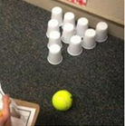
Start with a number of cups/pins. Create subtraction calculations to show how many fell.

Challenge:
Increase the value of each cup for example, each cup can be worth 10 points (write on top of each cup 10). After some of the cups fall create calculation to show how many points were taken away.

Thursday 4th June 2020
Today we are going to continue revisiting/ practising subtraction.
Activity - Who can collect the most pieces?
You can use Lego/ wooden blocks or Jenga pieces. Work out the answer first (use practical resources to support finding the answer)

Challenge:
Subtraction numbers 1-20
http://www.rabbittakeaway.co.uk/activity/

Friday 5th June 2020 – word problems
Today we are going to practise addition and subtraction word problems.
https://www.starfall.com/h/addsub/addsub-ladder/?sn=math1--math0
Challenge:
https://www.youtube.com/watch?v=FDP0mbsVX9A
See if you can write the number sentence and find the answer to each problem before you are given the answer.

Date: | Activity:
Monday 1st June 2020 | Geography  Look at a large map such as a road atlas and explain the locations of each type of area (Town, Countryside, Seaside, Roads). The seaside areas are along the coast. Towns are busy places with lots of roads, buildings and traffic. Point these out on the map (these are large shaded parts with many roads around them). Countryside areas are quieter with less roads and buildings. Point these out, how could you describe them? (smaller shaded areas which often surround the town areas, and have fewer roads).  Can you think of a town and find the name of a town, countryside or seaside area on the map?
Tuesday 2nd June 2020 | PSHRE (Personal, Social, Health, Relationships and Emotional Development)  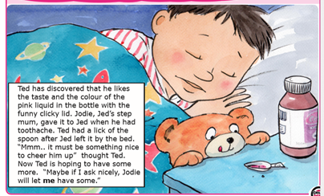  To learn that household products, including medicines, can be harmful if not used properly.  Read the story and discuss what is happening.  What was the pink liquid in the bottle? • Why did Jed have it? • Was it okay for Ted to lick the spoon? • Is it okay for Ted to have some [medicine] just because it tastes nice? • Why not? • When is it okay to have medicine?
Wednesday 3rd June 2020 | Art – paper sculpture  Do you know what a sculpture is? Artists do more than just paint pictures. Lots of artists like to express their ideas through sculpture. Can you think or find any? Sculptures can be carved out of different materials. Can you think of any? (wood and stone) They can also be made through joining and shaping different materials (metal or plastic).  Look at some famous sculptures online then look at 3D paper sculptures below and create your own.  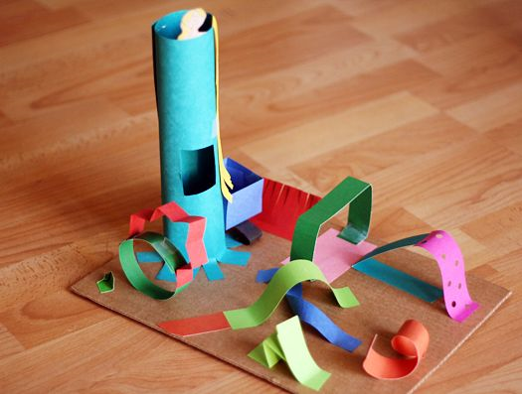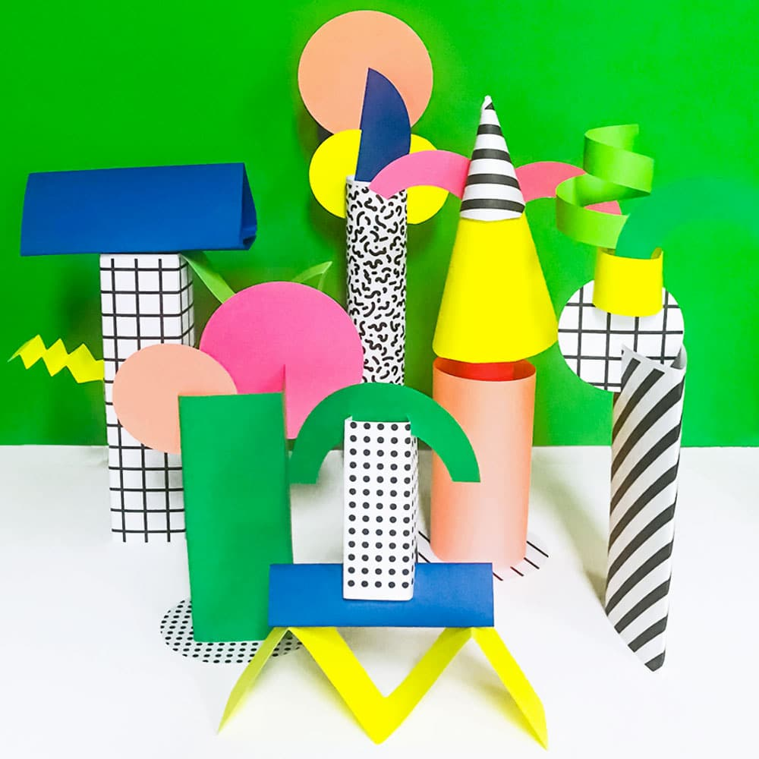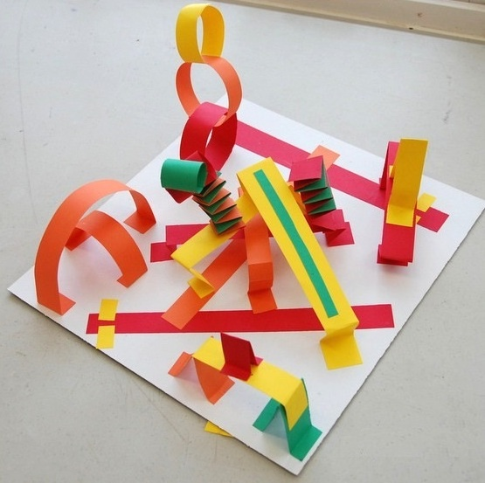
Thursday 4th June 2020 | History – Victorian holiday  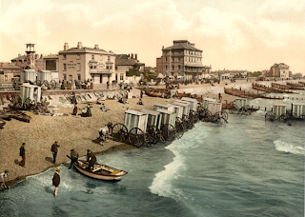  What do you think about Victorian seaside holidays?  Were they popular? Why? Discuss  Would you like to go on a seaside holiday in Victorian times?  If so, why/ why not? Discuss and write down your choice explaining why you chose it.  You can start by saying: ‘I would like to go on Victorian seaside holiday because…’  Open the links below to get more information about Victorian holiday?  https://sites.google.com/site/primaryschoolhistory/victorians/victorian-seaside-holidays  http://victorian-era.org/victorian-times-seaside.html
Friday 5th June 2020 | Science – World Environment Day  World Environment Day is celebrated every year on 5th June. On this day people from all over the world can do something positive to help our planet. What could you do? Lots of little things can make a big difference. Discuss what you could do to make a difference. Write down your ideas or make a poster to show what we can do every day to help our planet.  Song: https://learnenglishkids.britishcouncil.org/songs/do-your-best  Game: https://learnenglishkids.britishcouncil.org/games/clean-and-green
Year 1 Theme activities – Summer 2 Week 1

