Thursday 18th June 2020
SPaG
Spellings – Words with a chuh spelt ture
Arrange the words in your spelling list into alphabetical order. Remember, if two words start with the same letter then look at the second letter. If the second letter is the same then look at the third letter...
nature
future
pasture
gesture
mixture
picture
puncture
creature

Word of the Day – fragile

Definition ____________________________________________
_____________________________________________________
_____________________________________________________
Used it in a sentence: ____________________________________________________
_________________________________________________________________________
Word Class: ____________________________________________________
Synonyms

English
To draft an explanation text in the style of a newsletter or blog to share our recent work on mummification.

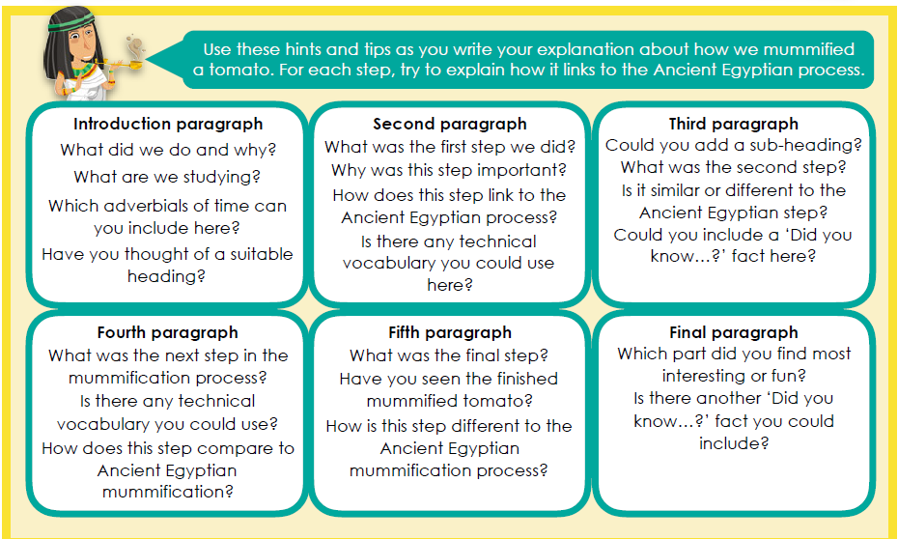

Maths Starter
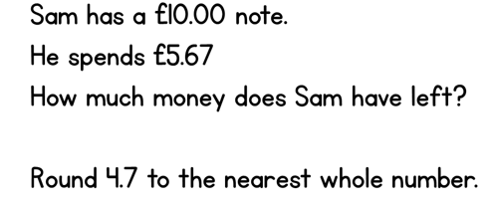
Maths Main Lesson
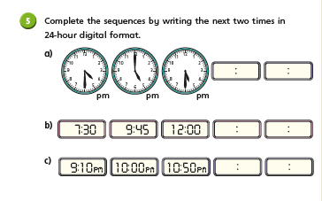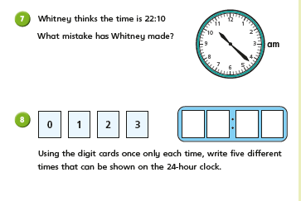

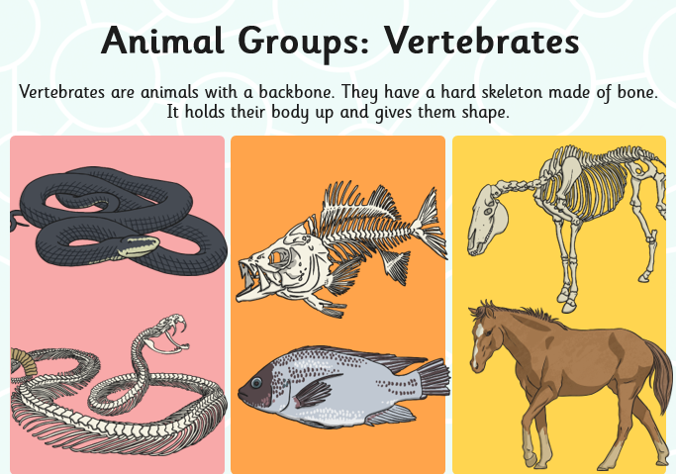
Science
When scientists discover a new animal, they give it a name and record everything they know about it.
With so many living things to make records of, and so many yet to discover, it is important that we have a system to organise and make sense of the information we have about them.
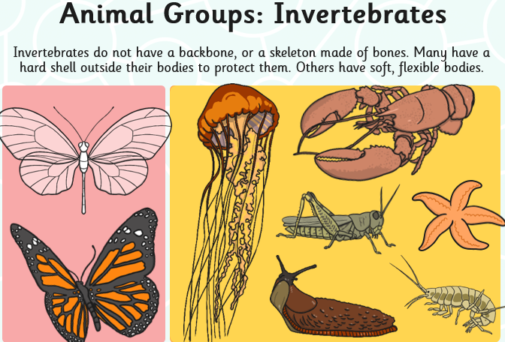
We organise living things into groups based on their similarities and differences, so that we can learn more about what makes each species unique. The differences between living things is sometimes called variation.
It is easy to sort most of the living things we can see in the world into two groups: plants and animals. Plants and animals share life processes, but they do them very differently. TASK: Can you remember what the 7 life processes are? (Tip: use MRS GREN)
When looking at animals, scientists usually split them into two groups: vertebrates and invertebrates.
TASK: use the posters below to help you explain what vertebrate and invertebrate means.
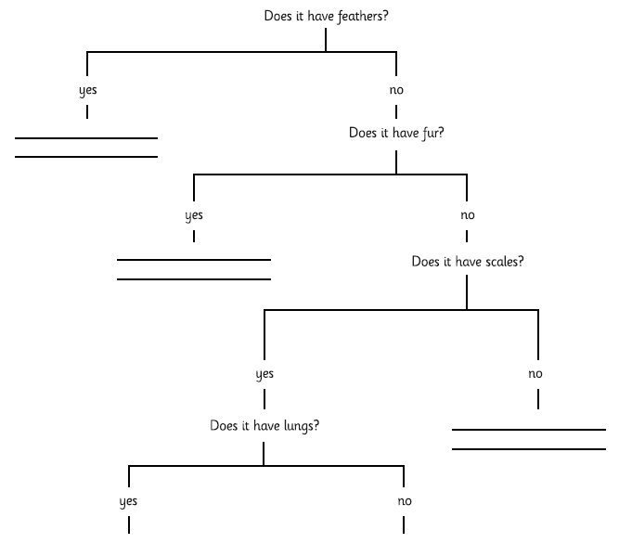
TASK: Sort these animals using the key below.

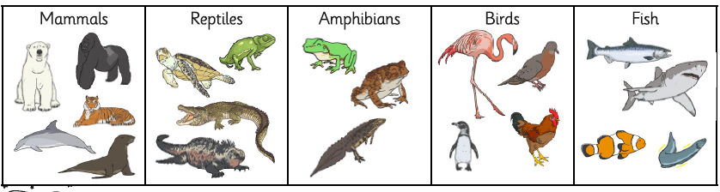

Challenge: Make up your own questions for a classification key.

