Year 2 Phonics/Spelling Practice – w/c 11.5.20 Monday
This week we will be learning words which have the ‘ey’ ending or where an ‘o’ spelling makes an ‘u’ sound.
Practise writing your new spelling words each day using your best Russell handwriting.
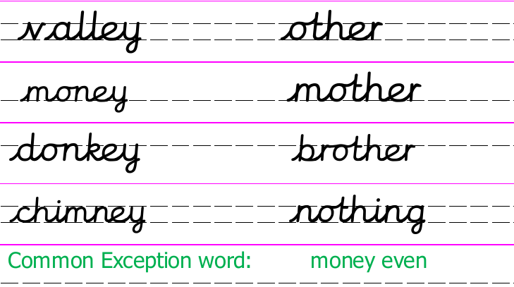
We already know that the sound /ee/ can be spelt in different ways –ee, e_e, ea, e.
This week we’ll look at another spelling - ey
Today and tomorrow we will concentrate on the words ending in –ey.
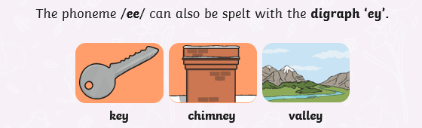
The vowel digraph ‘ey’ can be used to spell the /ee/ sound at the end of words.

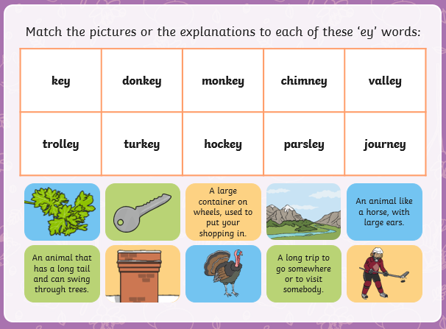

Maths 11.5.20
Watch the video and copy and complete the questions below. 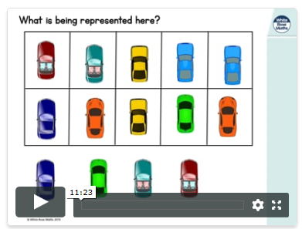
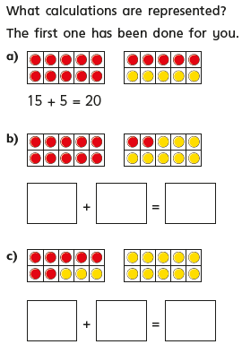
https://whiterosemaths.com/homelearning/year-2/
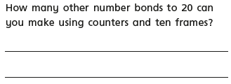
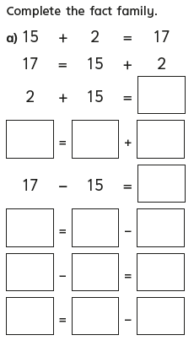
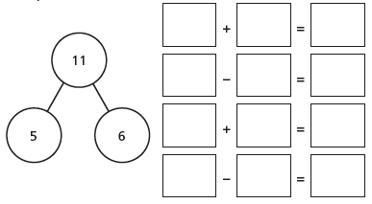
Complete the number sentences for the part-whole model.

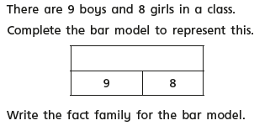
How many number facts can you write?
9 + 8 = ?
? = 9 + 8

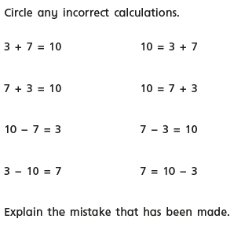

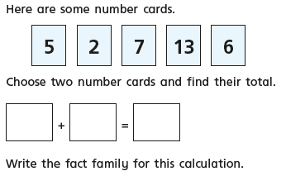
Monday 11th May 2020 - English
Inspirational quote of the day! 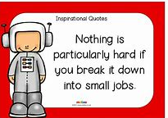
Word of the week – Victory.
Good Morning, year 2. How are you all getting on? Did you have a nice bank holiday? I celebrated V.E day by having a two minute silence at 11.00 am. We decorated the front garden with bunting to mark the historical event and had afternoon tea with cream scones and some champagne. It was not what we had originally planned but it was lovely to all be together and I think we will probably remember the day more in the future as it was simple and we were at home. How did you celebrate?
WALT use our inference skills.
Today’s VIPER lesson is titled ‘Let’s Play Football! I know in our house we are missing being able to watch football and sport on the television. My daughter Drew plays for Kempston Rovers U18 and this was her last season. She too has been disappointed like many of you not to have been able to play at weekends and train in the week. This picture made me think of all you Russell Raiders who are missing the sport. It also made me think of our wonderful countryside and all the special places we didn’t know were so close to where we live.
Can you imagine if on your walk you came across this field?

For today’s VIPERS we are going to focus on I.

Can you remember what the I stands for?

Inference.
- What do you think of this setting?
- Is this a good place to play football? Why/why not?
- What are the pros? Cons?
- Which half/side do you think has the advantage?
- If you were playing here, how would you adapt to this pitch?
- Why do you think this pitch was built here?

PSHRE 11.5.20 – WALT: to understand that people and other living things have rights and that everyone has responsibilities to protect those rights

Can you remember the 4 Russel Rights?

The right to be safe, to learn, to be included and to be happy.

All living things have rights that we have to respect.
Not only humans like us but animals too.
Our pets have rights that we need to respect. Our pets have basic needs just as we do but many people feel that we need to do more than just meet their basic needs. Look at this website for more information on animal rights:
https://kids.britannica.com/kids/article/animal-rights/442497
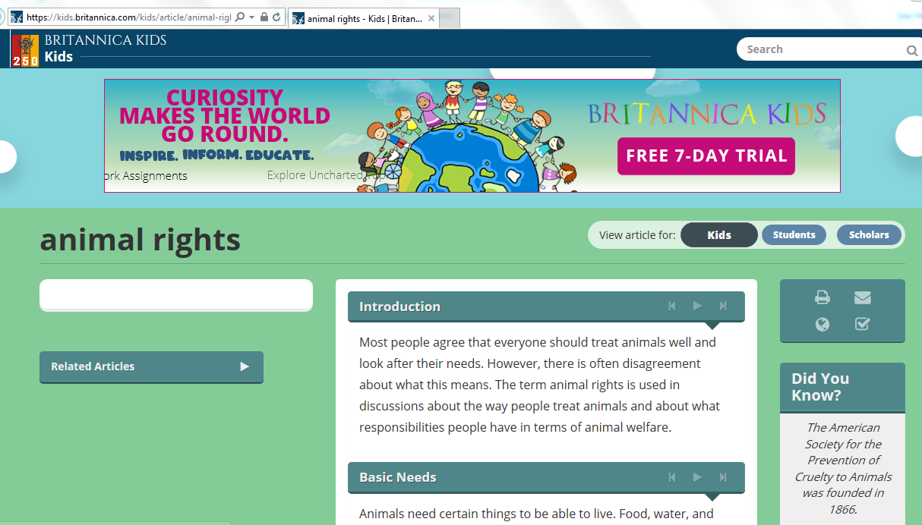

Think of a pet that you have or you would like to have. It could be a dog, cat, stick insect, donkey……the list goes on!

Can you think of a list of at least 5 rights that the pet has that go beyond just basic needs such as food and water?
(Thinking of our Russell Rights might help you)
11.5.20 Music FRIENDSHIP SONGS
Today we’ll listen to another ‘Friendship’ song. This one is song by some famous singers.
https://www.youtube.com/watch?v=66Qkf2Jm6pc&list=RD66Qkf2Jm6pc&start_radio=1
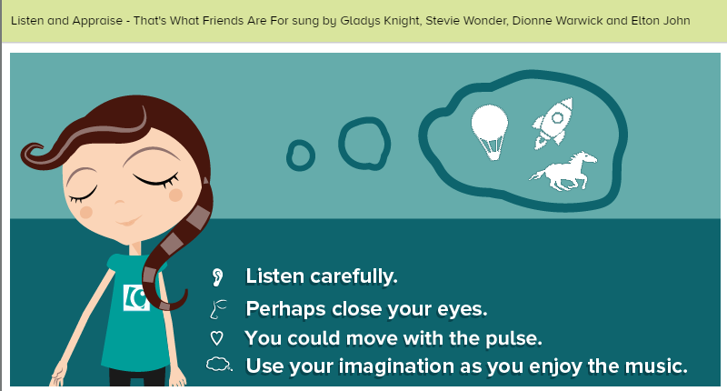
Listen and Appraise - That’s What Friends Are For sung by Gladys Knight, Stevie Wonder, Dionne Warwick and Elton John:
Play the song. Move to the music or sit down to listen with closed eyes. After listening, talk about the song and answer the questions together using correct musical language.
● Listen and Appraise - How is this song different to the others we’ve listened to, how is it similar? Does this song tell a story? Perhaps the words tell a story or perhaps the music creates a story in your imagination. What is that story?
● What can you hear? Harmonica, bass, keyboards, piano, drums, electric guitar, male and female vocals, strings
● How does the music make you feel? Music brings many emotions along with it and often each person feels something different. Perhaps share with someone how the music makes you feel.
● What did you like about the song? It doesn't matter if you like or don't like a song or a piece of music. Think about the reasons why you do or don't.

