Friday 15th May 2020
SPaG
Spellings – Suffix - ous
Use each word in your spelling list in a sentence.

joyous
dangerous
hazardous
poisonous
riotous
mountainous
momentous
scandalous

Word of the Day – impact

Definition ____________________________________________
_____________________________________________________
_____________________________________________________
Used it in a sentence: ____________________________________________________
_________________________________________________________________________
Word Class: ____________________________________________________
Synonyms

English – VIPERS
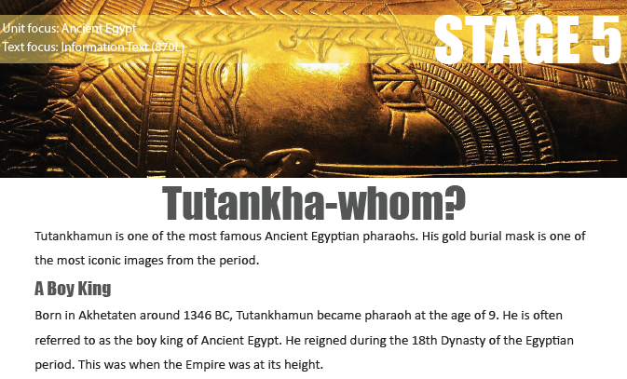

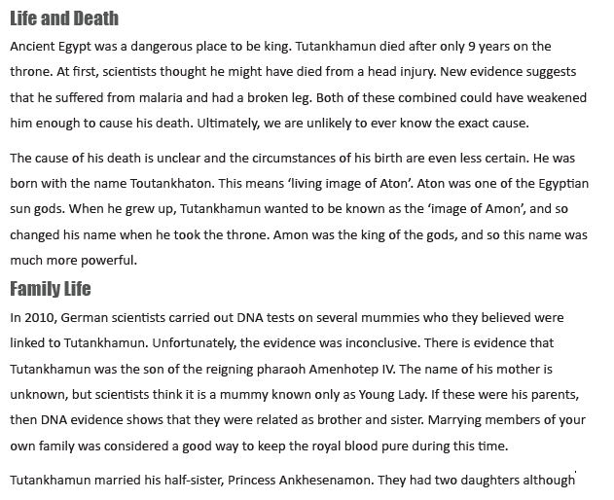
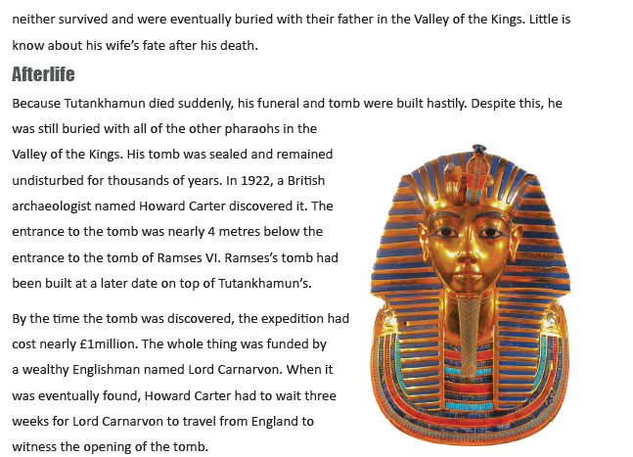

Text Title: Tutankha-whom? Vocabulary Focus
1. Which word tells you that something wasn’t explained with a definite answer?
2. What does the word “iconic” tell you about his burial mask?
3. Which phrase tells you that we know little about Tutankhamun’s birth?
4. Find a word or phrase that is closest in meaning to “the future events of somebody’s life”
5. How do you know that nobody else had found the tomb before Howard Carter?
Why was Tutankhamun referred to as the “boy king”?

Why do you think Tutankhamun’s mother’s mummy is simply known as the Young Lady?
Why has the author chosen the title for this text?
What material was used to make the burial mask?
Write a summary of the story in three sentences.

Maths – Mental
If you know an addition fact, you can work out a related subtraction fact.

11 4 7

4 + 7 = 11 11 - 4 = 7

7 + 4 = 11 11 - 7 = 4
Write the addition and subtraction facts for each trio of numbers.

1. 7 8 15

2. 12 32 44

3. 125 41 166

Maths – Main Lesson
Today you will divide 2 and 3 digit numbers by 10.
This video shows how 3 digits are divided by 10 but it still explains the process of moving digits one place to the right when we divide by 10.
https://www.bbc.co.uk/bitesize/clips/zcnyr82

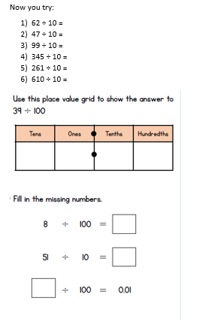

Science
Food chains

Use books or the internet to find out about food chains, you will need to find out:

What is a food chain?
What is a Producer?
What is a consumer?
What is a predator?

Give an example of a food chain to show what you have found out. You might like to use a drawing with labels, take care with the direction of your arrows. The arrows show the direction that the energy travels.

Top tip: You could use some helpful free videos on the BBC: https://www.bbc.co.uk/bitesize/topics/zbnnb9q/articles/zwbtxsg

