RUSSELL LOWER SCHOOL

QUEENS ROAD

AMPTHILL, BEDFORDSHIRE MK45 2TD

Telephone: 01525 755664

Email: office@russell-lower.co.uk


To all 2022 Prospective Parents
OPEN DAYS

You are invited to our ‘Open Days’ to be held on:

Thursday 23rd September at 9.30 a.m.
or
Thursday 30th September at 2 p.m.
or
Wednesday 13th October at 9.30 a.m.
or
Thursday 2nd December at 9:30 a.m.

Do come along for a meeting with Nicki Walker, our Headteacher.
Learn all about our very popular Foundation Stage and our
wonderful, modern learning spaces

Staff will be available to answer any questions you may have

To register your interest in attending please contact our
school office (office@russell-lower.co.uk or 01525 755664)

In the meantime, please visit our website at
www.russell-lower.co.uk and browse our prospectus

LEARNING ENVIRONMENT
Come and see our impressive learning environment:
Purpose-built dining hall, library, main sports hall, computer suite, modern classrooms and garden.
PTA
We have a very active and supportive PTA

EXTRA-CURRICULAR CLUB OPPORTUNITIES
We are very fortunate to have a large variety of extra-curricular clubs held weekly,
both at lunchtime and after school such as:

Premier Sport: Gymnastics, Dodgeball, Multi-sports, Ball Skills, Archery
Art Adventurers
French Club
Russell Raiders Football Teams
Choir
Gardening Club
Music Lessons
Violin, Viola, Flute, Guitar, Drum, Piano, Cello and
Brass lessons are available at school through Inspiring Music
THE AVIARY
Before and After School Club
We run a very popular and successful ‘Before and After’ School Club
Breakfast / snacks are included
We can provide childcare between 7:45am and 6pm if needed
More details of costings etc. are available on request
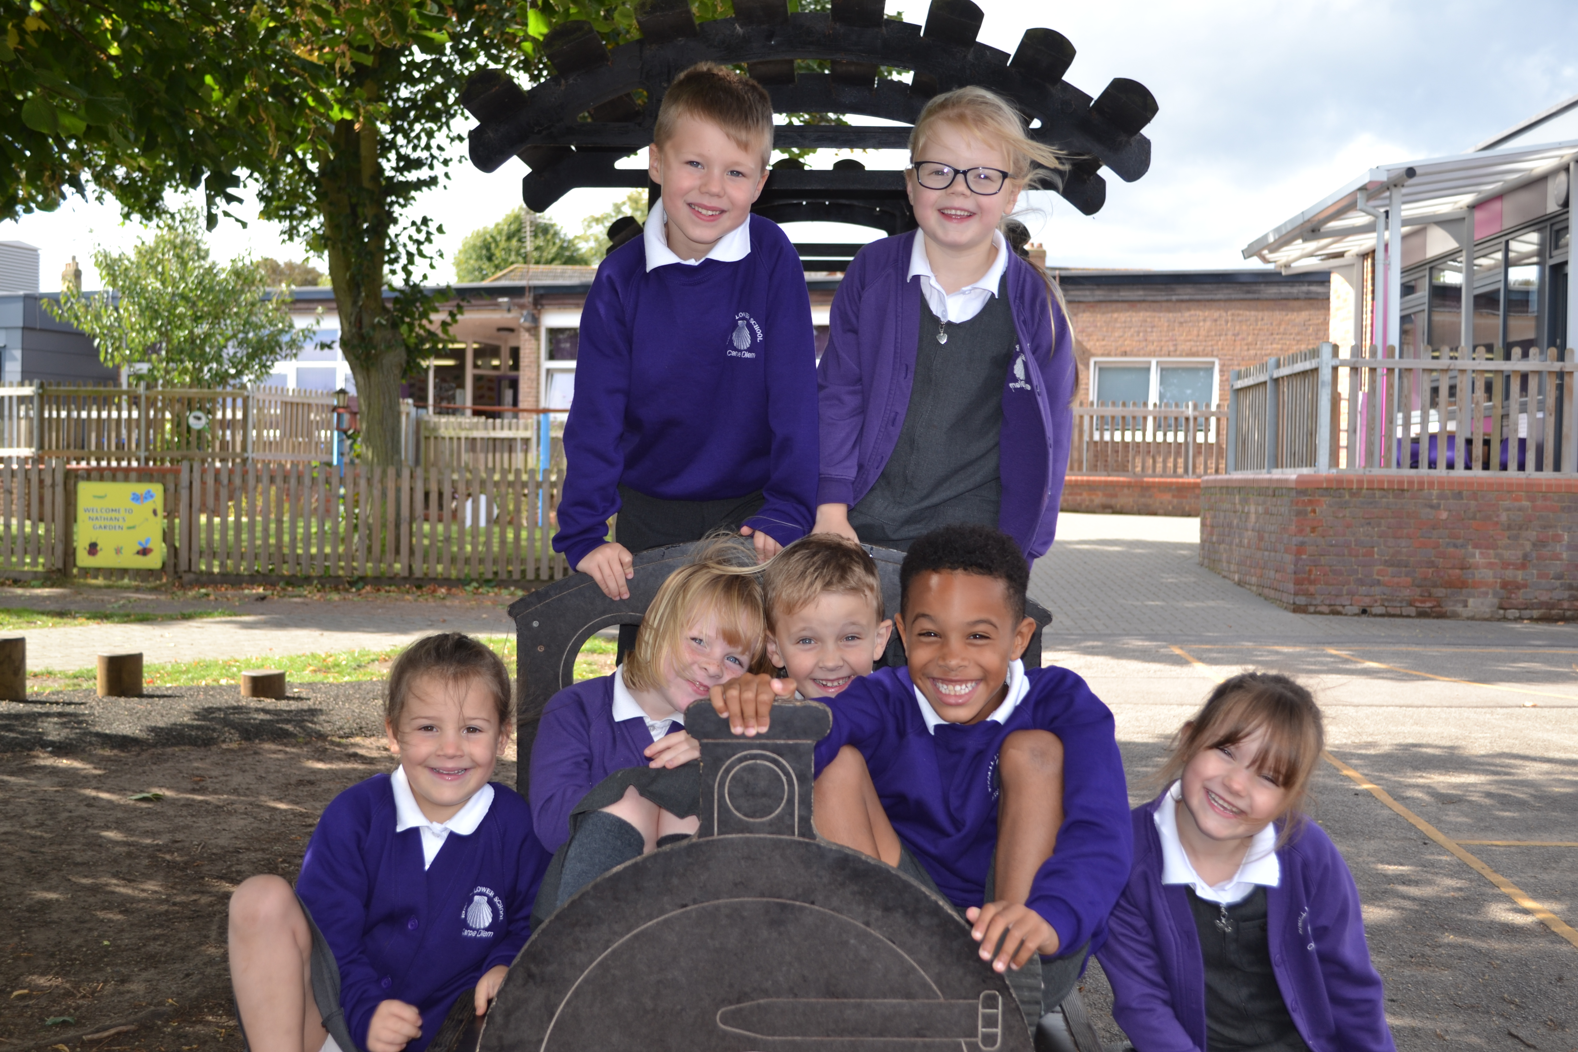
If you are unable to attend one of our Open Days but would like to
arrange a visit, please telephone the school office
01525 755664
office@russell-lower.co.uk

