Tuesday 19th May 2020
English
SPaG
Spellings – Prefix – re
Arrange the words in your spelling list into alphabetical order. Remember, if two words start with the same letter then look at the second letter. If the second letter is the same then look at the third letter...

redo
refresh
return
reappear
revenge
remember
retrieve
redecorate
Word of the Day – capital

Definition ____________________________________________
_____________________________________________________
_____________________________________________________
Used it in a sentence: ____________________________________________________
_________________________________________________________________________
Word Class: ____________________________________________________
Synonyms

English
Task – Using Information below to write a biography of Howard Carter, attempting to include the features of a biography below and the model text on Queen Victoria you read yesterday.

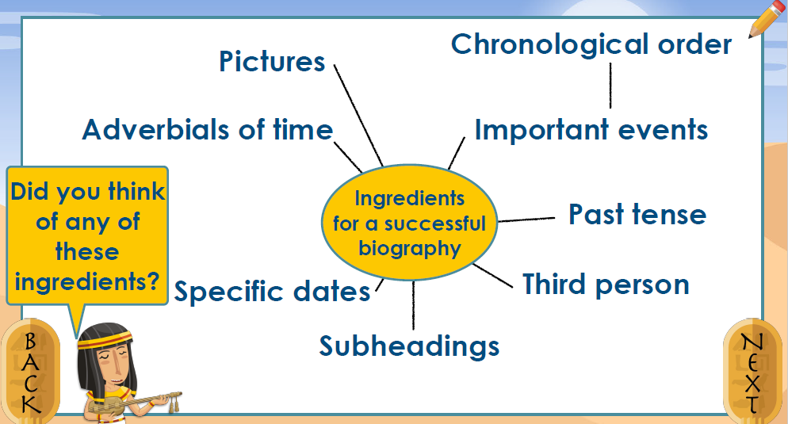

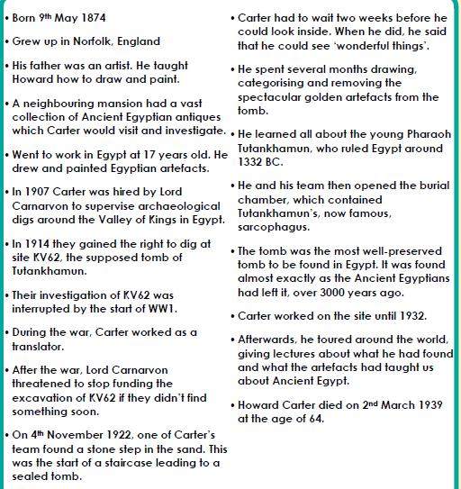

Maths – Mental
Partition the numbers to make them easier to add up in your head.
Add the hundreds first, then the tens, then the ones.
123 + 141 =
100 + 100 = 200
20 + 40 = 60
3 + 1 = 4
200 + 60 + 4 = 264

Maths – Main Lesson
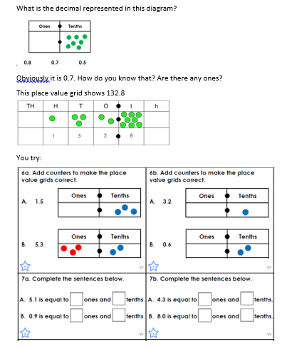
Before we place decimals on a place value grid, I want you to talk to an adult in your house about what time you ate breakfast this morning. What time did you start eating, what time did you finish eating, how long was this? How long is it until your next meal?

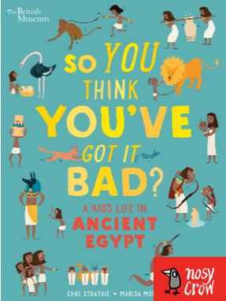
History
Do you know what the Egyptians used to catch criminals? What did Egyptian mothers eat to try to cure their sick children? And what did they eat for breakfast? Find out the answers to all these questions and many more in the fun, interactive video quiz with the award-winning author of So You Think You’ve Got It Bad? series, Chae Strathie by following the link below:
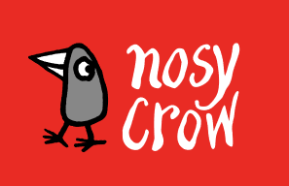
https://nosycrow.com/blog/chae-strathie-quiz/

All you need for the quiz is a pen, paper, and the video on the link. You can access the book for free, just scroll down. Happy quizzing and good luck!

