Thursday 2nd April 2020
SPaG
Spellings - Word Families based on common words, showing how words are related in form and meaning.
Practise your spellings
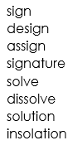
Write each word in your spelling list using two different colours. Write the constants in one colour and the vowels in another colour.
signature

Word of the Day – flexible

Definition ____________________________________________
_____________________________________________________
_____________________________________________________
Used it in a sentence: ____________________________________________________
_________________________________________________________________________
Word Class: ____________________________________________________
Synonyms

English
Watch the clip called ‘Once in a Lifetime’ again.
https://vimeo.com/23805703
What might the sky explorer experience while standing on the deck of his boat in the sky?
See | Hear | Smell | Touch | Taste

Maths – Mental

1) Subtract 20 from seven sixes.

2) 56 ÷ 8 =

3) What is half of £5?

4) Round 45 to the nearest 10.

5) Continue this sequence 8½, 9½, 10½,

6) What is 100 less than 2001?

7) Which unit should you use to measure the length of a classroom?

8) What needs to be added to 342 to make 450?

Maths – Place Value

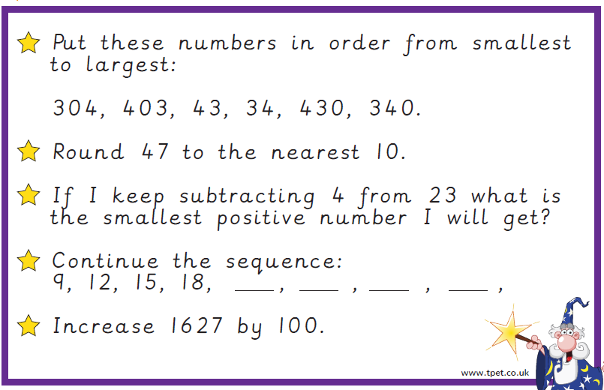

History / Art – Romans

A mosaic is a piece of art made up of small coloured pieces. These pieces can be coloured glass, stone, paper or other materials. The small pieces combine to make one large picture or pattern. The Ancient Greeks and Romans created mosaic art, some of which we can still see today. They also used mosaics to decorate the floors and walls of their houses. Use pencil crayons or felt tips to colour this mosaic.

