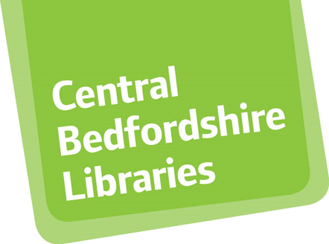

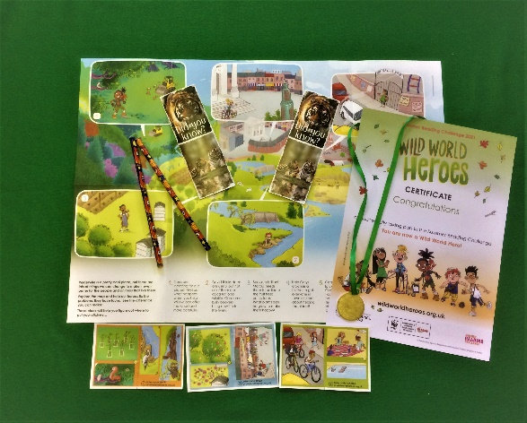
Summer Reading Challenge
The Summer Reading Challenge is an annual challenge run jointly by The Reading Agency and public libraries. This year the theme is Wild World Heroes, with a nature-themed challenge, supported by the World Wildlife Fund.
Families can join at your local library any time during the summer, from 23rd July. There will also be craft packs available from your library and online events.
Further information on the challenge will be made available at: Centralbedfordshire.gov.uk/libraries
The Challenge
- Children must be members of the library service. Join the library online here: https://bit.ly/2VR7Q1N
- The challenge invites children to read any six library books or more during the summer holidays.
- Families can sign up for the challenge at any library, at any stage in the summer from Friday 23 July.
- Children can borrow books in person, via our Select and Collect Service or use our e-books, magazines and audiobooks available from our Virtual Library.
- All our libraries are now open for in-person browsing, but please keep an eye on COVID updates.
- Children collect rewards for the books they read – a bookmark for reading 2 books; a pencil for reading 4 books; a certificate and a medal for reading 6 books.
- Children aged 4-16 completing the challenge (6 books) will be entered into a lucky draw at their library for the chance to win a tablet computer.

Ideas for reading

Here are suggestions for books about nature and animals, as part of the Wild World Heroes theme: https://www.pinterest.co.uk/bedslibraries/wild-world-heroes/. You do not need to sign up to Pinterest to view the list. Children may read any library books, including ebooks and audiobooks. There are more ideas on our Virtual Library.

Events and activities
There will be a series of Summer Reading Challenge online events organised by Central Bedfordshire Libraries.
Children can also enjoy craft activities throughout the summer, by collecting a craft pack when you pick up your books.
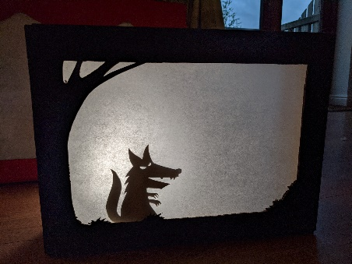
- Wednesday 28th July 2pm. We’re going on a Countryside story hunt. Let your imagination run wild as you join a virtual storytelling experience like no other, with storyteller John Kirk. Jammed packed with interactive scavenger hunting fun this session is suitable for families with story hunters age 3+. Book your free ticket: https://centralbedfordshire.ticketsolve.com/shows/873620903
- Friday 13 August 11am. Little Red Riding Hood Shadow Puppetry Online Workshop. Create your own shadow-stories by joining storyteller, Robin Simpson. Robin will perform his own telling of Little Red Riding Hood and provide simple instructions so you can follow along. Age 6+. Book free ticket:
https://centralbedfordshire.ticketsolve.com/shows/873625341/events

