Thursday 30th April 2020 Year 2 Phonics/Spelling Practice – w
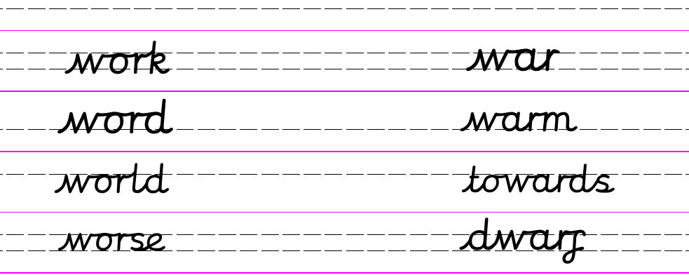
Look carefully at the spelling of these words:
war ward warm warn towards

Now choose just one of them and practise writing it using rainbow Russell writing.

ie. towards

Can you then put this word into a sentence of your own?

Maths 30.4.20
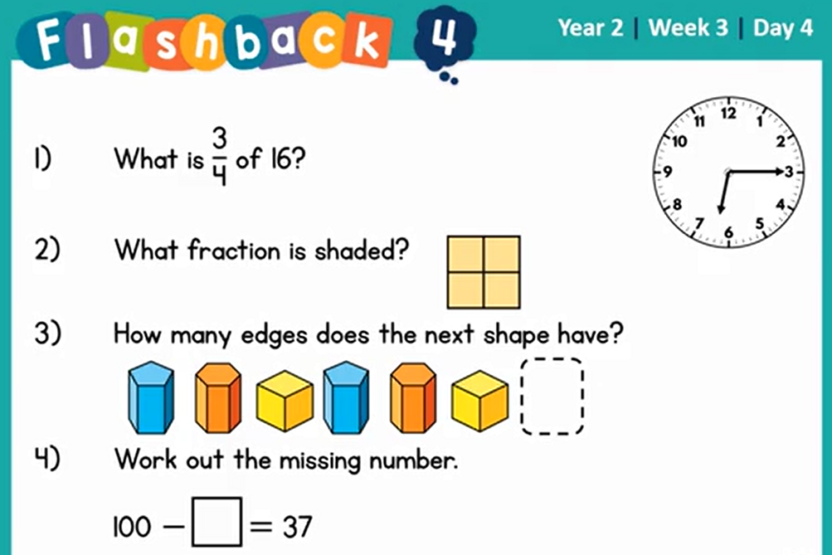
Look around your home and garden.
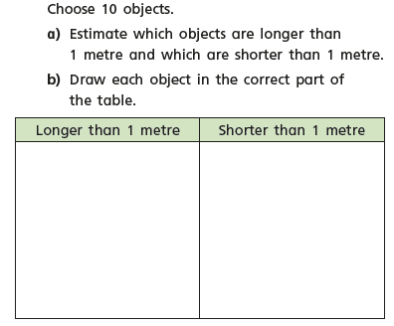
30.4.20 – English
Word of the week ‘cautiously’.
WALT write about the key events and characters in a story.
Last Thursday we started to look at some of the work of the author Eric Carle. Today we are going to look/watch two more of this stories (don’t forget you can find these stories on youtube). ‘The Very Busy Spider’ and ‘The Mixed up Chameleon’.
Can you look for similarities/differences to the other stories.
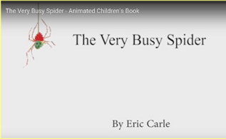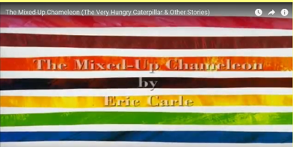

Your task today is to create a poster all about one of the stories you have read. Below is a template that I found that shows the things I would like you to put on your poster.
Where is the story set?
Who is the main character?
What happened first? What happened second? What happened at the end?
Make your poster colourful and bright.
Which story will you choose? Have you now got a favourite Eric Carle story?
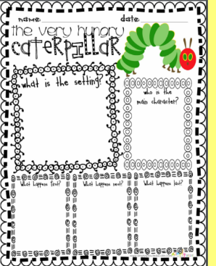
Can you include adjectives and adverbs?

30.4.20 – D.T. - WALT identify and explore different picnic food.
Last week we started looking at different types of food and identifying where they may have come from such as were they farmed, caught or grown. Did you make the ‘Rainbow Omelette cakes’? I did they were very tasty and nutritious; I enjoyed mine outside in the garden sat under my apple tree.

Can you remember what picnic foods we identified last week?
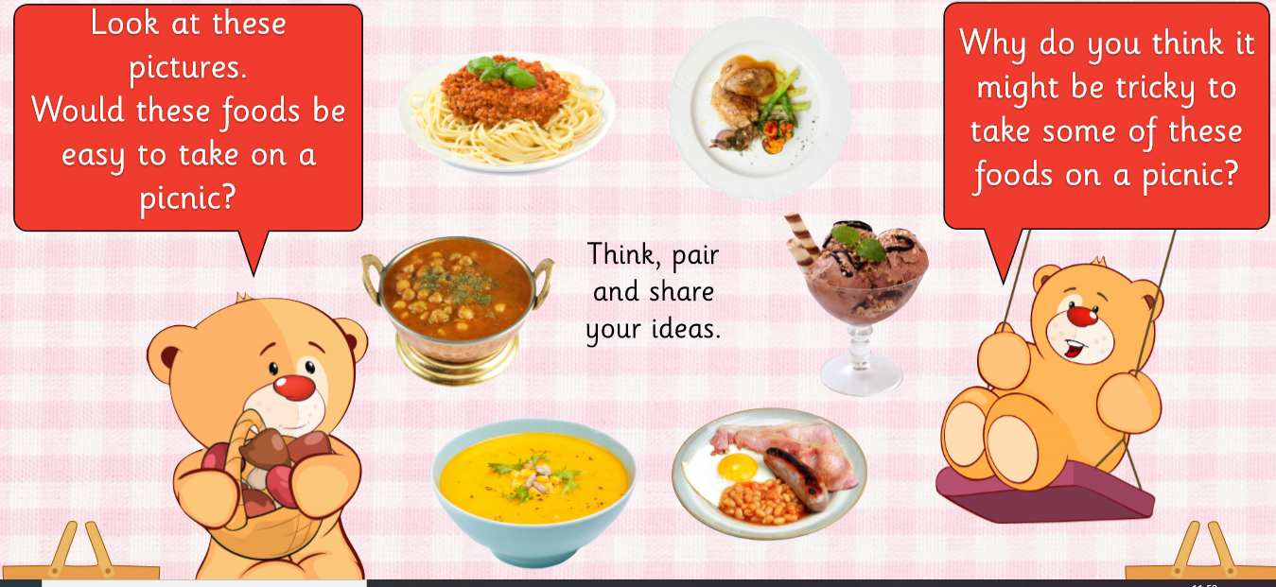

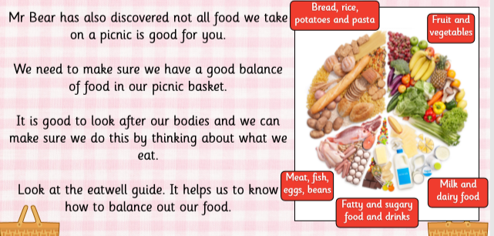

Task
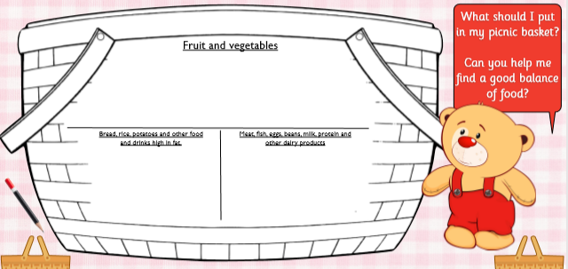

Challenge me
