Year 2 Phonics/Spelling Practice – w/c 21.5.20 Thursday
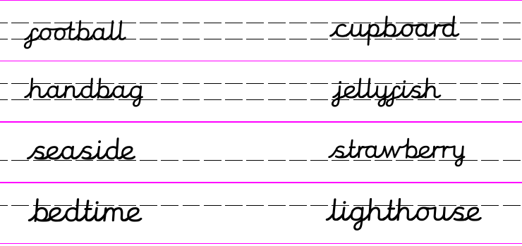

Can you think of a compound noun which starts with ‘Fire’?

Which of these make a real word when put with ‘Fire’?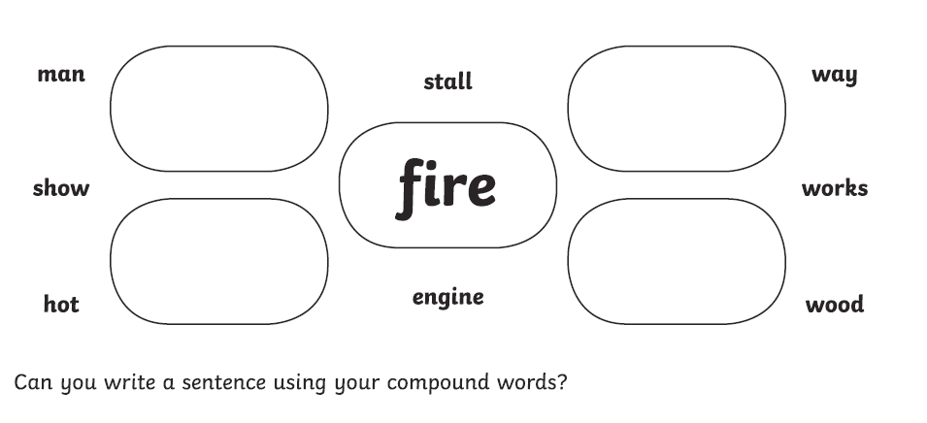
Dictation sentence to practise:
The fireman took a strawberry from the cupboard.

Maths 21.5.20 Bonds to 100 (Tens and Ones)
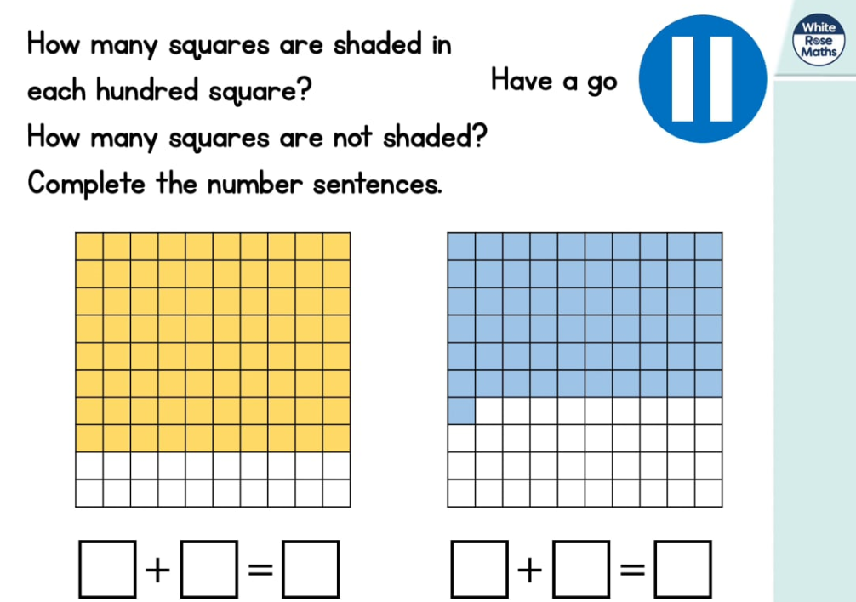
https://whiterosemaths.com/homelearning/year-2/ (week 4 dated w/c 11.5.20 Lesson 4)

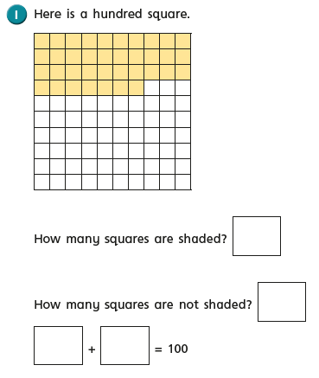
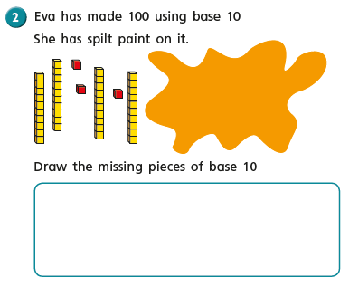

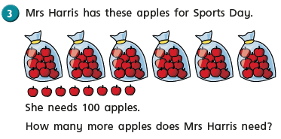
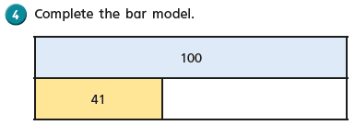
Copy and complete these calculations: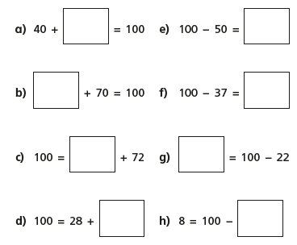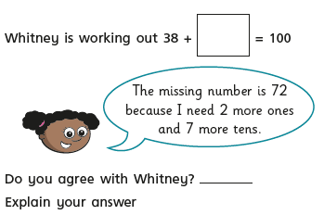
English - Thursday 21st May 2020
WALT describe a character in detail.
Today we are going to look closely at the character of Mr Fox in ‘Fantastic Mr Fox’.

Do you like the character of Mr Fox? What is it you like about him?

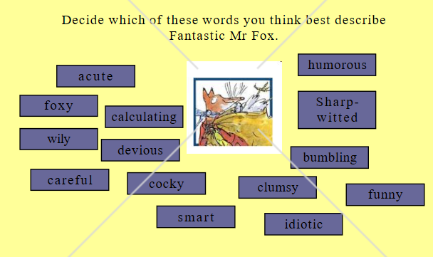
I want you to look back at the first few chapters of the story that we read on Monday and Tuesday and find evidence that describes Mr Fox. I also want you to look at the pictures of him. What does he look like? What does he wear?
I have given you an outline of a fox. Can you put words or sentences in the middle of the outline to describe Mr Fox’s personality, which words best describe him e.g clever, fantastic, caring …… On the outside can you write sentences or words that describe what he looks like e.g. pointy nose, whiskers etc.

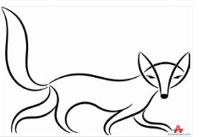

D.T. Thursday 21st May 2020
WALT make picnic food from our design sheet.

How did you get on last week designing a picnic skewer? Today is the last day in our d.t topic and we will get to make our picnic skewers. I hope it is a lovely day and you will be able to enjoy them outside in the garden but if not you can have a picnic in your front room.

Let’s remind ourselves of Mr Bear’s letter from last week. What types of food is he asking us to make?

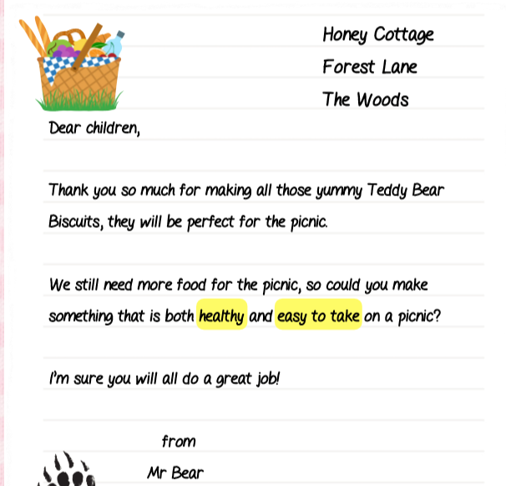
Have a look at your design sheet from last week. Do you think you have met all of Mr Bear’s needs?
It is important when you are preparing food that you stay safe. How can you keep safe when making our skewers?

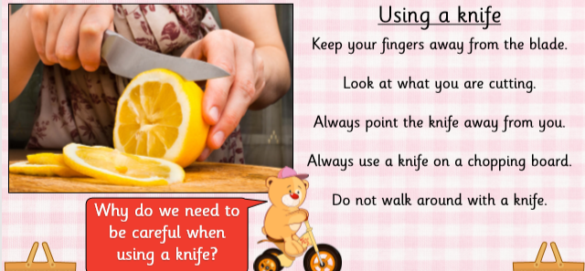

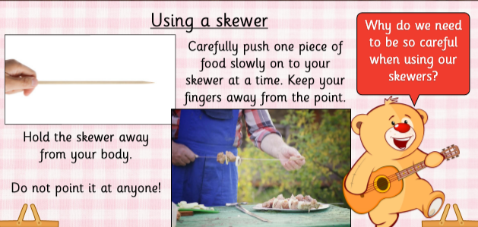
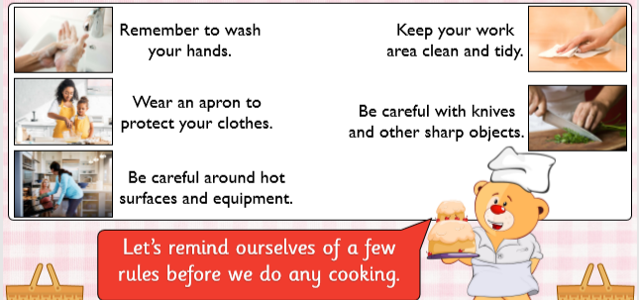
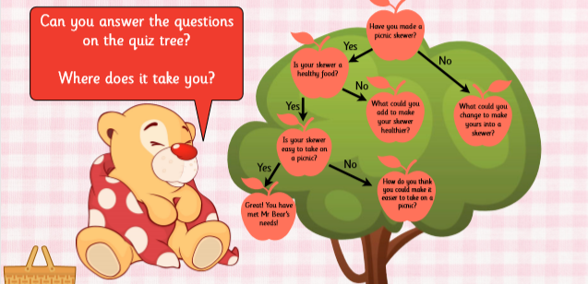

Well done, you are now ready to make your picnic skewers.
I would absolutely love it if you could take a picture of your picnic skewer when you have finished or of you enjoying your picnic.

Have fun.

