Wednesday 6th May 2020
SPaG
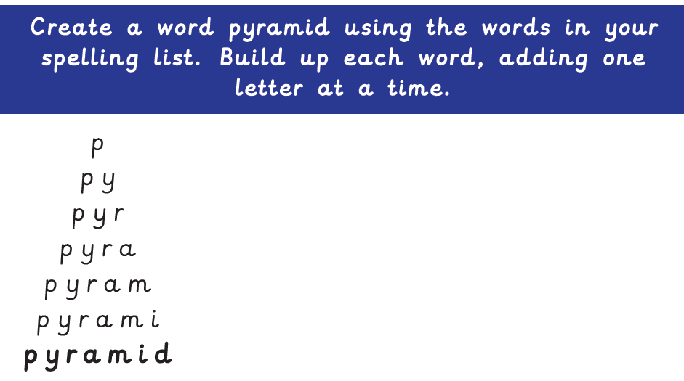
Spellings - The u sounds spelt ou.
young
touch
double
county
trouble
cousin
encourage
flourish

Word of the Day – arena

Definition ____________________________________________
_____________________________________________________
_____________________________________________________
Used it in a sentence: ____________________________________________________
_________________________________________________________________________
Word Class: ____________________________________________________
Synonyms

English
Next week you will be writing your own version of a fairy tale in an Egyptian setting. Like in ‘The Egyptian Cinderella’, you will need to keep the key events of the fairy tale, but change the setting and characters to fit into an Ancient Egyptian setting.

Today, you will choose the fairy tale you want to convert into an Ancient
Egyptian setting. You need to make a storyboarding or draw a story map of the main events of the traditional version. You should be able to retell the story using your board/map.

If you want some tips on retelling stories watch this You Tube clip - https://www.youtube.com/watch?v=w33-m8-geuM&feature=youtu.be

First you need to choose your traditional tale - you can choose any story or one of the two below.

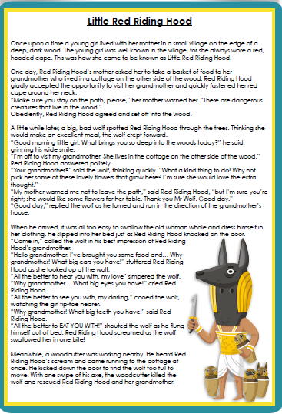
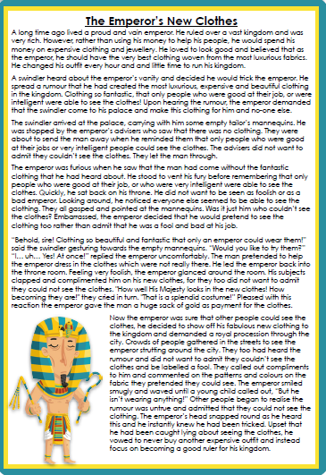

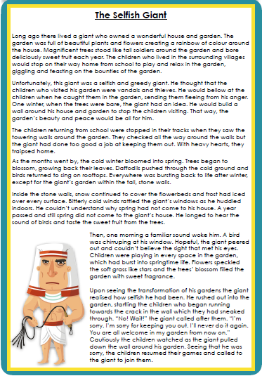

Examples of story maps and story boards
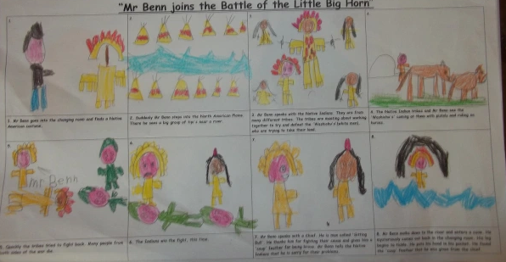
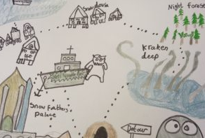

Maths – Mental
1) Jake earns 10p per minute. He works for ten minutes. How much money does he earn?
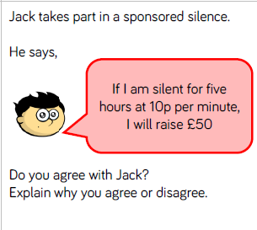
2)

Maths – Main Lesson – Decimals
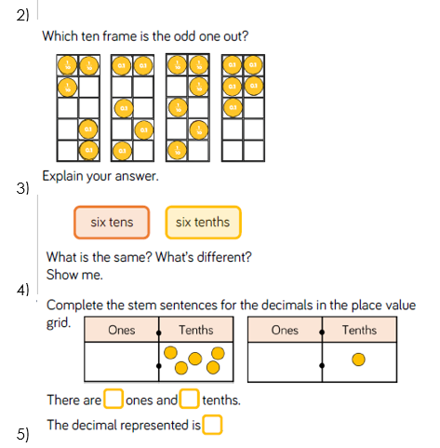
Watch - https://www.youtube.com/watch?v=t9vqm2eM5mk

History - Did you know the ancient Egyptians had a unique writing system now known as hieroglyphs?
Hieroglyphics were typically carved on walls, tombs, monuments and other places made of stone or brick. But what did they mean? Why did they write them? Who carved them? How do you read them?
Use books or the internet to help you find out the answers to these questions. You could make a poster to show what you have learnt. I recommend twinkl’s ‘the ancient Egyptians hieroglyphs information print out’ which is below:
