Wednesday 1st July 2020
SPaG
Spellings – Words with the sh sound spelt ch
Write each word in your spelling list using 2 different colours. Write the consonants in one colour and the vowels in another colour.

chef
chute
chalet
machine
brochure
parachute
ricochet
moustache

Word of the Day – invisible

Definition ____________________________________________
_____________________________________________________
_____________________________________________________
Used it in a sentence: ____________________________________________________
_________________________________________________________________________
Word Class: ____________________________________________________
Synonyms

English – Comprehension
Reread chapter 13 and 14 of the Twits ready for tomorrow’s lesson and then answer the following questions.
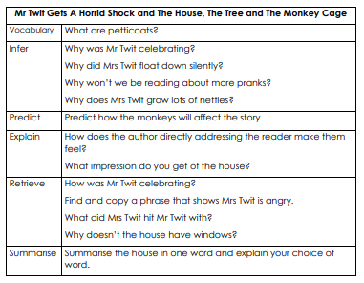

Maths
- Write the shaded area as a fraction.
- Write the shaded area as a decimal.
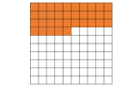

You will have. to learn the types of quadrilaterals. A quadrilateral is a polygon (a 2d shape with straight sides that is fully closed) with 4 sides .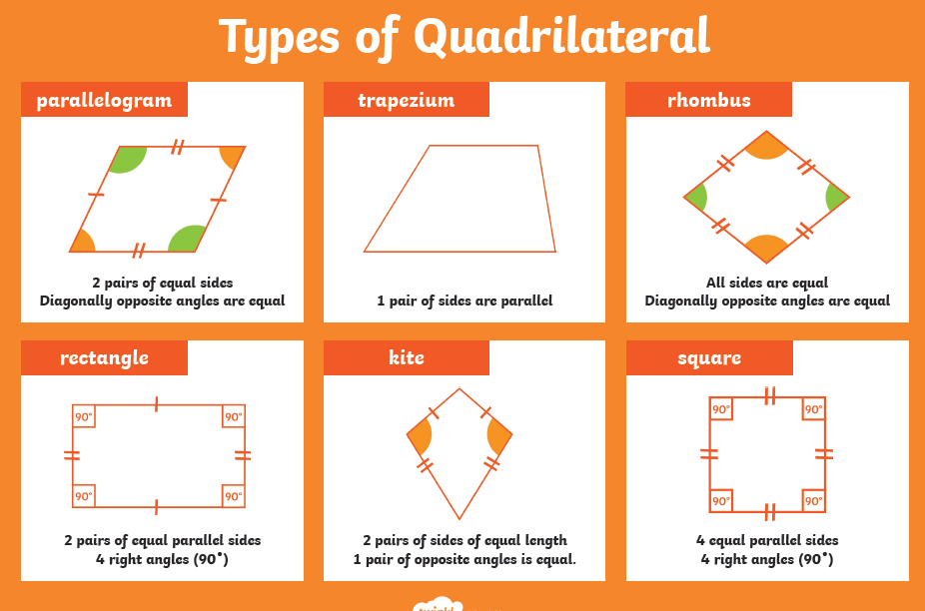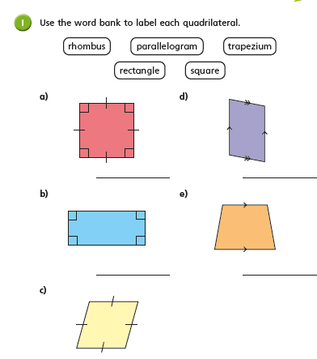 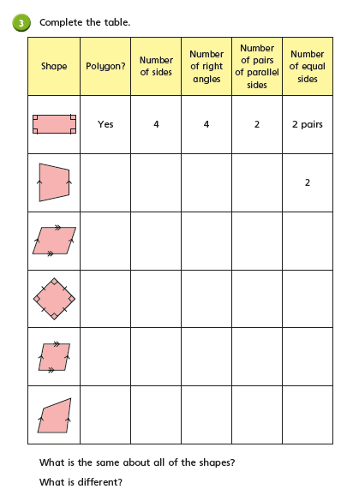
Geography
An ecosystem is a system of plants and animals, which are interconnected, and working together.
Some ecosystems are found under a stone or in a pond and are very small, whereas others are very large and cover the majority of a continent.
An ecosystem covering a large area of a continent is called a biome.

Think – use the map to find out what the biome of the UK is.
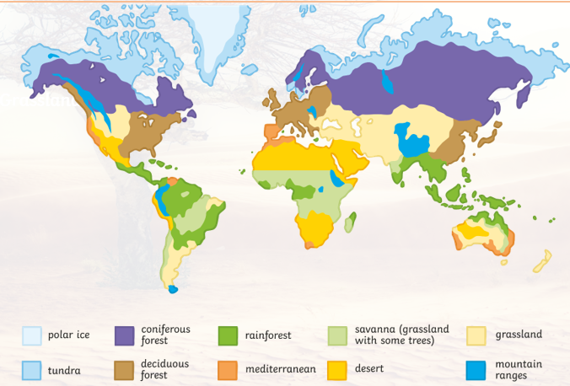

Here’s some help with understating what these words mean
Alpine | Colder climates found at high altitude in mountainous ranges. Populated with coniferous trees such as fir and pine.
Chaparral | Hot and dry like a desert, but has more rain so plants and animals can thrive (like lizards, cacti, coyotes…).
Decidious forest | Warm, wet and mild areas with lots of deciduous trees (trees that loose their leaves in autumn)
desert | Deserts that are dry and have hardly any rain. Can be hot and sandy OR cold and icy!
Rainforest | Warm, wet and humid rainforests are home to half of the world’s species and are populated with dense vegetation and trees.
Grasslands | Areas where a variety of grasses grow. There are few other trees or plants apart from near to water sources. The grasslands are very hot in the summer but can become very cold in the winter.
Desert scrub | Very dry areas of hot deserts populated with grasses, herbs and shrubs.
Savannah | A mixture of grassland and woodland.
Taiga | Very wet and cold, snows lots in the winter.
Tundra | Super cold and tricky for anything to survive for example the top of a mountain or the North Pole.

Task: Choose 5 countries and use an atlas to help you locate them and name their biomes.
Challenge: What plants and animals might live in your chosen countries? Use the internet to find pictures of these countries so you can see what they look like.

