Tuesday 31st March 2020

**SPaG**

Spellings - Word Families based on common words, showing how words are related in form and meaning.

**Practise your spellings** 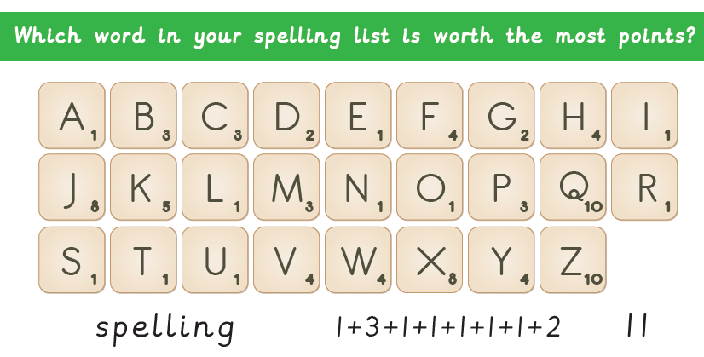

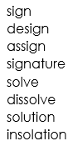



Word of the Day – **increase**

**Definition ____________________________________________**

**_____________________________________________________**

_____________________________________________________

**Used it in a sentence: ____________________________________________________**

**_________________________________________________________________________**

**Word Class: ____________________________________________________**

**Synonyms**

**English**

Watch the clip called ‘Once in a Lifetime’ again.

<https://vimeo.com/23805703>

Can you create a job description for the job of sky explorer?

|  |
| --- |
| **Are you looking for adventure within your job? Does the thought of being paid for a ’once in a lifetime’ experience excite you? Then this could be the job for you!** |

Location

Job Description



Contact and closing date

Working Hours

Benefits

**Mental Maths**

1) ½ of 68 =

2) What is the value of 8 in 8543?

3) Round 458 to the nearest 100.

4) What are the next two numbers? 18, 22, 26, 30,

5) What is the largest number you can make from 9, 2, 5 and 8?

6) How many minutes are there in two hours?

7) I think of a number, I subtract 17 from that number. My answer is 72. What number did I think of?

8) Write ½ as a decimal

**Maths – Measure**

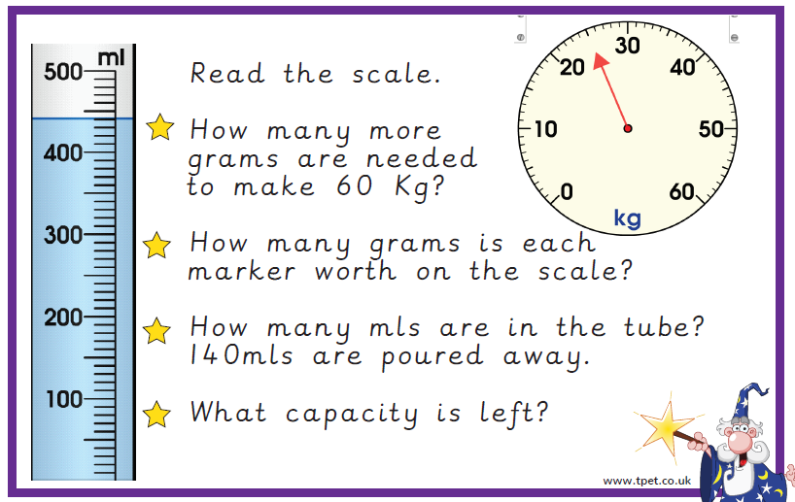

**History – Romans**

You have just been assigned a new task from the Emperor, Septimius Severus. He wants you to create a menu for his next banquet. Severus has given us strict instructions. Can you help us? The Romans had some very strange tastes in foods – take a look and see what menu you can come up with.

