Wednesday 1st April 2020
SPaG
Spellings – To apply the prefix super-
superhero | superfluent | superman | superstore
superpower | superstar | supernatural | supermarket

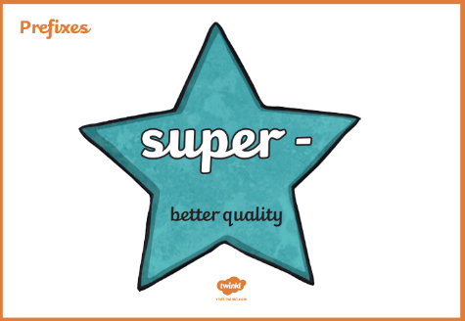
Challenge! Write each of your words. Go over the vowels in a coloured pencil.
superhero

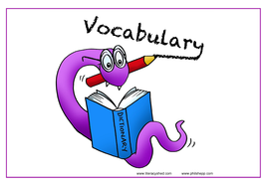
Vocabulary – Word of the Day!
stupendous
Definition _______________________________________________
_________________________________________________________
_________________________________________________________
Used it in a sentence: ____________________________________
___________________________________________________________________________
Synonyms: _______________________________________________________________________

English
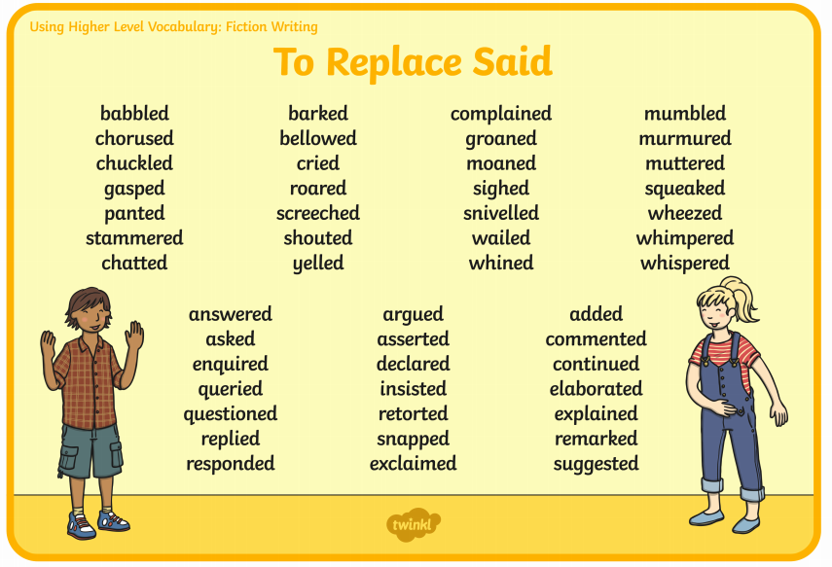
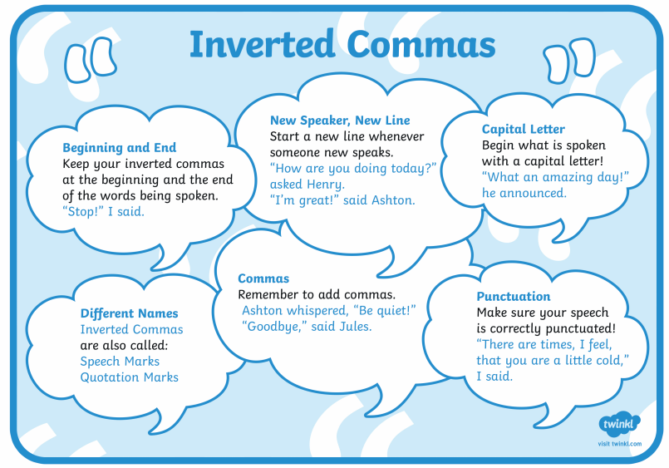
Imagine the boy goes back and tells his friend at the village what happened. Write a conversation between the two characters using correct speech punctuation. Remember ‘said’ is banned!

____________________________________________________________________________________________________________________________________________________________________________________________________________________________________________________________________________________________________________________________________________________________________________________________________________________________________________________________________________________________________________________________________________________________
_______________________________________________________________________________________________________________________________________________________________________________________________________________________________________________________________________________________________________________________________________________________________________________________________________________________________________________________________________________________________________________

Maths
Four Awesome Operations
Addition (using column method)  672 + 243 | Subtraction (using column method)  472 - 238 | Multiplication (using grid method)  28 x 3 | Division (using sharing of place value counters)  17 ÷ 4
Comparing lengths
Use <, > or = to compare the lengths below – be careful you may have to convert the measurements first!
1cm |  | 1m
12cm |  | 14mm
50mm |  | 5cm
1m and 50cm |  | 250cm
365cm |  | 3m and 65cm
22mm |  | 2cm
9cm and 7mm |  | 82mm
436cm |  | 3m
335mm |  | 30cm
92cm |  | 9cm and 2mm
12cm and 5mm |  | 252mm
900mm |  | 1m
5m 29cm |  | 5290 mm

Put these measurements in descending order:
1 m and 25cm | 1cm and 2mm | 25mm | 2cm

Put these measurements in ascending order:
90cm | 90mm | 90m | 900mm

Here are the heights of a family:
Mum: 1m and 50cm | Dad: 1m and 96cm | Sister: 86cm | Brother: 1m and 22cm | Me: 1m and 2cm

Put the family in order from shortest to tallest:

Just for Fun
- Measure how tall each member of your family is and put them in height order from shortest to tallest.

- Research: What is the length of the longest line ever drawn?

Science

Challenge! Can you find out about the different types of rock in the table below.

Rock | What does it look like? | What does it feel like? | What is it used for and why?
Sandstone
Marble
Chalk
Pumice
Clay
Granite
Slate

Useful words
dull | brittle | hard | soft | sharp | smooth | heavy
jagged | square | strong | round | light | shiny | grainy
grains | rough | crystals | powdery | yellow | brown | grey
black | pink | white | blue | red | green | breakable

