Year 2 Phonics/Spelling Practice – Thursday 25.6.20. 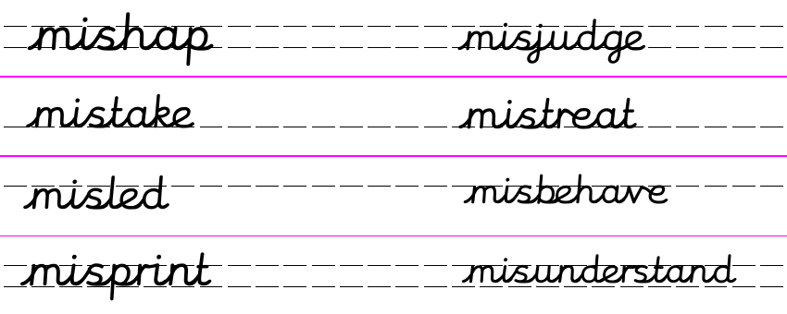
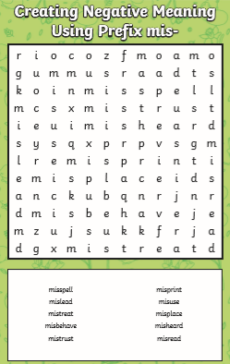
Practise: Word Search – find the mis- words or create your own word search.

Dictation:
Ask someone to read out the sentence to you – try to write it from memory.

The teacher made a mistake by misprinting the word.

Maths 25.6.20
Make patterns with 2-d shapes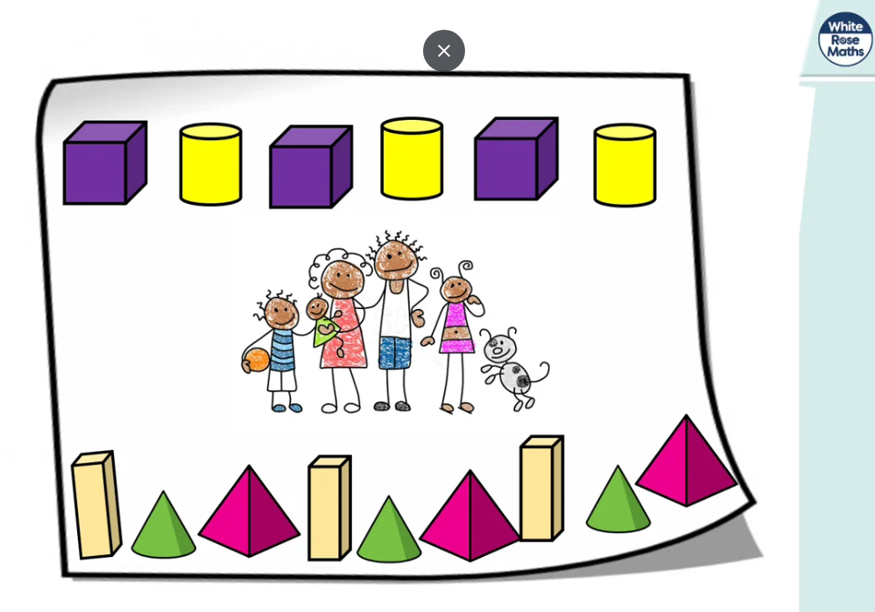
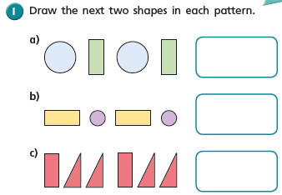
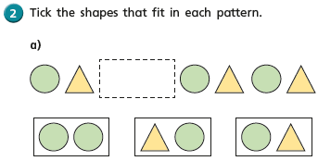
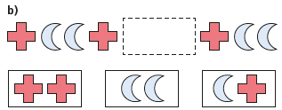

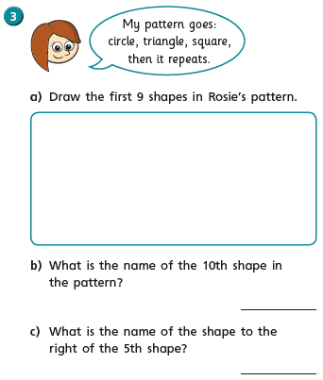
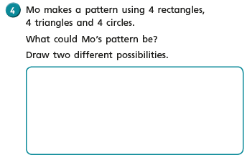
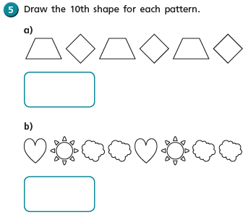
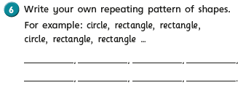

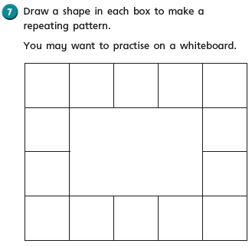
Thursday 25th June 2020 Fun fact of the day: Shark pregnancies last up to 4 years.
WALT write an information text.

Yesterday we wrote our information text about Giraffe. How did you get on? What exciting facts did you learn about Giraffe? They are really extraordinary creatures aren’t they! Our information text is starting to come together now isn’t it?
Today is our last day researching an animal for our text and it is of course the monkey!
I will go through the videos below on my daily English loom video.

https://www.bing.com/videos/search?q=Everything+you+wanted+to+know+about+monkeys+for+kids&&view=detail&mid=FDEE74012372D3EA1827FDEE74012372D3EA1827&&FORM=VRDGAR&ru=%2Fvideos%2Fsearch%3Fq%3DEverything%2520you%2520wanted%2520to%2520know%2520about%2520monkeys%2520for%2520kids%26qs%3Dn%26form%3DQBVDMH%26sp%3D-1%26pq%3Deverything%2520you%2520wanted%2520to%2520know%2520about%2520monkeys%2520for%2520kids%26sc%3D0-52%26sk%3D%26cvid%3DABCC7EE430ED46ACB783CC8A569413DF
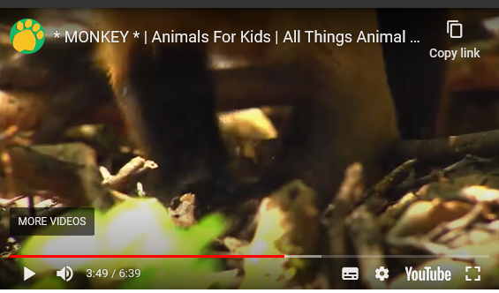

As I said yesterday, I would watch the videos a couple of times and write down in rough any key facts, or press pause on your tablet and copy them down.

Don’t forget: to include headings, captions, drawings with labels and facts about monkeys.

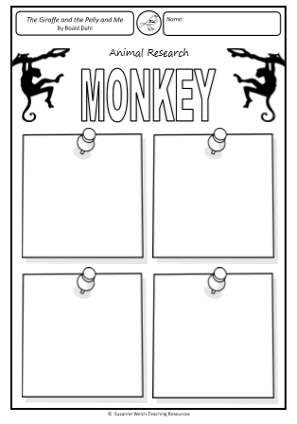
Thursday 25th June 2020
WALT create a front cover for our non-fiction information texts.
WALT draw in the style of Quentin Blake.

In English this week you are creating an information text about the three animals in our story ‘The Giraffe, The Pelly and Me’. For art this week I thought it would be nice if you could create the front cover to your text.
I would suggest looking at the front cover of the story, you could try to draw in the style of our illustrator ‘Quentin Blake’. Have a look at some videos on you tube to help you. There are lots but the two I have snipped are very good. Make sure you give your front cover a title. E.g All about Giraffe, Pelicans and Monkeys by ………………………………………………..
