Monday 15th June 2020 – English
SPaG
Spellings – Words with a chuh spelt ture

nature - __________________________________________________________________
future - ___________________________________________________________________
pasture - __________________________________________________________________
gesture - __________________________________________________________________
mixture - __________________________________________________________________
picture - __________________________________________________________________
puncture - ______________________________________________________________
creature - ____________________________________________________________

Look up the meaning of each of these words in a dictionary so you understand what each word means.
Word of the Day – outstanding

Definition ____________________________________________
_____________________________________________________
_____________________________________________________
Used it in a sentence: ____________________________________________________
_________________________________________________________________________
Word Class: ____________________________________________________
Synonyms

English
Today you will have ago at improving a set of instructions by adverbs, better imperative verbs, adverbials of time, more detail or re-write it completely.

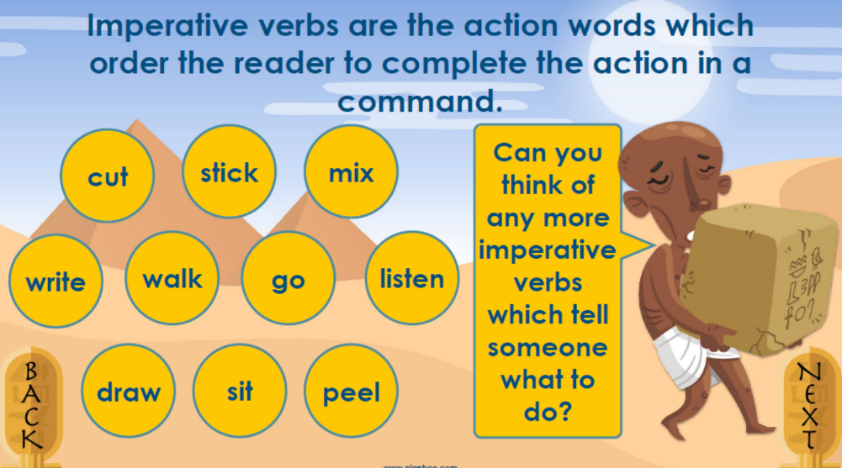

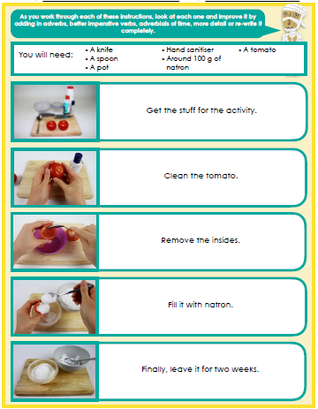

Maths Starter
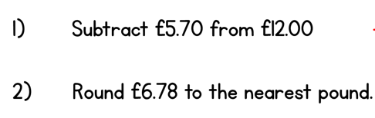

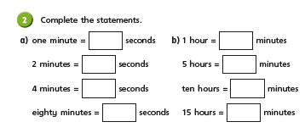
Main Lesson

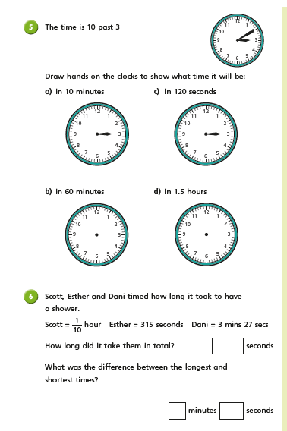

PSHCE
This week it is Refugee Week 2020. It is a special celebration of the contributions of refugees to the arts, culture and our society. The annual event provides an opportunity to welcome refugees into communities, form connections and share experiences. The theme for Refugee Week 2020 is 'Imagine.'

What is World Refugee Day?

World Refugee Day is an international day of awareness run by the United Nations (UN) to show support for refugees who have been forced from their homes by violence. In 2020, World Refugee Day will take place on 20th June, which coincides with Refugee Week 2020.

What is a refugee?
A refugee is someone who has had to leave their home and country, as they are unable to stay. This may be due to persecution, war, natural disasters and more. Refugees are often unable to return to their home countries, as it would not be safe for them to do so. Refugees could be individuals, families or even children. According to the international charity Save the Children, there are around 25.4 million refugees around the world.
How do I find out more?
Watch this video called ‘help them feel at home’ to help you answer the questions below https://refugeeweek.org.uk/get-involved/education-resources/educational-videos/

Why do you think refugees leave their homes where they were born?

How do you think they feel when they leave their home?

How do you think they feel when they arrive in a new country?

What useful things could you do to help refugees settle in their new country and home?
Imagine you had to leave your home and live somewhere new, what would you hope to find?

