Day 2 - Week Beginning 13th July 2020 – English
English
SPaG
Words with the k sound spelt with que
Write each word in your spelling list backwards.

mosque
unique
antique
plaque
cheque
boutique
picturesque
grotesque
Word of the Day – escalate

Definition ____________________________________________
_____________________________________________________
_____________________________________________________
Used it in a sentence: ____________________________________________________
_________________________________________________________________________
Word Class: ____________________________________________________
Synonyms

English
Read the instruction features used in Recipe Card - Spaghetti Bolognese and Meat Pie.

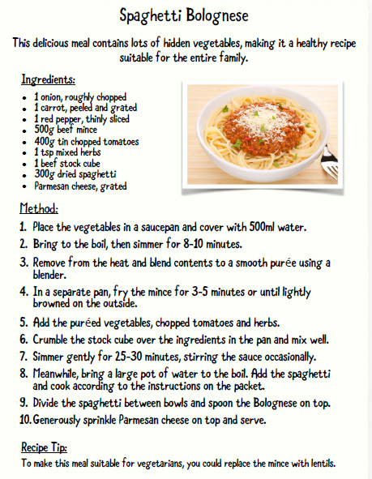

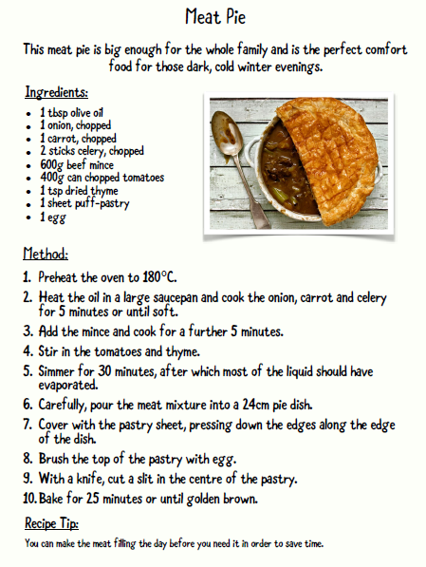
Answer the following questions
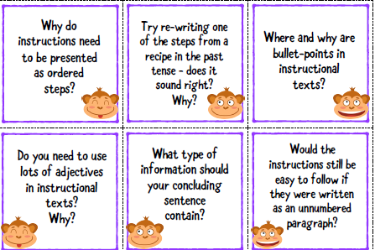

Day 2 starter
- 679 + 411
2) 574 – 274
- 57 x 8
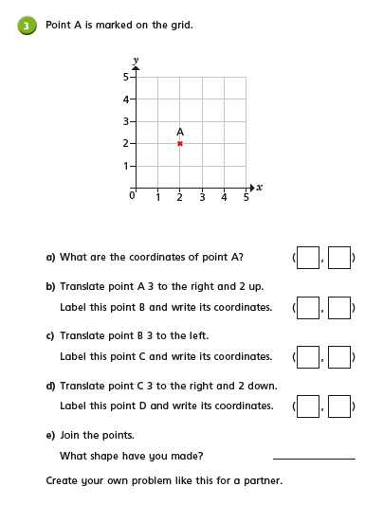
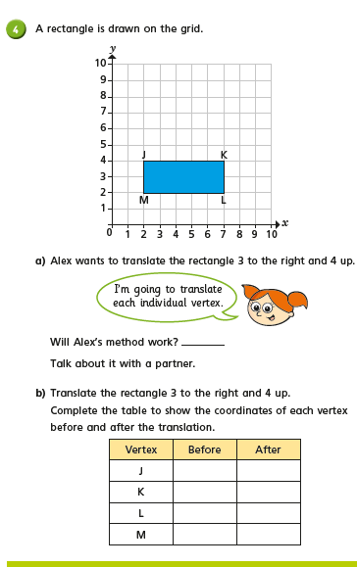

Day 2 Science
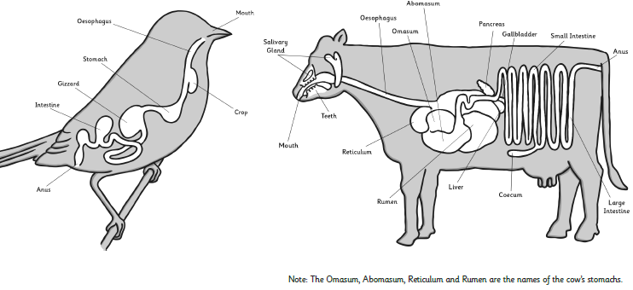
Task: Look at the digestive systems of the two animals below, what do you notice is the same? What is different? It might be helpful to record your observations in a table:

Similar parts of the digestive systems | Differences between the digestive systems

Challenge: What do the two animals above and the human digestive system (see yesterday’s learning) all have in common?
Why do you think different animals have different digestive systems? (Explain your answer by giving at least two reasons)

