Year 2 Phonics/Spelling Practice – w/c 14.5.20 Thursday
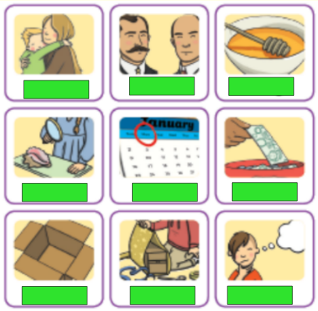
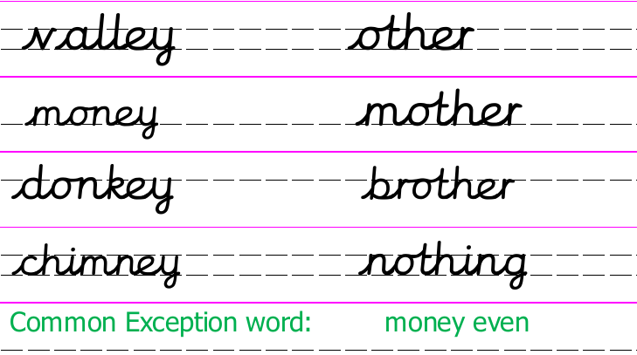
I’ve covered up the captions for the pictures.

Use the word bank to work out which caption goes with which picture.

mother
honey
brother
discover
wonder
money
nothing
cover
month

Read the passage below. How many spelling mistakes can you spot? Write out the passage with the correct spellings.
On Munday I went to visit my muther and my bruther. There was nothing to eat in the house so I set off to see if my uther bruther had sum cakes.
Maths 14.5.20
Watch the video and copy and complete the questions below.
https://whiterosemaths.com/homelearning/year-2/
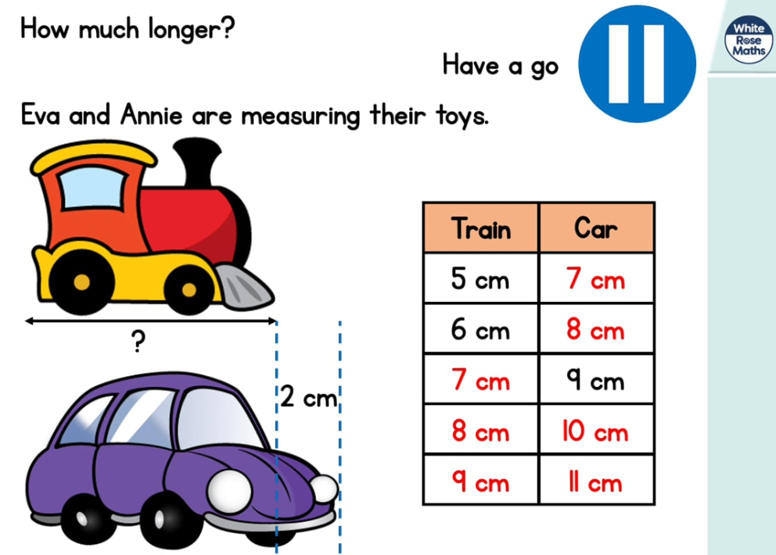
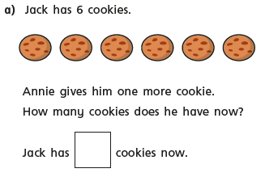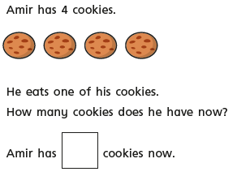
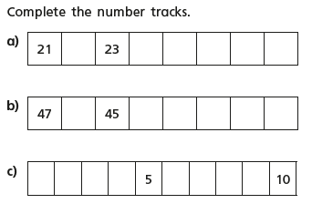
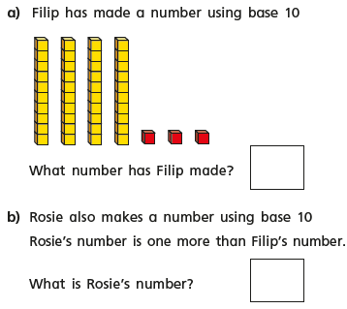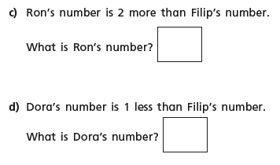

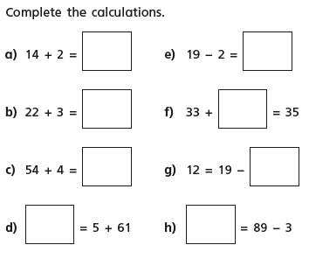
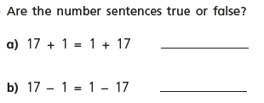

Thursday 14th May 2020 and Friday 15th May 2020
WALT write a story in the style of Eric Carle.
^{Word of the week ‘Victory’.’}
^{Quote of the day} 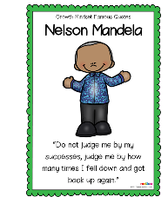

Today we are going to finish our work on Eric Carle and his stories by writing our very own story in the style of Eric Carle. I am going to give you two days to complete your stories, so this work is set for today and tomorrow

What can you remember about the stories we have read? Is there a common theme?
Can you write a similar story? Perhaps ‘a very hungry animal’, ‘a very bad tempered creature’ or a ‘very busy animal’. What happens to your character? Think carefully back to the stories we read. Did things happen in an order, different days or different characters coming in to the story. Make sure you use exciting adjectives, noun phrases and the correct punctuation. I would like you to illustrate your story too, in the style of Eric Carle. Have fun and I look forward to reading them when we are all back together soon.

D.T. - Thursday 14th May 2020
WALT design a picnic skewer.

How did you get on last week with the Teddy Bear biscuits? Did they taste nice? Today we have received a letter from Mr Bear asking us to design a food skewer to take on a picnic.
Do you know what a skewer is?
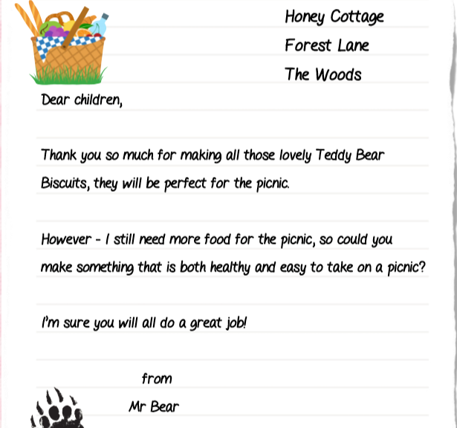

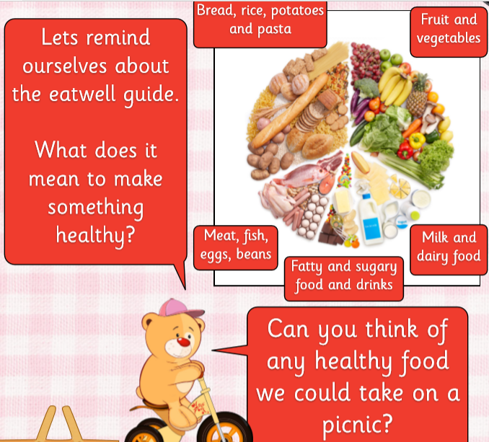
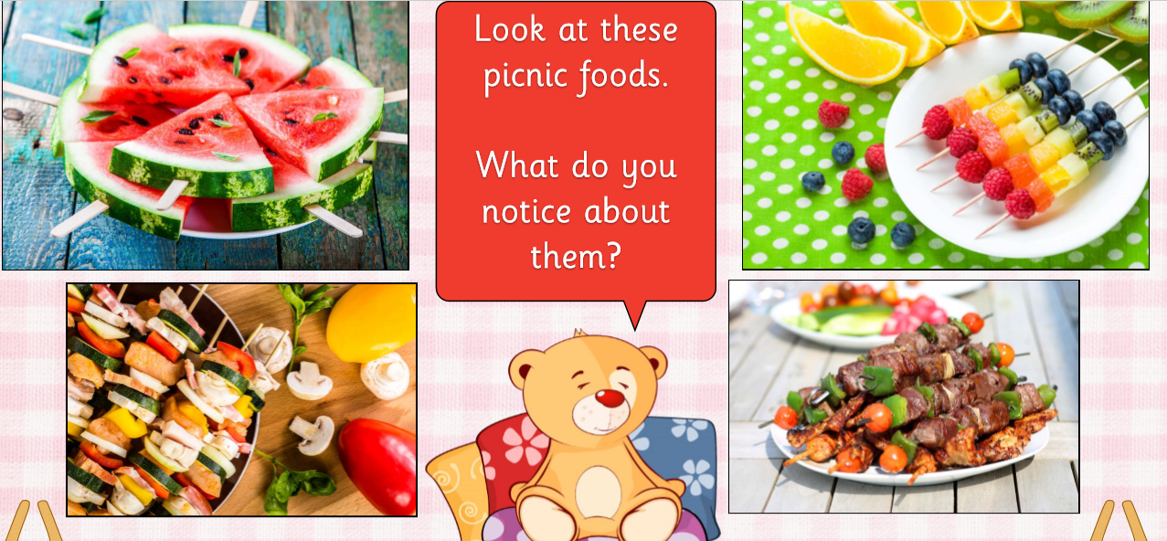
Today we are going to be designing our own picnic skewers.
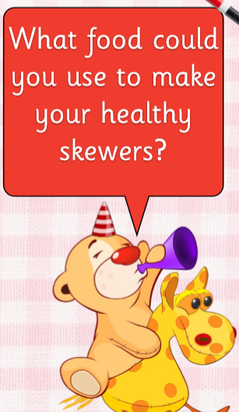
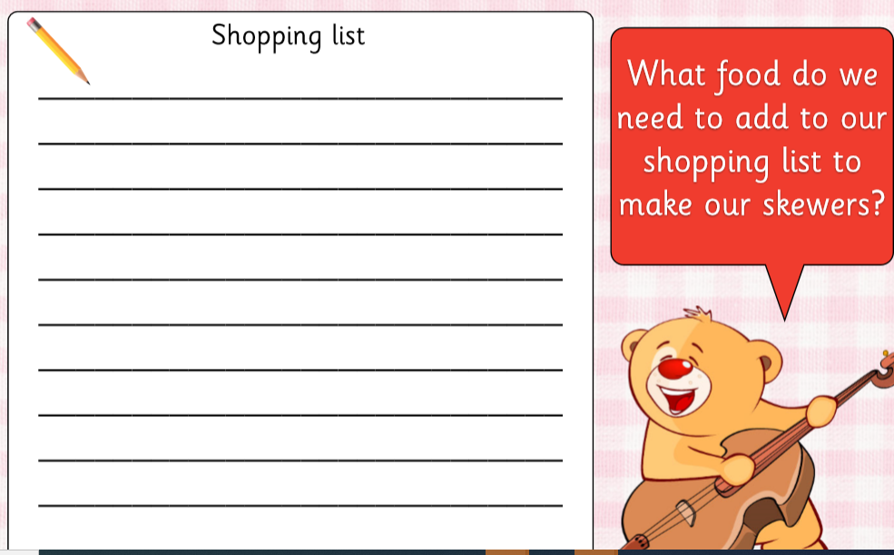
Task

Design your picnic skewer. Make sure you choose healthy options. Use the eatwell guide to help you choose well. Compile a shopping list of all the ingredients you may need.

