Tue More practice |  | Tue Feeling confident |  | Tue Challenge Me
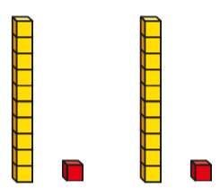  - This base ten model shows you 11x2.  Use your own base ten to solve 11 x 3. Draw your model in your book and complete the sum.  Copy these sums into your book. Draw a  model to represent each sum (you could  use place value counters OR base ten).  - 5 x 11 =  - 11 x 4 =  - 12 x 3 =  - 4 x 12 = |  | - Use base ten to build the 12 times table. For example: 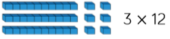  Copy and complete these sums in your book.  Use your models on your table to help you.  - 12 x 5 =  - 12 x ? = 120  - ? = 9 x 12  - 48 divided by 12 =  - 12 x ? =132  - ? divided by 12 =8 |  | 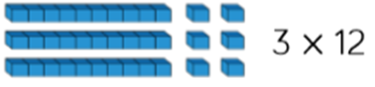  - Use base ten to build the 12 times table. For example:  Copy and complete these sums in your book. Use your models on your table to help you.  - 12 x 7 =  - 12 x ? = 108  - ? = 8 x 12  - 48 divided by 12 =  - 12 x ? = 120  - ? divided by 12 = 8
Reasoning  Crayons come in packs of 12.  Dora buys 5 packs of crayons  How many crayons will she have?  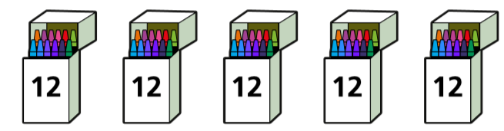 |  | Reasoning  Mia is spotting patterns in the 11 times table.  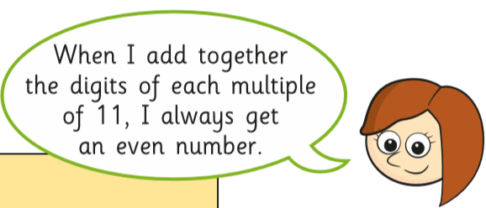  2 x 11 = 22 2+2=4 which is an even number.  Do you agree? Why? Explain.  What else do you notice? Explain. |  | Reasoning  Mr Scott is organising a cricket tournament.  - There are 11 players in a cricket team. 5 teams have signed up for the tournament. How many players have signed up?  - Mr Scott needs 132 players signed up to go ahead with the tournament. How many more teams are needed?

Tue More practice ANS |  | Tue Feeling confident ANS |  | Tue Challenge Me ANS
- This base ten model shows you 11x2.  Use your own base ten to solve 11 x 3. Draw your model in your book and complete the sum.  Copy these sums into your book. Draw a  model to represent each sum (you could  use place value counters OR base ten).  - 5 x 11 = 55  - 11 x 4 = 44  - 12 x 3 = 36  - 4 x 12 = 48 |  | - Use base ten to build the 12 times table. For example:  Copy and complete these sums in your book.  Use your models on your table to help you.  - 12 x 5 = 60  - 12 x 10 = 120  - 108 = 9 x 12  - 48 divided by 12 = 4  - 12 x 11 =132  - 96 divided by 12 =8 |  | - Use base ten to build the 12 times table. For example:  Copy and complete these sums in your book. Use your models on your table to help you.  - 12 x 7 = 84  - 12 x 9 = 108  - 96 = 8 x 12  - 48 divided by 12 = 4  - 12 x 10= 120  - 96 divided by 12 = 8
Reasoning  Crayons come in packs of 12.  Dora buys 5 packs of crayons  How many crayons will she have?  60 crayons |  | Reasoning  Mia is spotting patterns in the 11 times table.  2 x 11 = 22 2+2=4 which is an even number.  Do you agree? Why? Explain.  What else do you notice? Explain.  Yes the pattern works  Various answers as to why |  | Reasoning  Mr Scott is organising a cricket tournament.  - There are 11 players in a cricket team. 5 teams have signed up for the tournament. How many players have signed up? 55players  - Mr Scott needs 132 players signed up to go ahead with the tournament. How many more teams are needed? 7more teams needed

