Monday 29th June 2020 – English
SPaG
Spellings – Words with the sh sound spelt ch
chef - ____________________________________________________________________
chute - ___________________________________________________________________
chalet - __________________________________________________________________
machine - ________________________________________________________________
brochure - ________________________________________________________________
parachute - _______________________________________________________________
ricochet - ________________________________________________________________
moustache - _____________________________________________________________

Look up the meaning of each of these words in a dictionary so you understand what each word means.
Word of the Day – peculiar

Definition ____________________________________________
_____________________________________________________
_____________________________________________________
Used it in a sentence: ____________________________________________________
_________________________________________________________________________
Word Class: ____________________________________________________
Synonyms

English –
See loom intro video first. – Link - https://www.loom.com/share/f0a08b8ae38b4032881250096819ad67

Task
Draw a picture of your new character on a piece of paper.
Describe your horrible character below your picture. It’s best to start with their name and one of their key features which makes them so horrible. Use a thesaurus to help you choose words which will engage and interest the reader.

Maths
Starter
What number is represented on the grid?
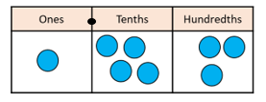
2) Write 3/10 as a decimal.
3) What is 1000 less than 4463?
An angle is a measure of a turn measured in degrees. An angle is the space between two intersecting lines.
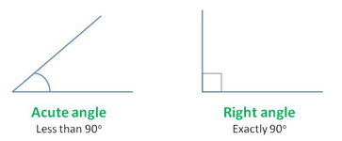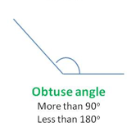

Watch this video up to 1 minute 10 seconds, it explains about acute, obtuse and right angles.
https://www.youtube.com/watch?v=NVuMULQjb3o&safe=active

Remember:
a right angle = 90 ⁰ (90 degrees)
an acute angle is less than 90 ⁰
an obtuse angle is greater than 90 ⁰ but less than 180 ⁰
180 ⁰ can be seen on a straight line
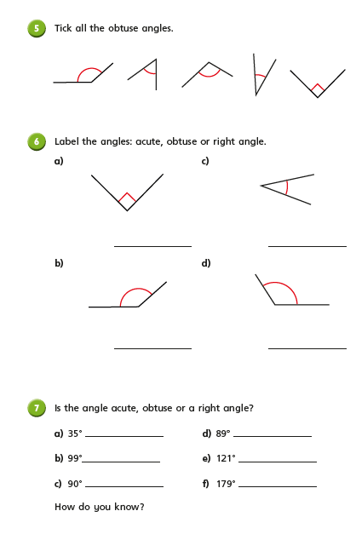
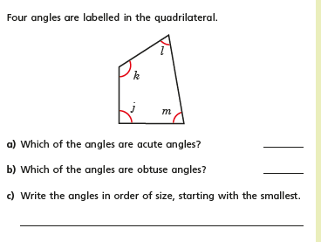
Reading
With all this lovely weather this summer we hope you have discovered some wonderful new places to get comfortable and enjoy reading a book. Maybe you like to read in the paddling pool or you’ve found the comfiest spot in the shade under a tree? Wherever it is, take a moment to reflect on your favourite book this year or the last book you read and complete the review below.

