Friday 1st May 2020
English
SPaG
Spellings - The I sound spelt y elsewhere that at the end of the word
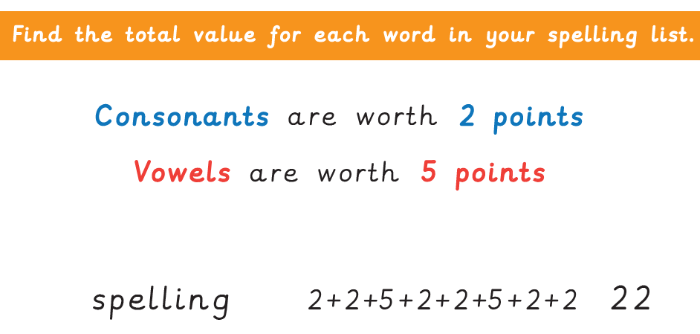
myth
Egypt
gym
pyramid
mystery
symbol
physical
synonym

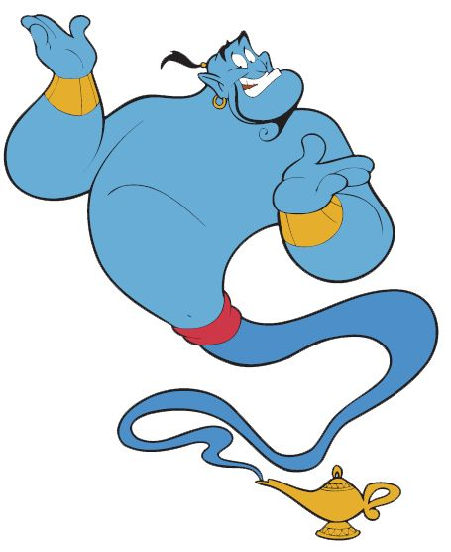
Word of the Day – recent

Definition ____________________________________________
_____________________________________________________
_____________________________________________________
Used it in a sentence: ____________________________________________________
_________________________________________________________________________
Word Class: ____________________________________________________
Synonyms

English - That’s a Fact!
Factual books are known as non-fiction.

Do you own a non-fiction book in your collection?

What is it’s title?

What is it about?

List ten facts from this book.

Maths
- 162 + 553

- 562 – 161= (calculate mentally)
- Use the digits 3 4 6 7. Write the largest possible number.
- What does the product mean in maths?
- What is the product of 4 and 12?
- 6 x 2 x 3 =

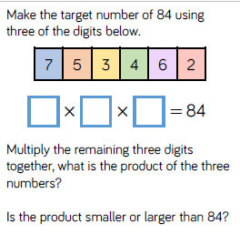

8) How many days in May?

Design Technology.
Ancient Egyptians liked gold jewellery; can you design and make your own gold bands and collars? Old plastic water bottles are good for cuffs, cut a ring, cover in foil or paint then add details with beads for jewels or felt tip for patterns. You could use card for a collar.

