Wednesday 3rd June 2020

SPaG

Spellings – Suffix ly

Write each word in your spelling list using 2 different colours. Write the consonants in one colour and the vowels in another colour.

happily

angrily

gently

simply

humbly

nobly

frantically

dramatically



Word of the Day – **indicate**

**Definition ____________________________________________**

**_____________________________________________________**

_____________________________________________________

**Used it in a sentence: ____________________________________________________**

**_________________________________________________________________________**

**Word Class: ____________________________________________________**

**Synonyms**

**English**

This week you will be writing your own newspaper report. Headlines are really important to grab the readers attention so today you need to practice writing your own headlines.

Carefully read these short newspaper stories and create an interesting headline for each, which will grab the reader’s attention.

1. Three children were walking across a field in Hounslow when they discovered a hole. At the bottom of the hole was a chest filled with gold and silver. The children ran and told the police about their discovery.
2. Two days ago a kitten called Cookie, belonging to Mrs Daniels, climbed a tree. It got stuck at the top and could not get down. A large crowd gathered. They could not help the cat. In the end they sent for the fire brigade. The firemen put a ladder up the tree and brought the frightened cat down.
3. Late last night, three men disguised wearing wigs and sunglasses stole over £1000 worth of goodies from a sweet shop. They smashed their way through the front door around midnight and filled sacks with delicious treats. It is hoped that they will be found and arrested soon.
4. Mrs Sullivan, the headteacher, is celebrating her first prize win at a local gardening contest. Her beautiful display of flowers beat many other contestants. Rumours have it that her own back garden looks better than the Queen’s! Photographs of her display can be seen on our website.

Task 2.

Newspapers often have pictures to give the reader an idea of what the story is about. A caption is used to describe what the picture shows.

[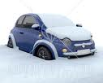](http://www.google.co.uk/imgres?imgurl=http://images.clipartof.com/small/29721-Clipart-Illustration-Of-A-Blue-Compact-Car-Stuck-And-Covered-In-Snow-In-A-Cold-Winter-Day.jpg&imgrefurl=http://www.clipartof.com/details/clipart/29721.html&usg=__lglDBgjlPyN7n1WmHr2o1FDGUCU=&h=360&w=450&sz=60&hl=en&start=14&zoom=1&um=1&itbs=1&tbnid=XFSymyhv638s3M:&tbnh=102&tbnw=127&prev=/images?q%3Dcar%2Bstuck%2Bin%2Bsnow%26um%3D1%26hl%3Den%26rls%3Dcom.microsoft:en-gb:IE-SearchBox%26rlz%3D1I7ACAW_en%26tbs%3Disch:1)[](http://www.google.co.uk/imgres?imgurl=http://www.topnews.in/files/Fire_1.jpg&imgrefurl=http://www.topnews.in/polish-hostel-where-22-died-ruled-unsafe-2152610&usg=__3VS4B4XwW5y3jJlFLBkvkf30Cag=&h=304&w=468&sz=30&hl=en&start=4&zoom=1&um=1&itbs=1&tbnid=pJvT4453YFeYWM:&tbnh=83&tbnw=128&prev=/images?q%3Dfire%2Bbuilding%26um%3D1%26hl%3Den%26rls%3Dcom.microsoft:en-gb:IE-SearchBox%26rlz%3D1I7ACAW_en%26tbs%3Disch:1)Have a go at writing your own captions for these pictures.  
1) 2)

**Maths**

Have a look at this video today about fractions greater than 1.

<https://vimeo.com/418154723> Watch the first 3 minutes only today.

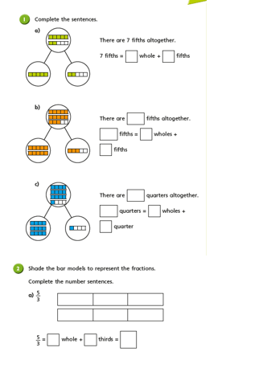

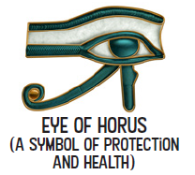Wednesday – ART

The Eye of Horus was an important symbol in ancient Egypt. It was the **symbol of protection and Royal Power** from Ra or Horus. Horus was an ancient Egyptian sky god in the form of a falcon. The right eye represents a **peregrine falcon 's eye and the markings around** it.

It was thought that the Eye of Horus had healing or magical powers and could also represent the 5 senses.

Have a go at drawing the eye, you could use felt tips, pencils, paints, oils or even chalks outside!

