SWIFTS, SWANS & DOVES - AUTUMN 2020 - 1st half term
KNOCK! KNOCK! Who’s behind the door?

Personal Social and Emotional Development  - Outdoor tour of the school  - Covid, indoor and outdoor rules  - Value – Respect  - New Beginnings  - Talk about the contents of their ‘My Special Things’ box  - Forming positive relationships with adults and other children  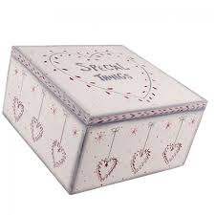  - Stories about how they and others show feelings  - Mindfulness and belly breathing  - Circle time sessions |  | Communication and Language  - Listening attentively  - Expressing themselves effectively showing awareness of listeners’ needs when sharing the contents of their ‘My Special Things’ box  - Talking about events that have happened or are to happen in the future  - Sound discrimination and voice sounds  - Using language in role play situations e.g. Theatre (Swifts), Home Office (Doves) and Fruit Shop (Swans) ((Swans |  | Physical Development  - Whole body action rhymes  - Energetic games  - Parachute games  - Dressing and going to the toilet independently  - Manipulation and Coordination activities in PE  - Dances – People, Mr Jelly and Mr Strong  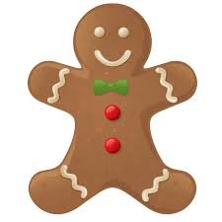  - Using tools effectively including pencils for writing and scissors for cutting  - Handwriting patterns
Literacy  - Listening to stories – ‘When I’m feeling ….’ series, The Gruffalo, Elmer, The Very Hungry Caterpillar, noisy stories, rhyming stories, stories about families, owls and dinosaurs  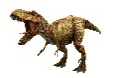  - Looking at books independently  - Rhyme and alliteration  - Oral segmenting and blending  - Continuing a rhyming string  - Hearing and saying initial sounds in words  - Segmenting sounds in simple words and blending them together to read/write them  - Sounding the letters of the alphabet  - Writing own name and other words using cursive style | Mathematics  - Numbers: Just Like Me!  - Sorting objects according to size, colour and shape  - Finding their own ways to sort objects such as leaves, buttons, fruit, people, toys etc.  - Sorting, matching and comparing sets of objects  - Comparing and ordering objects using language such as big/small, short/long and short/tall  - Recognising and creating simple patterns using objects  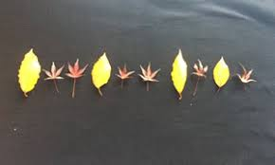 |  | Understanding the World  - Talking about past and present events in their own lives and in the lives of family members  - Use computer programs to create a face, colour an owl and create patterns  - Similarities and differences in relation to living things (humans)  - Sorting photographs according to eye/hair colour etc.  - Traditions – design a Christmas card  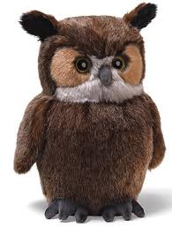  - R.E. - Being special. Where do we belong? |  | Expressive Art and Design  - Painting  - Printing  - Collage  - Model making  - Observational self portrait  - Playing instruments  - Singing action songs about ourselves and our feelings  - Music unit – Me!  - Acting out stories and making up dances  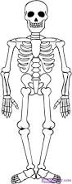  - Skeleton pictures

