Year 2 Phonics/Spelling Practice – Friday 19.6.20.
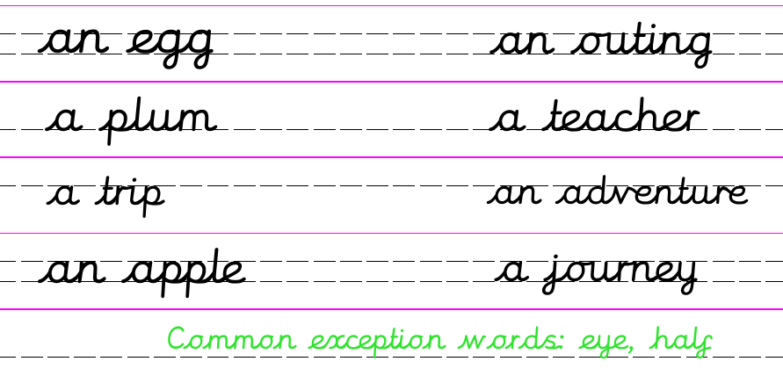
Today we’ll practise what we’ve learned this week:
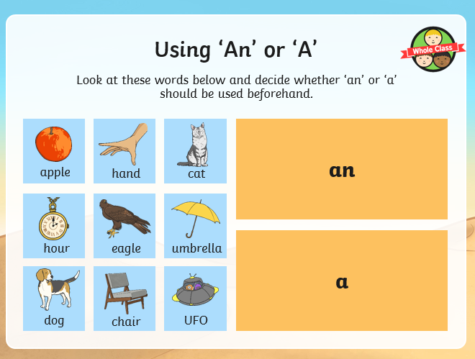
Common Exception Words:
Our two common exception words for this week are:
an eye 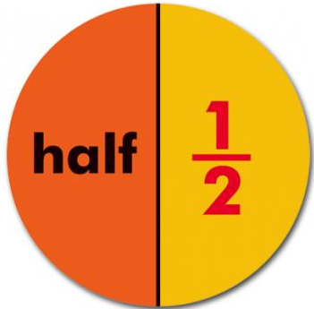a half
Practise writing them – perhaps draw a picture for each to help you remember.
Dictation:
I kept an eye on the clock for an hour and a half.
Maths 19.6.20
Fractions
https://www.bbc.co.uk/teach/supermovers/ks1-maths-fractions-with-joe-tracini/zmjy2sg
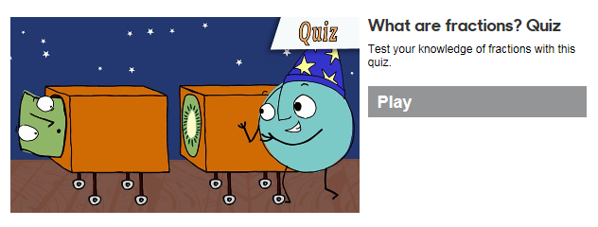
Use this link to try the fraction quiz:
https://www.bbc.co.uk/bitesize/topics/z3rbg82/articles/zq2yfrd

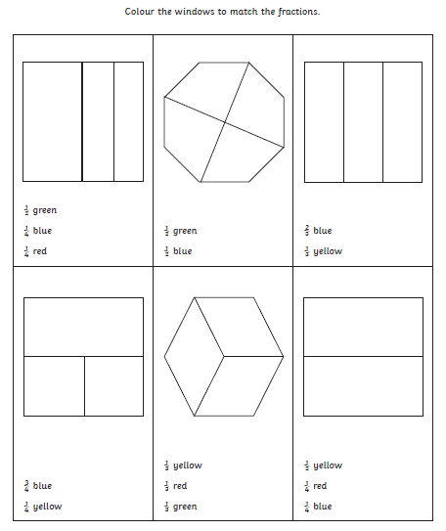

Friday 19th June 2020 Word of the day: renovate.

WALT write a descriptive passage about a place we have read.
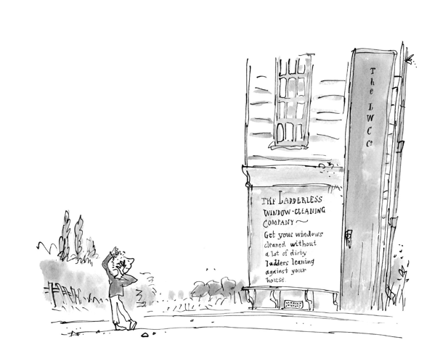
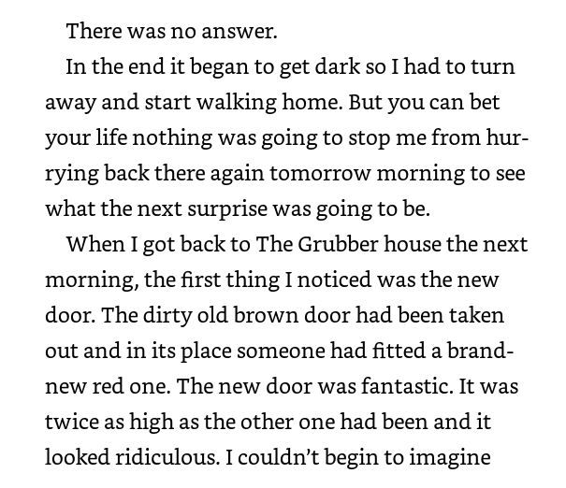
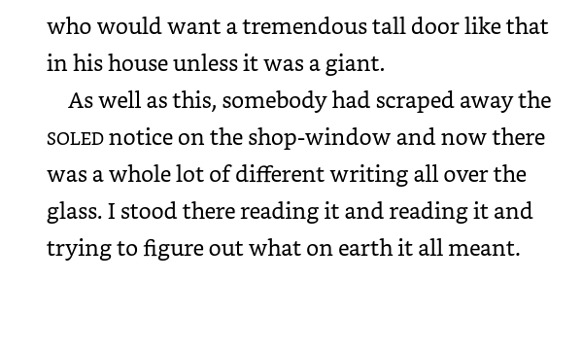
Are there any words in the text that you don’t know? If there are underline them and look them up in the dictionary.

A nice simple task for today. Can you draw a picture of the newly renovated shop and write a short description of it. What words can we take from the text to help us? Can you underline them. Remember don’t just say It had a red door, add some adjectives to make your sentence interesting e.g an amazing, brand new, tall, red door.
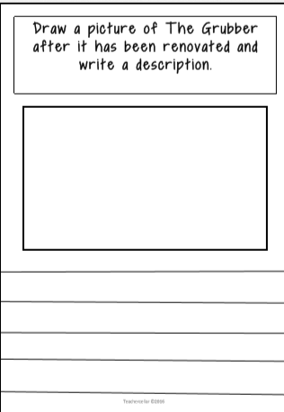
Science 19.6.20
WALT: identify and name a variety of plants and animals in their habitats.
What is a habitat? A habitat is where animals and plants live.
Let’s explore different habitats by watching the clips below:
https://www.bbc.co.uk/bitesize/articles/zhvmt39

