Evidencing the use of the PE and Sport Premium funding: Action plan and Impact Review
The DfE Vision for the Primary PE and Sport Premium

ALL pupils leaving primary school physically literate and with the knowledge, skills and motivation necessary to equip them for a healthy, active lifestyle and lifelong participation in physical activity and sport.

The funding has been provided to schools to make additional and sustainable improvements to the quality of PE and sport they offer. This means that you should use the funding to:
- develop or add to the PESSPA activities that your school already offer
- build capacity and capability within the school to ensure that improvements made now will benefit pupils joining the school in future years
Schools need to ensure impact against the following 5 Key Indicators:
- the engagement of all pupils in regular physical activity - the Chief Medical Officer guidelines recommend that all pupils and young people aged 5 to 18 engage in at least 60 minutes of physical activity a day, of which 30 minutes should be in school
- the profile of PE, Sport and Physical Activity being raised across the school as a tool for whole school improvement
- increased confidence, knowledge and skills of all staff in teaching PE and Sport
- broader experience of a range of sports and activities offered to all pupils
- increased participation in competitive sport

It is a statutory requirement of Ofsted, under their Common Inspection Framework, to ensure that information on the use of the Primary PE and Sport Premium and the impact it has had on pupils PE and sport participation and attainment is available on the school website by 31st July 2021. Schools also have a responsibility to publish on their website the % of pupils who achieve the expectation for swimming by the end of Year 6.
*In the case of any under-spend from 2019/2020 which has been carried over this must be used and published by 31st March 2021
You should not use your funding to:
- employ coaches or specialist teachers to cover planning preparation and assessment (PPA) arrangements - these should come out of your core staffing budgets
- teach the minimum requirements of the national curriculum – including those specified for swimming
- fund capital expenditure
If any funding from the academic year 2019/2020 has been carried over you MUST complete the following section. Any carried over funding MUST be spent by 31st March 2021
Academic Year: September 2020 – March 2021 | Total Fund Carried over  £ 500 | Date updated  Autumn 2020
What key indicator(s) are you going to focus on?

The profile of PE and sport being raised across the school as a tool for whole school improvement
Intent | Implementation | Allocated funds | Anticipated outcomes
Pupils to have pride in their school and a sense of team spirit. | Purchase festival jackets. | £500 | Pupils feel proud to play sport for their school when attending competitive sports festivals.

Academic Year: | 2020-2021
Funding Allocation: | £18,960
Carry over from 2019-2020 | £500
Total | £19,460
Predicted Spend: | £18,996.80
PE and Sport Premium Action Plan
Indicator 1: The engagement of all pupils in regular physical activity – the Chief Medical Officer guidelines recommend that all pupils and young people aged 5 to 18 engage in at least 60 minutes of physical activity a day, of which 30 minutes should be in school |  |  | Percentage of total allocation: 37%
Intent | Implementation | Allocated funding | Anticipated outcomes
Encourage more physical activity during lunchtimes for all pupils through use of Sports Leaders. | With the support of RSSP training, Sports Leaders to lead lunchtime games for all pupils on rotation throughout the week. | Within the £1,750 to join RSSP | Sports ambassadors to enjoy the training and gain skills to enable them to work with and initiate sports activities with pupils in all year groups of the school at lunchtimes including offering personal challenges.
Least active pupils within school to have access and opportunity to attend an extra-curricular club to increase their physical activity. | Autumn term audit to discover least active pupils in school.  Pupils to be offered a school-funded club to attend later in the year.  Find out if all PPG/SEND pupils are in at least one club over the year. If this is not the case, offer a club to them. | £300 for funded extra-curricular clubs | The least active/vulnerable pupils within school to have been identified and offered the opportunity to attend a club. This will hopefully prove to be a positive experience for the pupils and they will look to attend in the future.
School to be well resourced in order to support regular physical activity – curricular, extra-curricular and lunchtime. | Staff to make the PE lead aware of any gaps in resources or additional resources required in order to support regular physical activity within curriculum lessons, extra-curricular clubs and breaktimes.  PE lead to source appropriate recourses according to the need within school. | £450 | All pupils to be able to participate in high quality PE lessons/physical activity with safe, high quality resources.
Outdoor KS2 gym equipment purchased last year to be accessible in all weathers. | Completion of astro-turf surrounding the outdoor gym to ensure it is accessible in all weathers. | £4500 | Pupils able to independently work on their own fitness during break and lunch times as well as during planned PE sessions using the equipment.  Pupils will be able to be more active, more of the time.  Pupils will be able to access the outdoor gym equipment and trim trail in all weathers.  The gym equipment will be able to be used as part of the personal challenge, by sports ambassadors.
Indicator 2: The profile of PE, Sport and Physical Activity being raised across the school as a tool for whole school improvement |  |  | Percentage of total allocation: 22%
Intent | Implementation | Allocated funding | Anticipated outcomes
Continued celebration of sporting and physical activity success across the school so pupils feel a sense of pride and community. | Pupils who attend festivals through RSSP awarded certificates/medals presented in our whole school assemblies in order to raise the profile of PE.  Certificates to be displayed on main PE board. | Within the £1,750 to join RSSP | The profile of PE, Sport and Physical Activity is raised across the school through whole school celebration and pupils feel proud of their achievements.
Sports Leaders to have a high profile within all key stage playgrounds and across the school and support peers in working towards their personal best. | With the support of RSSP training, Sports Leaders to lead lunchtime games for all pupils on rotation throughout the week.  Focus on leaders encouraging peers to complete the ‘personal challenges’ – link to KI5.  A display board dedicated to the Sports Leaders and their achievements as well as a board dedicated to PE across the school. | Cost covered within RSSP offer | Physical activity to be prominent across all times of the school day included outside of PE lessons.  Pupils to be able to see and celebrate their improvements and success.  Sports Leaders to feel valued and a sense of pride carrying out their role.
A greater number of pupils to achieve the expected standard of swimming by the end of KS2. | Year 3 pupils to attend swimming lessons beyond the core offer in year 4.  Breakdown of KS2 swimming outcomes into 2 years’ worth of smaller steps rather than the core year 4 lessons alone (PE milestone document) should ensure that more pupils achieve the expected swimming KS2 milestones before they leave year 4. | £2000 | Pupils to have water confidence before their curriculum lessons in year 4.  Pupils’ swimming skills are increased  Pupils’ water confidence is increased  Pupils’ activity levels are increased
Development and enhancement of resilience and behaviour through an inspirational sports person delivering sport and physical activity enrichment opportunities. | Roller-skate/skateboard workshop with a core message.  Resilience Q and A session around the belief to overcome obstacles in life. | £1500 | Pupils to further develop skills around these areas as in previous years, such as workshops by Mike Mullen.  Pupils to learn to improve their habits, confidence and reactions to challenges through being inspired by sporting achievements.  Pupils to be inspired to try a new sport.
Year 4 pupils to be aware of basic safety factors when riding a bike. | Level 1 Bikeability to be offered to all Year 4 pupils | Cost covered within RSSP offer | Pupils will learn to:  - control and master their bikes in a space away from traffic  - prepare themselves and their bike for cycling  - get on and off their bike without help  - start off, pedal and stop with control  - pedal along, use gears and avoid objects  - look all around and behind, and control the bike  - share space with pedestrians and other cyclists
Year 2 pupils to be aware of basic safety factors when scooting. | Scootability to be offered to all Year 2 pupils | £ 210 (½ days of 4 sessions) | Pupils will develop confidence with an active travel method to get to school  Pupils enjoy being active and are more active more of the time
Understanding around health and wellbeing (including diet) to be raised across the school as a tool for whole school improvement. | Purchase a vegetable bed/planter for each class so they are able to grown simple vegetables such as potatoes, carrots and onions. They will then be able to use this produce in healthy eating lessons with a link to physical health.  To arrange for a gardener to come in and speak to the pupils about growing their own food. | £500 | Pupils to understand how diet can influence healthy lifestyles.  Pupils to gain enjoyment and success from growing their own produce.  Pupils to be more aware of where their food comes from and the health benefits of freshly grown food.
Indicator 3: Increased confidence, knowledge and skills of all staff in teaching Physical Education and Sport |  |  | Percentage of total allocation: 23%
Intent | Implementation | Allocated funding | Anticipated outcomes
For staff confidence, knowledge and skills to increase/develop in teaching Physical Education and Sport. | Join the Redborne School Sport Partnership (SSP). This provides support for local schools including professional development for teachers and entry into all local school festival and transition events.  Access to YST membership level 2  Access to online resources, topical updates, exclusive offers, discounts and priority access to YST National PE & School Sport Awards & National Programmes – used for resources and staff training  Nationally recognised badge of excellence for PE and school sport. | Cost covered within RSSP offer | Current staff/PE lead to increase skillset and confidence in order to provide high quality sessions that pupils engage well with.
Further develop the skillset/confidence of the PE lead. | PE co-ordinator to attend the PE conference in March 2021. | £150 | For the PE lead to feel confident in their role and be able to support and guide others in improving PE and physical activity across the school.
Further increase confidence, knowledge and skills of staff in teaching Physical Education and Sport | To purchase the PE Hub in order to support the planning, delivery and assessment of PE across the school. | £444 | Staff feel confident in delivering/assessing sessions and have the resources available to do this to a high standard.
Staff to gain experience in teaching a new physical activity – maypole dancing. | Maypole dancing workshop. Highly skilled coaches to teach one PE lesson alongside staff and then offer lunchtime/twilight CPD to share new techniques and planning strategies. | £1916.40 | Staff to have updated teaching and learning techniques to use when teaching specific physical activity. Staff to be confident in their own ability.
Staff to gain experience in teaching a new physical activity – Bollywood dancing. | Bollywood dancing workshop. Highly skilled coaches to teach one PE lesson alongside staff and then offer lunchtime/twilight CPD to share new techniques and planning strategies. | £1916.40 | Staff to have updated teaching and learning techniques to use when teaching specific physical activity. Staff to be confident in their own ability.
Indicator 4: Broader experience of a range of sports and activities offered to all pupils |  |  | Percentage of total allocation: 18%
Intent | Implementation | Allocated funding | Anticipated outcomes
Pupils to be able to experience a broader range of sports/physical activity. | Through RSSP pupils to attend local school festival and transition events where there are a range of sport/physical activities for pupils to take part in including SEND/inclusion events. | Cost covered within RSSP offer | For pupils to have fun and feel part of a team.  Pupils to experience ‘new’ sports/physical activity in order to enthuse and motivate including our SEND and vulnerable pupils.  Pupils to be inspired to try a new sport.
Pupils to be able to experience a broader range of sports/physical activity. | To fund a series of extra-curricular clubs exposing pupils to a wider variety of sports/physical activity such as archery, bocce, fencing etc. | Within the £300 for funded extra-curricular clubs | For pupils to have fun.  Pupils to experience ‘new’ sports/physical activity in order to enthuse and motivate.  Pupils to be inspired to try a new sport.
Pupils to experience new physical activity – maypole dancing | Maypole dancing workshop. Highly skilled coaches to teach one PE lesson alongside staff.  British values focus on PE. | Within costing above | For pupils to have fun.  Pupils to experience a new ‘traditional’ physical activity, develop new skills, and possibly seek pursuing this outside of school hours.  To add to pupil’s cultural capital via PE.
Pupils to experience new physical activity – Bollywood dancing | Bollywood dancing workshop. Highly skilled coaches to teach one PE lesson alongside staff.  Booked to coincide with Diwali and Hinduism workshops to add to pupils’ cultural capital. | Within costing above | For pupils to have fun.  Pupils to experience a new multicultural physical activity, develop new skills, and possibly seek pursuing this outside of school hours.  To add to pupils’ cultural capital via PE.
Pupils to experience new physical activity – ice skating | Ice rink hire to enable all pupils the chance to ice-skate. | £3360 | For pupils to have fun.  Pupils to experience a new physical activity, develop new skills, and possibly seek pursuing this outside of school hours.  To add to pupils’ cultural capital via PE.
Indicator 5: Increased participation in competitive sport |  |  | Percentage of total allocation:
Intent | Implementation | Allocated funding | Anticipated outcomes
All pupils in year 4 to attend a transition event and 1 additional event  All pupils in year 3 to attend at least one event  All pupils in year 2 to attend at least one event. | Join the Redborne School Sport Partnership (SSP). This provides support for local schools including professional development for teachers and entry into all local school festival and transition events.  Pupils are given the opportunity to attend a range of festivals and transition events  To enter all sports competitions through Redborne School partnership with both A and B teams | Within the £1,750 to join RSSP | Pupils experience interschool sports festivals and therefore will be more confident to put themselves forward for these in the future.

PE and Sport Premium Impact Review
Academic Year: | 2020-2021
Funding Allocation: | £18,960
Carry over from 2019-2020 | £500
Total | £19,460
Actual Funding Spent: | £19,350.04
Carry over for 2021-2022 | £109.96

Academic Year: September 2020 – March 2021 | Total Fund Carried over  £ 500 | Date updated  Autumn 2020
What key indicator(s) are you going to focus on?  The profile of PE and sport being raised across the school as a tool for whole school improvement |  |  |  | Total carry over funding
 |  |  |  | £ 500
Intent | Implementation | Actual cost | Impact | Sustainability
Pupils to have pride in their school and a sense of team spirit. | Purchase festival jackets. | £690 for 30 | Pupils feel proud to play sport for their school when attending competitive sports festivals.  To gain pupil feedback around pride and team spirit through pupil survey – this has not been sought yet due to no interschool festivals taking place. | Investment has been made into festival jackets which children will be able to make use of for several years before needing to be replaced.  To be replaced as and when needed from either fund raising or core budget.

Indicator 1: The engagement of all pupils in regular physical activity – the Chief Medical Officer guidelines recommend that all pupils and young people aged 5 to 18 engage in at least 60 minutes of physical activity a day, of which 30 minutes should be in school |  |  |  | Percentage of total allocation: 77%
Intent | Implementation | Actual Cost | Impact | Sustainability and suggested next steps
Encourage more physical activity during lunchtimes for all pupils through use of Sports Leaders. | With the support of RSSP training, Sports Leaders to lead lunchtime games for all pupils on rotation throughout the week. | Part of £1,750 RSSP package | Sports ambassadors to enjoy the training and gain skills to enable them to work with and initiate sports activities with pupils in all year groups of the school at lunchtimes including offering personal challenges.  Sports leader training did not take place due to COVID-19.  Children have still been encouraged and supported to be active through the use of outdoor equipment such as trim trails and play boxes.  Activity levels are high during breaktimes through access to play equipment and outdoor equipment. | Children enjoy and are enthusiastic about sport, creating a positive sporting culture within school. Children also have a good understanding of health and well-being  Pupils to disseminate skills further down the school.  Within summer term year 4 to buddy up with year 3 to coach.
For the least active pupils within school to have access and opportunity to attend an extra-curricular club to increase their physical activity. | Autumn term audit to discover least active pupils in school.  Pupils to be offered a school-funded club to attend later in the year.  Find out if all PPG/SEND pupils are in at least one club over the year. If this is not the case, offer a club to them. | £3,480 for Summer term | The least active/vulnerable pupils within school to have been identified and offered the opportunity to attend a club. This will hopefully prove to be a positive experience for the pupils and they will look to attend in the future.  Autumn term least active identified:  18% KS1  11% KS2  14.5 % combined  Spring:  We were not able to offer anything to support this during the Spring term due to the Lockdown period.  Summer:  Although we focused initially on the identified least active children we decided to fund all clubs for all children during Summer 1 due to the Lockdown period and general decreased activity. This considerably helped to increase the uptake that was initially very low.  Summer 1.  26% of the identified least active children attended a club  33% of PP children (years 1 -4) attended a club  Summer 2  20% of the remaining identified least active children attended a club. There were also some least active children who attended again from summer 1 (12%)  41% of PP children (years 1-4) attended a club (some of these are the same as summer 1)  Over the summer term 41% of the identified least active children took part in a sports club. Considering the implications and limitations that are still in place due to covid 19 we feel this has been successful. | As a school, we shall continue to support our least active/vulnerable pupils and allow equal opportunities.  This to then be tracked through to Sept 21 to see how many sign up to clubs.
School to be well resourced in order to support regular physical activity – curricular, extra-curricular and lunchtime. | Staff to make the PE lead aware of any gaps in resources or additional resources required in order to support regular physical activity within curriculum lessons, extra-curricular clubs and break times.  PE lead to source appropriate recourses according to the need within school. | £127.56 – gym mats  £44.75 tag rugby belts  £482.73 outdoor activity boxes | All pupils to be able to participate in high quality PE lessons/physical activity with safe, high quality resources.  Resources have been purchased as and when needed such as additional tag rugby belts due to increased participation in festivals.  The majority of the spend has gone on outdoor play equipment for lunchtimes to support physical activity. Activity during these times has been high even without the presence of the sports leaders.  The equipment in each class bubble is often being completely used with children playing things such as catch, tennis, skipping, football, volleyball. | PE resources within school continue to improve year after year, allowing teachers to deliver the PE curriculum effectively and allowing lunchtime supervisors and after school club workers to deliver other sports activities.  Equipment is kept all together in a safe place. It is maintained and therefore will be used for many years to come.
Outdoor KS2 gym equipment purchased last year to be accessible in all weathers. | Completion of astro-turf surrounding the outdoor gym to ensure it is accessible in all weathers. | £5088  £3500 | Pupils able to independently work on their own fitness during break and lunch times as well as during planned PE sessions using the equipment.  Pupils will be able to be more active, more of the time.  Pupils will be able to access the outdoor gym equipment and trim trail in all weathers.  The gym equipment will be able to be used as part of the personal challenge, by sports ambassadors.  This was delayed due to covid 19 - To be installed 22nd and 23rd July – feedback to be sought September 2021.  Prior to this installation we have also purchased additional outdoor gym equipment (installation 28th June) to encourage more physical activity by more children. This has also been part funded (£2383) by the PTA.  Due to zones being in place during the pandemic this space and gym equipment has been in use during all break times and lunchtimes (weather permitting). | Investment has been made in outdoor gym equipment and multi-weather surfacing which will provide pupils with the opportunity to use this equipment for a number of years before needing to be replaced.
New scooter racks for FS and KS1 | To ensure there is more storage for the greater number of scooters we now have in school. | £549 | Children to have storage for their scooters and therefore be more motivated to be active on their journey to and from school.  This has meant that the overflow of scooters in the FS/KS1 are now able to be stored safely and will hopefully encourage even more children to scoot to school. Increase in scooting from Challenge Tokyo and Sustrans events encouraging active travel to school. | Future storage for years to come.
WIDER IMPACT AS A RESULT OF ABOVE
A huge range of sport and activity has been on offer this year. See activity across the school document.
Indicator 2: The profile of PE, Sport and Physical Activity being raised across the school as a tool for whole school improvement |  |  |  | Percentage of total allocation:
 |  |  |  | %
Intent | Implementation | Actual Cost | Impact | Sustainability and suggested next steps
Continued celebration of sporting and physical activity success across the school so pupils feel a sense of pride and community. | Pupils who attend festivals through RSSP awarded certificates/medals presented in our whole school assemblies in order to raise the profile of PE.  Certificates to be displayed on main PE board. | Part of £1,750 RSSP package | The profile of PE, Sport and Physical Activity is raised across the school through whole school celebration and pupils feel proud of their achievements.  There is a large emphasis placed on the fact that the pupils are representing their school and to do their best, but the main message portrayed is for the pupils to enjoy themselves and have fun.  Due to COVID19 festivals have all happened virtually this year. This has meant that all children have been involved in at least one festival and have been awarded a certificate for their participation.  Some children received medals for their cross-country results and although this could not be done via an assembly the PE lead personally presented these.  RSSP supported on the 16th June with an intra-school athletics competition for all of year 2.  All certificates have been displayed on the PE display board but sadly have not been able to be awarded in assemblies as these have all been virtual this year. | Children enjoy and are enthusiastic about sport, creating a positive sporting culture within school.
Sports Leaders to have a high profile within all key stage playgrounds and across the school and support peers in working towards their personal best. | With the support of RSSP training, Sports Leaders to lead lunchtime games for all pupils on rotation throughout the week.  Focus on leaders encouraging peers to complete the ‘personal challenges’.  A display board dedicated to the Sports Leaders and their achievements as well as a board dedicated to PE across the school. | Part of £1,750 RSSP package | Physical activity to be prominent across all times of the school day included outside of PE lessons.  This has been achieved through other avenues such as movement breaks and take part in a wide range of physical activities this year.  The PE display board has been dedicated to displaying all the activity opportunities children have had this year.  Pupils to be able to see and celebrate their improvements and success.  Sports Leaders to feel valued and a sense of pride carrying out their role.  This has not taken place this year due to COVID 19. | Children enjoy and are enthusiastic about sport, creating a positive sporting culture within school.  Children also have a good understanding of health and well-being
A greater number of pupils to achieve the expected standard of swimming by the end of KS2. | Year 3 pupils to attend swimming lessons beyond the core offer in year 4.  Breakdown of KS2 swimming outcomes into 2 years’ worth of smaller steps rather than the core year 4 lessons alone (PE milestone document) should ensure that more pupils achieve the expected swimming KS2 milestones before they leave year 4.Year 3 pupils to attend swimming lessons beyond the core offer in year 4.  The breakdown of KS2 swimming targets into 2 years’ worth of lessons rather than the core year 4 lessons alone (PE milestone document) should ensure that more pupils achieve the expected swimming KS2 milestones before they leave year 4. |  | Pupils to have water confidence before their curriculum lessons in year 4.  Pupils’ swimming skills are increased  Pupils’ water confidence is increased  Pupils’ activity levels are increased  This has not taken place due to COVID19.  Pupils will still receive their curriculum entitlement next year when in year 4. | Pupils are more confident and competent swimmers for use in later life. Due to the middle school not providing swimming as part of the curriculum, we felt this ‘additional’ swimming was an excellent use of the premium.
Development and enhancement of resilience and behaviour through an inspirational sports person delivering sport and physical activity enrichment opportunities. | Roller-skate/skateboard workshop with a core message.  Resilience Q and A session around the belief to overcome obstacles in life. |  | Pupils to further develop skills around these areas as in previous years, such as workshops by Mike Mullen.  Pupils to learn to improve their habits, confidence and reactions to challenges through being inspired by sporting achievements.  Pupils to be inspired to try a new sport.  This has not taken place due to COVID19. | Pupils enjoy and are enthusiastic about sport, creating a positive sporting culture within school.  Pupils also have a good understanding of health and well-being.  Pupils develop skills around resilience and perseverance linked to sporting activity.
Year 4 pupils to be aware of basic safety factors when riding a bike. | Level 1 Bikeability to be offered to all Year 4 pupils | Part of £1,750 RSSP package | This was only able to happen for two bubbles due to the last bubble being cancelled due to weather.  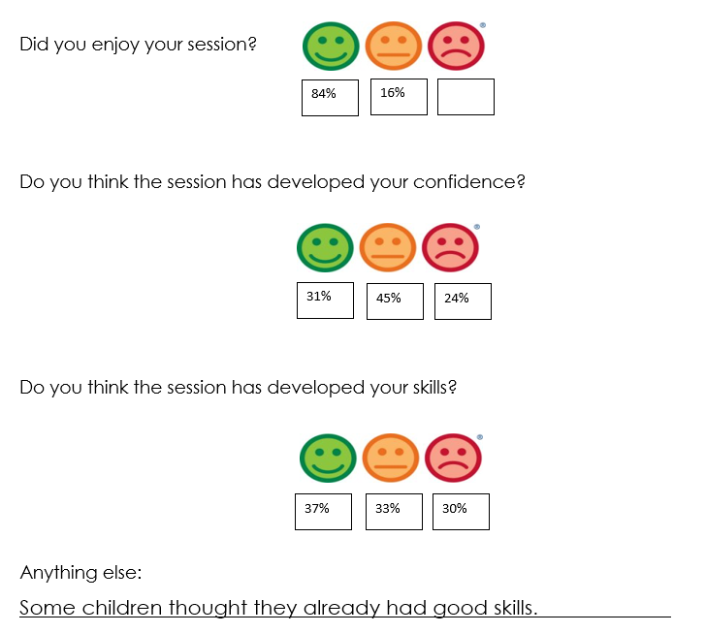 | Skills that pupils will be able to use once they have left Russell and develop further should they wish.  To continue to fund this programme through main school budget if required.
Year 2 pupils to be aware of basic safety factors when scooting. | Scootability to be offered to all Year 2 pupils |  | 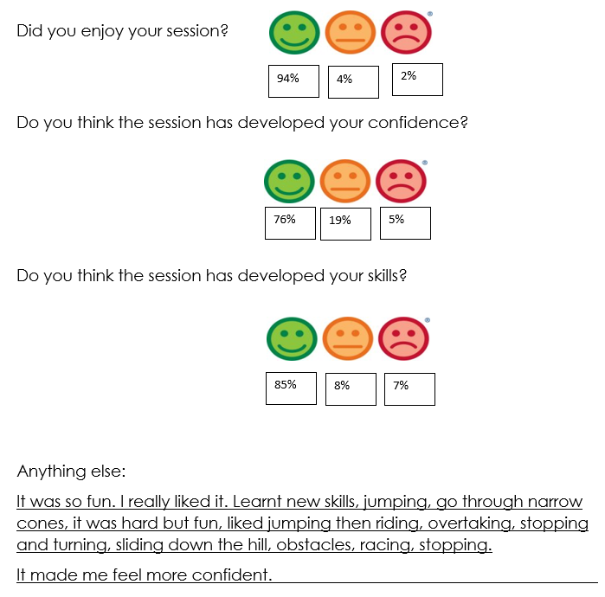 | Skills that pupils will be able to use once they have left Russell and develop further should they wish.  To continue to fund this programme through main school budget if required.
Understanding around health and wellbeing (including diet) to be raised across the school as a tool for whole school improvement. | To purchase a vegetable bed/planter for each class so they are able to grown simple vegetables such as potatoes, carrots and onions. They will then be able to use this produce in healthy eating lessons with a link to physical health.  To arrange for a gardener to come in and speak to the pupils about growing their own food. |  | Pupils to understand how diet can influence healthy lifestyles.  Pupils to gain enjoyment and success from growing their own produce.  Pupils to be more aware of where their food comes from and the health benefits of freshly grown food.  This has been delayed until 2021-2022. Seeds and planter will be purchased for Spring/Summer terms.  Via the PTA children have been involved in growing tomato plants as part of our sustainability day. Each child was also given some sunflower seeds to grow at home. | Investment made in vegetable beds/planters that will provide pupils with the opportunity to use this equipment for a number of years before needing to be replaced.  Pupils also have a good understanding of health and well-being.
WIDER IMPACT AS A RESULT OF ABOVE
PE, sport and physical activity is a high priority across the school. This will be further developed next year to support whole school development through links to mental health and wellbeing and physical activity.
Indicator 3: Increased confidence, knowledge and skills of all staff in teaching Physical Education and sport |  |  |  | Percentage of total allocation: 19%
 |  |  |  | %
Intent | Implementation | Actual Cost | Impact | Sustainability and suggested next steps
For staff confidence, knowledge and skills to increase/develop in teaching Physical Education and Sport. | Join the Redborne School Sport Partnership (SSP). This provides support for local schools including professional development for teachers and entry into all local school festival and transition events.  Access to YST membership level 2  Access to online resources, topical updates, exclusive offers, discounts and priority access to YST National PE & School Sport Awards & National Programmes – used for resources and staff training  Nationally recognised badge of excellence for PE and school sport. | Part of £1,750 RSSP package | Current staff/PE lead to increase skillset and confidence in order to provide high quality sessions that pupils engage well with.  Staff have not attended any training offered by RSSP this year due to covid restrictions.  The PE lead has attended a range of training (see below) which has then been deiminated with staff as appropriate. | Improved capabilities within the school that will benefit pupils in years to come.  As a school, we will continue to be a member of RSSP and be involved in all that they have to offer.  Consider the impact of this and whether we need Level 2 if it needs paying for moving forward.
To further develop the skillset/confidence of the PE lead. | PE co-ordinator to attend the PE conference in March 2021. | Part of £1,750 RSSP package | For the PE lead to feel confident in their role and be able to support and guide others in improving PE and physical activity across the school.  PE lead has virtually attended the following:  - Inclusive PE Jan 21  - The role of PE in the recovery curriculum Feb 21  - PE package to support effective use of funding and sustainability Feb 21  - PE conference 26.5.21 – then followed up by several workshops  - 10.6.21 Stormbreakers – a step to better mental and physical health.  PE lead was involved in LA deep dive on 11.5.21 (virtual) and 7.7.21 (in school).  It was noted: ‘She speaks confidently and knowledgeably about the subject and has a clear picture of where PE fits into the whole curriculum and its contribution to the breadth and balance of the whole curriculum.’  The PE led has some clear next steps for PE, sport and physical activity across the school including community links and parental involvement. | Improved capabilities within the school that will benefit pupils in years to come.
To further increase confidence, knowledge and skills of staff in teaching Physical Education and Sport | To purchase the PE Hub in order to support the planning, delivery and assessment of PE across the school. | £444 | Staff feel confident in delivering/assessing sessions and have the resources available to do this to a high standard.  100% of staff use PE hub consistently for PE planning.  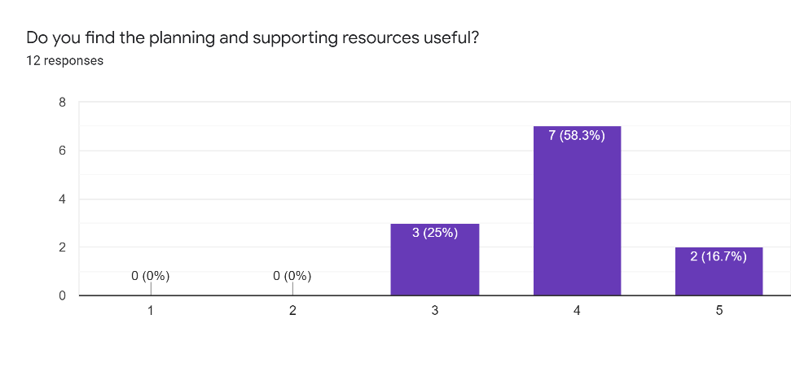  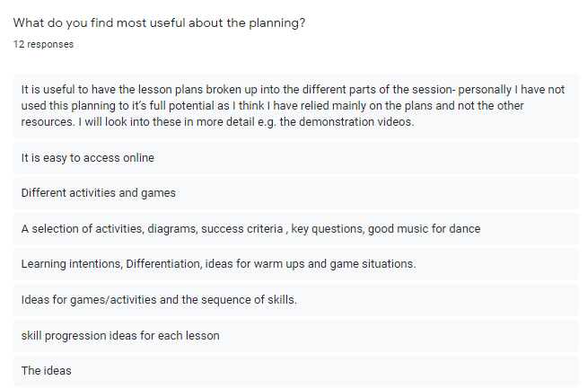  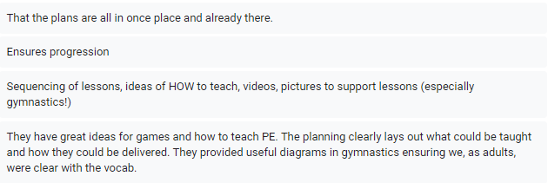  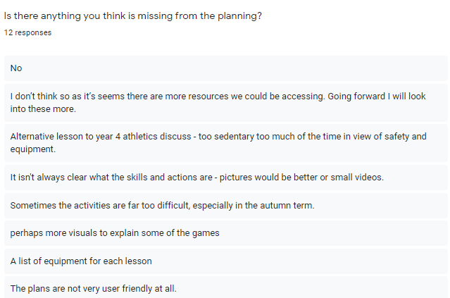  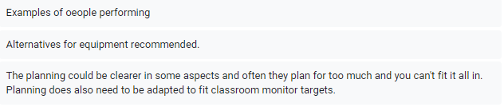  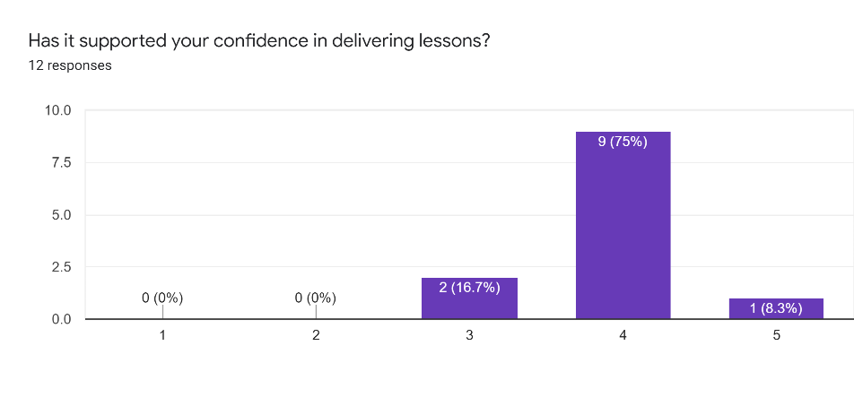  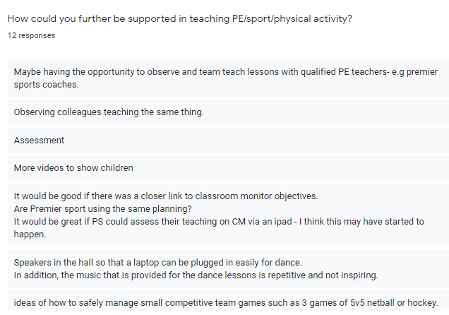  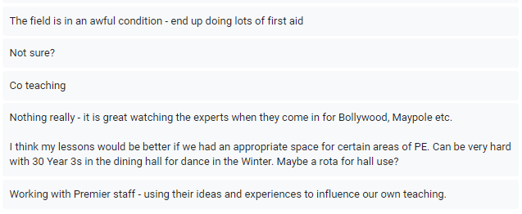 | Planning tool has now been in place for a few years to support teachers in planning and delivering effective PE lessons.  Good practice is shared amongst staff, co-ordinated and monitored by the PE Lead.
Staff to gain experience in teaching a new physical activity – maypole dancing. | Maypole dancing workshop. Highly skilled coaches to teach one PE lesson alongside staff and then offer lunchtime/twilight CPD to share new techniques and planning strategies. | Part of £1597 | Staff to have updated teaching and learning techniques to use when teaching specific physical activity. Staff to be confident in their own ability.  100% had never taught maypole dancing  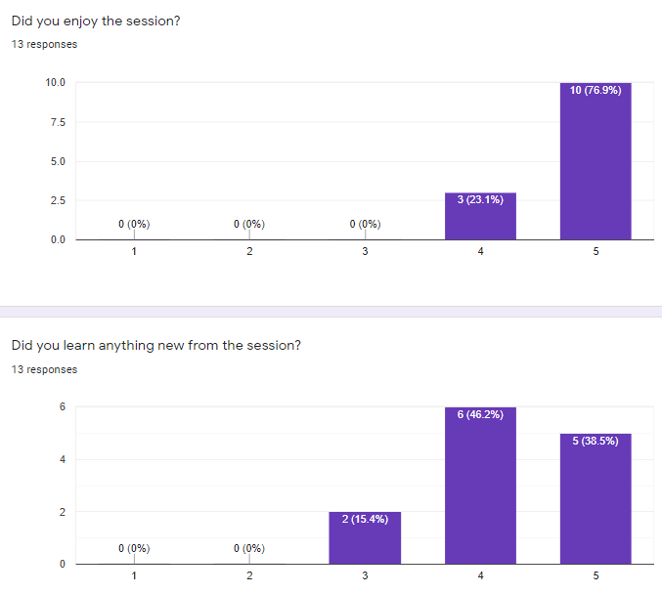  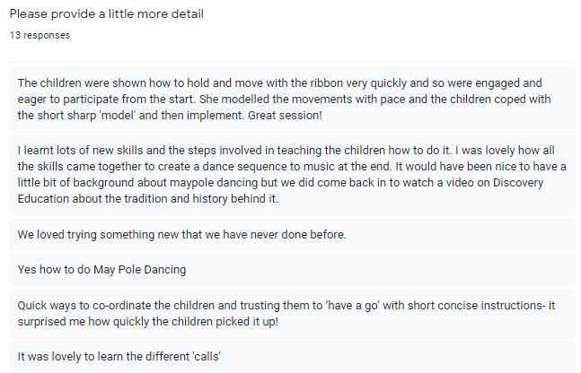  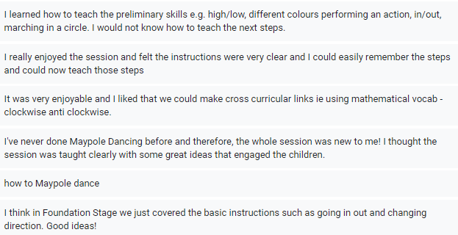  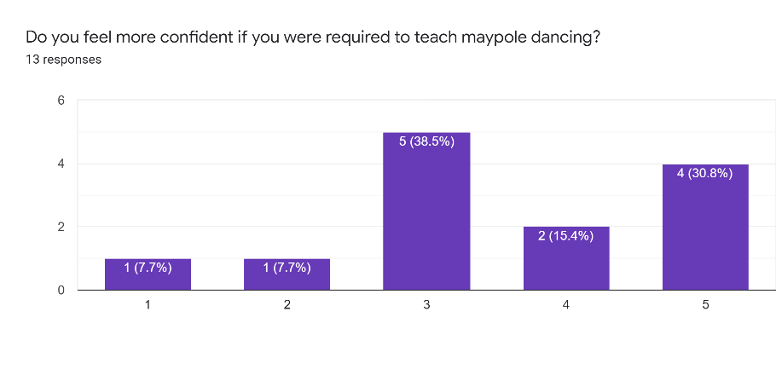  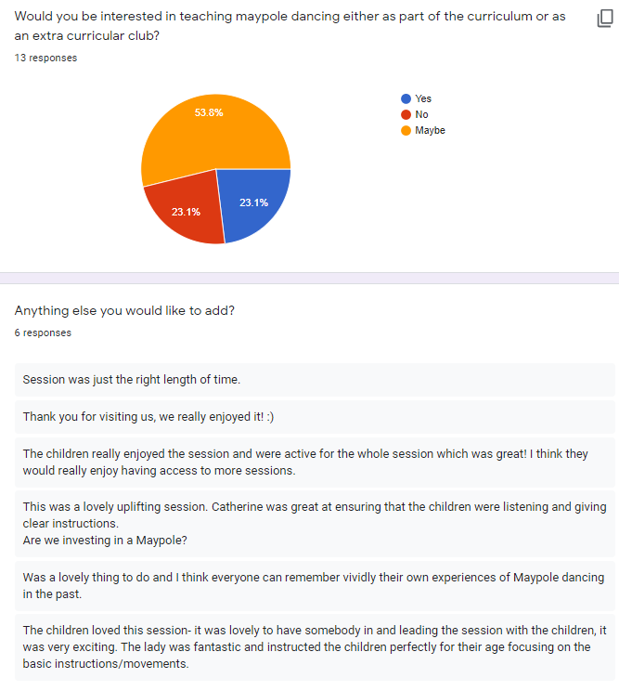 | Maypole sessions are able to be delivered in-house as a result of staff working alongside qualified coaches.
Staff to gain experience in teaching a new physical activity – Bollywood dancing. | Bollywood dancing workshop. Highly skilled coaches to teach one PE lesson alongside staff and then offer lunchtime/twilight CPD to share new techniques and planning strategies. | Part of £1597 | Staff to have updated teaching and learning techniques to use when teaching specific physical activity. Staff to be confident in their own ability.  89% had never taught Bollywood dancing.  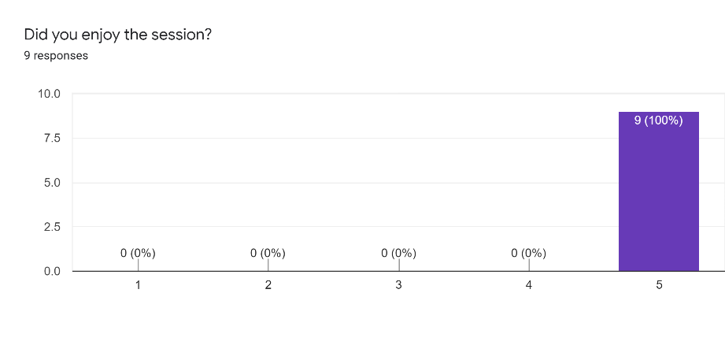  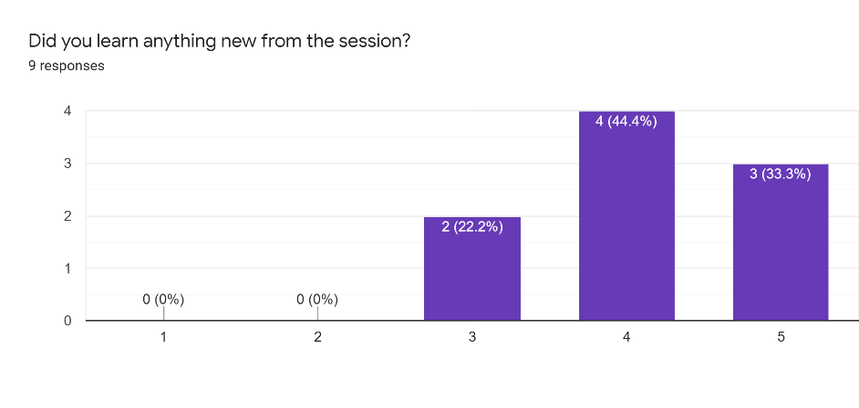  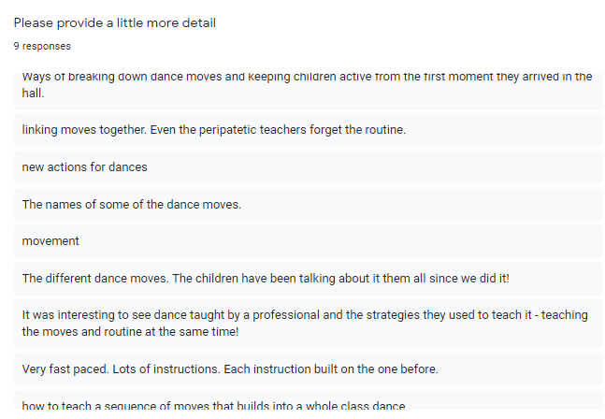  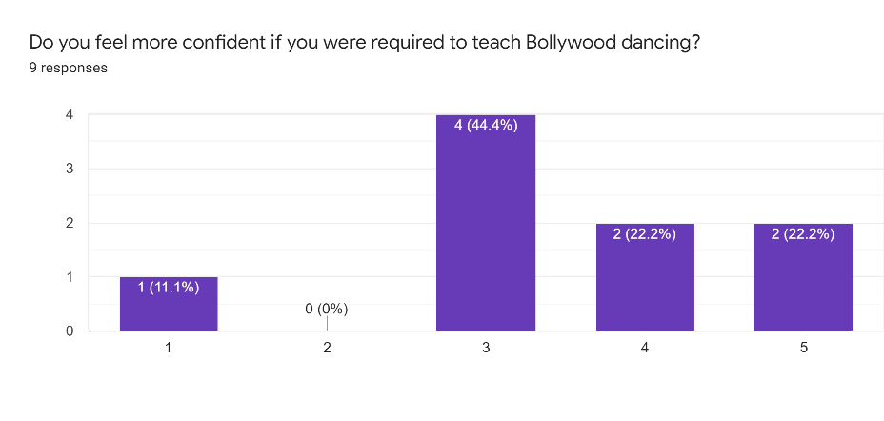  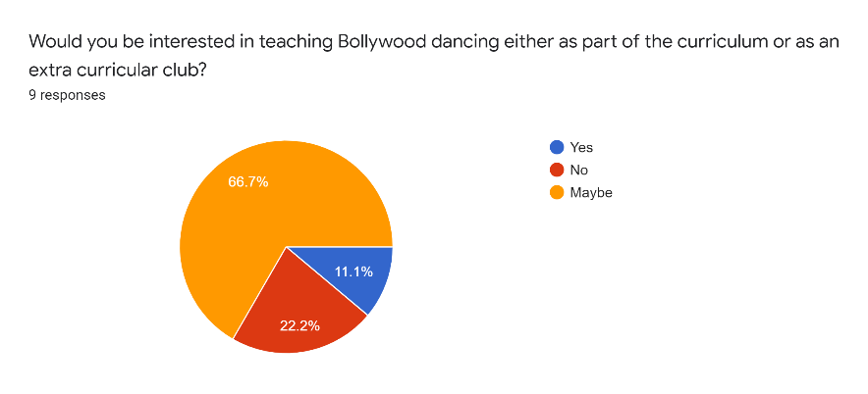  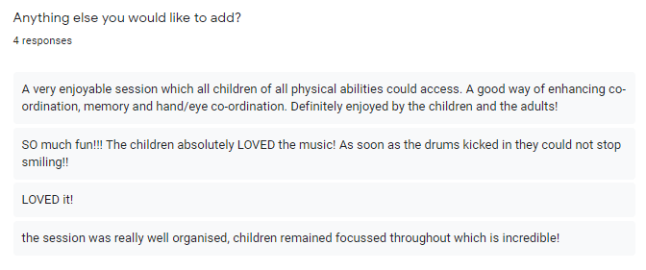 | Bollywood dance sessions are able to be delivered in-house as a result of staff working alongside qualified coaches.
WIDER IMPACT AS A RESULT OF ABOVE
Staff clearly enjoyed the dance sessions and learnt new skills/strategies from both sessions which could be applied to other areas of the curriculum.
Indicator 4: Broader experience of a range of sports and activities offered to all pupils |  |  |  | Percentage of total allocation:
 |  |  |  | %
Intent | Implementation | Actual Cost | Impact | Sustainability and suggested next steps
For pupils to be able to experience a broader range of sports/physical activity. | Through RSSP, pupils to attend local school festival and transition events where there are a range of sport/physical activities for pupils to take part in including SEND/inclusion events. | Part of £1,750 RSSP package | For pupils to have fun and feel part of a team.  Pupils to experience ‘new’ sports/physical activity in order to enthuse and motivate including our SEND and vulnerable pupils.  Pupils to be inspired to try a new sport.  Due to COVID19 festivals have all happened virtually this year. This has meant that all children have been involved in at least one festival and have been awarded a certificate for their participation. | As a school we will continue to be a member of RSSP and be involved in all that they have to offer.
For pupils to be able to experience a broader range of sports/physical activity. | To fund a series of extra-curricular clubs exposing pupils to a wider variety of sports/physical activity such as archery, bocce, fencing etc. | Part of the £3,480 for Summer term | For pupils to have fun.  Pupils to experience ‘new’ sports/physical activity in order to enthuse and motivate.  Pupils to be inspired to try a new sport.  Although we focused initially on the identified least active children we decided to fund all clubs for all children during Summer 1 due to the Lockdown period and general decreased activity. This considerably helped to increase the uptake that was initially very low. | In partnerships with Premier Sport to continue to offer a broad range of sports both curricular and extra-curricular.
For pupils to experience new physical activity – maypole dancing | Maypole dancing workshop. Highly skilled coaches to teach one PE lesson alongside staff.  British values focus on PE. | Part of £1597 | For pupils to have fun.  Pupils to experience a new ‘traditional’ physical activity, develop new skills, and possibly seek pursuing this outside of school hours.  To add to pupil’s cultural capital via PE.  93% of the school said they had not done maypole dancing before  91% enjoyed all/most of the session  80% felt they learnt something new such as:  - Crouching down and moving in  - How to work and dance in teams  - Staying in rhythm.  - How to walk in an accurate circle  - Making a pattern out of ribbon around the pole  - Maypole dancing terms  - Steps in and steps out  - Skipping around,  - Letting go of the ribbons  - How to listen/follow instructions  99% said they we active within the session  79% said they would be interested in doing maypole dancing outside of school or as a club  Other comments:  - It was fun  - We would love to have our own maypole and teach it as a unit  - The teachers and LSAs loved it  - I loved it  - A great new thing to do that I haven’t done before  - The colours weaving around were fascinating  - It made me happy doing it  - I was really tiring holding my arm up  - I really enjoyed it  - It was really fun using the ribbon.  - Loved dancing to the music  Parent comment: I just wanted to say thank you for organising both the Maypole and Bollywood dancing sessions. A has loved them both and come home to teach us all everything she has learnt too. | Pupils enjoy and are enthusiastic about sport, creating a positive sporting culture within school.  Pupils may be inspired to pursue outside of school.
For pupils to experience new physical activity – Bollywood dancing | Bollywood dancing workshop. Highly skilled coaches to teach one PE lesson alongside staff.  Booked to coincide with Diwali and Hinduism workshops to add to pupils’ cultural capital. | Part of £1597 | For pupils to have fun.  Pupils to experience a new multicultural physical activity, develop new skills, and possibly seek pursuing this outside of school hours.  To add to pupils’ cultural capital via PE.  94% of the school said they had not done Bollywood dancing before  88% enjoyed all/most of the session  85% felt they learnt something new such as:  - How to do lion, snail and turtle symbols.  - Bollywood dance moves (upside down DJ, lightbulb etc)  - How to move with a beat  - How to hold your hands different ways and head movements  - The lion and the lightbulb  - Hand moves and names, feet moves  - Country that it originated  - Jelly wobble action  - New style of moves, eight-step move  99% said they we active within the session  62% said they would be interested in doing maypole dancing outside of school or as a club  Other comments:  - We would like to do it again  - We really enjoyed it  - We loved dancing to the music  - I went home and did it in the shower  - Positive parent comment on Tapestry  - Loved the music  Parent comment:  I wasn't quite sure who to send this to but, big thank you for organising this weeks Bollywood dancing, T absolutely loved it, and we've since had kitchen discos where we've applied the upside down dj and lightbulb move and had the best of fun! | Pupils enjoy and are enthusiastic about sport, creating a positive sporting culture within school.  Pupils may be inspired to pursue outside of school.
For pupils to experience new physical activity – ice skating | Ice rink hire to enable all pupils the chance to ice-skate. |  | For pupils to have fun.  Pupils to experience a new physical activity, develop new skills, and possibly seek pursuing this outside of school hours.  To add to pupils’ cultural capital via PE.  Rescheduled from Spring 1 to January 2022 due to covid already booked | Pupils enjoy and are enthusiastic about sport, creating a positive sporting culture within school.  Pupils may be inspired to pursue outside of school
WIDER IMPACT AS A RESULT OF ABOVE
Children have experienced some new physical activities and enjoyed the sessions. This may encourage them to pursue new activities outside of school and also try activities in school they might otherwise have not.
Indicator 5: Increased participation in competitive sport |  |  |  | Percentage of total allocation:
 |  |  |  | %
Intent | Implementation | Actual Cost | Impact | Sustainability and suggested next steps
All pupils in year 4 to attend a transition event and 1 additional event  All pupils in year 3 to attend at least one event  All pupils in year 2 to attend at least one event. | Join the Redborne School Sport Partnership (SSP). This provides support for local schools including professional development for teachers and entry into all local school festival and transition events.  Pupils are given the opportunity to attend a range of festivals and transition events  To enter all sports competitions through Redborne School partnership with both A and B teams | Part of £1,750 RSSP package | Pupils experience interschool sports festivals and therefore will be more confident to put themselves forward for these in the future.  Autumn 2020: Only virtual competitions have been offered though School Games due to COVID 19. All bubbles complete the event and the best 4-6 children were then selected for the virtual event.  Year 1 - rugby  Year 2 - tennis  Year 3 - dodgeball  Year 4 - table tennis  Cross country intra and inter competition - All children took part in class bubbles and fastest girl and boy from each year entered into virtual school games  Year 1 boy = 3m 58s, girl = 4m 44s  Year 2 boy = 1m 50s, girl = 2m 02s  Year 3 boy = 4:31, girl = 5:04  Year 4 boy = 3:43, girl = 4:02  We were the winners of this event and received a set of medals for our fastest children.  Spring 2021:  KS2 cricket festival  Summer 2021:  Year 2 intra school festival supported by RSSP | Pupils enjoy and are enthusiastic about sport, creating a positive sporting culture within school.  Pupils may be inspired to pursue outside of school.  Children experience interschool sports festivals and therefore will be more confident to put themselves forward for these in the future.  To allocate funding to be part of RSSP (bespoke package tailored to our needs) if needed in the future.
WIDER IMPACT AS A RESULT OF ABOVE
Children have still managed to partake in festivals over the course of the year resulting in them being able to represent their school and feel a sense of pride and achievement.

Financial Year | Budget | Actual Spend | Key Impact for each year
2019 - 2020 | £ 23,590 | £ 23,194 | COVID 19 year  - We could see the impact of the year 3 additional swimming from the previous as Year 4 children had much better competitive swimming results at the inter-school competition with Team 2 coming first.
2020 - 2021 | £19,460 | £19,350.04 | Another COVID 19 year  - Increased engagement of pupils in regular physical activity

Summary of key achievements for 2020-2021 | Summary of key plans for 2021-2022
Another COVID year but much of the sports premium was still achieved.  - We were able to get 41% of the identified least active children to attend a club. We also had 33% of PP children (years 1 -4) attended in summer 1 and 41% of PP children (years 1-4) attended a club (some of these are the same as summer 1) in summer 2.  - The PE lead was able to attend a range of training to further develop confident in their role and be able to support and guide others in improving PE and physical activity across the school. PE lead was involved in LA deep dive on 11.5.21 (virtual) and 7.7.21 (in school). The PE led has some clear next steps for PE, sport and physical activity across the school including community links and parental involvement.  - The school was still able to attend a range of festivals virtually and ensured that every child took part in at least one event.  - Introduction of activity tracker across the school has helped to evidence all the opportunities for children to increase their physical activity which has been support by home and the PTA.  - Children clearly enjoyed the enrichment opportunities of maypole and Bollywood dance. | - To broaden community links and achieve the platinum sports award.  - To continue to offer cultural capital and enrichment opportunities linked to physical education, sport and physical activity whilst developing teaching knowledge and understanding and confidence.  - To continue to target the least active and vulnerable groups.  - To support staff in providing more cross curricular links which involve the outdoors and physical activity.  - To support staff in continuing to develop the PE curriculum focussing on physical activity, mental health and wellbeing.

Signed off by |  | Date
PE Lead

Headteacher

Governor

