SWIFTS, SWANS & DOVES - SPRING 2021 - 1st half term
FROZEN WORLD - PENGUINS

Personal Social and Emotional Development  - Value – Courage  - ‘Going for Goals!’ activities identifying individual strengths and goals.  - Feelings relating to penguin stories – shy, lonely, confused, home sick.  - How are we different from one another?  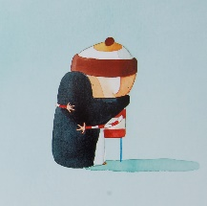  - Stories illustrating perseverance, e.g. The Tortoise and the Hare, Gordon and Edward (Thomas the Tank Engine), Story about Samindra. |  | Communication and Language  - Listening attentively.  - Express themselves effectively.  - Show an awareness of listeners needs when sharing Learning Logs and Show and Tell items.  - Discuss content for speech bubbles.  - Role-play activities – Antarctic explorer.  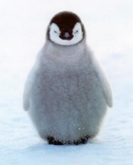  - Use language in role-play situations e.g. Book Shop/Publisher, Ice Palace and Research Centre |  | Physical Development  - P.E. Gymnastics – develop confidence in fundamental movements e.g. jumping, sliding, rolling, moving over and under apparatus.  - P.E. Dance – perform recognised actions to music. Copy, repeat and perform basic actions to music.  - Create a 3D penguin.
Literacy  - Listen to stories e.g. Lost and Found.  - Sequence stories.  - Non- fiction books.  - Write labels, lists, factual sentences and speech bubbles about penguins.  - Read and spell high frequency words.  - Segment sounds in simple words and blend them together.  - Sound and name the letters of the alphabet.  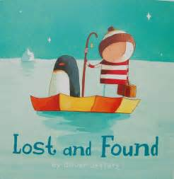 | Mathematics  - Introduce zero  - Represent and compare numbers 0 to 5 - more than, the same as and fewer.  - The composition of 4 and 5; subitise small quantities - numbers can be composed of 2 or more parts.  - Mass - make direct comparisons – heavy, heavier than, heaviest, light, lighter than, lightest.  - Capacity – use different sized containers (tall, thin, narrow, wide and shallow) to investigate empty, half full, nearly full and full.  - Represent numbers 6, 7 and 8.  - Understand that a pair is 2.  - Combine 2 groups – how many altogether?  - Length - longer, shorter; height – taller, shorter and breadth – wider, narrow.  - Time – sequence events and describe when events happen. |  | Understanding the World  - Ice investigations.  - Floating and sinking.  - How human activity influences the environment and living things.  - Life cycle of a penguin.  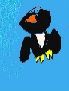  - Use iPad and log on to a computer to create pictures (fill tool).  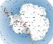  - Find out facts about Antarctica and penguins.  - Find UK, Antarctica and other destinations on a map. |  | Expressive Art and Design  - Hot and cold colour mixing/collage/printing.  - Antarctic Landscapes.  - Penguin artwork/ 3D work.  - Wax resist.  - Icing sugar painting.  - Create a 3D penguin.  - Music - Everyone

