Wednesday 13th May 2020
SPaG
Spellings – Suffix - ous
Write each word in your spelling list using 2 different colours. Write the consonants in one colour and the vowels in another colour.

joyous
dangerous
hazardous
poisonous
riotous
mountainous
momentous
scandalous

Word of the Day – recognise

Definition ____________________________________________
_____________________________________________________
_____________________________________________________
Used it in a sentence: ____________________________________________________
_________________________________________________________________________
Word Class: ____________________________________________________
Synonyms

English
To begin with read the traditional fairy story you wrote yesterday. Most books would have a blurb on the back cover. The blurb gives the reader an idea of what the book is about. Most of all, it should encourage people to want to read it. It’s a short piece of writing that summarises the story without giving away any story spoilers.
Use the space below or on your own piece of paper to write a blurb for your story. You can then decorate it with pictures from the book to try to give some clues about the story.
Maths – Mental
Two numbers in each sequence are out of place. Circle the 2 numbers and write the correct sequence.

1. 975 985 995 965 955 945 935

2. 80 180 280 380 680 580 480

3. 853 855 857 851 849 847 845

Maths – Main Lesson – Rounding Decimals
Watch this video on rounding decimals as money.
https://www.bbc.co.uk/bitesize/topics/zh8dmp3/articles/zsvt97h
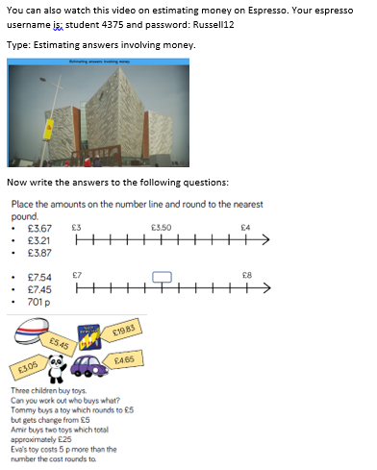
History
Use your research from yesterday to design your own Egyptian God or goddess.
Name: ____________________________
What they look like:

What is unique about my god:
_________________________________________________________________________________________________________________________________________________________________________________________________________________________________

Why are Gods important to ordinary Egyptian people?
____________________________________________________________________________________________________________________________________________________________________________________________________________________________________________________________________________________________________________

