Tuesday 30th June 2020
English
SPaG
Spellings – Words with the sh sound spelt ch
Write each word in your spelling list backwards.

chef
chute
chalet
machine
brochure
parachute
ricochet
moustache

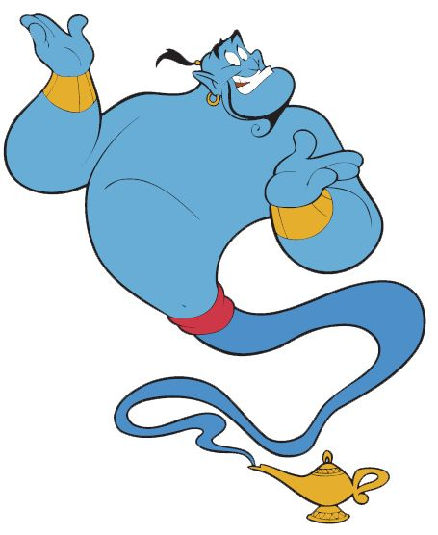
Word of the Day – manufacture

Definition ____________________________________________
_____________________________________________________
_____________________________________________________
Used it in a sentence: ____________________________________________________
_________________________________________________________________________
Word Class: ____________________________________________________
Synonyms

English
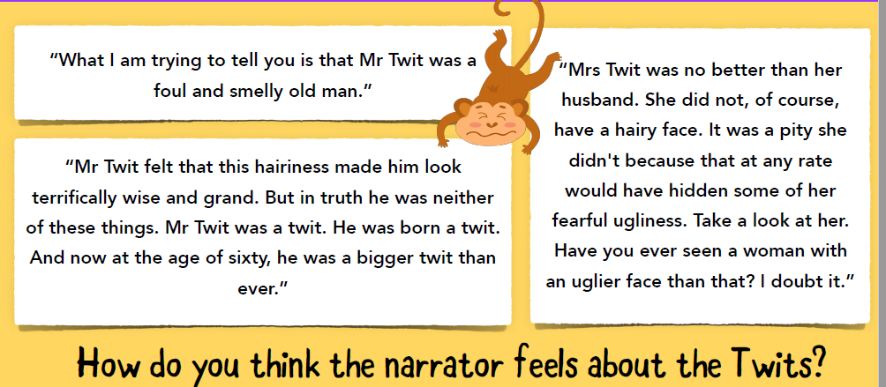
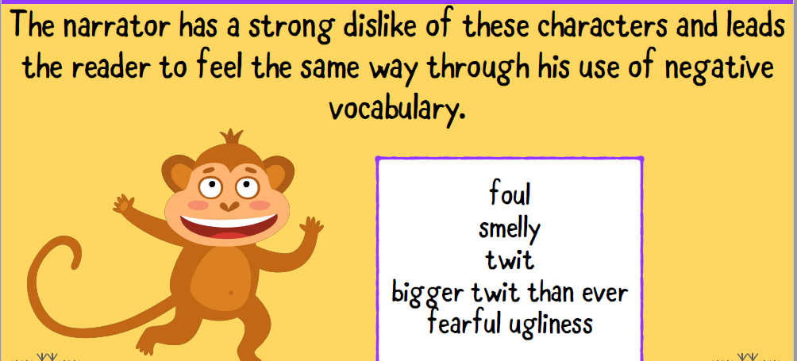
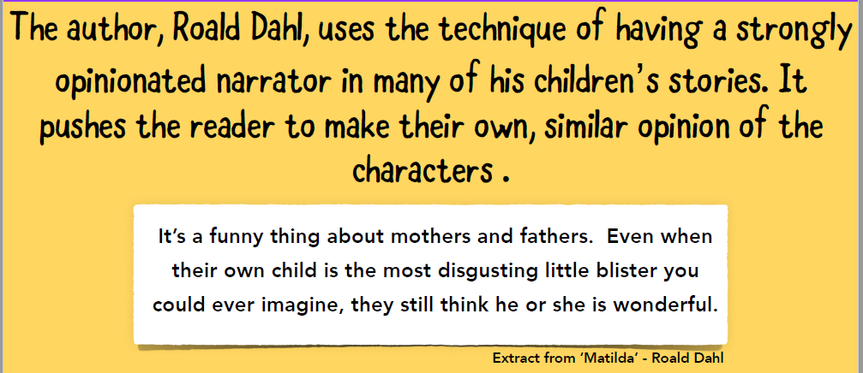
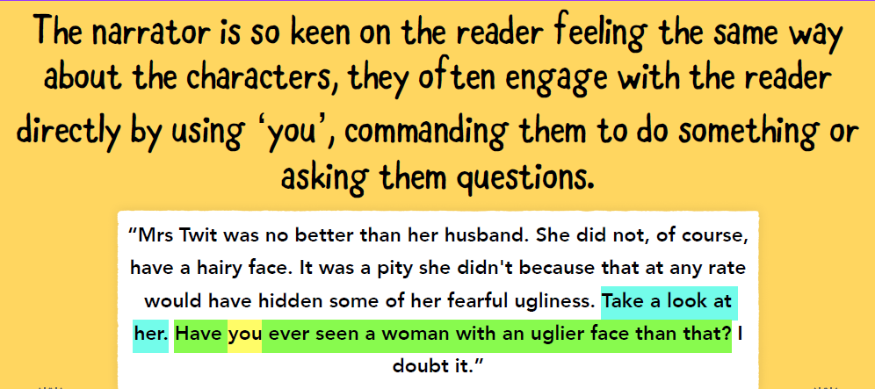
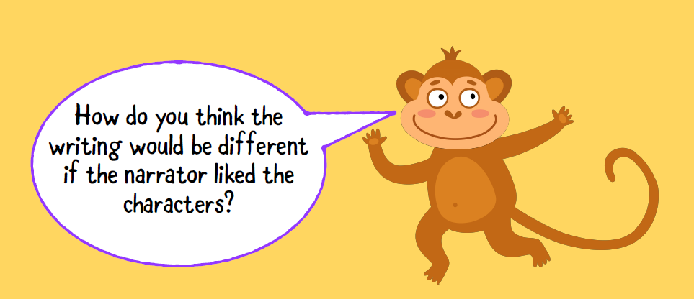
Task
Write a positive sentence for each feature around the picture of Mr and Mrs Twit. You need to choose the words carefully to make the sentences sound more positive. There is a word bank on the sheet to
help you.
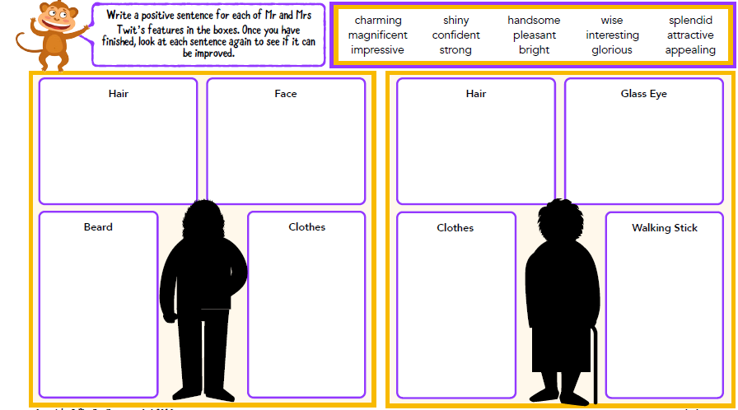
Maths
- Write 3 tenths as a decimal.
- Write 16 hundredths as a decimal.
- What is the product of 4 and 7?
You will have to learn these types of triangle.
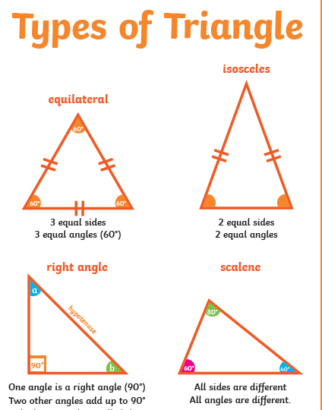
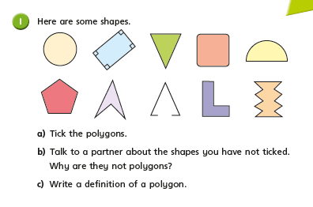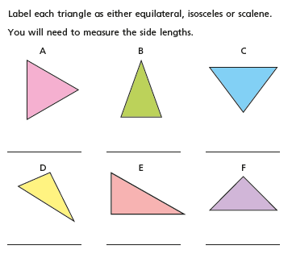
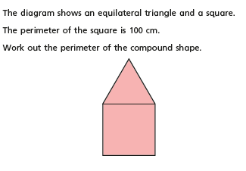

History
Think- What do you know about the ancient Egyptian ceremony of ‘the weighing of the heart’? Watch this video carefully, you might find it useful to record important information in bullet points as you listen. https://www.youtube.com/watch?v=1yv_MXNYbAo
Then answer the questions below.

