Wednesday 10th June 2020
SPaG
Spellings – Words with a zhuh ending spelt sure
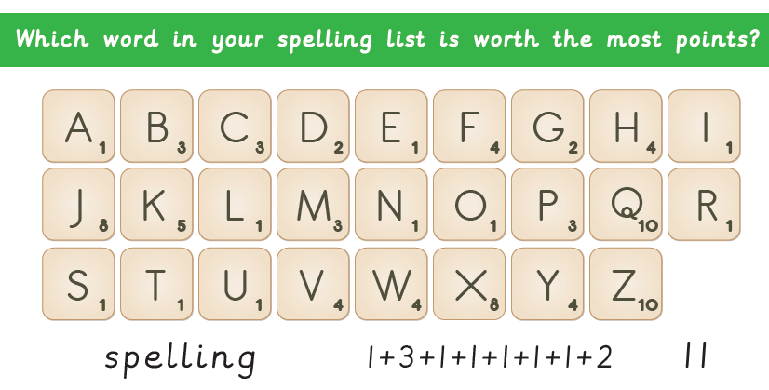
unsure
leisure
measure
closure
treasure
pleasure
composure
enclosure

Word of the Day – inspire

Definition ____________________________________________
_____________________________________________________
_____________________________________________________
Used it in a sentence: ____________________________________________________
_________________________________________________________________________
Word Class: ____________________________________________________
Synonyms

English
Let’s find out about the mummification process by watching the video below.
https://www.youtube.com/watch?time_continue=5&v=D1ToNThT0DY&feature=emb_logo
Put all the pictures in the order they happen. Display the pictures neatly on a piece of paper. Write step by step instructions - make sure you have a title and numbered instructions.
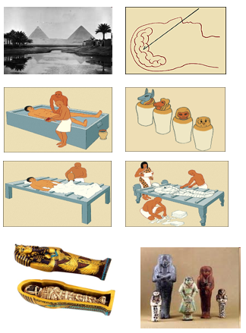

Maths

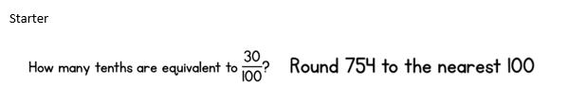
Ava buys ice-cream for £2.50 and John buys some for £3.50. What is your estimate of the total of the two ice creams, £5.00 or £6.00, why?
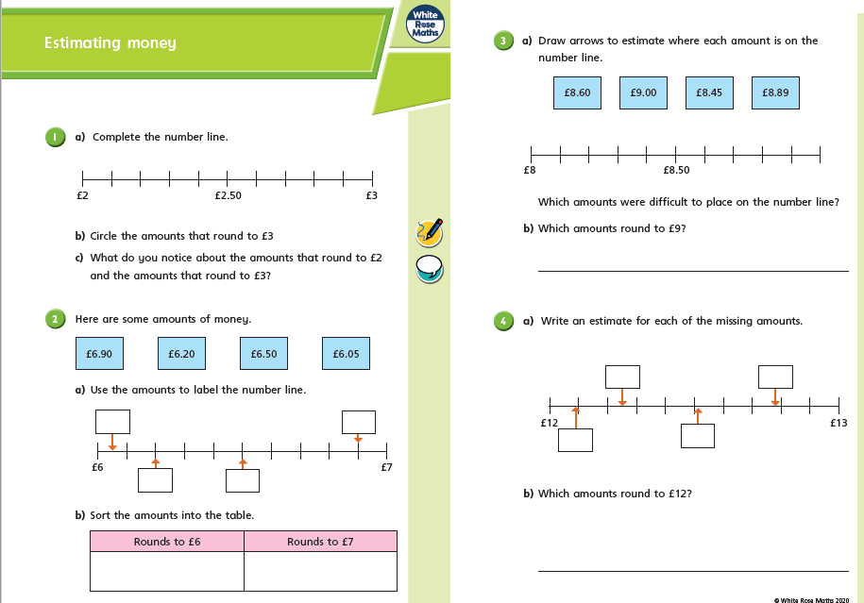

Science
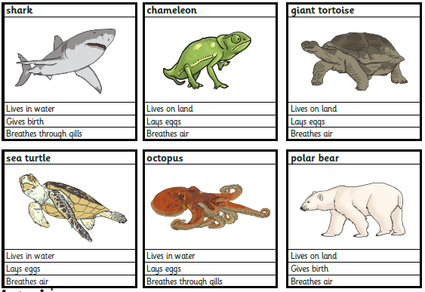
Sort the following animals into a Venn diagram and answer the questions below.
