Thursday 2nd April 2020
SPaG
Spellings – To apply the prefix super-
superhero | superfluent | superman | superstore
superpower | superstar | supernatural | supermarket

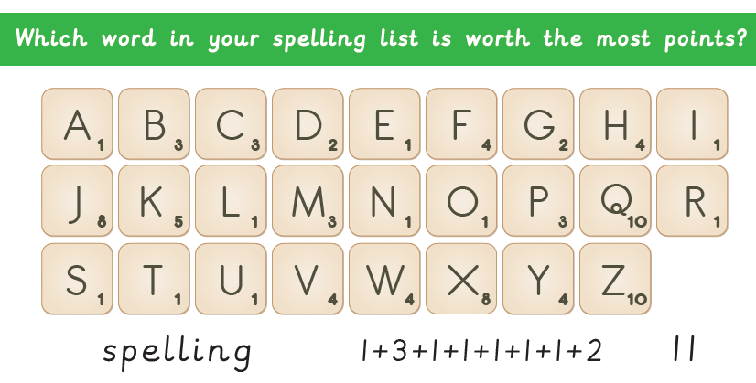
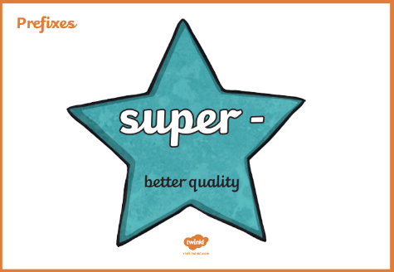
Challenge!

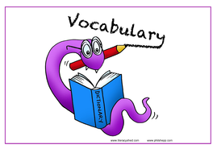
Vocabulary – Word of the Day!
aghast
Definition _______________________________________________
_________________________________________________________
_________________________________________________________
Used it in a sentence: ____________________________________
___________________________________________________________________________
Synonyms: _______________________________________________________________________

English
A haiku is a type of poem from Japan. Haiku poems have three lines and a total of 17 syllables. The first and third lines of the poem have five syllables each. The middle line has seven syllables. Usually, a haiku does not rhyme.
Remember, a syllable is a sound which makes up a word. You can clap them out.
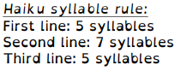
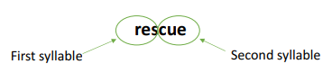

Example
A small, hungry boy (5 syllables)
A rescued fox showing thanks (7 syllables)
Desperate tribe, saved. (5 syllables)

Have a go at writing your own Haiku poem.
Maths
Four Awesome Operations
Addition (using column method)  591 + 367 | Subtraction (using column method)  726 - 419 | Multiplication (using grid method)  45 x 8 | Division (using sharing of place value counters)  88 ÷ 4
Comparing lengths
Use <, > or = to compare different objects around your house! Can you estimate what symbol you will use for each comparison? You can either measure the objects or find another way to compare/measure them – you could use string, bits of paper, pencils or even leaves!
TV |  | Sofa
Plate |  | Spoon
Table |  | Bed
Wardrobe |  | Window
Plant pot |  | Door
T-shirt |  | Coat
Come up with three comparisons of your own!
Measuring without a ruler?
Without using a ruler or tape measure, measure five objects in your home. You may choose to use leaves, cups, fingers, teddies or anything you can find!
- How accurate is your measuring?
- Why do we not usually measure things in this way?

Object 1 | Object 2 | Object 3 | Object 4 | Object 5

Science

Challenge! Rock observation. Find and draw a rock in the box below.

Describe your rock by using your own words and the words from the list.

________________________________________________________________________________________________________________________________________________________________________________________________________________________________________________________________________________________

Useful words

dull | brittle | hard | soft | sharp | smooth | heavy
jagged | square | strong | round | light | shiny | grainy
grains | rough | crystals | powdery | yellow | brown | grey
black | pink | white | blue | red | green | breakable
spotted | speckled | shimmery | crumbly | metamorphic | light | striped
rounded | flat | triangular | sedimentary | transparent | translucent | igneous

