Year 2 Phonics/Spelling Practice – Thursday 2.7.20. 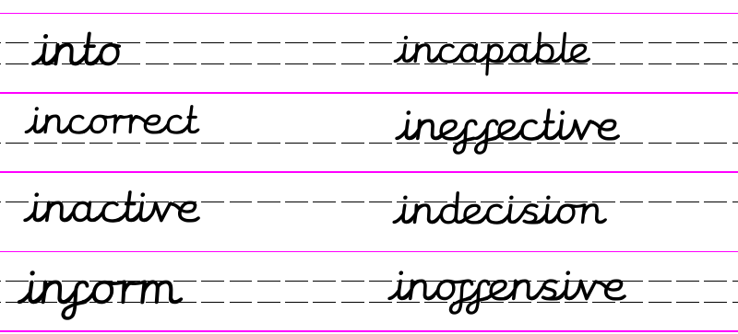

Practise: Can you add the correct prefix to each word, changing the meaning to ‘not’ or the opposite of’?
expensive _______________________________
offensive _______________________________
capable ________________________________
active __________________________________
effective ________________________________
Dictation:
Ask someone to read out the sentence to you – try to write it from memory.
It is better to be active not inactive.

Maths 2.7.20
Compare Mass
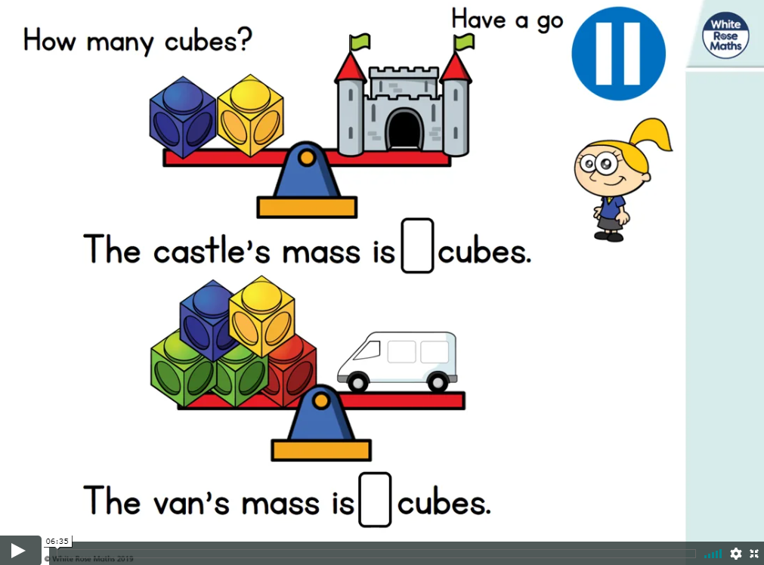
https://whiterosemaths.com/homelearning/year-2/ (week 9 w/c 22.6.20)
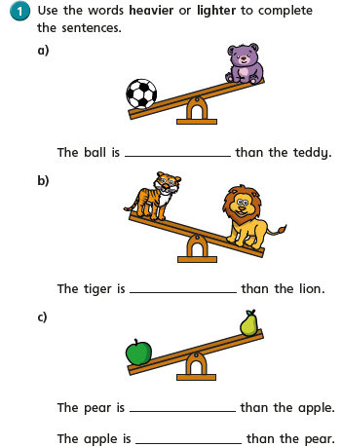
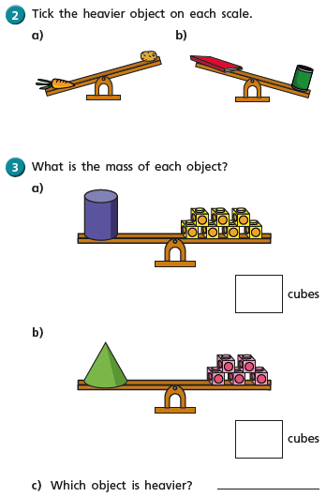
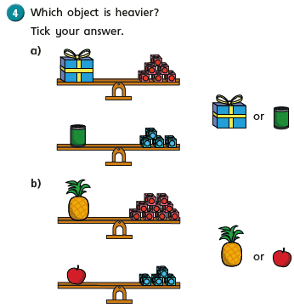
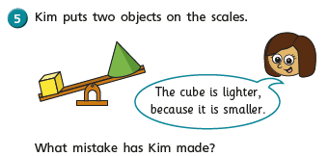
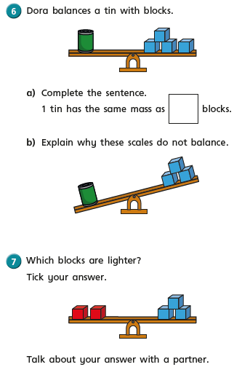

English - Thursday 2nd July 2020
Fun Fact. Cats use their whiskers to decide if they can get through small spaces!
WALT write an acrostic poem
Word of the day: Acrostic.

Today we are going to write an acrostic poem. I know that a lot of you enjoy this form of poetry. Let’s remind ourselves of what an acrostic poem is.

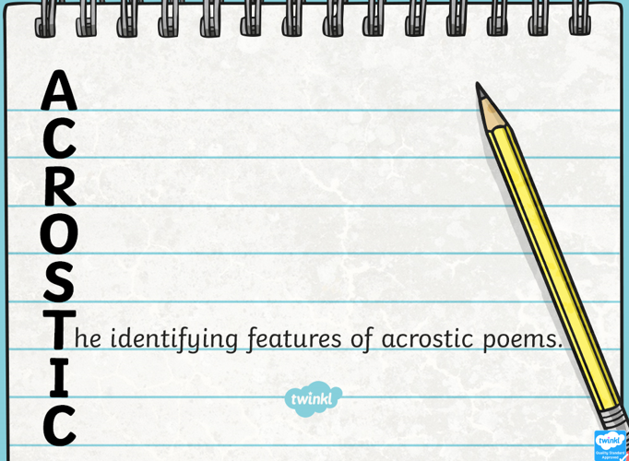

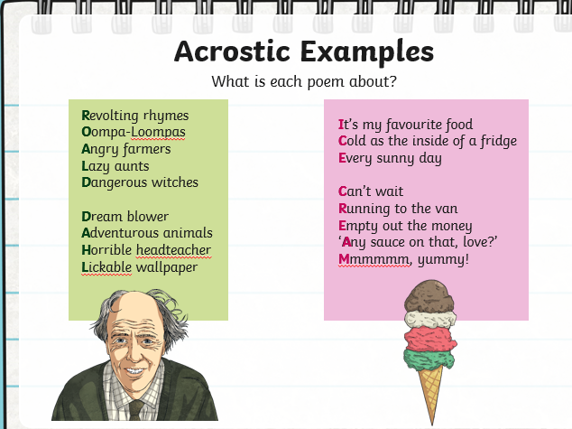
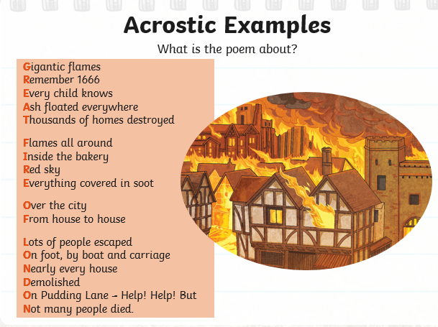
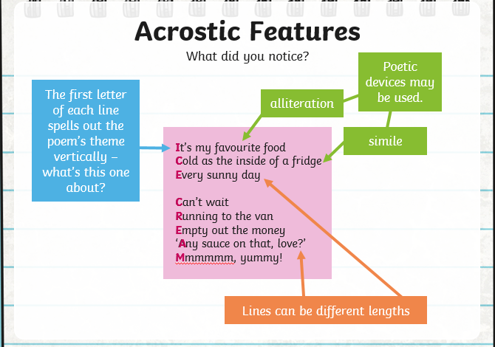
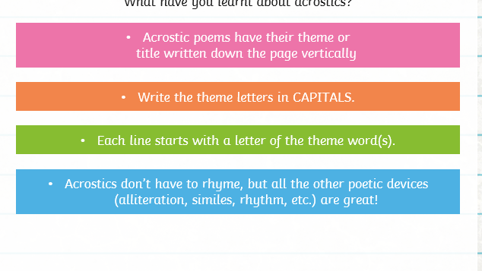
Your turn: I would like you to write an acrostic poem about Monkeys.
You should look back at your work from last week when you wrote your information text and try to find as many words as possible that would fit with the theme.
Write the word Monkey, vertically down the page.

Here are some to give you an idea.

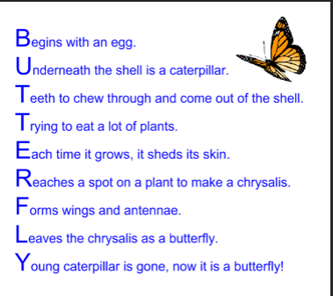
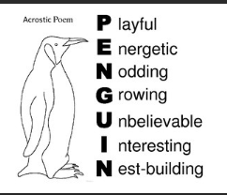

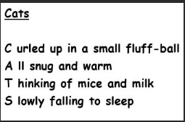

As always, I have attached a sheet you can print out if you want to, or you can just write your own and decorate it with a border?
If you are finding it too difficult, just write a few lines e.g
M ad little creatures,
O
N uts are their favourite snack
K
E xtra bouncy with long curvy tails
Y

Have fun.
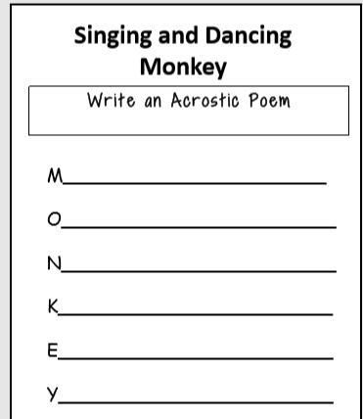

2.7.20 - Art
WALT design an advertising poster for ‘The Giraffe, The Pelly and Me’.
WALT draw in the style of Quentin Blake.

Well done, last week you designed front covers for ‘The Giraffe, The Pelly and Me’ in the style of Quentin Blake. I have seen some of them and they are brilliant.
This week we have read about how our three friends, the Giraffe, the Pelly and Monkey are starving hungry and desperate for their business to do well. Whenever anyone starts a new business it is really important to advertise their skills and what they are providing and are good at. Today I would like you to create an advert advertising the ‘Ladderless Window Cleaning Company’.

What makes an advert good!

Bright bold headings! Give your heading a logo style.
The heading should be catchy – Let’s re-read when we are first introduced to the Window Cleaning Company. There are some really catchy ideas here……………..

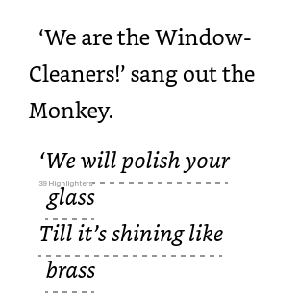
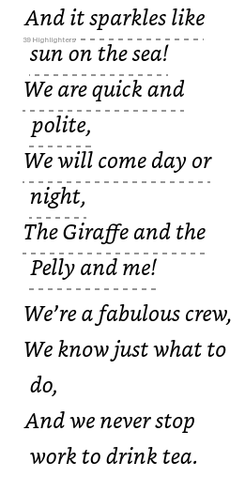
Success criteria:
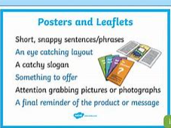
Make sure you draw a picture in the style of Quentin Blake. Watch the videos again from last week to help you.

