Friday 1st May 2020 Year 2 Phonics/Spelling Practice
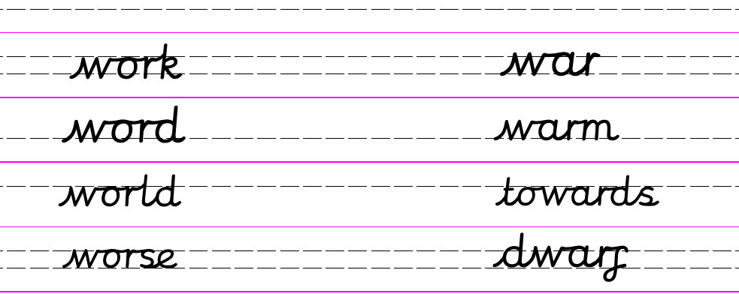
This week we have been learning two different spellings for /er/ and /or/ which come after the letter w.
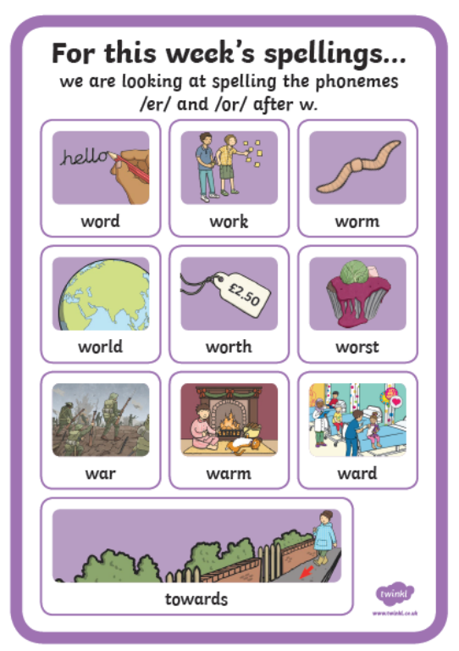
If you want or need them, more practise activities can be found on www.twinkl.co.uk (access details on Russell website)
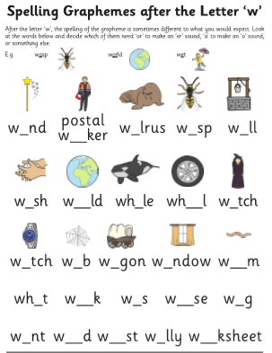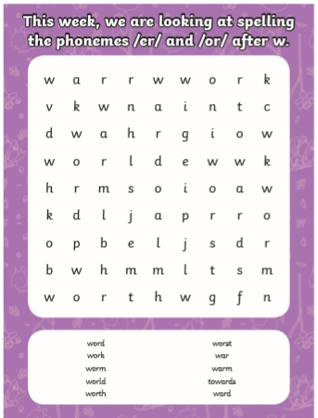

Dictation Sentence:
I will work towards stopping the world from getting too warm.
Now write your own sentence using as many of this week’s words as you can.
Maths 1.5.20
Choose a challenge or three to complete. Can anyone else in your family have a go?
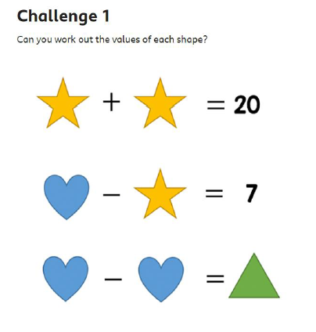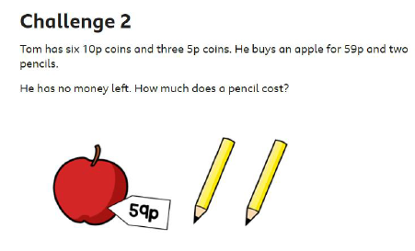
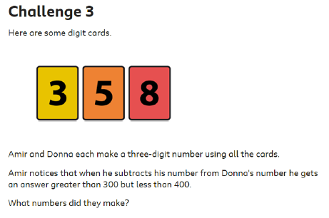
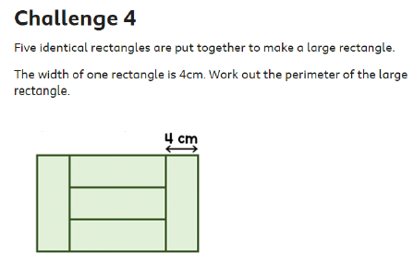
Perimeter is the distance around the
2-d shape.

1.5.20 – English
Word of the week ‘cautiously’
Walt listen carefully to a story read by a familiar author and to be able to show understanding of what we have been read.

Welcome to May children, how quickly did April go!
Today we are going to read the story of ‘A House for Hermit Crab’. This is a lovey story.
Your task after you have read this is to draw a picture of Hermit Crab and write as many adjectives as possible around your picture that describe him.
Challenge me: Can you write a short character description. Describe Hermit Crab so that your parents know a little bit more about him.

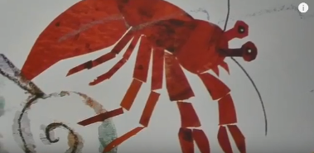

1.5.20 – Science Plants-Seeds
WALT: to understand that different seeds grow into different plants.
Can you name these different seeds?
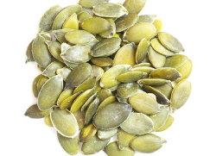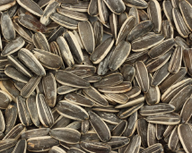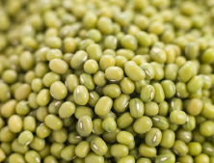

All seeds have the potential to grow into a plant.
Do you know which plants these seeds will grow into?
Different seeds need to be planted at different times of the year.
They also need to be planted in different places.
We find all of this information on the seed packet.

Look at the information that you can find out from these two seed packets.
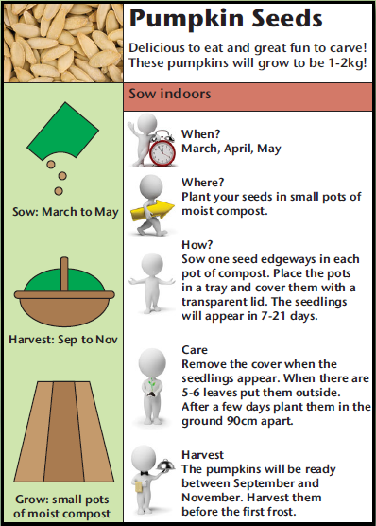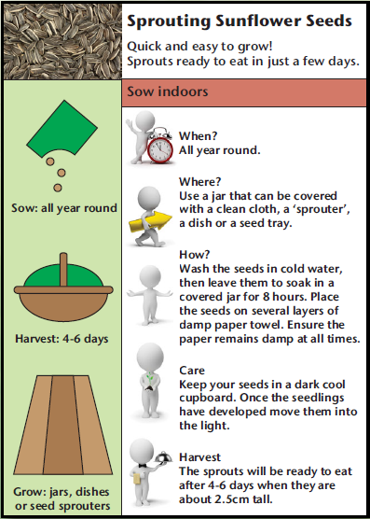
Task: Read the information about the two plants and create a seed packet for each one.
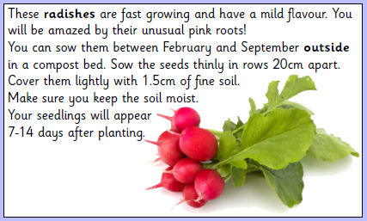
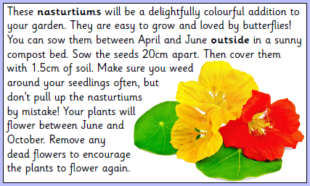
Here is an example of what information you can include on the packet:
