Wednesday 17th June 2020
SPaG
Spellings – Words with a chuh spelt ture
Write each word in your spelling list using 2 different colours. Write the consonants in one colour and the vowels in another colour.

nature
future
pasture
gesture
mixture
picture
puncture
creature

Word of the Day – instant

Definition ____________________________________________
_____________________________________________________
_____________________________________________________
Used it in a sentence: ____________________________________________________
_________________________________________________________________________
Word Class: ____________________________________________________
Synonyms

English
Today you will be planning your writing for an explanation of the
mummification process for a school blog or newsletter.
Who might want to read your writing? What might they want to see
in your writing? What will you make sure you include?
Below are some of the features you could use to make your writing more effective.

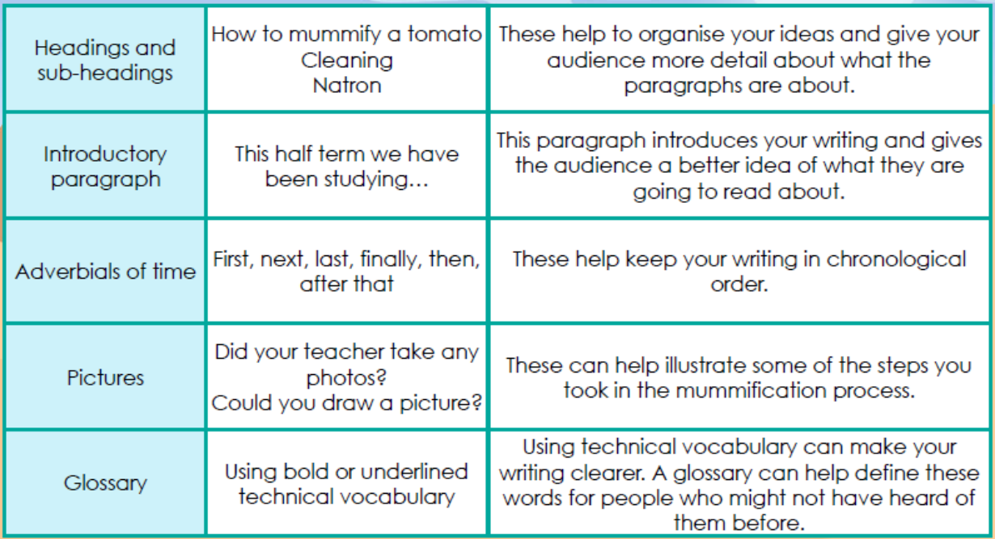

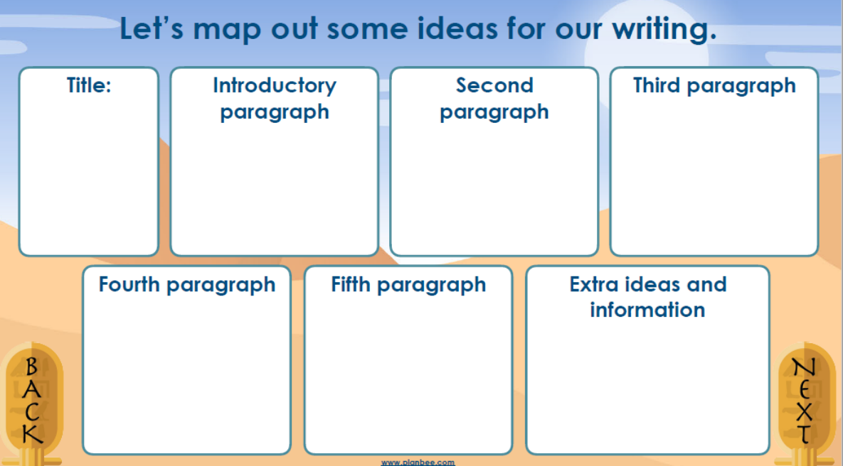
Maths Starter
- What is 1/5 of 50?
- What is 3/5 of 50?
- What is 4/5 of 50?

Maths Main Lesson
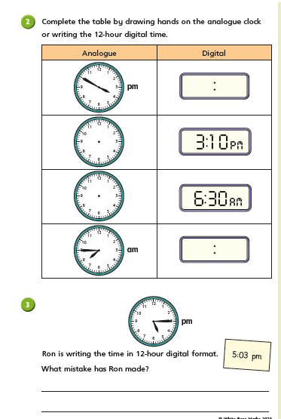

Science
Wildlife is everywhere, if you know where to look…
We may all be largely confined to our homes, but there are still lots of ways that you can help wildlife - whether it's from your window, on your street, during your daily exercise or in your garden.
TASK: Spend a few moments in your garden or looking out of a window. Try to be mindful of what you can hear, smell and see. Jot down what creatures you saw.
TIP: if you’re not sure what your creatures are called, there are some really helpful guides on BBC Springwatch: https://www.bbc.co.uk/programmes/articles/RVN7BFtLDybfxqKbQrcZBB/keep-doing-your-bit-for-wildlife
NEXT, Can you spot the 13 differences?
Finally, when you are finished you could colour the top picture in realistic colours and then one below in all your favourite colours.
