Monday 6th July 2020 – English
SPaG
Words spelt with a g sound spelt gue
league - __________________________________________________________________
tongue - __________________________________________________________________
vague - ___________________________________________________________________
plague - _________________________________________________________________
meringue - ________________________________________________________________
synagogue - ______________________________________________________________
epilogue - ______________________________________________________________
monologue - _____________________________________________________________

Look up the meaning of each of these words in a dictionary so you understand what each word means.
Word of the Day – spurt
Definition ____________________________________________
_____________________________________________________
_____________________________________________________
Used it in a sentence: ____________________________________________________
_________________________________________________________________________
Word Class: ____________________________________________________

Synonyms

English - See loom intro video first. – Link –
https://www.loom.com/share/c147174c79e34bc7b6fc0719478a2e18
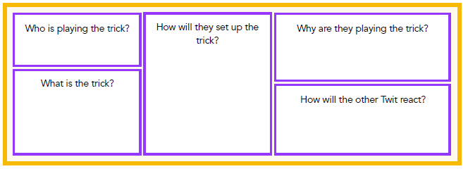
Task – Use the boxes below for your ideas for the missing chapter. Then use this as a basic plan to write out the new chapter, including correctly punctuated direct speech using a variety of synonyms for ‘said’.
Maths
- What is the name given to all 4 sided shapes?
- List the factor pairs of 16.
- Write 100 more than 2034.

We can use co ordinates to describe a position. Co ordinates are plotted on a graph and we use them to find a position. Just like when we looked at bar charts and line graphs, we have an x and a y axis.
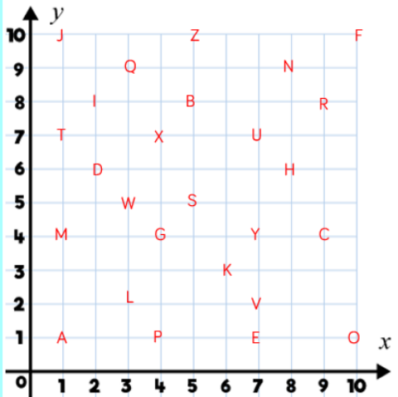

Co ordinates are written by using the x axis first so the letter P above would be at co ordinate ( 4,1 ). We place the co ordinates in brackets.
The letter S would be ( 5, 5 ).

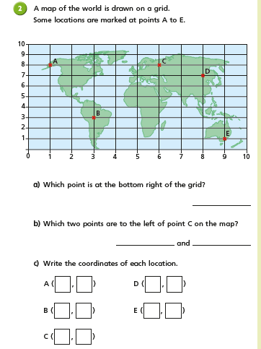

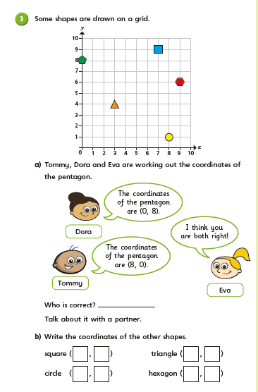

Geography
Last week we learned lots about world biomes (a naturally occurring ecosystem that covers a really large area) and climates. It might have surprised you to learn that deserts can be very hot or very cold! Read the posters below to find out more about deserts:
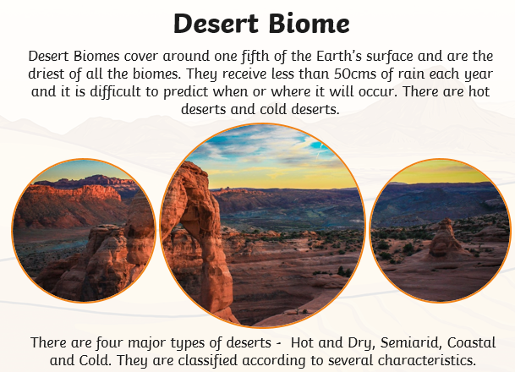

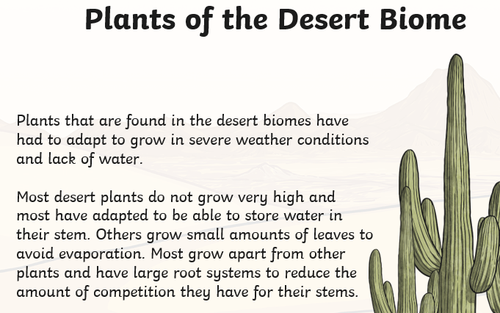

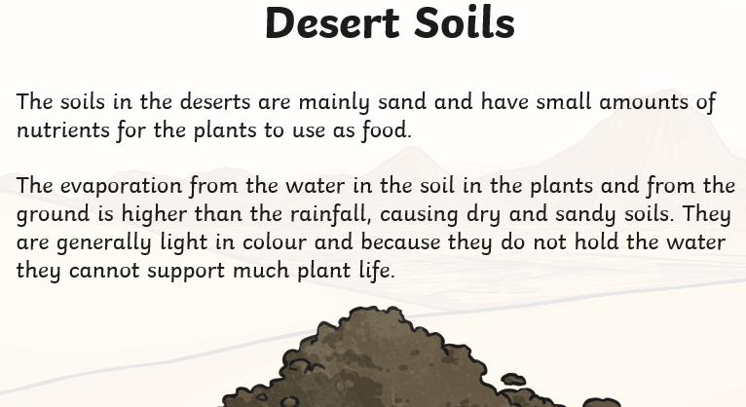

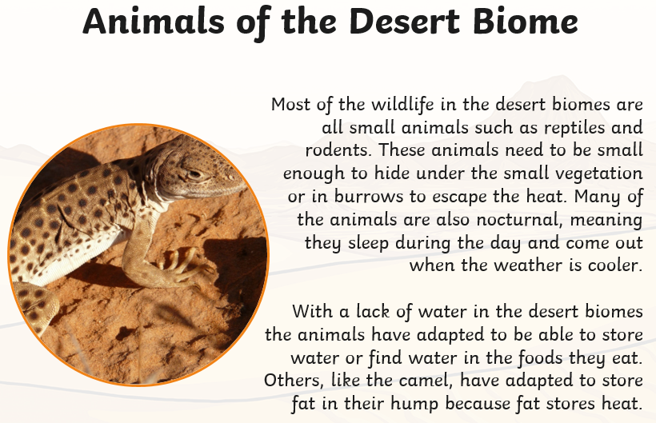

TASK Use google maps or an atlas to help you locate the following deserts in the world then label them on a map
Great Victoria | Arctic Polar | Patagonian | Arabian | Gobi
Sahara | Karahari | Syrian | Great Basin | Antarctic polar

Tip: you might find it useful to search ‘BBC bitesize biomes’ or click: https://www.bbc.co.uk/bitesize/articles/z4qfbwx
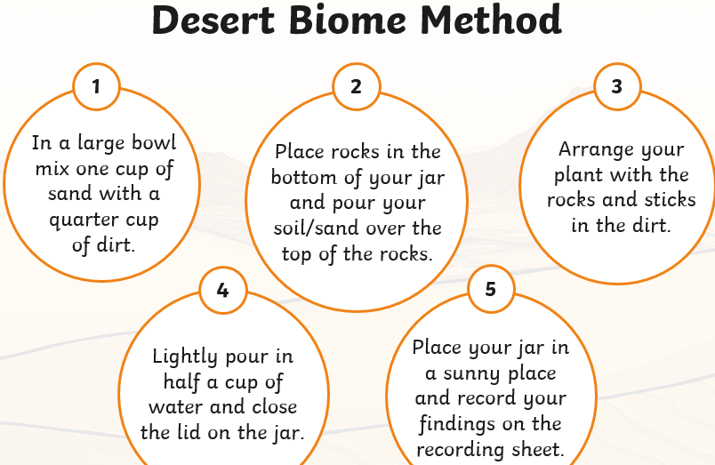
Challenge: Make your own desert biome!
