Year 2 Phonics/Spelling Practice – Monday 22.6.20.
This week we are looking at words with the prefix ‘mis’. The prefix mis- creates words with a negative meaning.
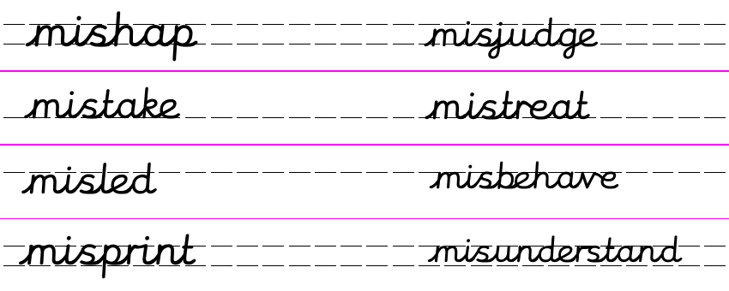
Practise writing your new spelling words each day using your best Russell handwriting.
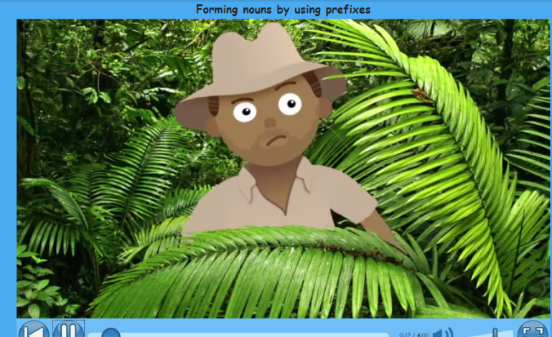
https://central.espresso.co.uk/espresso/primary_uk/subject/module/video/item372629/grade2/module305320/collection361815/section361775/index.html?source=search-all-all-all-all&source-keywords=prefix%20mis

If you can access Espresso – watch this video
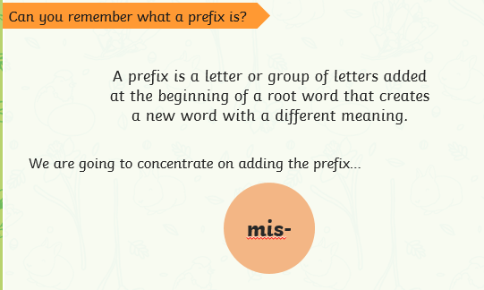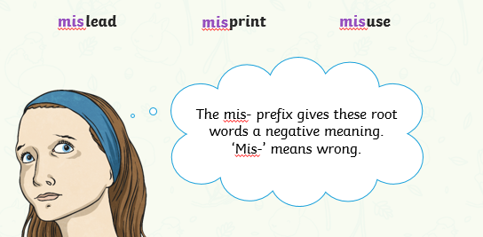
Practise: Practise writing these two mis- words. Perhaps use a different colour to write the prefix.
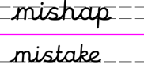
Dictation:
Ask someone to read out the sentence below so that you can write it down – try not to look until after you’ve written it. Check your punctuation and spelling.
By mistake a mishap took place at school.
Maths 22.6.20
Count sides on 2-d shapes
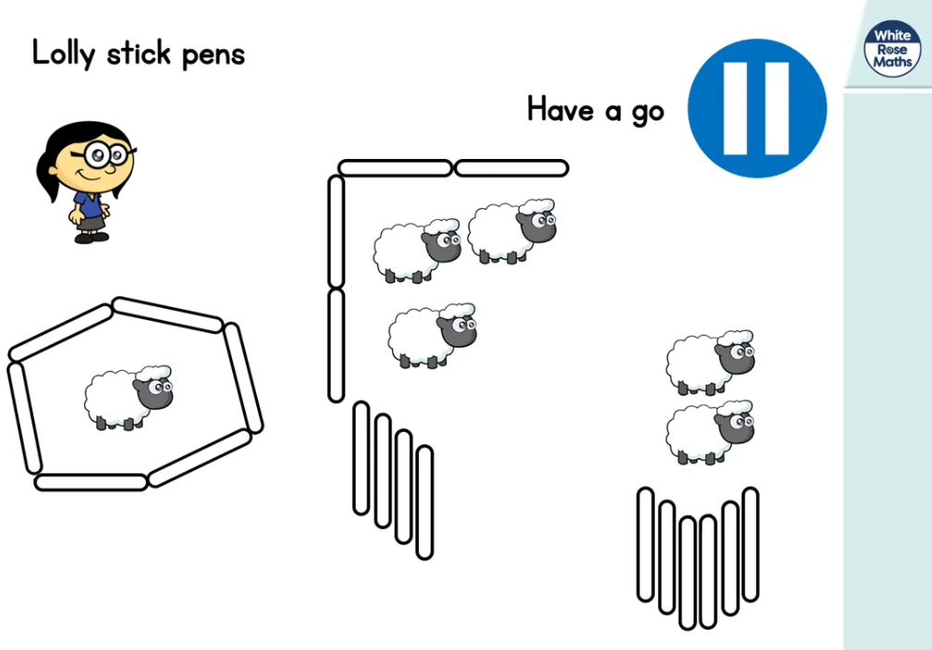
https://whiterosemaths.com/homelearning/year-2/ (Week 8 W/C 15.6.20)
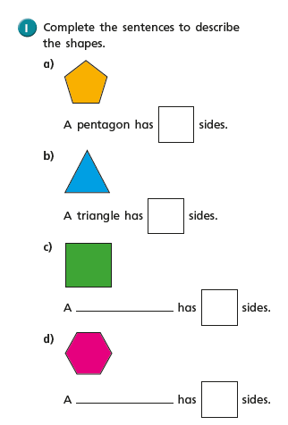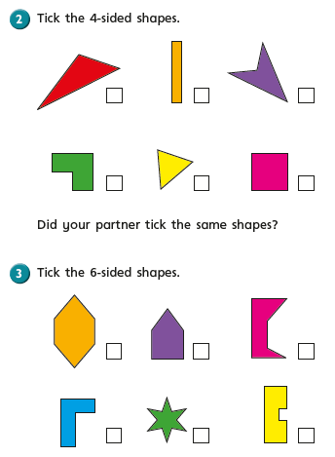

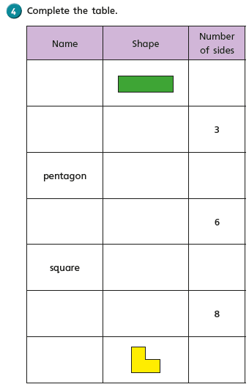

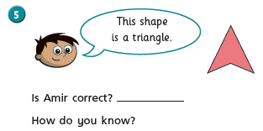
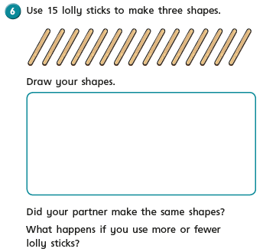

Monday 22nd June 2020 Fact of the day An ant’s sense of smell is stronger than a dog’s.
Word of the day: enthralled.

WALT engage and respond to a text.
WALT identify and understand new vocabulary.

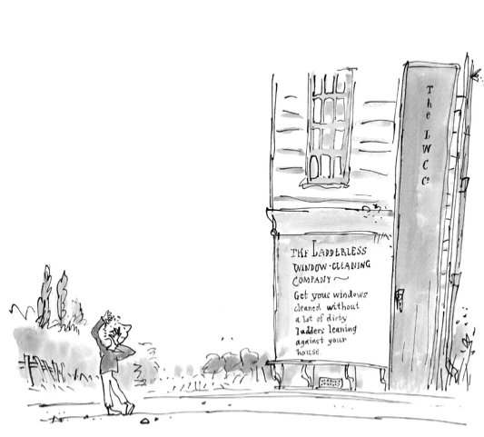

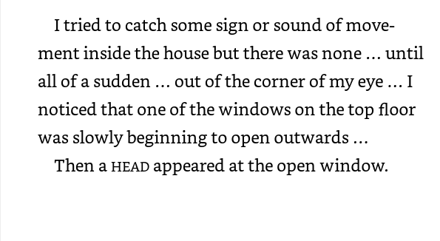

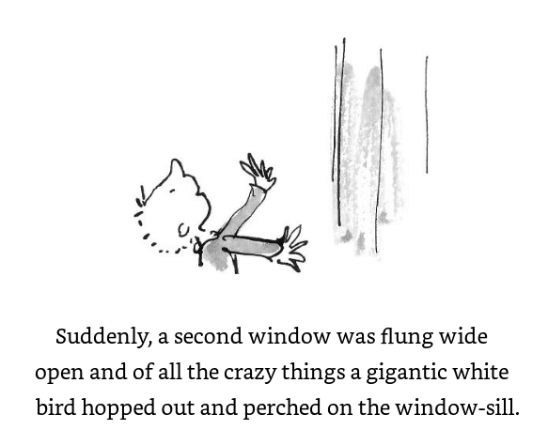
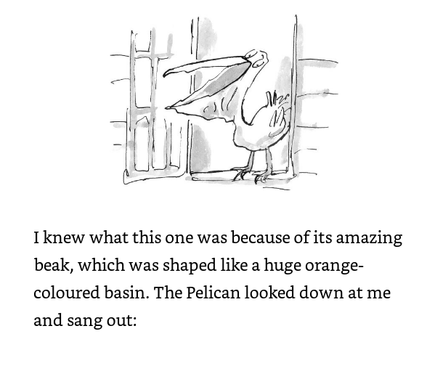
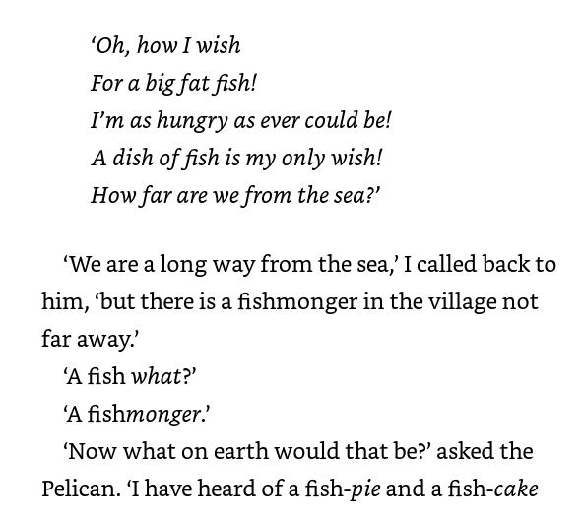
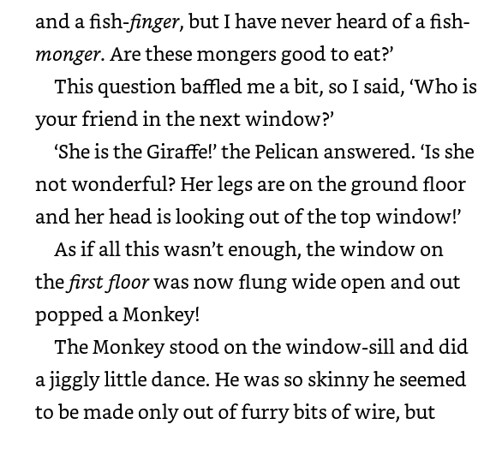
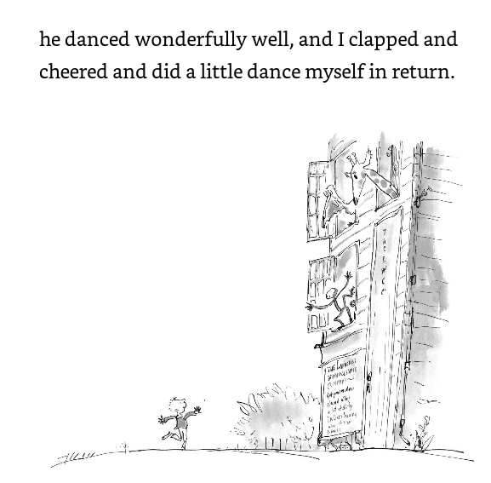

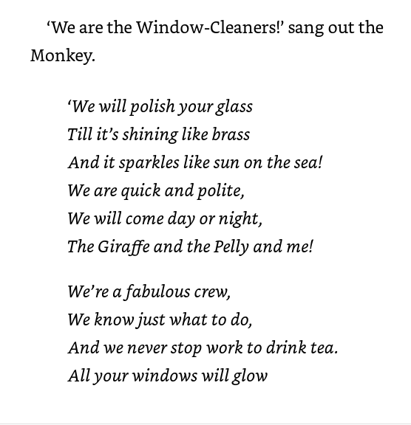
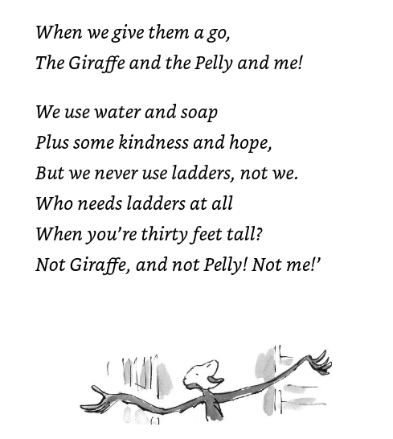
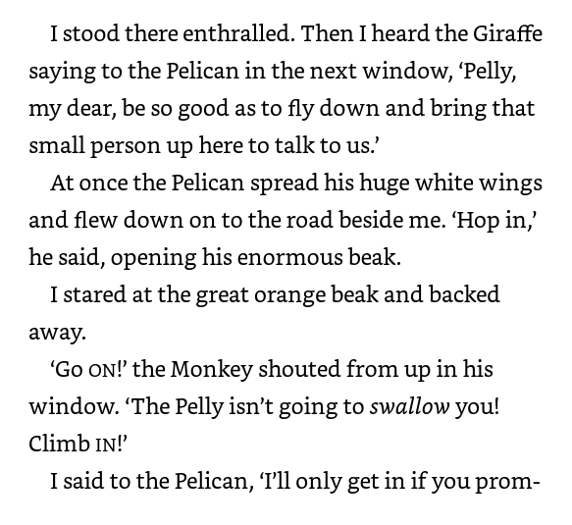
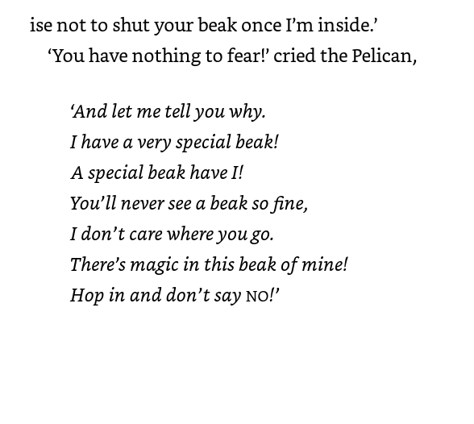
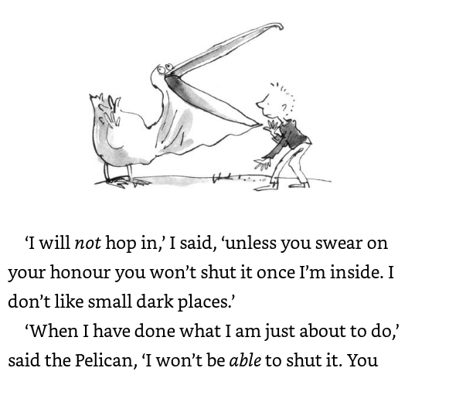
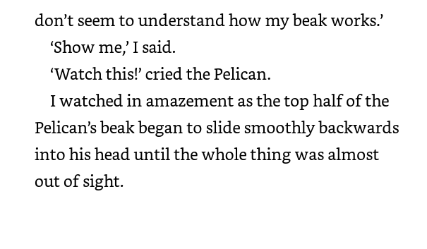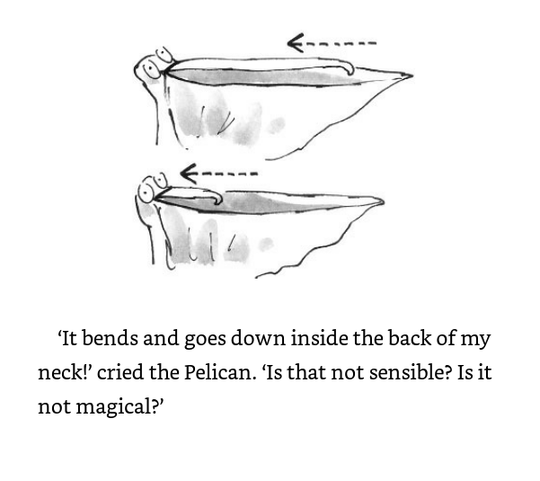

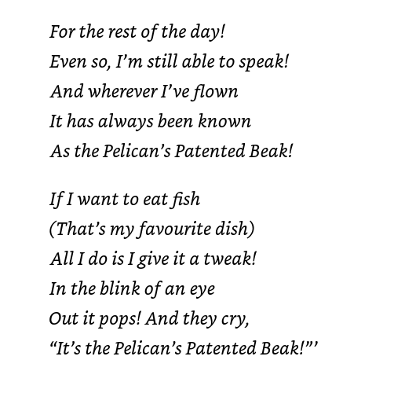
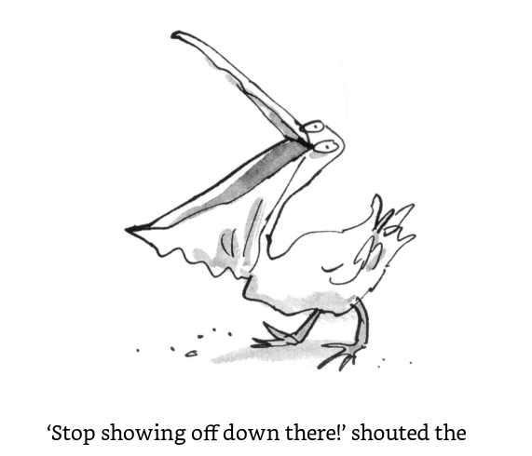
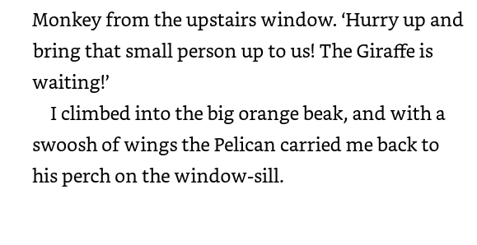
Well done, I hope you are enjoying the story so far.

Task: Today we are going to concentrate on vocabulary. There was lots of unusual vocabulary in the parts of the story we read today.
They are: perched, basin, Fishmonger, baffled, enthralled, patented.
Your task is to look them all up in the dictionary and find out their meanings.
Challenge me: Can you find out what enthralled means. Find some synonyms for it. Write a definition and then write a sentence with ‘enthralled’ in it.

Don’t forget to write today’s date and walt on your paper and to underline it. If you do this work on a computer, I would expect you to do the same.

Have fun.

22.6.20 PSHRE
WALT: understand that there are somethings we have to buy and some things we choose to buy.

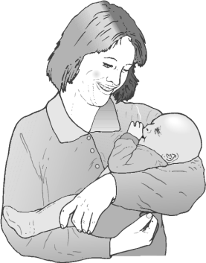
What does a new baby need?

Think of all of the things that a new born baby needs. The list isn’t very long…

Now thinking of a child your age, can you think of all of the needs (not wants).

We need more than water, food and shelter to be happy...

My Needs My Wants

In the story, did Sam need any of the things that he saw?

Did the old man need things? What?
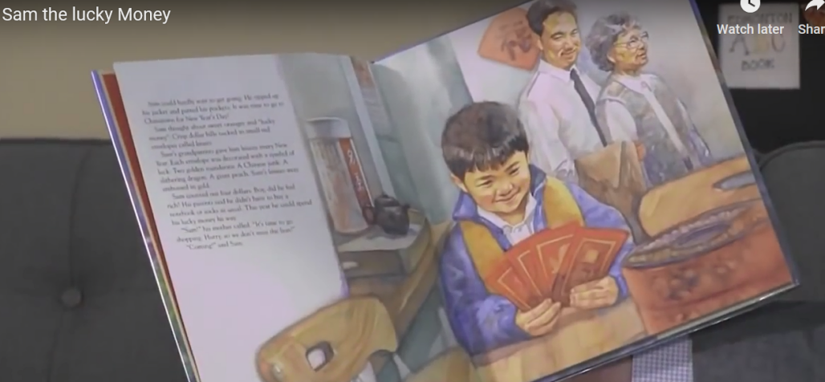
https://www.youtube.com/watch?v=wWuDJFUrfoc
Are all children's wants the same?

Zeze lives in this house in Brazil, will his needs be the same as yours?
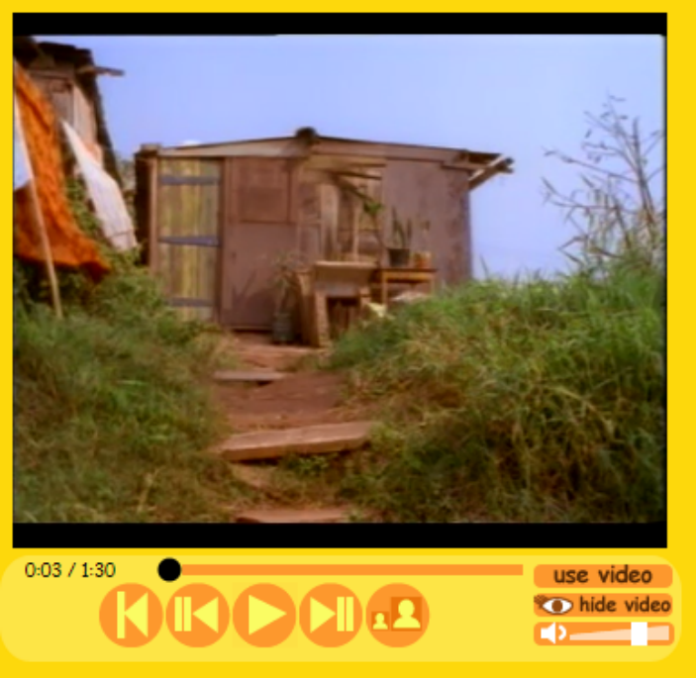

ESPRESSO video: https://central.espresso.co.uk/espresso/modules/t1_openadoor/video_files/video_brazil.html

Year 2 Music Summer Term 2 – 22.6.20
Consolidating Year 2 music learning – history of music, musical language.

Classical music
The term 'Classical music' has come to be known as a term for music that spans the course of hundreds of years, including all Western music from Medieval Church music, to Stravinsky, to the current day.
It is music that has been composed by musicians who are trained in notating their compositions so that other musicians can play them.
Many people are unaware that Classical music is still being composed today, although it is very diﬀerent from what was created several hundred years ago.
Classical music diﬀers from Pop music because it is not made just to be popular for a short time or just to be a commercial success. It is diﬀerent from Folk music, which belongs to the people who want to perform it and passed to future generations by listening and copying.
Listen and appraise
https://www.youtube.com/watch?v=Ak85S5KZoKE
Fantasia On Greensleeves by Ralph Vaughan Williams written for harp, ﬂute and string orchestra in 1934 - from the Mid 20th Century. Stand or sit to ﬁnd the pulse or just listen to the music. Listen out for the well-known tune played by violins, violas, harp and flutes.
What can you hear?
How does the music make you feel?
How would you describe the music?
Do you like the music?

Ralph Vaughan Williams born in 1872 and died in 1958, was an English composer of symphonies, chamber music, opera, choral music and ﬁlm scores. He composed Fantasia On Greensleeves based on the famous ‘Greensleeves’ melody, in 1934. He was one of England’s leading 20th century composers. As a child, he knew he wanted to be a composer, and he followed his dream even though members of his family weren’t very supportive. In the end, Vaughan Williams played a key role in reviving his country’s music. He composed many, many works, including songs, operas, ballets, choral pieces, and nine symphonies.
Do you fancy having a sing yourself today?
Try warming up your voice first – watch this video and it shows you how.
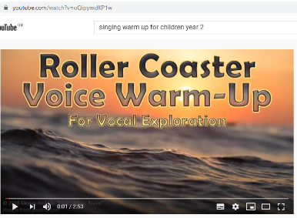
https://www.youtube.com/watch?v=oQipymdKP1w
Now that your voice is warm – find your favourite song or piece of music and sing along! Use your body to make percussion too if you want – clap hands, stomp feet.

