We provide confidential, impartial support and advice for parents, carers, children and young people (up to 25 years) in relation to Special Educational Needs and Disability.
We are a team of three:
Wanda Chappell
Angela Davey
Corrina Durcan

We have three trained volunteer Independent Parental Supporters and one trained Independent Supporter able to provide face to face help.
We provide a year round service
Contact us on 0300 300 8088
Email us at: parent.partnership@centralbedfordshire.gov.uk
www.centralbedfordshire.gov.uk/parentpartnership

Do you have questions about your child’s or your own educational need?
Would you like more information or support in relation to SEN and /or Disability?
Do you need help with a Statement or Learning Difficulty Assessment conversion to an Education, Health & Care Plan?
Do you want to request an Education, Health & Care Plan?
Are you, or your child, due to move school and need help regarding a setting?

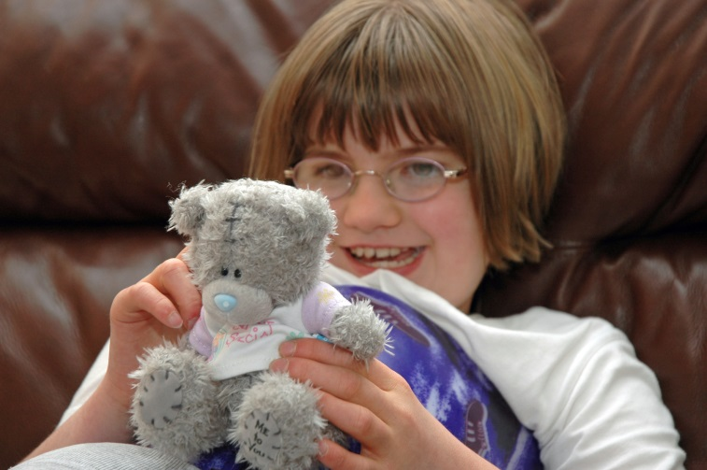
- We listen to your views and concerns
- We work with you to explore your options
- We help prepare you for meetings
- We help you find the confidence to express your views
- We help with forms, letters and understanding paperwork
- We help you understand your rights in relation to SEN/ Disability
- We work in partnership with schools and the Local Authority to develop positive relationships

Providing Confidential & Impartial Advice
We provide free confidential, impartial support and advice for parents, carers, children and young people (up to 25 years) in relation to Special Educational Needs and Disability.

No access referral or criteria required
- Telephone helpline
- Email contact
- Face to face support
- Free drop in sessions
- Access to an Independent supporter where appropriate
- Information, advice & support around many areas in relation to SEND, including Statements and Education Health and Care Plans
- We listen and work with you and the school to build relationships

A great place to live and work

CBC SEND PYPPS
Special Educational Needs & Disability Parent & Young Person Partnership Service
Phone: 0300 300 8088
Email: parent.partnership@
centralbedfordshire.gov.uk
More information about our service can be found at:
www.centralbedfordshire.gov.uk/parentpartnership

CBC SEND parent & Young person Partnership Service
Providing Information, Advice & Support in Central Bedfordshire
A year round service, passionate about working together to improve outcomes for children, young people and their families

