Year 2 Phonics/Spelling Practice – Thursday 4.6.20.
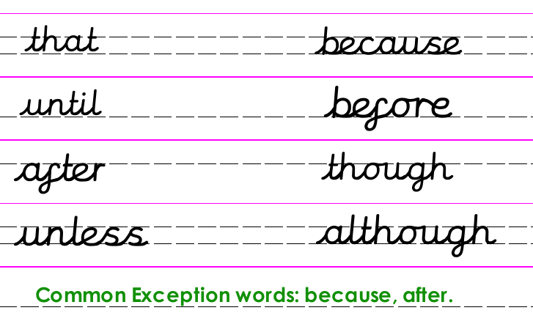
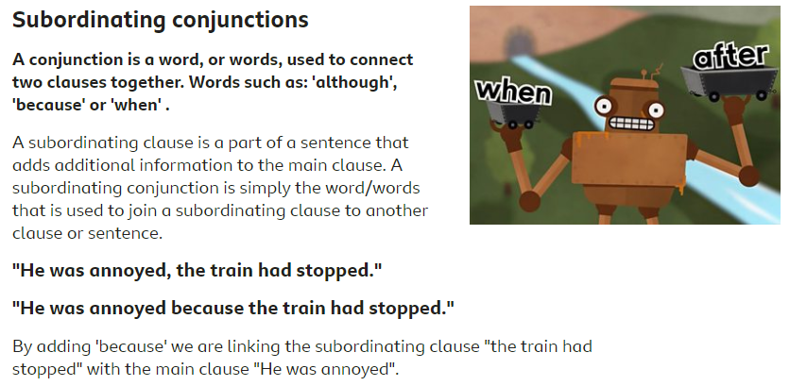
If you can access BBC Bitesize watch the video explaining this at: https://www.bbc.co.uk/bitesize/topics/zwwp8mn/articles/zqk37p3
Copy out and underline the two subordinating conjunctions in the text below:
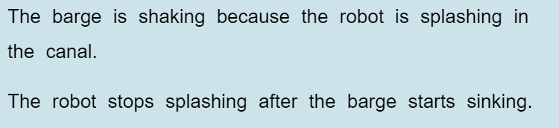
Dictation sentence to practise:
The boy ate the strawberry although he wasn’t hungry.

Maths 4.6.20
The 5 times table
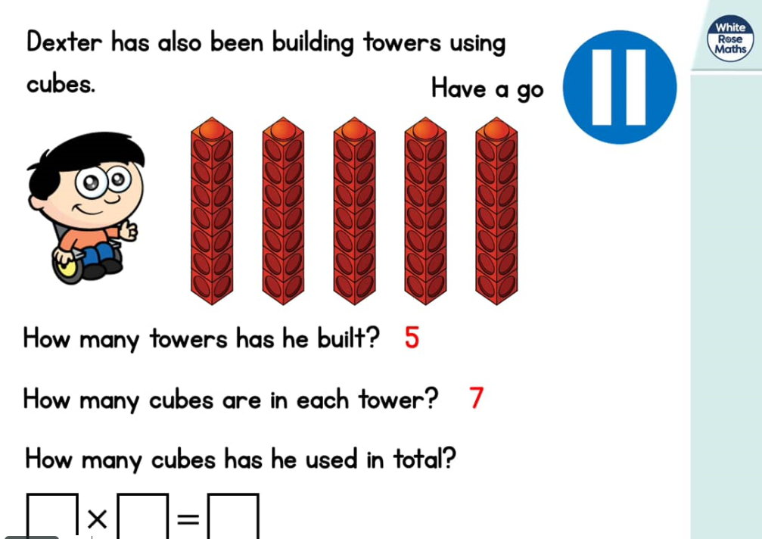
https://whiterosemaths.com/homelearning/year-2/ (Week 5 W/C 18.5.20)
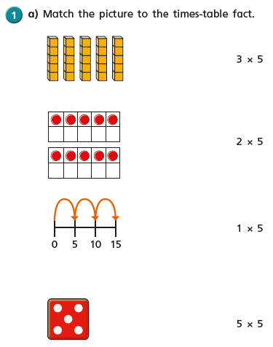
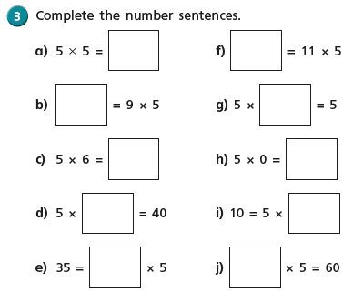
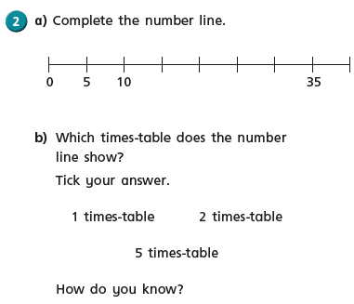
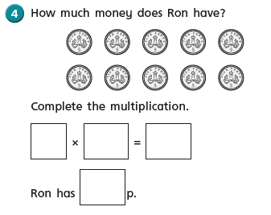

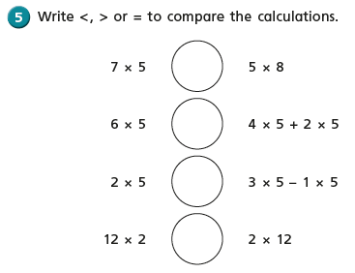
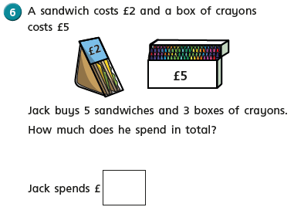

English Thursday 4th June 2020
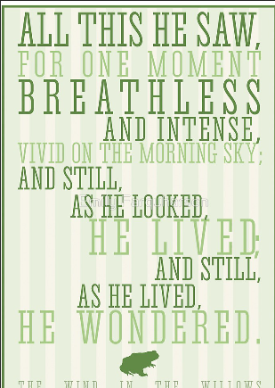
WALT write a narrative about a book we have listened to using adjectives and adverbs.
Can you go on to the BBC website and listen to episode 1 of the story 1. The River Bank. https://www.bbc.co.uk/sounds/play/p07sny1n
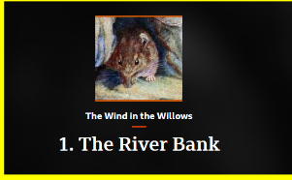
Let’s look at the narrative a little bit more closely. There will be lots of words you may not understand. Ask an adult to read it through with you.
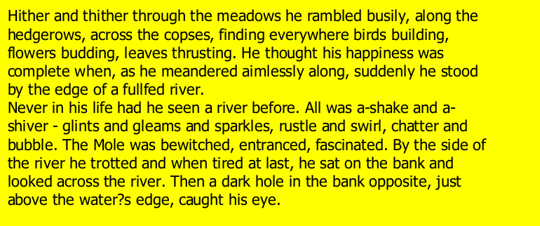

Today’s task is to use a dictionary either a book one that you may have in home or an online dictionary and to look up any words that you don’t understand.

Challenge – can you find synonyms for some of the words that you have looked up?
Art Thursday 4th June 2020
WALT make a sculpture using nature materials to show a simple idea/using our imagination.

As part of our Countryside tales topic, we are going to look today at some Nature Art.
What do you think art in nature is?
We are going to look at an artist called Andrew Goldsworthy today, who uses art in nature.
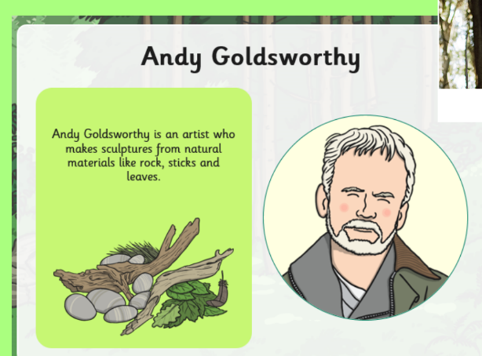

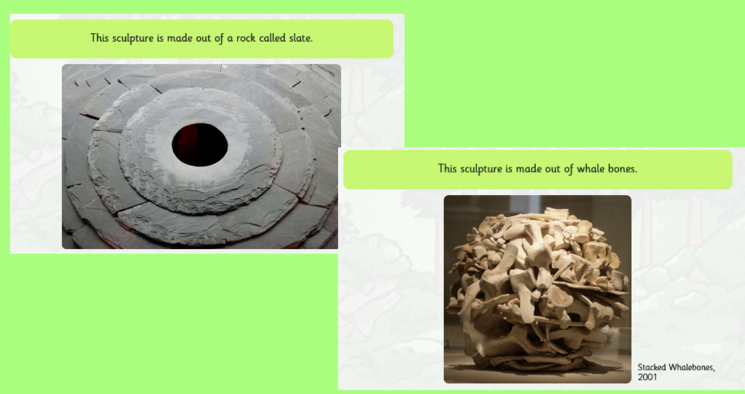

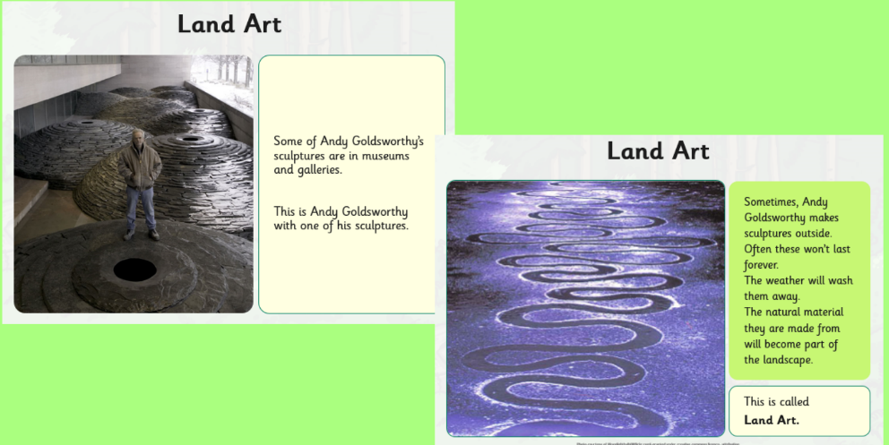

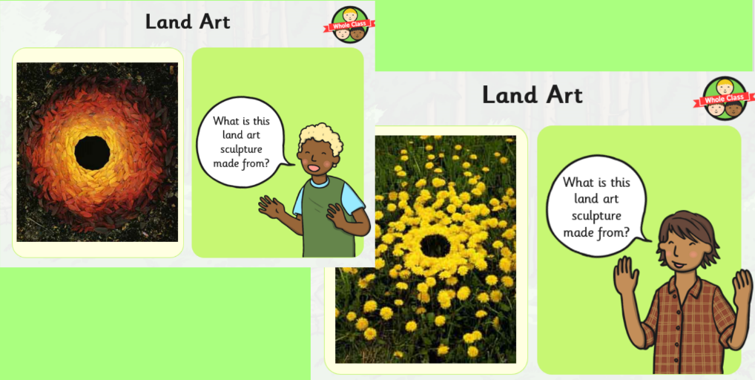

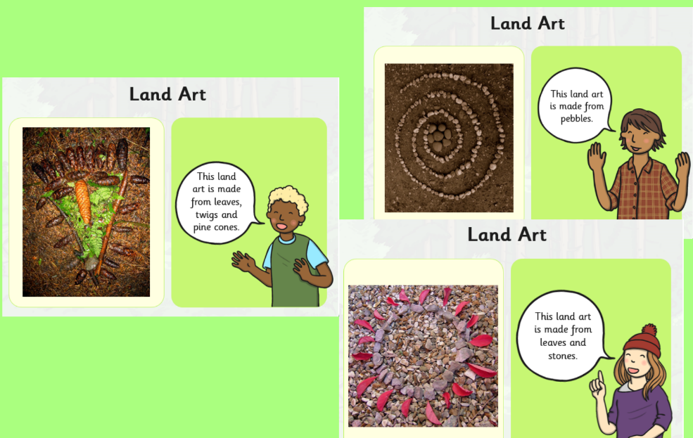

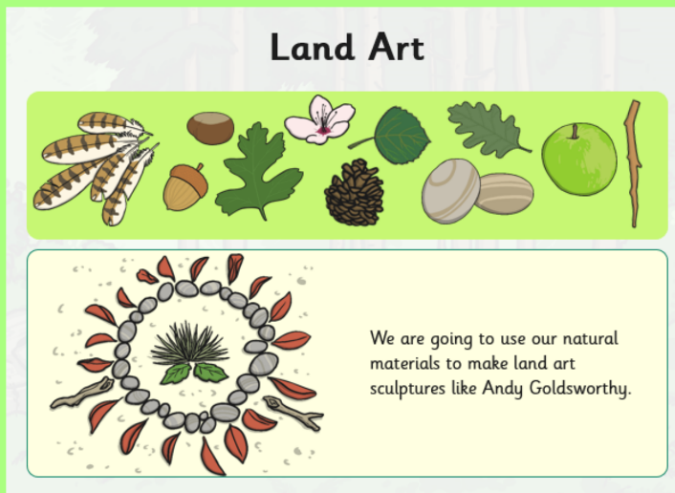
Task
You are going to go outside and find the materials to make your own land/nature art outside.
Try and take a photograph of your art work as it will only last for a short time.
