Year 2 Phonics/Spelling Practice – w/c 20.4.20 Day 4
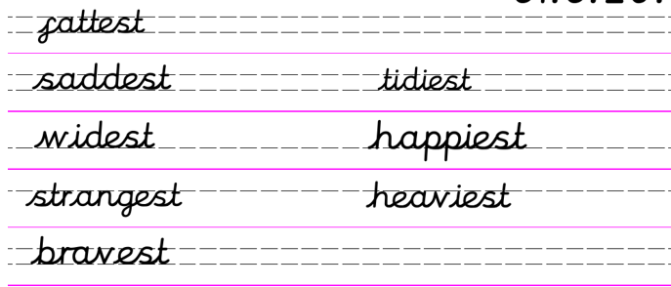
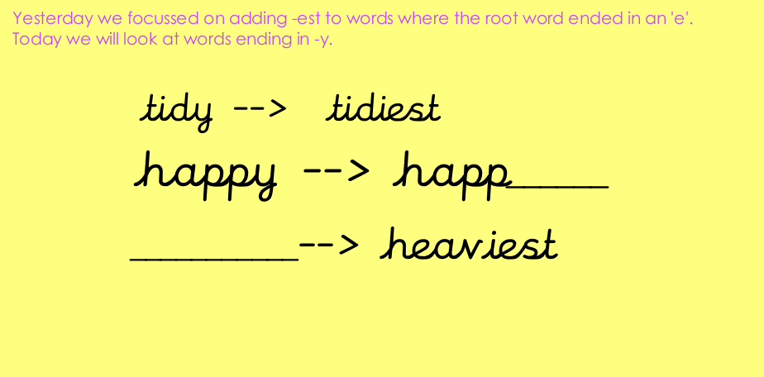
When the word ends in –y, remove the –y and replace it with ‘i’. Then add the suffix. Ie. Tidy tidiest.

Now use these root words to write some more…
funny | happy | dry | creamy | pretty
silly | lonely | soggy | chilly | chewy

English 23.4.20 Word of the day Gluttony
Good morning year 2. As you know this would have been our first week back after the Easter holidays and the first week of our Summer Term. Fortunately, we are all at home staying safe and also we have managed to escape our SATS tests however, unfortunately it has meant I am not in school to share with you the wonderful work we would have been doing on animals, plants, nature and minibeasts. But I am hoping that I can still share with you all the wonderful things we would have been doing. One of the things I am missing most is sharing with you all the wonderful stories by the author Eric Carle. Have you heard of him? Look carefully at his picture, what is the book he is reading?
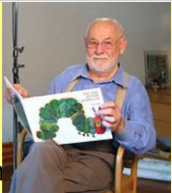
This week and next we will be reading some of his books. The best bit about this is that they are all online and I will include the links for you.
We are going to start by reading ‘The Very Hungry Caterpillar’.
https://www.bing.com/videos/search?q=the+very+hungry+caterpillar&FORM=HDRSC3
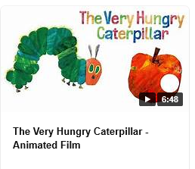

We are going to start our work on Eric Carle and his books by writing an author fact file. Read through this article with your adult underlining things that you find interesting such as where he was born, what his first job was.
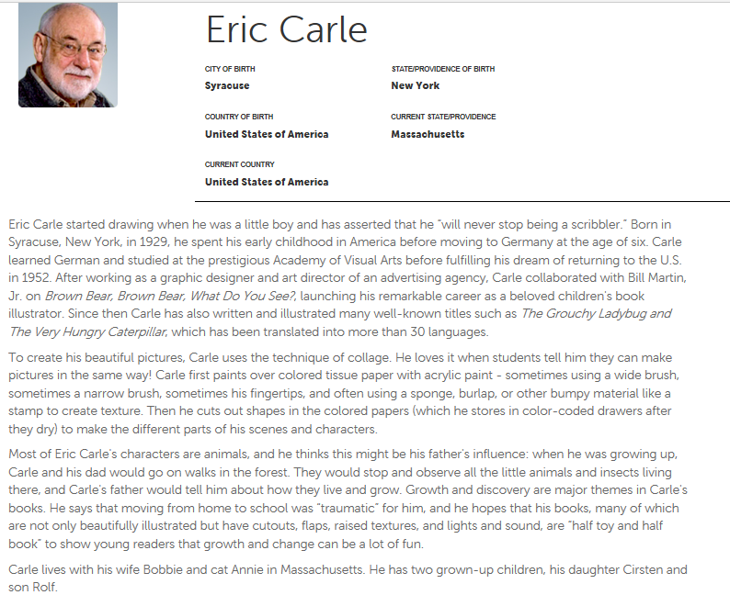
You are now going to put all your key information together to make an author profile. You can use one of the templates on the next pages or make up your own either on paper, online or how about you record all your information on your iPads or cameras?
There is a video of Eric talking about his life on YouTube too.

NMP
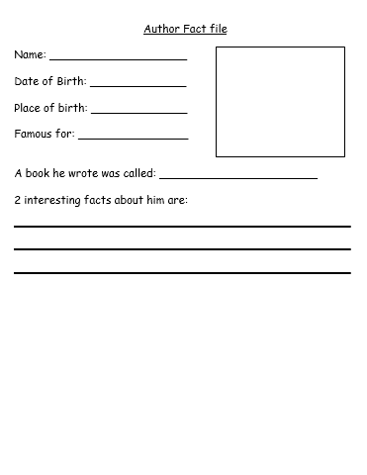

Feeling confident.
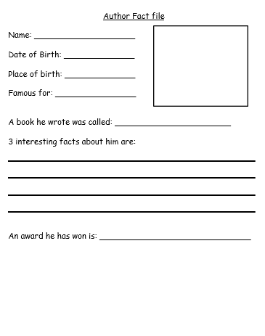

Challenge me
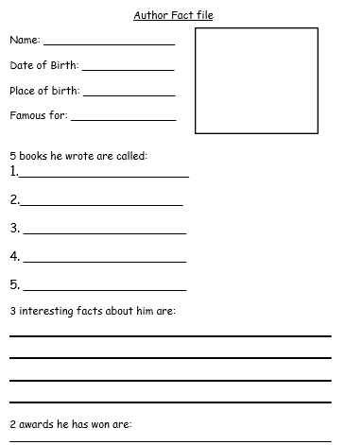

Maths 23.4.20
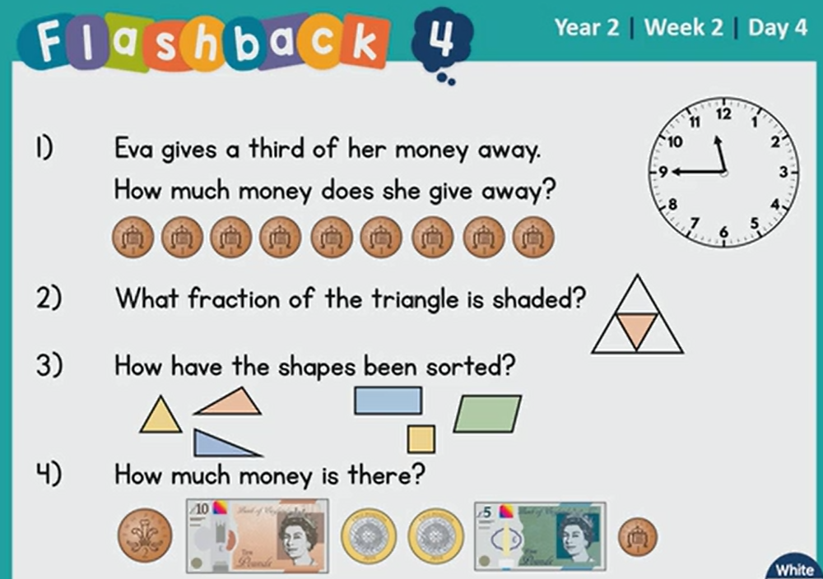
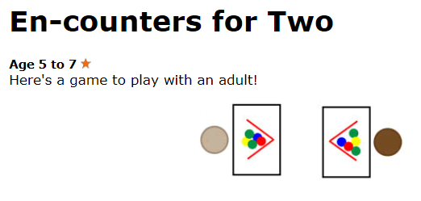

How do you play?
You'll need an adult to play with.
You also need two matching sets of counters (or something similar - bottle tops, coloured circles of paper etc) - up to 12 in each set.
Give one set to the adult and keep the other set for yourself.
Make a secret place where the adult can hide the counters. You could make a screen with a book, or do it on a tray and cover it up with a piece of cloth.
The adult secretly makes a pattern or design with the counters, describing what they are doing as they make it.
Your job is to make the same design by asking questions, which the adult answers as helpfully as possible.
When you think you have a completed design, ask the adult to check.
If you're right you could swap roles.
If you're wrong keep going! How many questions did you need to ask?
23.4.20 D.T.
Thursday 23rd April 2020
WALT investigate different types of picnic food and where they come from.
D.T – Today especially as it is Thursday and our clap for the NHS day we are going to be making ‘Rainbow Omelette Cakes’.
This term in D.T we will be looking at cooking and nutrition. This is something we love doing and already this year we have made bread rolls and decorated cakes. This term we are going to be looking at different types of picnic foods and finding out a bit more about where our food comes from. I am sure that you have been making lots of different things with your family recently, I know I have. Apart from the usual breakfast, lunches and teas I’ve made caramel shortbread, bread, cheesecakes, brownies and brioche rolls for our bbq! It has been lovely to have had the time to experiment with different recipes too. One thing I have noticed I have been trying to do a lot is to buy my food locally from farm shops and butchers. I am a vegetarian but the rest of my family aren’t and they have had some lovely meat from our local butchers and this is something I am going to make sure I continue to buy in the future. The good thing about buying locally is you know where your food has been grown and how long it has taken to get there and this is something we will look at more this term. It is perfect picnic weather at the moment and although we must stay at home to stay safe we can all have a picnic either in the garden whilst the weather is so nice or if we haven’t got a garden or it is raining in our front rooms on a blanket.

Here is a letter I received inviting you all to have a Teddy Bear’s picnic at your home.

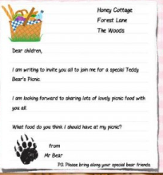

What type of food do you like in your picnic basket?
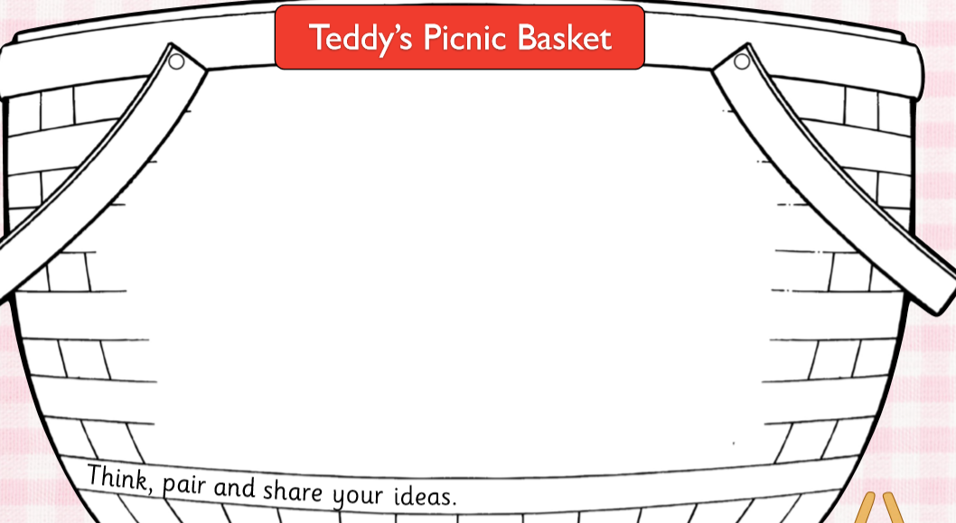

Well done, here are the ones I thought of. Did you have similar?

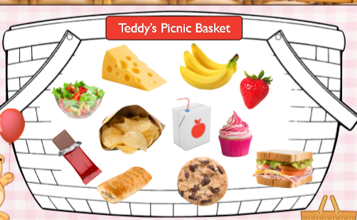
Did you know the food that we eat has either been ‘farmed’, ‘caught’ or ‘grown’ before it ends up on our plate or in our picnic baskets?
When we say food has ben farmed we mean it has been grown, bred or raised on a farm. It is then sold on to companies who use it to make different types of food for us to buy.
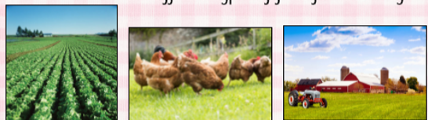
When we say food has been ‘caught’, we are talking about fish and other seafood that has been living in the sea, lakes or rivers. Some fish is also farmed.
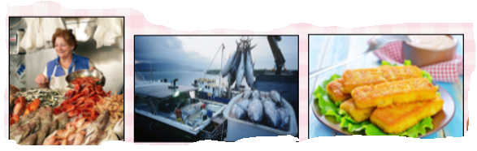
When we say food has been ‘grown’ we are talking about food which has been grown on a farm, in the ground at home, in someone’s garden allotment or plant pots. Have you ever grown anything to eat at home?
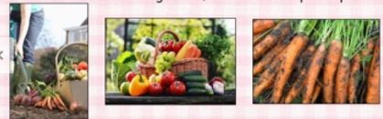
Quite often our foods are made up of more than one ingredient. The foods below fit into one or more of the three groups ‘farmed’, ‘caught’ or grown. Can you work out which ones fit into which groups?

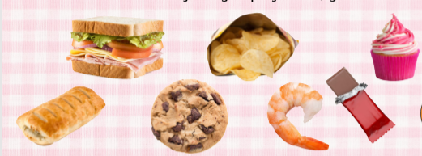
Now let’s make some picnic food of our own ‘Rainbow’ omelette cakes.

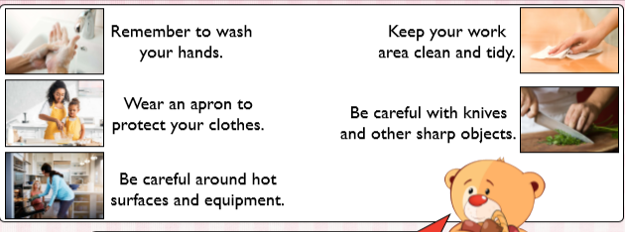

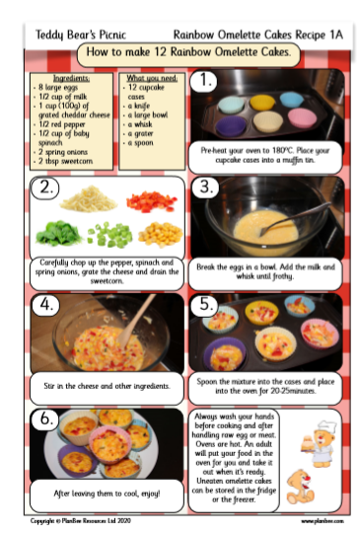

I am going to have a go at making these too. If you make them can you take a photograph so you can remember why we made Rainbow Omelette cakes on this day in April 2020!

