Wednesday 8th July 2020
SPaG
Words spelt with a g sound spelt gue
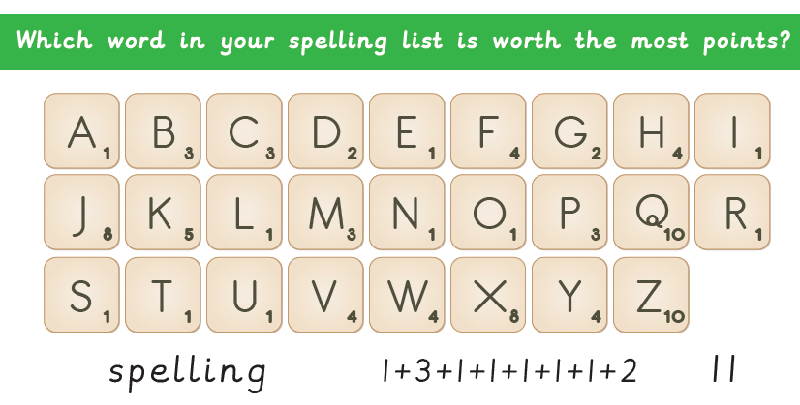
league - tongue
vague
plague
meringue
synagogue
epilogue
monologue

Word of the Day – saunter

Definition ____________________________________________
_____________________________________________________
_____________________________________________________
Used it in a sentence: ____________________________________________________
_________________________________________________________________________
Word Class: ____________________________________________________
Synonyms

English
Today you will be turning your missing chapter into a playscript.
Follow these instructions to help you achieve it . . .
1) First look through your text and make a list of any characters involved.

2) Then do the same for any props you think might be needed in the scene.

3) Next, figure out where the scene is happening. Look or clues in the text and think about how you would show this on a stage.

4) Most, if not all, of the speech will be important to include. You may need
to add a few more lines in to make sure the story makes sense.

5) Next, you need to look for any important action that the characters will need to perform. This will come across in your stage directions.

6) Now you have picked out the important information you can
start piecing together your script.

7) Give your script a title and list the characters and props that the scene
will need.

8) Next, set the scene. Make it clear where the scene will take place and what the stage will look like. You may also like to add detail about where the
characters are when the scene begins.

9) The next step is to add in all the speech in the scene. Remember, you can add in some extra lines to help the scene make sense and avoid long silences.

10) Now you can add in your stage directions to describe how the actors should say each line and what actions they need to do.

Maths
- 34 – 20 = 2 x ___
- 2 x ____ = 100- 50
- 32 ÷ 8 = 4 x ___
Watch this video to remind you about ordering money.
https://vimeo.com/430337688

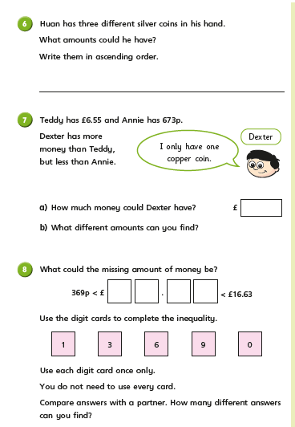

Science
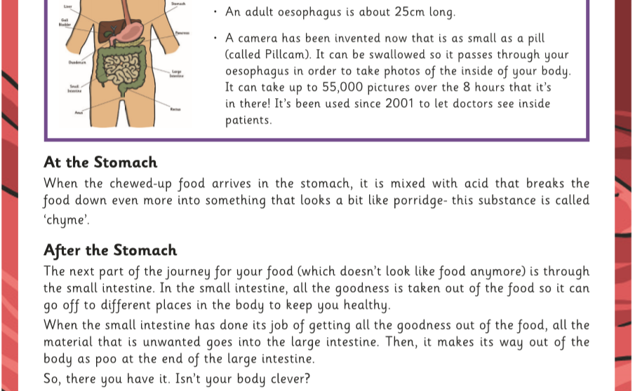
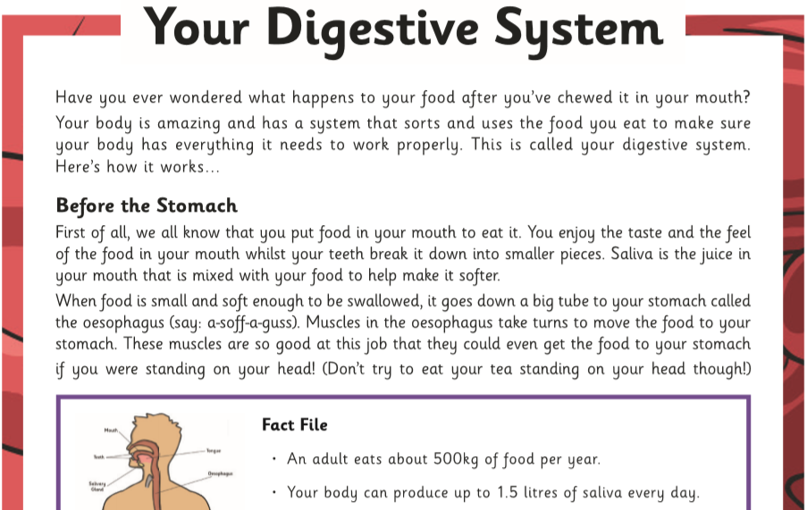
- Why do you have to chew food before it goes down the oesophagus?

- What mixes with the food in your mouth?

- How much food does the average person eat in a year?

- Put these organs in the correct order to show the stages of digestion: Large intestine, mouth, small intestine, stomach, oesophagus.

- Where in your body does all the waste go right before it leaves the body?

- What does ‘chyme’ look like?

- At the end the author says: ‘Isn’t your body clever?’ Do you agree? Why or why not?

