Year 2 Phonics/Spelling Practice – w/c 15.5.20 Friday
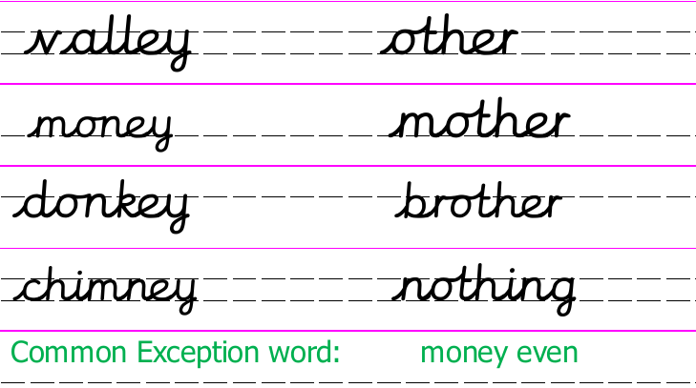

Now choose some of the words which you might find useful and practise writing them using rainbow Russell writing.
ie. nothing, some, money
Can you then put these word into a sentence of your own?
Example: I spent my money in the shop.

This week’s Year 2 common exception words both have an /ee/ sound in them:
money even
Practise writing them. Perhaps draw a picture to go with them.
Dictation sentence to practise:
I wonder if the other key costs even more money.

Maths 15.5.20

If you are able to, use ‘Hit the Button’ to practise number bonds to 10, 20, 100. Can you challenge yourself to beat your best score?

Now print or copy and complete these additions.
Can you challenge any members of your family to beat your time?
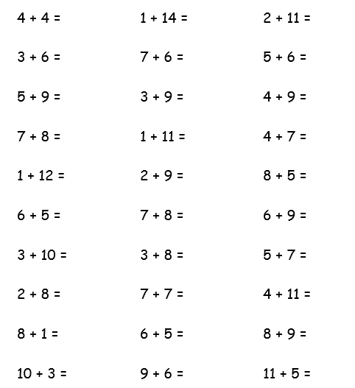

Choose some of these additions and write the numbers as 10s.
e.g. instead of 4 + 4, write 40 + 40.
What do you notice?
English 15.5.20 – Continue your story from yesterday
-------------------------------------------------------------------------------------------------------------------------------------
15.5.20 Science
WALT: understand that plants can be grown from bulbs.
Last week we looked at seeds and how plants can be grown from them. This week we will discover how plants can also be grown from bulbs. What do you already know about bulbs and what we can grow from them?
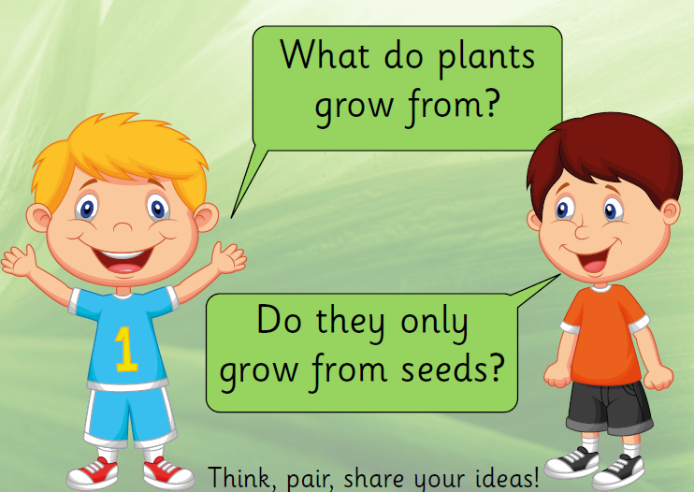

Why are bulbs so much bigger than seeds?
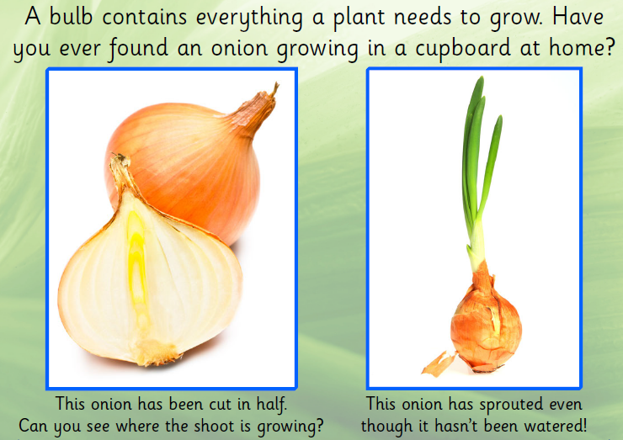
Have you ever planted any bulbs? If so, which ones?
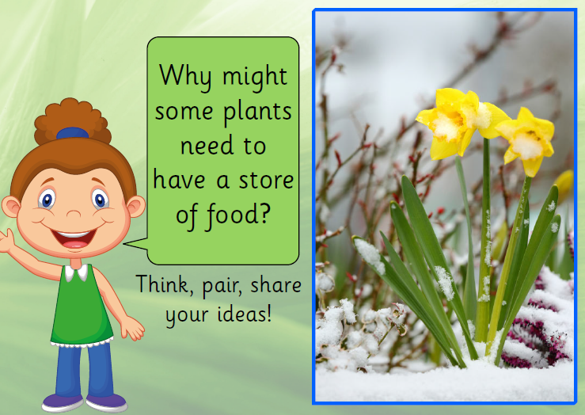
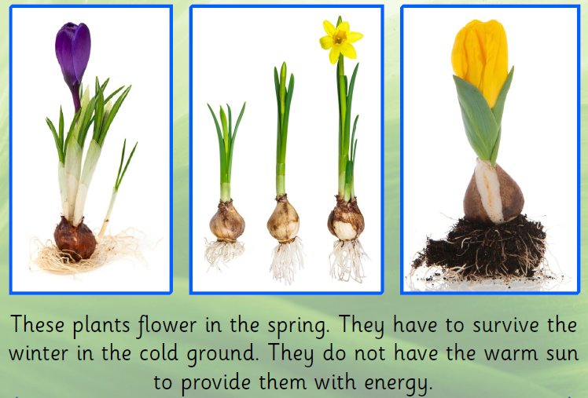
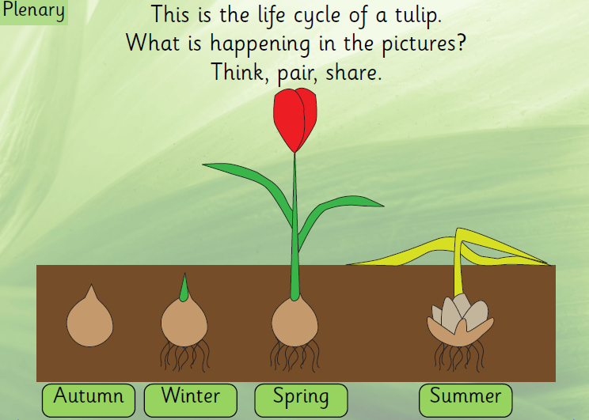
Task: Draw or stick the pictures of the bulb growing into the plant in the correct order. Write a sentence about what is happening in each picture.
