Dear Puffins, Owls and Wrens!

How are you all? We hope you are all well and continue to enjoy the Home Learning Activities.
We always love to hear what you’ve been up to and how you got on with the activities. Were there any activities you particularly liked? Let us know. We look forward to seeing your work and photos 😊
Please find the next week’s Home Learning pack attached to this letter. Have a go and as always try your best. We are very proud of all of you for trying hard and completing the activities we sent you every week. We can’t wait to see how you are going to impress us and your grown-ups this week! If you have any questions about any of the activities, please just let us know. We are here to help.
We hope you will enjoy these new activities.
Also, here are a couple of riddles for you to solve this week 😊
- What’s bright orange with green on top and sounds like a parrot?
- What has legs but doesn’t walk?

Also, 24th June 2020 is a National Writing Day! To find out more go to:
https://www.awarenessdays.com/awareness-days-calendar/national-writing-day-2020/

Take care, look after yourselves and your families and keep smiling

We miss you all,
Mrs. Cox, Mrs. Milligan, Mrs. Jochacy and Mrs. Athanasiou xxxx

P.S. You will find the answers to the riddle and brain teaser at the end of this pack.

Year 1 Phonics activities – Summer 2 – Week 4 and Year 1 spellings

Session 1 - Monday 22nd June 2020  Warm up activity – listen to the ‘tricky word song’  Encourage your child to sing along and have a go at writing the words.  https://www.youtube.com/watch?v=3NOzgR1ANc4&safe=active  At the end of the clip see if they can write a sentence using one or more of the tricky words they have written down. | Session 1 - Main activity  u split e digraph  (u_e – e.g., cute, tune, tube)  Introduction to u split e digraph – watch the video to introduce the sound.  You will need to login to ‘Espresso’ which can be accessed from the school website – ‘kids area’ and follow the link  https://central.espresso.co.uk/ (once logged in please go to – Espresso/Key Stage1/ English/Phonics / Ash’s Phonics /o-e)  https://central.espresso.co.uk/espresso/primary_uk/subject/module/video/item97585/grade1/module63425/index.html  Have a go at making a list of split digraph u_e words together.  If for any reason you are unable to access Espresso then please use the YouTube link below which will give you some split digraph i words to read.  https://www.youtube.com/watch?v=CQXnqp8g9WM  Read some u split e digraph words: cube, huge, mute, tune
Session 2 - Tuesday 23rd June 2020  Warm up activity – Tricky words and Year 1 Common Exception Words:  many, laughed, his, has, I, you  Write down the words on a piece of paper. Use look, say, cover, write and check to practise those words.  Look – have a look at one of the words  Say – say the word out loud  Cover – cover the word  Write – write the word down on a separate piece of paper  Check – uncover the word and check your spelling | Session 2 - Main activity  Choose a picture and write the word – remember the split digraph u_e will be in each word.  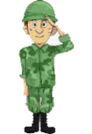  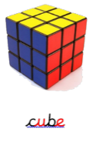  salute  Remember your sound lines and buttons!
Session 3 - Wednesday 24th June 2020  Warm up activity – Recap phase 5 phoneme flashcards  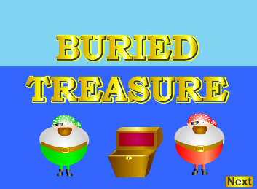  Play buried treasure – phase 5 – a_e  https://www.phonicsplay.co.uk/resources/phase/2/buried-treasure | Session 3 - Main activity  Practise spelling the u split e digraph words  How many split digraph u_e words can you write in 1 minute?
Session 4 - Thursday 25^{h} June 2020  Warm up activity –  How many words with split digraph u_e can you make in 2 minutes? | Session 4 - Main activity  Can you think of words with the long u sound? How are they spelt? Split your paper into 4 and write words under each heading.
Session 5 - Friday 26th June 2020  Warm up activity  Many, laughed, his, has, I, you  Choose three of these words and write your own sentence using them.  Think – how do you need to start and end your sentence? | Session 5 – Main activity  Write the sentences adding the correct u split e digraph word from the green words below.  We played a lovely _____________ together.  The ____________ is full of toothpaste.  It was ______________ lesson time and we were excited!  Please could you pass me the _________________?  The month of _________________was warm and sunny.  ruler, computer, June, tune, tube

Year 1 English Activities – Summer 2 Week 4
This week’s English will be based around the book ‘Lost and Found’ by Oliver Jeffers. If you have the book at home, read it either on your own or to a grown up.
If you don’t have the book you can watch the video here...
https://www.youtube.com/watch?v=xNgh3Q58QoI
Before reading/ watching the video, look at the book cover:
What do you think this book is going to be about?
What characters might we meet?
Do you think it is going to be fiction or non-fiction?
Monday  22nd June | Listen to the story again. As you listen write down/ make a list of any feelings you think the penguin and the boy may have felt throughout the story.  *adjective - an adjective is a word that describes an animal, person, thing, or thought. Adjectives include words that describe what something looks like and what it feels like to touch, taste, or smell.
Tuesday  23rd June | Write a list of items you would take to the South Pole. Remember each item starts on a new line. Pick an item and write a sentence to explain why you are taking it using the connective because.
Wednesday 24th June | Make a poster to tell people that you have found a penguin, in case anyone has lost it (you can use the resource below to help you or make your own poster)
Thursday 25th June | Write your advice to the boy and how he could help the penguin. Remember to use 'and/because' to join your sentences.
Friday 26th June | Watch the film and compare it to the book.  https://www.youtube.com/watch?v=g-N-m0N0vtM

Year 1 Maths Activities – Summer 2 week 4
This week we are looking at capacity, volume, mass and weight.
Do you know what capacity is/ means? What does mass means? Have a think and share your idea/s with someone.

Vocabulary:
Capacity/ volume – jug, litres measure, empty, half empty, capacity, full, half full, nearly full, nearly empty, container, cup, millilitres, volume
Mass/ weight – weigh, weighs, balances, heavy, heavier, heaviest, light, lighter, lightest, scales, predict, equal
Mass is a measure of how heavy an object is.

Monday 22nd June 2020
Watch a short clip about capacity:
https://www.bbc.co.uk/bitesize/topics/zt9k7ty/articles/zp8crdm
Activity:
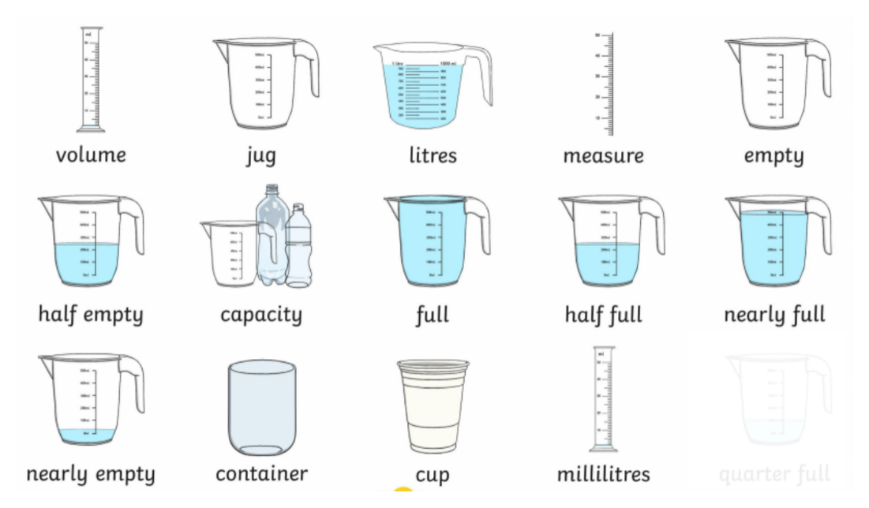

Use a jug with coloured water to practise pouring the liquid into cups to show: full, half full, empty, nearly full and nearly empty. Label each cup and/ or tell your adult what you did describing the amount of liquid in each cup.
Challenge:
Draw a line to match the sentences to the correct cup.
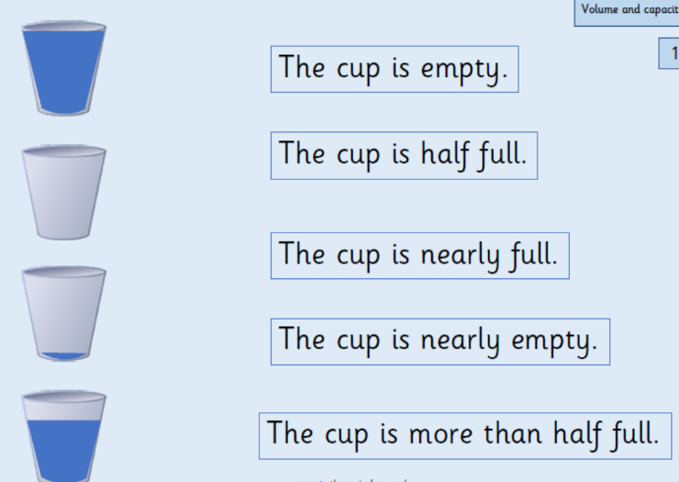

Tuesday 23rd June 2020

Activity:
Choose 2 different sized containers.
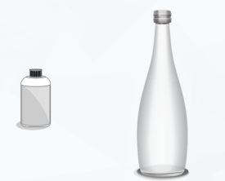
Examples:

Predict:
Which container will hold the most?
Which will hold the least amount?

Use a small cup as a non-standard unit of measure. How many cups do you think it will take to fill each container? Was your prediction right? Explore with different size containers.
Challenge:
Draw 5 cups on a piece of paper to show empty, nearly empty, half full, nearly full and full.

Wednesday 24th June 2020
Use this game to practise weighing objects.

https://pbskids.org/peg/games/happy-camel

Activity:
What do you notice about these balance scales?

The _________________________ is heavier than the _____________________________

The _________________________ is of equal weight to the _________________________

The _________________________ is lighter than the ______________________________

Challenge:
Who is correct? Explain why.
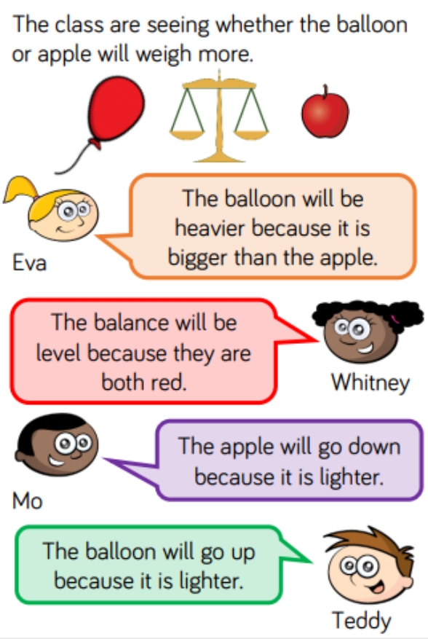

Thursday 25th June 2020
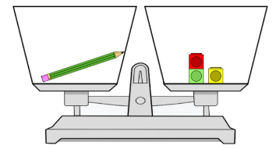
We can use different objects to measure the mass of items. We call these objects non-standard units. When we use non-standard units to measure mass, we must make sure both sides of the scales balance.

Activity:
Select objects you are going to use to measure mass of items you choose, then choose 6 items such as shoe, apple, teddy and start by predicting their weight. Record your prediction then check their weight. Record what you found out.
If you do not have a scale practise by solving the problems below.

Challenge:

Friday 26th June 2020
Enjoy Weight and Mass Reasoning Game
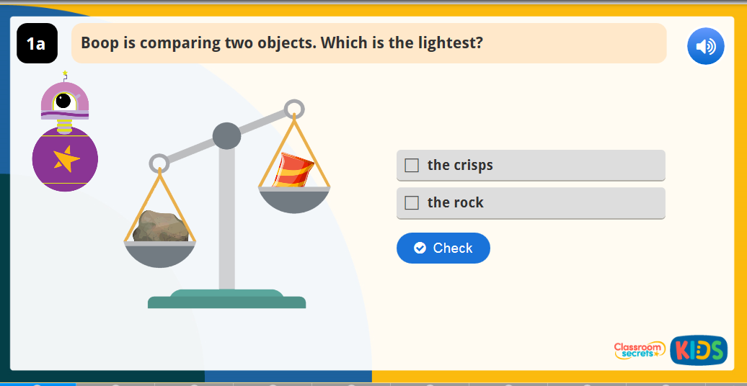
https://kids.classroomsecrets.co.uk/resource/year-1-introduce-weight-and-mass-reasoning-game/

Challenge – word problems
Weight word problems
1. One pencil weighs 10g. How much do two pencils weigh?

2. I have a truck that weighs 7g and a truck that weighs 9g. How much do both my trucks weigh altogether?

3. Mum buys 20g of grapes, 15g of melon and 10g of limes. How much do the items, mum buys, weigh altogether?

4. Tom buys a chocolate bar that weighs 60g. Emma buys a chocolate bar that weighs 40g. How much chocolate do Emma and Tom have all together?

Year 1 Theme activities – Summer 2 week 4
Date: | Activity:
Monday 22nd June 2020 | History – Holidays in the past  Watch these two videos to give you some more information about holidays in the past.  https://www.youtube.com/watch?v=zWgnpY4L9so&safe=active  https://www.youtube.com/watch?v=1N6peInd_pI  On a piece of paper write down any questions you would like to find answers for about holidays in the past. E.g. Why are they wearing those clothes? How did they go swimming? How will I get to the seaside?  Play ‘Hot Seat’ with someone in your family. Ask them to think about their recent holiday or pretend they were on holiday 100 years ago. They can’t tell you which one they are thinking about. Next ask them questions about their holiday to find out/ guess when they went on their holiday. You can take turns when playing this game. Have fun!
Tuesday 23rd June 2020 | History  Cut out and sort the pictures or write down the things you’ve learned /know (you can use phrases below as well) about the seaside into the correct area on the Venn diagram. You can draw/ make your own Venn diagram.  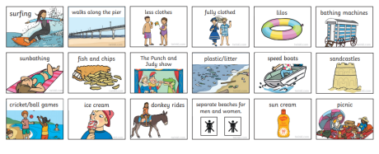  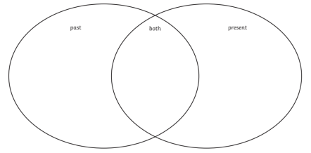
Wednesday 24th June 2020 | History – using timeline to order events  What is a timeline?  A timeline is a way of showing important events in the order in which they happened.  https://www.youtube.com/watch?v=xc64qurhFng  Past Present Future  Create a timeline of your life so far.
Thursday 25th June 2020 | History  Sort the pictures into three groups - 100 years ago, 50 years ago or today. Then arrange the pictures on the timeline. What differences can you spot between the 3 groups?  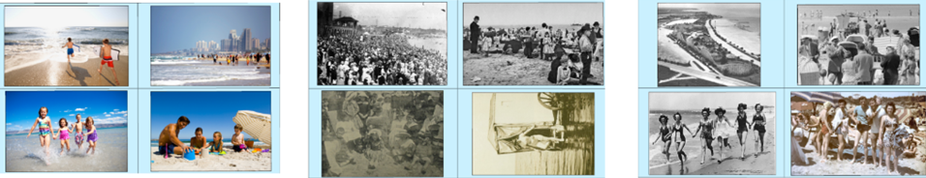
Friday 26th June 2020 | History  If you could get into a time machine and either go and have a seaside holiday 100 years ago, or 50 years ago, which would you choose and why? Record your answer.

Here are the answers to the riddles on the first page:

Answer to the riddles:
- A carrot
- A table

