RUSSELL LOWER SCHOOL
Curriculum and Religious Education Policy
Autumn 2023 - 2024

1. Introduction:

The curriculum lies at the heart of education. It determines what children will know, understand and be able to do by the time they leave Russell Lower School. The curriculum is broad, balanced, ambitious and coherently planned and sequenced towards cumulatively sufficient knowledge and skills for the next stage in children’s education. It provides children with the knowledge, skills and learning behaviours required to become successful life-long learners. Our curriculum is a progression model: we have subject-specific, year group milestones (assessment outcomes) that focus on progression through content and skills learned.

2. Legislation and guidance
This policy reflects the requirements of the National Curriculum programmes of study, which all maintained schools in England must teach.
It also reflects requirements for inclusion and equality as set out in the Special Educational Needs and Disability Code of Practice 2014 and Equality Act 2010, and refers to curriculum-related expectations of governing boards set out in the Department for Education’s Governance Handbook.
In addition, this policy acknowledges the requirements for promoting the learning and development of children set out in the Early Years Foundation Stage (EYFS) statutory framework.

3. The curriculum’s intent:

At Russell Lower School, we have designed a curriculum which is built upon our vision statement, so children can be challenged, enjoy their learning, respect each other and succeed.

At the heart of our school are a set of core rights and values. These underpin our curriculum and the ethos of the school. At Russell Lower School, we place great importance on a curriculum which develops the whole child. Through our core values and rights, we foster an environment where the emotional, physical, academic, social, moral, spiritual and cultural development of each child is developed. We firmly believe that everyone is entitled to an ambitious curriculum and our curriculum design is accessible for all, including children with SEND and disadvantaged backgrounds.

At Russell Lower School, we are a knowledge-engaged school, where knowledge underpins and enables the application of skills, and we aim to develop both. We also aim to develop life skills such as resilience, a growth mind-set and perseverance, alongside our school values and four Russell Rights. See more on this below in our ‘Whole School Curriculum’:

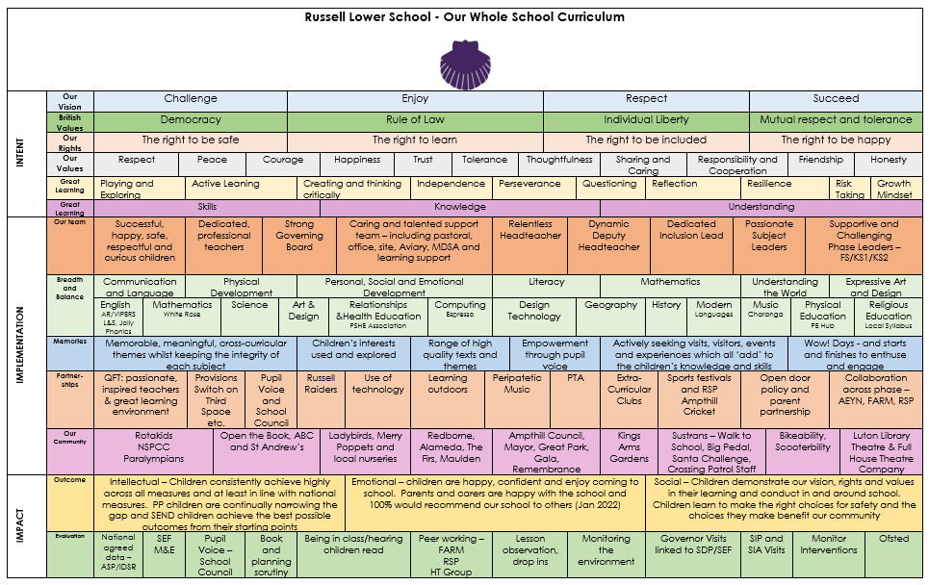

Within our curriculum, there is a strong emphasis on developing core skills in literacy and maths, but also personal, social and emotional skills. There are opportunities to apply these across the curriculum. We consider the Russell curriculum to be so much more than the individual subjects.

The curriculum is the totality of all the children’s learning experiences.

At Russell Lower School we believe that the curriculum should be broad, balanced and relevant. It should meet all the needs of the children, whatever their ability. The curriculum taught is made up of:

- the Early Year Foundation Stage Curriculum (2023)
- the National Curriculum (September 2013)
- The Rising Stars Progression Framework
- RE syllabus (Religious Education in English Schools, Non-statutory Guidance 2010 - Agreed 2017 – 23)
- Personal, Social, Relationships and Health Education
- Spiritual, Moral, Social and Cultural education
- British Values
- Russell Rights and values
- A wide range of extra-curricular activities and experiences

The curriculum taught meets the statutory requirements.

The aims of our school curriculum at Russell Lower School are to enable children to:

- feel safe and valued
- be prepared effectively for the next stage of their education
- know, understand and be able to do progressively more
- achieve age related expectations, whenever possible
- have the knowledge, skills and understanding they need to be educated citizens across a broad range of subjects and experiences
- be able to make connections across areas of learning leaning through a practical, thematic approach
- be confident enough to take risks in their learning
- challenge themselves and rise to our high standards of achievement and progress
- develop an understanding of themselves and others through social, moral, spiritual and cultural development
- develop as caring and responsible citizens who respect one another, our planet and a range of values and beliefs
- be independent thinkers/learners who are able to seek solutions creatively and cooperatively
- develop a sense of self-esteem: be well balanced and healthy individuals who are able to self regulate
- understand and respect diversity

4. Implementation of the curriculum:

To ensure the highest possible levels of progress and attainment for all the children who attend Russell Lower School, it is essential that there is a shared understanding of what constitutes highly effective learning and the highly effective teaching that enables this to occur.
We aim to use research-based approaches, with proven impact. ‘Golden threads’ through our implementation are a focus on teaching, learning and using vocabulary and building ‘sticky knowledge’ via ‘Flashback 4’ and similar recall methods.

As curriculum lies at the heart of education, and subject lies at the heart of the curriculum, then it follows that teachers need solid knowledge: content knowledge and understanding of the subjects they teach. As well as this, they need to know how to teach that particular subject (pedagogical knowledge), and more generally how to teach effectively. At Russell Lower School we use ‘Rosenshine’s Principles of Effective Instruction’ and the EEF’s ‘Great Teaching Toolkit’ as our guiding models.

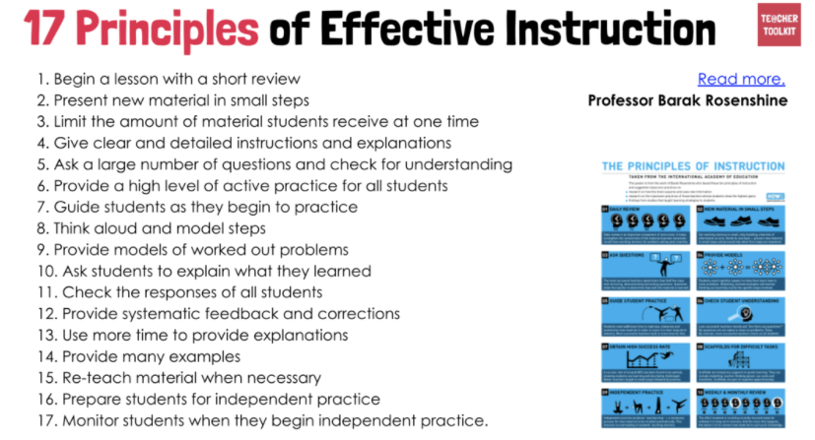

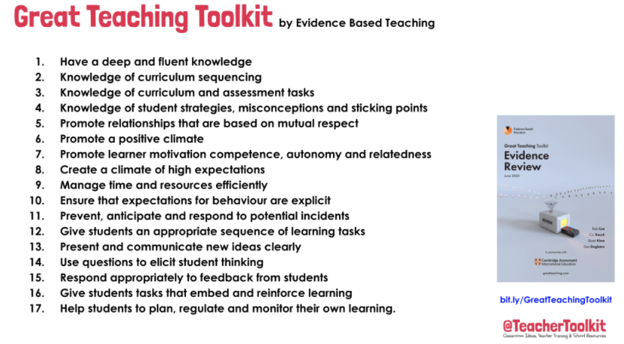

5. Cultural Capital

Cultural capital is the essential knowledge that children need to prepare them for their future success. It is about giving children the best possible start to their early education.
At Russell Lower School, we see cultural capital as the accumulation of knowledge, skills, attitudes, habits and vocabulary that enables individuals to thrive. Our curriculum plays a crucial role in developing this through immersing children in sport, dance, music, visiting theatres, galleries and historic sites; and by introducing them to literature and art.
Embedding cultural capital into our curriculum is a way of closing the gap between children from differing socio-economic backgrounds by ensuring that children from all backgrounds have opportunities to achieve their full potential. We also apply RADY (Raising Attainment of Disadvantaged Youngsters) principles as a ‘RADY school’.

6. Spiritual, Moral, Social and Cultural learning
There are numerous opportunities for supporting the pupils’ SMSC development through all areas of the curriculum. Spiritual development is promoted through RE sessions and a range of Collective Worships.

Moral development is promoted through class Circle Times, discussions about class and school rules and the school values. There are also elements considered within PSHRE themes, e.g. ‘Tolerance’.

Social development is promoted through a wide range of collaborative learning experiences and opportunities for play, PSHRE, Pupil Voice Groups and community events.

Cultural development is promoted through specific learning via the RE and PSHRE curriculums. This is also achieved through positive sharing of the increasing variety of languages and cultural identities of our pupils, their families and the wider world.

7. Implementation of the Curriculum:

Implementation describes the way in which we deliver our curriculum intent consistently each day. To do this we have carefully designed our knowledge engaged curriculum. This is designed to enable all children to acquire relevant subject knowledge which underpins the application of skills. Knowledge, skills and understanding are carefully and progressively mapped across each key stage and subject area using Milestones and year group Medium Term plans.
Knowledge is consolidated and built upon to support retention and recall. This ensures that by the time children leave our school they have learned, and are able to recall and apply the key information that we feel is important in order for them to be successful in the next stage of their education.

The curriculum is designed to promote enjoyment of learning and to be fun. We endeavour to ‘bring learning to life’ and make it ‘irresistible’ wherever possible through visits, visitors, theme days and ‘wow’ events. We consult the children regularly (pupil voice) to involve them in planning and decision making and involve parents in their children’s learning at every opportunity. We have challenged our own previous practice, by asking ‘how much will this contribute to a child’s learning and, furthermore, their cultural capital?’ If the answer is very little, we will change the plan.

Assessment for Learning (AfL) is used in every lesson to ensure skills, knowledge and understanding are built on from what children already know, at a pace and level that ensures good progression and achievement.

8. Organisation of the Curriculum.

Theme Webs and information for parents:
Theme webs are designed by each year group to show in more detail what will be taught within the theme that term. In Foundation Stage the themes are half termly; in the rest of the school these are termly. These are shared with parents. Year group termly overviews add further planning detail.
Subject syllabuses - we have subject syllabuses in place for each subject within the curriculum. The subject syllabus contains all the essential information needed in terms of planning and assessment for teaching and learning within that subject area. This includes the National Curriculum subject content and Early Learning Goals outcomes, unit/long term overview, links to medium term plans and assessment outcomes for each year group.

Long Term Planning/Unit overview:
The next level of planning is long-term/unit overviews .

Medium Term planning.
Teachers create a Medium-term plan for each subject which identifies the specific knowledge required to achieve each milestone (assessment outcome), this ensures that each milestone is broken down into specific knowledge that forms the focus of the lesson.

Weekly Planning:
Teachers work together in year groups to develop weekly lesson plans for each subject. This planning shows the Learning Objectives (or WALT in KS1), the success criteria, the vocabulary, the adaptation, the resources and a flexible outline of the lesson plan. Each teacher then personalises the plan for their own class, carefully ensuring the plans and resources meet the needs of all their children.
Teachers teach what their children need and will amend plans according to the outcomes of on-going AfL (assessment for learning).

Assessment outcomes (milestones):
The end of year expectations for each year group are found within the subject syllabuses. These same outcomes are held within the objectives section of our assessment tool Insight in order for staff to complete regular and accurate formative assessment in order to facilitate their planning.

9. Inclusion
Teachers set high expectations for all pupils. They will use appropriate assessment to set ambitious targets/goals and plan challenging work for all groups, including:
- More able pupils
- Pupils with low prior attainment
- Pupils from disadvantaged backgrounds
- Pupils with SEN
- Pupils with English as an additional language (EAL)
The curriculum in our school is designed to provide access and opportunity for all children who attend the school. Teachers will plan lessons so that pupils with SEN and/or disabilities can study every National Curriculum subject, wherever possible, and ensure that there are no barriers to every pupil achieving. If a child has a special educational need or disability, our school does all it can to meet these individual needs. Our provision complies with the requirements set out in the SEND Code of Practice [2015]. In most instances, if a concern arises suggesting that a child may have special educational needs, the teacher is able to provide resources and educational opportunities which meet these needs within the normal class organisation.
Teachers will also take account of the needs of pupils whose first language is not English. Lessons will be planned so that teaching opportunities help pupils to develop their English, and to support pupils to take part in all subjects.
Further information can be found in our statement of equality information and objectives, and in our SEN policy and information report.

10. The Impact of the curriculum:

Children leave Russell Lower School with the academic, personal, social, moral and cultural skills, knowledge and understanding that they need to be successful in the next stage of their education. They know how to make a positive contribution to their local community and how to be the best they can be. Children leave Russell Lower School as confident and respectful learners.

Ultimately, the impact of the curriculum is the sum total of the skills, knowledge and understanding the children have acquired, as well as the personal characteristics they have developed, during their time at Russell Lower School.

The impact of the curriculum is measured in a variety of ways, using data (a summary of knowledge and skills in a range of forms) and ‘softer’ outcomes such as behaviours, attitudes, understanding and enjoyment.

Staff assess the impact of the lessons they teach using a range of methods. Formative assessment and feedback are on-going all the time in lessons. Planning is adapted in the light of assessment so that learning activities best meet the children’s needs and enables progress to the next steps in learning.

INSIGHT captures the outcome of ongoing assessments and this information allows for the identification of individual progress, analysis of data and subject trends. Each autumn, spring and summer term, summative assessment information is gathered in the core subjects and shared via Pupil Progress Meetings. Foundation Subjects summative data is only gathered once a year, in the summer term, when it is meaningful to make such judgments.

Pupil voice interviews, planning scrutinies, book scrutinies, deep dives and lesson observations take place termly to assess the quality and impact of the curriculum.

Children’s achievements are celebrated regularly in school through discussion, marking and feedback, displays, certificates, stickers, Dojos, parent events and assemblies.

Parents receive feedback on the impact of the curriculum via their children, Parents’ evenings, mid and end of year reports and discussions with staff.

11. Roles and Responsibilities:
11.1 The governing board
The governing board will monitor the effectiveness of this policy and hold the headteacher to account for its implementation.
The governing board will also ensure that:
- A robust framework is in place for setting curriculum priorities and aspirational targets
- Enough teaching time is provided for pupils to cover the National Curriculum and other statutory requirements
- Proper provision is made for pupils with different abilities and needs, including children with special educational needs (SEN)
- The school implements the relevant statutory assessment arrangements
- It participates actively in decision-making about the breadth and balance of the curriculum
- It fulfils its role in processes to disapply pupils from all or part of the National Curriculum, where appropriate, and in any subsequent appeals
11.2 Headteacher supported by the SLT including the curriculum lead
The headteacher is responsible for ensuring that this policy is adhered to, and that:
- All required elements of the curriculum, and those subjects which the school chooses to offer, have aims and objectives which reflect the aims of the school and indicate how the needs of individual pupils will be met
- The amount of time provided for teaching the required elements of the curriculum is adequate and is reviewed by the governing board
- Where appropriate, the individual needs of some pupils are met by permanent or temporary disapplication from all or part of the National Curriculum
- They manage requests to withdraw children from curriculum subjects, where appropriate
- The school’s procedures for assessment meet all legal requirements
- The governing board is fully involved in decision-making processes that relate to the breadth and balance of the curriculum
- The governing board is advised on whole-school targets in order to make informed decisions
- Proper provision is in place for pupils with different abilities and needs, including children with SEN
This is achieved by:
- Talking to children about what they are learning, how they are learning it and why
- Regular formal and informal discussions and training with staff
- Staff Development Meetings
- Carrying out book scrutinies, deep dives and moderations both within and beyond school
- All the activities in the Monitoring and Evaluation Policy
- Observing learning and teaching
- Monitoring of planning on the Learning Platform
- Giving staff feedback and making changes where necessary
- Providing information to parents via Parents Evenings, Reports, Theme Overviews and webs

11.3 Subject Leaders
Each of our subjects is led by a member of staff.
Each subject has its own Intent, Implementation and Impact statement which can be found on the website under the ‘Curriculum’ tab. https://www.russell-lower.co.uk/website/curriculum/437827

The role of the subject leader is to:

- provide a strategic lead and direction for the subject;
- supporting others in the effective Intent, Implementation and Impact of their subject;
- support and offer advice to colleagues on issues related to the subject including moderation and assessment;
- monitor pupil progress in that subject area through a variety of activities;
- provide efficient resource management for the subject.

The school gives subject leaders non-contact time, so that they can carry out the necessary duties involved with their role, part of which is the completion of the subject leader guide and action plan. It is the role of each subject leader to keep up to date with developments in their subject, at both national and local level. They review the way the subject is taught in the school and plan for improvement. This development planning links to whole-school objectives. Each subject leader reviews the curriculum plans for their subject, ensures that there is full coverage of the National Curriculum, learning intentions are clear and that progression is planned into schemes of work and seen within books.

All subject leaders work hard to provide a broad and balanced curriculum which meets the needs of all learners including those with special educational needs.
11.4 Other staff
Other staff will ensure that the school curriculum is implemented in accordance with this policy.
Phase teams and Class Teachers have the final responsibility to produce medium and short term planning for their pupils. They also have responsibility for the standards their pupils achieve, the progress they make and the evidence of this learning. Class teachers should ask for guidance from Subject Leaders when appropriate and are required to ensure all provision promotes our school values.

12. PSHE and Relationships Education:

All primary schools are required to deliver ‘Relationships Education’, as well as personal, social and health education. At Russell Lower School, we have adopted the PSHE Association Programmes of Study for KS1 and KS2. These not only meet, but exceed the government’s requirement for statutory PSHE/RSE education. In Foundation Stage, we continue to use SEAL planning (Social, Emotional Aspects of Learning) as it effectively meets our children’s needs.

13. Religious Education (RE):

In all maintained schools, religious education should be taught to all registered children in full-time education including those in reception classes in Foundation Stage. For greater detail on the RE syllabus within Russell Lower school please refer to appendix 1.

14. Monitoring arrangements
Governors monitor coverage of National Curriculum subjects and compliance with other statutory requirements through school visits and conversations with staff members.
Subject leaders and SLT monitor the way subjects are taught throughout the school by:
- completion of the subject leader guide and action plan
- planning scrutinies
- learning walks
- book scrutinies
- moderation both internally and externally
This policy will be reviewed regularly by the Curriculum, Learning and Standards Committee. At every review, the policy will be shared with the full governing board.

15. Links with other policies
This policy links to the following policies and procedures:
- EYFS policy
- Assessment policy
- SEND policy and information report
- Equality information and objectives

Appendix 1:

The RE curriculum

In all maintained schools, religious education should be taught to all registered children in full-time education including those in reception classes in Foundation Stage.

Legal Requirements:

- Every area of the curriculum, including religious education, should promote the spiritual, moral, social and cultural development of children.
- An agreed syllabus should ‘reflect the fact that the religious traditions in Great Britain are in the main Christian, whilst taking account of the teaching and practices of the other principal religions represented in Great Britain.’ (Education Act 1996)
- Russell Lower School follows the RE Agreed Syllabus for Bedford Borough, Central Bedfordshire and Luton 2017-23: Identities, Meanings and Values. This takes account of the fact that Bedfordshire children come from a range of different religious traditions and from non-religious backgrounds.
- Parents have an absolute right to withdraw a child from receiving RE and the school must comply with the request for withdrawal. Reasons do not have to be stated and the school continues to be responsible for the supervision of any child withdrawn from RE lessons by his/her parents.
- No teacher can be required to teach RE if he/she does not wish to do so.
- RE taught in accordance with an agreed syllabus is subject to OFSTED inspection arrangements.

The Aim of Religious Education:

The aim of Religious Education in the schools of Bedford Borough, Central Bedfordshire and Luton is to contribute educationally to the development of children as individuals and members of society by fostering a reflective approach to life in the context of a growing understanding of the experiences, attitudes, beliefs and religious practices of humanity.’

The principal aim of RE at Russell is to explore what people believe and what difference this makes to how they live, so that pupils can gain the knowledge, understanding and skills needed to handle questions raised by religion and beliefs, reflecting on their own ideas and ways of living.

The threefold aim of RE elaborates on the principal aim and puts the purpose of the subject into action. The curriculum for RE aims to ensure that all pupils can do the following:
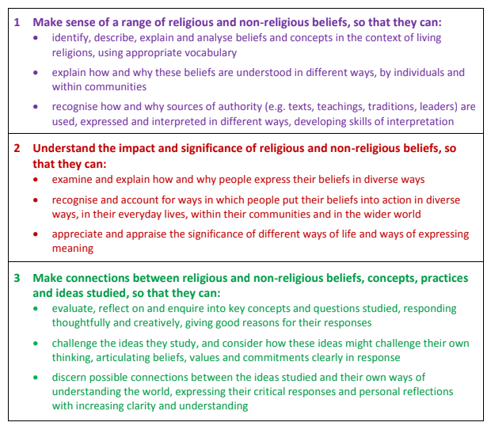

Good RE weaves all of these three areas together.

FS will encounter Christianity and other faiths as they develop a growing sense of self, their own community and their place in it.
KS1 will study Christians, Jews and/or Muslims
KS2 will study Christians, Muslims, Hindus, Sikhs and Jews

Learning is packaged in Units of Study from which teachers plan. These consist of key questions, principle aims, unit content and outcomes.

The Foundation Stage:

RE makes a particularly important contribution to the following Early Learning Goals:

• Personal, Social and emotional Development - building relationships
• Communication and Language
• Understanding of the World - past and present, people and communities
• Expressive arts and design - being imaginative and expressive

The syllabus links early learning goals to themes in the National Framework and to KS1 Recommended Study Units of the Agreed Syllabus. Russell Lower School children are offered experiences and opportunities through stories, role play, dressing up, taking part in plays, talking to visitors, watching films, handling artefacts, assemblies, art, music, dance, food tasting, exploring the natural world, celebration of special occasions and achievements.

KS1 and KS2:

In teaching, Russell Lower School takes account of the knowledge, skills and understanding children require. For example, they may:

- Explore a range of religious stories and talk about their meanings.
- Name and explore a range of celebrations, worship and rituals in religion and begin to note similarities and differences.
- Reflect on and consider religious and spiritual feelings and experiences.

Also, account is taken of the experiences and opportunities to be offered to children for example:

- Visiting places of worship and focusing on symbols and feelings;
- Using their senses and having times of quiet reflection;
- Using art and design, music, dance and drama to develop their creative talents and imagination;
- Sharing their own beliefs, ideas and values and talking about their feelings and experiences;
- Beginning to use ICT to explore religions and beliefs as practised in the local and wider community.

Assessing RE:
The principle aims for RE sets out the knowledge, skills and understanding that children of different abilities and maturities are expected to have by significant milestones. The key indicators of attainment in RE are contained in three principle aims – making sense of beliefs, making connections and understanding the impact. Each of the three elements of the teaching and learning approach is important, and pupils should make progress in all of them.
The steps to success are detailed for teachers to refer to.

Attitudes in Religious Education:

We aim to develop the following four attitudes:

• Self-awareness e.g. recognising their own uniqueness as human beings
• Respect for all e.g. developing skills of listening and a willingness to learn from others, even when others’ views are different from their own
• Open-mindedness e.g. being willing to learn and gain new understanding
• Appreciation and Wonder e.g. appreciating the sense of wonder at the world in which they live

Learning across the curriculum:

We recognise that religious education plays a significant part in promoting personal, social and health education. Religious education provides opportunities for children to develop the key skills of communication, use of ICT, working with others, thinking skills, problem solving and creativity.

Spiritual, Moral, Social and Cultural learning and British Values

The RE Agreed Syllabus will enable pupils to learn to think for themselves about British Values in relation to the values of different religions and worldviews and their own values. The subject offers opportunities to build an accurate knowledge base about religions and beliefs in relation to values. This in turn supports children and
young people so that they are able to move beyond attitudes of tolerance towards increasing respect, so that they can celebrate diversity.

Resources:

Resources such as books, posters and artefacts are stored in separate boxes labelled by themes. There is also a general resources area in the curriculum cupboard which contains books for staff to refer to for information about a variety of religious traditions and beliefs.

Collective Worship:

Collective worship and assembly are distinct activities and although they may take place as part of the same gathering, the difference between them should be clear. Acts of collective worship at Russell Lower aim to be of educational value, meaningful and in some sense reflect something special or separate from ordinary school activities. We recognise that in line with the 1993 Education Act, collective worship is to be ‘wholly or mainly of a broadly Christian character.’

If a parent asks that a pupil should be wholly or partly excused from attending collective worship then the school must comply. We continue to be responsible for the supervision of any child withdrawn by his/her parents.

Assemblies:

A range of assemblies are held across the week. On Fridays, there is a special assembly to celebrate achievements. During the course of the year special assemblies are held to acknowledge times of significance or celebration in different faiths and cultures. Visitors from the community are also invited to talk to the school about a range of topics and community projects and activities.

Responsibilities for RE:

The responsibility for the provision and delivery of Religious Education lies with the Headteacher but the Governing body must also exercise its function to secure the provision of RE and ensure that sufficient time and resources are given to RE in school to meet statutory requirements. RE is currently led by a member of SLT, Dawn Tuck.

